**Your name**

**Bakary K. Manneh**

**Your student ID number**

**UB64243SCI73300**

**COURSE NAME:**

**(Road Safety Engineering)**

**Assignment Title:**

**Road Safety Engineering Basic Principles**

**ATLANTIC INTERNATIONAL UNIVERSITY**

**FEBRAURY/2022**

Table of Contents:

1. Summary
2. Introduction
   1. **TRAFFIC SAFETY PRINCIPLES** 
      1. Road network functionality
      2. Visibility and predictability
      3. Traffic homogeneity
      4. Driving task simplification
      5. Error forgiveness
3. **Description**
4. General Analysis
5. Recommendations
6. References

**Summary**

Road Safety Engineering is a procedure, founded on investigation of road and traffic affiliated accident information, which utilize engineering principles in order to identify road design or traffic administration or management that will cut down the number of road accidents in the most economical way.

**Introduction**

The implementation of various infrastructure components is instrumental in improving road traffic safety. And maintaining and following road traffic safety protocols that are recommended and enforced by the state or local government to improve road safety (That is to deliver road safety recommendations that will have zero tolerance concerning traffic violations, fatalities and severe injuries.)

In addition, driving assistance systems play a major role in improving road traffic safety. Since the advent of cutting edges technologies that display a real time description of road traffics, drivers and motorist have opportunity to have an overview of a specific road traffic conditions or features. This cement the fact that understanding infrastructure features and their underlying concepts ease the implementation of driving assistance systems.

The essence of the backdrop of this paper is to discuss some of the concepts and principles of road safety and road designs and to recognize (identify) set of road traffic safety principles, that entails the functionalities of driving assistance systems and the necessary infrastructure measures.

Also the topic of road categorization is addressed, as different road categories involve different types and levels of traffic risk, and a specific infrastructure measure often relates to and is designed for a specific road category, while the definition of an adequate safety focused road categorization is useful for research on selection of optimal routes from a traffic safety perspective.

In addition, types of roads are discussed, as different categories of roads encounter sets of different levels or types of traffic risk, and especially infrastructural design sometimes relates to and for a particular road type or category, while traffic safety perspective that is useful to researchers for routes optimization is road categorization.

Furthermore, for a fruitful comparative functional analysis of driving assistance system, an overview of underlying infrastructure measures must be available as the basis for any analysis; and recommend effective and well-rounded road traffic safety measures.

**Description**

1.TRAFFIC SAFETY PRINCIPLES

Traffic safety principles concern with elements or factors that focus on preventing and mitigating conflicts among road users. The conflict between two driver-driver and a driver or the conflict between vehicle and other road users or the effect of certain obstacles on the road, when address prevent collisions or accidents on the road. As a result, improves the general safety of passengers and other road users.

These include single vehicle roll-over and single vehicle run-off road incidents, due to loss of lateral control or wrong maneuvering, and inappropriate speed when the vehicle approaches a curve. In addition, the principle of error forgiveness is missing. This implies that these safety requirements do not cover all measures based on infrastructure and driving assistance systems.

To achieve a sustainable road traffic safety, there are variables or components such as road network functionality, error forgiveness functionality, informative and predictability, traffic homogeneity, driving task simplification that should be taken as the core safety fundamentals with other traffic requirements to cement safety protocols.

**Road network functionality**

The functionality of the layout and structure of the road network should be sorted out. All unintended use of the road should be thwarted and functional use of the road should be maintaining against unintended uses of the road.

**Visibility and predictability**

The road situation should be modified to the limitations of the users of the road, and there should be information available to direct road users.

Complicated traffic situations should be discouraged or completely avoided, and all the route choices and necessary movements along roadways should be well explained or made easy to understand so that road users will find them useful and use the road with maximal efficiency. Road situation should be well recognized to help ease any tension along the traffic situation and signal the right choice for the road user and be able to predict their behaviors, and prevent loose and unclear behavior or decision making. It is important for the road users to willingly adhere to the standard rules and regulation.

**Traffic homogeneity:** Homogeneous use of the road network aims at preventing encounters between road users, and between road users and obstacles, at high differences in speed, direction and mass. This principle is rigorously expressed in the three speed rules.

**Driving task simplification**

Drivers can influence their driving experience by reducing the workload through simplification of driving task. This fundamental knowledge or know-how is synonymous to the principle of **Visibility and predictability,** that is making the traffic cases simple (prevent complex traffic situations or unnecessary delays)

This principle does not focus on the ad-hoc traffic situation but on the continuous process of driving. It aims at taking away some of the effort that is needed for driving, and/or at reducing the needed attention for certain parts of the driving task, and/or at helping to take correct decisions in certain situations.

The aforementioned principle does not focus on the need of traffic situation but the overall activity of driving. It works to minimize the effort that is needed for driving and as a result reduce work-done on other aspects of the driving task, and providing the driver with time to make sound decision on the roadway.

**Error forgiveness**

Drivers will continue to make errors regardless what principles they follow or not follow, this is due to being human.

The errors drivers make can be corrected; correcting errors make by drivers at an early stage when they first begin making the errors can help them improve on this aspect and mitigating effect of driving errors once they have gone too far.

**INFRASTRUCTURE MEASURES**

Here, we provide the general overview and description of the general infrastructural measures for improving road traffic safety.

In the previous sections, road traffic safety variables are outlined in relation to roadway intersections, road sections, and the overall routes (including speed zones). The macroscopic road network design described in the third subsection is an infrastructure measure.

It is declared that the type of collision concerned here is front-rear, likely due to an abrupt halt of a vehicle before actually diverging. Nevertheless, this is a form of position that may happen any place in the road network, and is not peculiar to any intersection.

**Figure 1 below** shows priority signs, traffic lights and grade separation. Intersections that are not controlled by traffic lights rely on a generic priority rule to point a right of way. Some control can be applied to road intersection by giving one by placing priority lanes, or roadway.

Road traffic lights are important components that provide means to guide traffic at road intersections and are ubiquitously use in built-up area. They have a constant time interval.

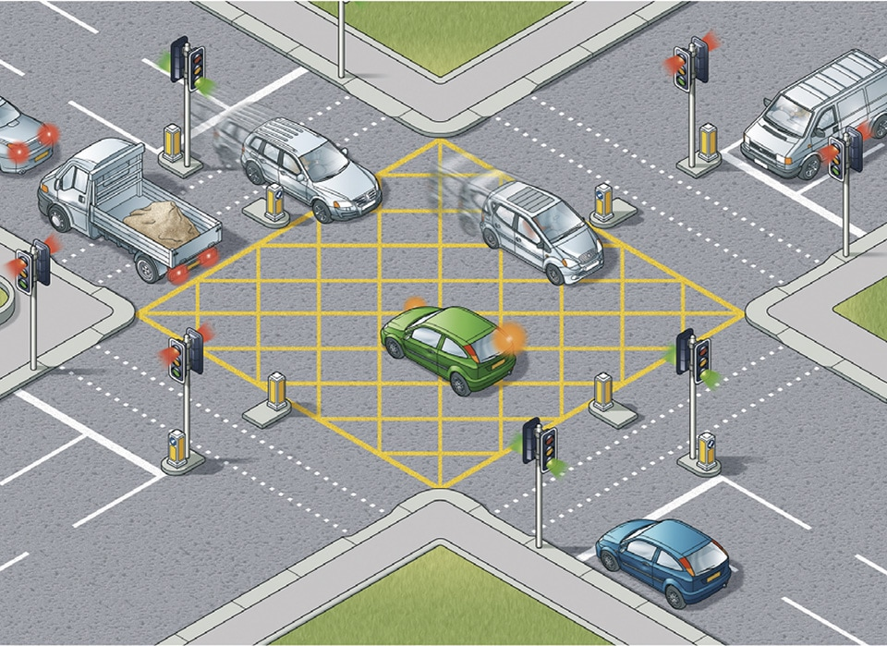Figure 1: Traffic lights---Intersection

**Figure 2** below shows channelized (including roundabouts): A channelized intersection is the phenomenon where the paths of travel for different movements are separated

and delineated. Hence, channelization explains where bicyclist, pedestrian or

driver should be as they come and travel through the intersection.

For example, signalized intersections with multiple lanes—and, in particular,

multiple turn lanes—can end up with a lot of open space within the intersection.

Striping inside the intersection guides each road user through this open area. The

use of traffic islands and safety bars is adequately illuminated by street lighting

for safe and efficient channelization.

The Gambia does not have a grade separated intersection yet. The work is in

progress to developed two grade-separated intersections. Two grade-separated

intersections are going to replace a roundabout and multi-leg intersections. This

development is going to improve the traffic since the roads will meet at different

heights.

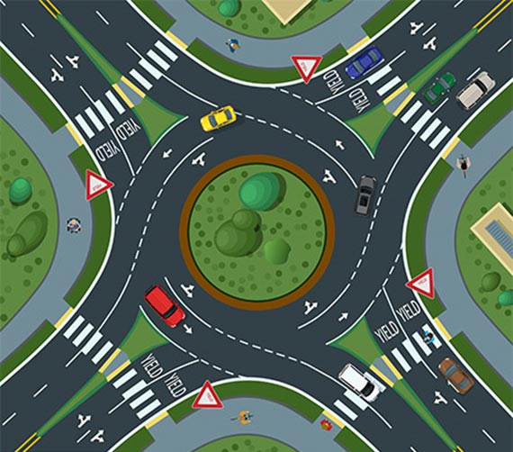Figure 2: Roundabout

**Conclusion**

The principal part of this composition to understanding in transportation science is facilitated in assembling a set of generic road traffic safety fundamentals.

It is for this backdrop that, based on a review of the fundamental principles of road design centering on sustainable road traffic safety, we extended the definition of road traffic safety to five road traffic principles and other road traffic safety requirement.

These set of rules and regulations must cover the whole sphere of road traffic safety measures and address specifically the infrastructural underlings, and in addition provide systematic basis for any scientific inquiries to improve the general safety of the roadway or provide information to improve the driving assistance system.

Another fundamental aspect of this composition, contribution of this paper is a recommendation for alternative forms of road categorization. The road categorization plays an important aspect in road traffic safety, which is focus the underlying design and the selection of roads to form an optimal route network.

A well designed road traffic safety composition, contains well description of physical infrastructure standard and their determinant factors, that is the fundamental measurements and the composition of the network layout of the roadway.

Road traffic safety is improved using the aforementioned design and redesign principles by controlling speed and direction or minimizing(preventing) conflict in the flow of road traffic. Speed control play a major role in enhancing accessibility of roadways (on collector) and direction and control aid help in aerial and through roads connections.

There are roads such as flow roads or highest level roads, that by far compliant with most of the road traffic safety regulations, and road traffic safety on these roadways. A further improve in the infrastructural layout hardly improve the road safety of these types of roadways.

The summary of infrastructural standard gives a good fundamental basis for any relative analysis (comparative analysis) to approximate the effects of variables for which some data and modest know-how exist.

Nonetheless, it is very difficult to determine the values of road traffic safety effects, even if the confidence level marked 95%. Reliable and accurate historical record and statistical analysis can help us address the effects but the analysis always leave some uncertainties.

Various variables influence the effect of road traffic safety; at road section or intersection infrastructural measures are mainly taken into account for comprehensive studies.

**Bibliography**

Put the bibliography of the

**books and other sources used to write the assignment.**

**Title Authors Publishers Year**

**Road Safety Annual Report 2020 International Transportation Forum International Transportation Forum 2020**

**Traffic Signs Manual Welsh Assembly Government The Stationery Office) 2019**

**Road traffic injury prevention training manual World Health Organization World Health Organization 2020 Highway Design and Traffic Safety Engineering Handbook R. Lamm Lost Bookstore 2017**

**Road Safety and Traffic A. Agrawal, & Rmenon Nova 2017**