WILLY KORIR
ID: UB50187SCI59141
GEOTECHNICAL ENGINEERING
BACHELORS IN CIVIL ENGINEERING
ATLANTIC INTERNATIONAL UNIVERSITY

Geotechnical Engineering
Introduction
The course involves designing and analyzing excavations, foundations, earthworks, earth-retaining systems, and slopes using soil mechanics ideas. Design and implementation of shallow foundations on rocks and soils based on load-carrying capacity and settling analysis; proper installation of pile foundation like driven and bored piles; engineering and implementation of earth retaining structures; slope stability; geotextiles and ground reinforcement; ground advancement; and unique construction techniques are among the topics covered.
Learning Outcome
- Before conducting a site inspection, interpret and summarize desktop data to estimate probable soil and groundwater conditions.
- Identify and design practical, cost-effective site studies that accurately characterize the ground.
- Create a simplified geotechnical model that summarizes the soil profile and detects and quantifies essential design factors.
- Calculate two-dimensional seepage, pore water pressure constants, lateral earth pressures, time-dependent consolidation, loading-induced pressures and displacements, and shallow foundation bearing capacity.
- Construct retaining walls and foundations, as well as assessing slope stability.
- Assess design alternatives and make final design recommendations based on sustainability, construction feasibility, and cost-effectiveness.
- In the laboratory, determine the qualities of the soil.
Site Investigation and In-situ Testing
Site investigation methods include boring, digging, sample selection, testing, and non - destructive testing, as required. Selection and testing takes place underneath the ground, away from the selection point. The soil specimen must be left undisturbed until testing is complete to obtain a clear picture of subsurface conditions. The material and chemical contents of the soil and its strength, thickness, and orientation may all be determined.
Site Investigation Stages
- Reconnaissance visit to provide information regarding site topography, geological features and vegetation.
- Study of Data and Maps to obtain and analyze data on Geological maps, photographs, and old plans.
- An in-depth investigation is conducted to assist in selecting trial pits and boreholes.
Figure: A suggested method for organizing a site investigation assessment

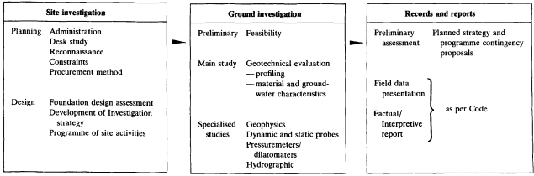
In-Situ Geotechnical Tests
  - Pressure meter Testing
  - Cone Penetration Testing (CPT)
  - Borehole Logging
  - Flat Dilatometer Testing (DMT)
  - Dynamic Cone Penetration Test (DCP)
  - Field Vane Test (FVT)
  - Plate Load Testing (PLT)
  - Standard Penetration Testing (SPT)
The two-dimensional flow of Water Through Soils
Soils are porous substances. The interconnecting spaces allow water to flow between them. Particle sizes and structural arrangement influence the flow velocity, seepage volume, and pore water pressure distribution.
Laplace's equation describes the movement of water through soils. Water flow through soils is similar to steady-state heat and current flow in homogeneous conductors. For two-dimensional water flow over the soil, the typical formulation of Laplace's equation is;
$$k_{x }\frac{∂^{2} H}{∂x^{2}}+k_{z} \frac{∂^{2} H}{∂z^{2}}=0$$
The total head is H, and the hydro-mechanical conductivities in the X and Z orientations are kx and kz, respectively. The requirement that increases in hydro-mechanical gradient in one axis is balanced by adjustments in the opposite direction and is expressed by Laplace's equation. If the surface is isotropic, kx=kz, and Laplace's formula becomes;
$$\frac{∂^{2} H}{∂x^{2}}+ \frac{∂^{2} H}{∂z^{2}}=0$$
The boundary conditions must be known in order to solve any differential equation. Because the boundary situations for most actual structures are complicated, they cannot be solved analytically or using closed-form methods. People must rely on approximations obtained using numerical approaches such as finite elements, boundary elements, and finite difference.
Flow net
- A graphical solution approach for two-dimensional constant flow in a homogeneous, isotropic aquifer with no scattered internal sources.
- It may be used for both homogeneous and anisotropic aquifers and specific basic heterogeneous scenarios.
- If the flow is continuous, the transmissivity is homogenous and isotropic, and there are no internal sources, such as recharge, it also works to vertically integrated, basically horizontal flow aquifer models.
Figure: Flownet Equation
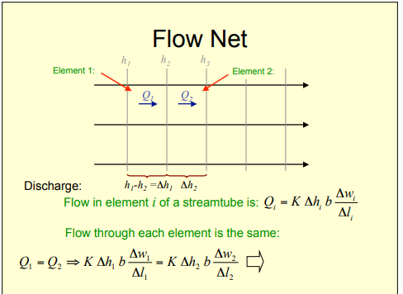

Application of Flownet
Computation of uplifting pressure, exit gradient or pipework, Heaving, and Pore Fluid pressure are all examples of flow net applications.
Advantages of Flownet
- Simple to use since it provides a fast overview of the flow regime
- Looks at the aquifer on a much bigger scale than the core, slug or testing involving pumps
- Can provide a result that is as accurate as the primary method.
Disadvantages of flownet
- Assumptions are pretty limiting, especially in; Stable State, a domain that is more or less homogenous and two-dimensional flows.
Pore water pressure distribution
In earthen dams, the variability of pore pressure is critical for maintaining stability. External loading conditions such as rapid drawdown of water, earthquake loading, and a rise in the water table induced by rainwater infiltration affect the pore pressure within the dam. Seepage through a dam involves both saturated and unsaturated flows. However, the flow in the unsaturated zone is ignored to simplify the solution of non-linear differential equations, and seepage evaluation is carried out by constructing a flow net with pore pressure beyond the free surface set to zero. In reality, due to capillarity, adverse pore pressure develops further than the free surface, leading to the development of soil matrix suction.
Determination of uplift pressure
In steady-state situations, Khosla provided a method for estimating uplift pressure under reservoirs based on resolving the Laplace equation as a dominating equation.
$$\frac{∂^{2}h}{∂x^{2}}+\frac{∂^{2}h}{∂y^{2}}+\frac{∂^{2}h}{∂z^{2}}=0$$
Heaving and piping failures
The soil's weight must outweigh the water's seepage force. Despite this well-known principle, piping and sand boiling happens at a significantly lower hydraulic gradient than the expected threshold. The stability of the whole soil prism should be explored in the event of a hydraulic heave, whereas the stability of one particle should be examined in the case of the commencement of piping on the soil surface. According to the findings, the hydraulic integrity of the soil cannot be well described by the hydraulic gradient alone. The hydraulic integrity of the soil is influenced by particle size and distribution. The Terzaghi criteria hold when the sizes of the particles in a soil mass exceed the critical diameter.
Consolidation
When the amount of saturated soil reduces as a result of applied stress, soil consolidation occurs. Terzaghi developed the one-dimensional consolidation hypothesis and revised the term, which had formerly been connected with clay soil compaction leading to the production of shales.
When weight is placed on a poor permeability ground, the weight is absorbed first by the liquid in the saturated soil capillaries, causing a quick rise in pore pressure.
When water seeps from the soil's cavities, the surplus pore pressure is reduced, and the stress is redistributed to the soil mass, which progressively compresses, causing settlements. The consolidation technique is repeated until the pore water pressure is reduced to a safe level. Natural forces, human-made loads, and even a reduction in groundwater level can all cause an increase in the weight exerted, resulting in consolidation.
Governing equation for 1-D consolidation
Consolidation is one-dimensional because water flow during pore water evacuation happens exclusively in the vertical direction (1D). Compared to the initial amount of soil, the change in volume due to consolidation is insignificant.
It consists of three non-dimensional factors, which include;
- The extent of consolidation represents the rate of consolidation at a specific point z in the compressive layer at any given time.
$$U=\left(\frac{u_{d}}{u}\right)×100$$
Where; u is the total pore pressure dissipated which is equal to $∇σ$ = applied stress increment.
- The drainage path ratio z given by $Z=\frac{z}{d}$ where; d is the maximum distance the pore water must travel for drainage and z is the length from the drainage face.
Time factor given by; ; $T= \frac{C_{v }×t}{d_{2}}$ where t is the period corresponding to a certain degree of consolidation, Cv is the constant of consolidation, which is a soil attribute that a laboratory consolidation test may evaluate, and d is the drainage channel length.
T = (π /4U2) if U < 60%
T = –0.9332log10 (1 – U) – 0.0851 if U > 60%
Time Rate of Consolidation
Slow seepage occurs, and excess pore pressures gradually diminish, resulting in consolidation settling. With time, the volume change slows; around half of the entire consolidation settlement is completed in one-tenth of the whole period.
Sand drains
The Sand Drain Process utilizes orthogonal sand drains and overflow fills to speed up ground consolidation and increase stability. This approach employs specialized equipment capable of concurrently driving one to twelve drains.
Stress Paths and Pore Pressure Coefficients
Skempton's pore pressure coefficients
Skempton's coefficient B is the ratio of generated pore water pressure to change in stress loading in undrained conditions, which is a crucial pore-fluid parameter. When it comes to assessing soil strength, pore pressures are crucial. The variation in pore water pressure generated by applied stress is described by dimensionless coefficients known as 'Pore pressure coefficients.
Pore water pressures arise when a cell or restricting pressure are imposed in the first stage, and extra-axial stress or deviator load in the second stage of an undrained triaxial compressive strength test. The B-parameter is defined as the relationship between the established water pressure and the applied confining pressure:
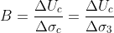
Figure: The experimentally discovered change of B with saturation degree.
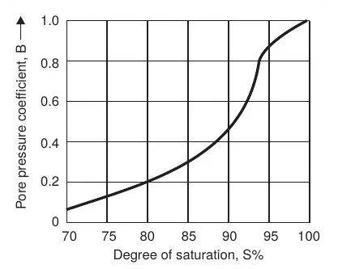
During deployment of the deviator stress in a triaxial compressive strength test, pore pressure rise, and the pore pressure coefficient, or parameter A, is defined as follows:
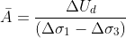
where,
∆ud = pore pressure due to increase in deviator stress
(∆σ1 – ∆σ3) and Ā = product of A and B.
The A-factor is affected by the soil, its stress history, and the deviator stress used.
Its value may be changed throughout the test, including when the test fails or when the maximum deviator stress is reached. In sands, the A-factor is affected by the initial density index, but in clays, it is affected by the over-consolidation ratio.
Purpose of stress paths
The stress path approach is presented and demonstrated for addressing stress-strain issues in soil mechanics. The stress route technique aids in the identification and comprehension of the foundations of the field issue, indicating the most acceptable solution components from those accessible.
Determination of Kf line and plot of total and effective stress paths;
A stress path is utilized during loading or unloading to represent the different states of stress in a soil test specimen. A sequence of Mohr circles can be drawn to represent subsequent states of stress, but representing a large number of circles in a single diagram is difficult. A series of stress points can represent successive states of stress, and a locus can be calculated from them.
Figure: different stress paths
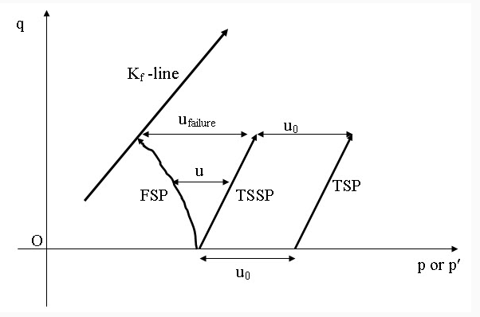
Lateral Earth Pressures and Retaining Wall Design
Since lateral earth pressure has an impact on the consolidation behavior and properties of the soil, it is factored into the design of geotechnical engineering structures such retaining walls, foundations, abutments, and propped excavations. Backfill is held in place by retaining walls, which also allow for a change in slope.
Figure: Retaining Walls
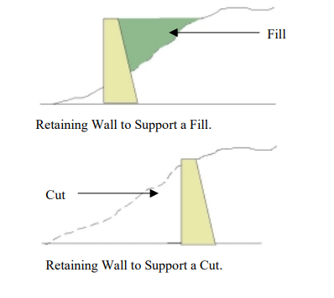
Soil pressure, surcharge loads, water, and earthquakes must all be considered when building these retaining walls. The forces operating on the wall must first be calculated before any retaining wall design can be completed.
When a wall is restrained from displacement, such as with a basement wall restricted at the bottom by a flooring and at the top by a floor structural frame before soil backfill is deposited against the wall a repose pressure builds due to the lateral movement restraint on the wall.
When a wall, such as a conventional retaining wall, can go outward and the soil expands sufficiently to utilize its shear strength, active pressure occurs.
Figure: wall movement
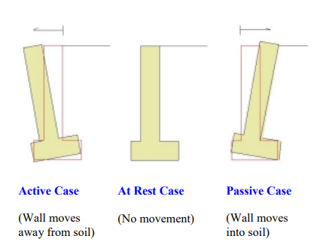
Active and Passive Earth Pressure Coefficients
Two fundamental classical theories are often employed when addressing passive and active lateral pressures: Rankine and Coulomb Earth Pressure Theory.
Assumptions of Rankine Theory
- There exists no friction or adhesion in between wall and ground.
- Lateral pressure is only applied to vertical walls.
- The pressure is one-third of the height (H) above the base of the building, and it is parallel to the fill surface.
- Backfill failure happens as a sliding wedge along anticipated failure plane indicated by φ
Assumptions of Coulomb's Theory
- Since there is resistance between wall and earth, a soil-wall angle of friction of δ is used to account for it. It is worth noting that δ runs from φ/2 to 2φ/3, with δ= 2φ/3 being the most popular.
- The deployment of lateral pressure is not limited to vertical walls.
The passive and active Rankine earth pressure coefficients for a certain situation is computed as shown below:
Ka = (1 – sin(φ)) / (1 + sin(φ)) - (Active)
Kp = (1 + sin(φ)) / (1 - sin(φ)) (Passive)
The Coulomb passive and active earth pressure coefficients are calculated using a more sophisticated formula that takes into account the angle of the rear of the wall, the soil-wall friction value, and the angle of backfill.
Factors leading to instability of a retaining wall
Poor drainage is the most frequent cause of retaining structure collapse. Hydrostatic pressure develops up behind the retaining structure if sufficient drainage is not provided. The wall may not be constructed to support the weight of saturated earth, which is far heavier than dry soil.
Other factors include; Overturning Failures, Bearing Failure of Soil, Sliding Failures and Slope Stability Failures.
Design of a retaining wall
The designing of a retaining wall is divided into two parts.
- Design in the Serviceability Limit State - Stability Analysis
The serviceability limit state checks the wall's stability depending on the applied loads—the stage checks for overturning, slipping, bearing, and slope stability problems.
- Designing for Ultimate Loads - Ultimate Limit State Design
With the ultimate limit stage, factored loads are considered while designing the corresponding wall. Assume a concrete retaining wall: the reinforcement for bending and shear is found in the wall and base, depending on the applied stresses.

Foundations
Shallow foundation
A shallow foundation does not exceed the safe bearing capacity of the earth. People dig the ground until the bottom of the foundation and then build the footing while building a shallow foundation. In this sort of foundation, the whole footing is exposed. It is most often used in lightweight structures with ideal soil conditions. Freezing may cause damage to shallow foundations. As a result, they must be sheltered in cold weather. They should also be built underneath the frost line and shielded from the elements.
Examples of shallow foundation
- Pad foundation
- Strip foundation
- Mat foundation
- Combined footing
Deep Foundations
Deep foundations go deep into the ground, allowing the structure to rest directly on the ground. They are frequently dependable in deep seas and target hard strata.
Examples of deep foundations;
- Pile foundation
- Drilled shaft foundation
Stresses and Displacements Induced by Loading
Vertical stress distribution in soil due to external Loadings
The vertical and side strains within the soil mass increase when a force is added to the soil surface. The elevated stresses are highest directly beneath the loaded area and diminish as a distance away from the load location within the soil mass is increased The term for this is "spatial attenuation of applied loads." A diagram depicting the vertical pressure distribution with depth along the midline underneath an embankment of elevation, h, built with the soil of total unit weight yt.
Figure: vertical stress distribution
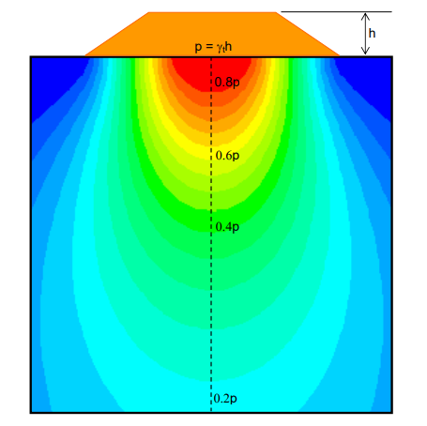

Boussinesq solutions
These formulae are based on the following assumptions:
- stress is proportional to the strain
- the soil is homogenous
- the material is isotropic
The Boussinesq solutions are commonly utilized in most scenarios, including those involving layered soils, as long as the layer thickness is in the range of a few feet or more.

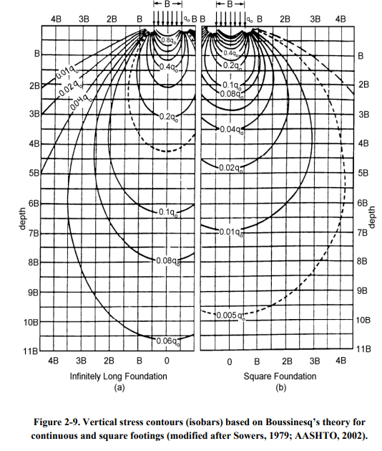
Fadum's chart calculates the increase in vertical stress beneath the corner of uniformly loaded flexible rectangular areas.
Shallow Foundation Bearing Capacity
The parameters for determining a foundation's carrying capacity are based on the foundation's structural needs. The following are the details:
- Foundation shear failure, which might not happen. It has to do with the plastic flow of soil beneath the foundation and lateral soil outflow from beneath the foundation's footing.
- The foundation's probable differential and total settlements must be determined.
Limitations are set at levels that are safe, bearable, and acceptable. The pressure exerted on the footing should not jeopardize the foundation's stability structure.
Factors that Influence Bearing Capacity
- Nature of the soil and its engineering and physical properties.
- Length, shape, depth underneath the ground surface, and resistance of the structure.
- Deformation settlements that the building can tolerate without functional failure.
- Position of the water table comparative to the point of the foundation.
- Preliminary stresses, if any.
Bearing capacity determination methods
- Tables of bearing capacity in different building codes
- Analytical methods
- Penetration tests
- Plate bearing tests
- Laboratory tests
- Model and prototype tests
Effects of soil parameters
Shear strength parameters influence the size of the spread foundation. The degree of internal friction and cohesiveness are two criteria that must be considered while building a spread foundation to determine the bearing capability of the foundation soil. The values of shear strength parameters acquired from a geotechnical study report on the spread foundation size are compared.
Groundwater and eccentric loads have an impact on bearing capacity.
The rise in the groundwater table is thought to impact settling substantially. Terzaghi (1943) proposed that submerging soil mass reduces soil stiffness by half, resulting in a two-fold increase in settlement. Various academicians have proposed a conversion factor to cater to the additional settlement caused by water table fluctuations. This topic aimed to assess the impact of rising water tables on footing settlement. In soft PLAXIS software, a two-dimensional model of sized particles and shallow foundations were constructed. The Mohr-Coulomb constitutive model was used in the analysis. Changes in elastic modulus, cohesion, internal friction angle, and dilation slope of soil on bearing capacity and settlement performance were also determined using elastoplastic soil characteristics.
Shallow Foundation Design
- The footing may hold a load-bearing wall, a single column, or multiple columns to support the structure.
- Depending on location and type of construction, different loads are carried by columns.
- The significant Loadings are dead and living loads, and each column carries a distinct type of load.
- The column does not bear the total amount of dynamic loads for the duration of its life. It is commonly thought of as a service load that will be applied to the column for the duration of its life, calculated as dead weight plus 50% of dynamic loads for ordinary buildings.
- Storage facilities and other warehousing floors should use a substantial percentage of live load.
- In most cases, the design of column foundations based on service weights is acceptable.
The following approach can be used to design footings.
- Calculate the loads that the footing is subjected to.
- Get a soil profile that depicts the site's soil stratification.
- Determine the highest water level possible.
- Collect relevant laboratory and field measurements as well as test findings.
- Determine the footing's depth and position.
- Determine the supporting stratum's carrying capacity.
- Align the size of the footings.
- Examine the contact pressure of the footing.
- Examine the footing's stability in the face of slipping, overturning, and uplifting pressures.
- Calculate the total as well as differential settlements.
- Create the foundation structure.
- Determine whether foundation drains, waterproofing or damp proofing are required.

Pile Foundation Analysis and Design
When the soil layers directly beneath the structures are incapable of holding the load with the acceptable settlement or appropriate safety against shear failure, deep foundations are used. Although expanding the degree of support to the first hard layer is necessary, it is insufficient. On the other hand, the deep foundation must be engineered in the same way that the shallow foundation keeps the soil strata below safe and secure from the deleterious settlement.
Deep foundation can be divided into two types; Pile foundation and pier or well foundation.
Piles classification
- Function or action piles
- End-bearing piles
- Tension and uplift piles
- Anchor piles
- Fender and Batter piles
- Composition of piles
- Timber and Steel piles
- Concrete and Composite piles
- Mode of Installation
- Driven, Cast-in-situ piles and Driven and cast-in-situ piles.
Pile driving
Pile driving is the process of lowering a pile into the ground. A hammer is an oldest and most widely used method. The 'pile driver' is the piece of equipment that lifts the hammer and allows it to crash upon the pile's head.
Figure 16.2 The 'leads,' are simply two parallel steel tubes joined by U-shaped spacers and reinforced by trussing, are attached to the boom. The leads are held against the crane by a stay, which usually is movable to allow batter pile driving. Steam hammers necessitate the use of a steam generator or an air compressor.
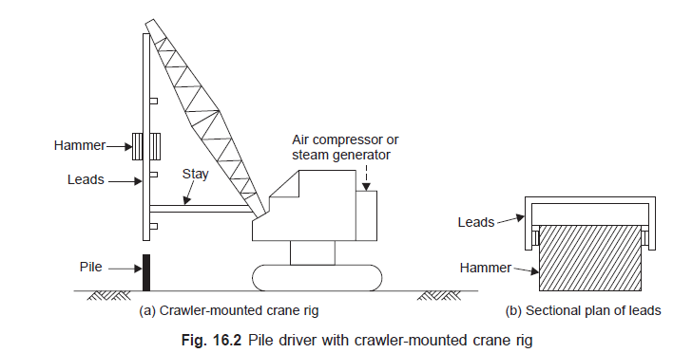
Pile capacity
The ultimate load is the highest weight it can support without failing or causing excessive ground settlement. The permissible weight on a pile is the maximum load that can be applied to it while maintaining a sufficient margin of safety. It could be the ultimate load multiplied by a reasonable safety factor or the weight at which the settling achieves the allowable value.
The pile shafts are a construction column with a fixed point and generally restrained top. Both theoretically and through load experiments, piles' elastic stability, or resistance to buckling, has been explored.
Slopes' Stability
Artificial or natural earth slopes are both possible. Roads, railways, dams, and river-training works all require these materials. The geotechnical engineer is concerned about the stability of these earth slopes since failure could result in the loss of life or property.
A 'slide' occurs when a slope fails. Gravitational pressures, forces caused by water seepage in the soil mass, increasing degradation of the soil mass's structure, and excavations are all significant causes of earth slope collapse. Earth slopes can slide and disintegrate slowly or unexpectedly.
The slope is deemed stable if the forces present to resist displacement are more potent than those causing movement. The force resisting movement is divided by the force driving movement to get a safety factor.

References
Asakereh, A., & Akbari, A. (2015). Effect of groundwater and various parameters on bearing capacity of shallow Foundations using finite element method. https://www.irjet.net/archives/V2/i5/IRJET-V2I507.pdf
Chi Fung Man. (2020). Flow of Water Through Soils. https://www.studocu.com/en-au/document/royal-melbourne-institute-of-technology/geotechnical-engineering-3/topic-2-flow-of-water-through-soils-2019-lecture-canva/7771294
DeJong, J., & Boulanger, R. (2022). Site Characterization & In-situ Testing. https://www.geoengineer.org/education/site-characterization-in-situ-testing-general
e-Krishi Shiksha. (2013). Soil Mechanics: LESSON 13. Stress Path. http://ecoursesonline.iasri.res.in/mod/page/view.php?id=125145
Farrance, W. (2022). Soil Consolidation and Odometer Test. https://www.geoengineer.org/education/laboratory-testing/soil-consolidation
Garai, J. (2016). Hydraulic failure by heave and piping - EPrints at HR Wallingford. https://eprints.hrwallingford.com/1060/
Hamid, M., Al-Maliki, L., Kareem, S., & Al-Ansari, N. (2021). Estimation of Uplift Pressure Equation at Key Points under Floor of Hydraulic Structures. https://www.tandfonline.com/doi/full/10.1080/23311916.2021.1917287
maramani.com. (2022). Types of Foundations in Building Construction & Where They're Used. https://www.maramani.com/blogs/home-design-ideas/types-foundations-building-construction#:~:text=Foundation%20is%20a%20critical%20stage,the%20load%20they%20can%20carry
Mishra, T. (2019). Understanding the 4 Stages of Site Investigation. https://www.trenchlesspedia.com/understanding-the-4-stages-of-site-investigation/2/4167
Obinna. (2020). What is Shallow Foundation? Its Types, Design Steps. https://civilseek.com/shallow-foundation-its-types-design/#:~:text=A%20shallow%20foundation%20is%20one,lowest%20part%20of%20the%20superstructure
PRASAD. (2022). Retaining Wall Failures - Structural Guide. https://www.structuralguide.com/retaining-wall-failures/
Trishna, B. (2022). Terzaghi's Theory of Consolidation | Soil Engineering. https://www.soilmanagementindia.com/soil/soil-consolidation/terzaghis-theory-of-consolidation-soil-engineering/13585
Vicky. (2021). Skempton's Pore Pressure Parameters - Civil Engineering Notes. https://civilengineeringnotes.com/skemptons-pore-pressure-parameters/#:~:text=Pore%20water%20pressures%20are%20important,a%20change%20in%20applied%20stress
Weber, R. (2012). Earth Pressure and Retaining Wall Basics for Non-Geotechnical Engineers. https://www.pdhonline.com/courses/c155/c155content.pdf
Wilson, J. (2006). Laplace’s Eqn and Flow Nets. http://www.ees.nmt.edu/outside/courses/erth441/lectures/L8_Flownets.pdf

