**WILLY KORIR**

**ID: UB50187SCI59141**

**BACHELOR IN CIVIL ENGINEERING**

**COURSE NAME: CONSTRUCTION ENGINEERING MANAGEMENT**

**ATLANTIC INTERNATIONAL UNIVERSITY**

**CONSTRUCTION ENGINEERING MANAGEMENT**

Engineering management is a particular type of management concerned about using engineering standards in business practice. Engineers regularly wind up at a choice point within 3 to 7 years after graduation. They pick either the specialized strength or specialized management course. As per different investigations led, it is assessed that over 75% of designers choose the technical management course and perform management undertakings while keeping up with personality in their specialized fortes. Notwithstanding this peculiarity, engineers are seldom prepared for management obligations. This course prepares designers to accept administrative situations inside their specialized specialty regions.

**Engineering Management**

Management portrays the most common way of driving and coordinating all or part of an association, regularly a business, by sending and controlling assets (human, monetary, material, scholarly or immaterial). Management in engineering is of a specific type and its keen on its application because of its compelling characters and specialized nature. Engineering management alludes to the practical management of technical experts. Model areas of engineering are item advancement, fabricating, construction, plant engineering, modern engineering, innovation, creation, or another field that make use of staff who play out an engineering capacity. Effective engineering administrators regularly require preparation and experience in business and engineering. Maladroit supervisors will more often than not being granted help by their group that is specialized, and non-business directors will more often than not need business discernment to convey in a market economy. Generally, engineering administrators oversee engineers driven by non-innovative reasoning, which requires the essential relationship-building abilities to mentor, tutor, and propel specialized experts.

**Fayol's Management Principles**

Fayol created the hypothesis of management. As per him, administrative greatness is an, in fact, capacity and can be obtained. He created speculations and management standards that are acknowledged and make him universalistic. He was a trailblazer of the conventional instruction in management. Fayol's standards of management meet the prerequisites of the current administration. Henry Fayol, a french industrialist, offered fourteen management standards without the 1916 precedent. In U.S as from 1920 to 1940, many creators accomplished difficult work in producing then did tests on different management standards. As per now, there is a highly comprehensive rundown of management standards, and it is unimaginable to expect to give a thorough parcel of these management standards. As per Fayol, management was different and particular expertise from other business work. He also felt that management abilities were the most overlooked part of business tasks. Fayol created fourteen general chiefs of management. These standards can be applied in various kinds, capacities, levels, and sizes of associations. This had acquired him the title of "UNIVERSALIST." Fayol's rundown was acknowledged on "Complete and Comprehensive" for quite a while. Following are the fourteen standards of management created by Henry Fayol:

1. Division of work: - This is the standard of specialization which applies to a wide range of work. The more individuals practice, the more productively they can play out their work. The specialization builds yield by making representatives more effective.
2. Authority and Responsibility: - According to Fayol, the obligation is an end product and an expected result of power. Obligation suggests a commitment to play out the assignment in an agreeable way.
3. Discipline: - Good discipline is the consequence of viable administration an unmistakable comprehension among management and laborers regarding the association's principles and the sensible utilization of punishments for infringement of the guidelines.
4. Solidarity of Command: - Every worker ought to get requests and guidance from only one predominant. Double order is a never-ending wellspring of contention. If an individual receives a request from more than one predominant, disarray and chaos will prompt.
5. Solidarity of Direction: - This guideline calls for one supervisor one arrangement for all activities having similar goals. This guideline, when applied appropriately, guarantees solidarity of activity and works with coordination.
6. The subjection of Individual Interest to the General Interests: - The association's interest is over the individual and the gathering. This can be accomplished when the director sets a model through their praiseworthy conduct. They should be ready to forfeit their advantage when such interests struggle with hierarchical attraction.
7. Remuneration-Workers should be paid a fair wage for their administration. The wage installment technique ought to give the two workers and business the greatest conceivable fulfillment.
8. Centralization: - Everything that goes to expand the subordinate job is decentralization, all that goes to diminish it is centralization. Whether independent direction is incorporated (to management) or decentralized (to subordinates) involves an appropriate extent. The issue is to track down the best measure of centralization for each situation.
9. Scalar chain pecking order: - The evaluated chain of power start to finish through which all correspondence stream is shaped the "Scalar Chain."
10. Request: - People and material should be ideally positioned brilliantly. A spot for everything and all things where they ought to be.
11. Value: - Managers should be well disposed and reasonable for their subordinates. Representatives ought to be equity and generosity advances better connection among workers and managers.
12. Security of faculty residency: - Management should carry out training that energizes workers' long-haul responsibility. Unsteadiness of residency can altogether influence the fortunes of an organization.
13. Drive: - Employees should be urged to think and carry out a game plan even though some mix-ups may result. The chance to perform autonomously is a fundamental part of worker development and improvement.
14. Soul of Co-activity (Spirit de crops) this guideline express that "Association is Strength." Fayol characterized esprit de corps as the solidarity of exertion through concordance of interest. Advancing group spirit will provide the association with a feeling of solidarity.

**Management Functions**

1. Planning- management of capacity fundamentally. Where it chalk out a future course of activity and choose the preferable method of activities to accomplish pre-decided objectives. Overcoming any issues arising.
2. Organizing- referred as a method involved the combination of physical, monetary, HR thus producing beneficial relationships among them to accomplish authoritative objectives.
3. Staffing is the continuous monitoring of an associated project.it has significance because of continuous innovation and business expansion.
4. Directing- It is administrative activating the tree techniques accomplishing superiority purposes.

**Types of Construction Projects**

In architecture and structural engineering, construction is a cycle that comprises the structure or collecting of foundation. A long way from being a solitary movement, enormous scale construction is an accomplishment of humans performing multiple tasks. Ordinarily, the occupation is overseen by a project director and regulated by a construction administrator/inhabitant engineer, plan engineer, construction specialist, or venture modeler. For the fruitful execution of an undertaking, viable arranging is fundamental. Those included with the plan and performance of the framework should consider the gig's natural effect, the fruitful booking, planning, construction site well-being, accessibility of building materials, strategies, and burden to people in general brought about by construction deferrals and bidding.

There are three types of construction projects;

* Industrial construction- However, modern building is vital, a generally little piece of the construction industry. Proprietors of these tasks are typically massive, for-benefit, modern organizations.
* Civil/heavy construction- manages the plan, construction, and support of the physical and usually assembled environment, including works like extensions, streets, channels, dams, and structures.
* Building construction- the method involved with adding structure to genuine property. Building construction projects remember a few components for the standard - plan, monetary, legality. Many size shift arrive at bothersome products, e.g, primary breakdown, cost overwhelms, or potentially prosecution reason for those with experience in this areas make itemized plan and are on the same page with cautious oversight during the venture to a secured good result. Construction of specifically buildings is secured by different transfer techniques, including hard bid, planned cost, day-to-day management contracting, construction management in danger, or potentially plan and assemble.

**Construction Processes**

1. **Design and construction**

In the cutting-edge industrialized world, construction includes the interpretation of designs into the real world for the most part. A conventional design group can be gathered to design and supervise procedures with different features. The design generally comprises drawings and details, usually ready by a design group counting surveyors, structural designers, cost specialists (or amount surveyors), mechanical specialists, electrical architects, underlying designers, and fire security engineers. The design group is generally usually utilized by (for example, in agreement with). Under this framework, when the design group finishes the design, various construction organizations can be visited for enquiry of work, either founded straightforwardly by the design, or the other hand by drawing plans and a bill of quantities given by the one who does the amount assessments. After assessing offers, the best bidder is contacted.

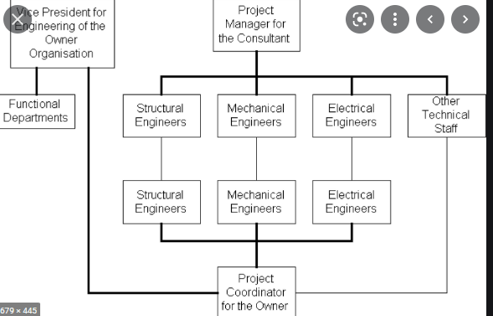

1. **Financial Models**

Numerous construction projects experience the ill effects of preventable monetary issues. Low-biders inquire for expenditure that can’t complete the task. Financial constraints arises when the current subsidizing measure funding cannot cater for work and purchase of materials. Because they entail being secured with enough assets at a particular time, they can arise in any event where the overall absolute is enough. Extortion is an issue in many fields yet is famously familiar in construction. Monetary anticipating the process is planned to guarantee that a solid arrangement, with sufficient security and favourable plans, is made prior to the task and is expected to ensure the agreement is appropriately carried out over the existence of the job. Brokers, monetary regulators, and cost engineers are possible members in making an in general arrangement for the financial management of the construction project. The presence of the investor is almost inevitable even in moderately little tasks since the proprietor's value in the property is the clearest wellspring of financing for a task. Monetary regulators act to concentrate on the regular money-related stream over the existence of the undertaking and to screen the payouts all through the interaction. Cost engineers apply the skill to relate the work and materials required to a fair valuation.

1. **Legal Implications**

A construction project should squeeze into the system is legally overseeing the asset. These remember superior guidelines for making use of commitments made and the property during the construction time that was spent. The undertaking should stick to drafting and construction law prerequisites. Building a project that neglects to adhere to codes won't help the proprietor. A construction project is a perplexing net of agreements and other lawful commitments, each of which should be painstakingly thought of. A contract is the trading of many obligations between at least two gatherings. Yet, it isn't the case straightforward as attempting to get the opposite party to agree and be reasonable. Procrastination in construction is very costly. Hence, common grounds to assure that both parties will commit to their tasks.

**Interaction of Expertise**

Design, finance, and lawful angles cross-over and interrelate. The design should be not just basically sound and proper for the utilization and area, yet should likewise be monetarily conceivable to construct and lawful to utilize. The monetary design must oblige the requirement for building the plan given and should pay lawfully owed sums. The legal construction should coordinate the design into the legitimate encompassing structure and implement the monetary outcomes of the construction cycle.

**Contractor Business Structures**

One of the initial steps you should accept while beginning a contracting business is to decide how to structure your business. There are a couple of decisions relating, for the most part, to charges and lawful contemplations. It's great to realize the choices before picking one.

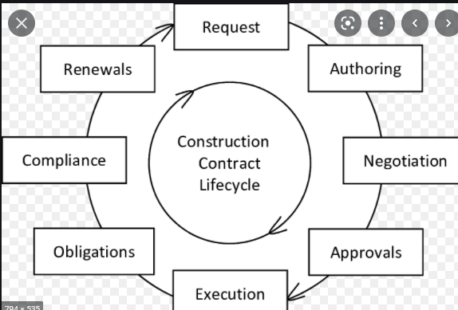

**Partnership**- Many contracting organizations decide to layout as an association. When two individuals begin a business together, the advantages of a shared responsibility that incorporates direction can appear to be engaging. Getting a business fully operational consistently seems more conceivable when another person assists. However, an organization takes simple, early arrangements. A review should address who settles on what choices, characterizes jobs and responsibilities, and decides how the business benefits will be separated. A composed understanding will help keep the business moving along as planned.

**Sole proprietorship**- A sole ownership is the minor demanding business design to set up. The sole owner possesses every one of the resources and benefits got by the business, and the exclusive owner moreover "claims" all the obligation and responsibility. For charge and legitimate purposes, the business and the person the sole owner are viewed as a similar substance. Along these lines, if the business gets sued, you as the sole owner are getting sued, and all your resources can be in danger. There are quite possibly the primary contemplations that need to be made. Assuming you maintain a contractor business that includes unsafe work, your possibilities of getting sued may be high. So sole ownership probably won't be the best approach.

**Corporation**- Laying out as a company implies the business is a substance separate from those who own and run it. As a proprietor, you are an investor, and you expect to be restricted risk. You should have a chosen governing body that meets overseas policymaking and authorization.

**Limited Liability Company (LLC)-** The LLC joins highlights from sole ownership and partnership structures. In an LLC, the proprietor is a part and gets obligation assurance comparable to an organization set-up. There are more adaptable benefit conveyance choices in an LLC; what is more, income is thought of as "go through" benefits, just getting burdened on the individual proprietor's tax document.

**Feasibility Studies**

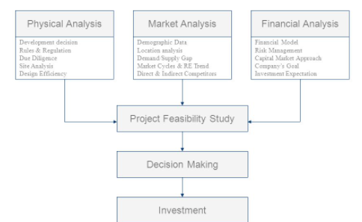

1. **Economic feasibility**

For any undertaking assuming the expected advantages equivalent or surpassing regular expenses, the task can be decided to be monetarily possible. In monetary practicality, the cost-benefit investigation is carried out in which desirable cost and pros are assessed. Examination of finance is employed to evaluate on how suitable the suggested framework is. In monetary plausibility, examination pertaining saving of money is the best. If the benefits offset the expenses, the choice is made to plan and execute the proposed project.

1. **Technical Feasibility**

In attainability that is specialized, thought on constraints are conducted.

When the special attainability is laid out, it is vital to contemplate about factors related to money. Speculations may be required in guarding a framework that is specified where the advantages might be either of bid or small value. Practicality involving money is done for assessment purposes.

1. **Legal Feasibility**

One must ensure that any task attempted will meet all lawful and moral necessities before the undertaking is on the table.

1. **Operational Feasibility**

Functional attainability is fundamentally worried about whether the proposed task will be utilized, assuming it is created and carried out, regardless of whether clients' opposition will influence the potential application benefits.

**Contract Documents**

All these documents form the basis of the contract;

* Agreement
* Special conditions
* General conditions
* Bill of quantities
* Drawings
* Specifications
* Program of works
* Cash flow estimates
* Insurances

**Chartered and Professional Engineers**

Proficient designers (Chartered Engineers) are different from different architects. They have gotten a permit, sanction, or enrollment from an administration office or contract conceding authority following up for their sake. They are dependent upon these bodies' guidelines, as are other-directed callings. Proficient and contracted engineers appreciate a significant impact on their guidelines. They are regularly the creators of the relevant sets of rules utilized by some of these associations. These designers in private practice frequently, however not generally, get themselves in conventional expert client connections in their training. Engineers utilized in taxpayer-supported organizations wind up on the opposite side of a similar relationship. Engineers in the industry here and there named "graduate architects" hold a Bachelor's certificate are not officially authorized by government offices. Their expert connections are significantly more prone to be representative business connections.

**References**

Chan, A. P., Scott, D., & Chan, A. P. (2004). Factors affecting the success of a construction project. *Journal of construction engineering and management*, *130*(1), 153-155.

Eisner, H. (2008). *Essentials of project and systems engineering management*. John Wiley & Sons.

Oberlender, G. D., & Oberlender, G. D. (1993). *Project management for engineering and construction* (Vol. 2). New York: McGraw-Hill.

Wang, J., Wu, P., Wang, X., & Shou, W. (2017). The outlook of blockchain technology for construction engineering management. *Frontiers of engineering management*, 67-75.