**WILLY KORIR**

**ID: UB50187SCI59141**

**BACHELOR IN CIVIL ENGINEERING**

**COURSE NAME: ENVIRONMENTAL ENGINEERING**

**ATLANTIC INTERNATIONAL UNIVERSITY**

**Environmental Engineering**

**Introduction**

Environmental engineering combines scientific and engineering principles to better the surroundings to offer safe water, air, and farmland for humans and other animals and clean up polluted regions. Public education, conservation, regulations, and the adoption of acceptable engineering approaches can all assist to prevent and alleviate undesirable environmental repercussions. Environmental engineers must typically hold a degree in environmental technology from a recognized university.

**Course objectives**

The student should be able to:

* Describe and use the foundations of air and water pollution to address fundamental environmental engineering issues by the conclusion of the course.
* Describe the environment's problems and how to solve them.
* Analyze and characterize the features of an environmental problem.
* Explain the concepts and procedures for conducting an environmental impact assessment.
* For the study and resolve engineering issues, identify and use relevant analytical tools.
* The capacity to analyze and solve civil engineering issues using mathematical approaches and instruments.
* Underpinning ideas and theories in environmental science and sustainability are known and understood.

**Environmental challenges**

* pollution

The soil, air, and water contamination are caused by nitrates, heavy metals, plastics, gases and toxins emitted by industries, oil spills and fossil fuel burning.

* global warming

Human activities produces global warming which increases surrounding temperature hence causing coastal flooding, melting of icecaps, flash floods, and deserts.

* Overpopulation

Intensive agriculture's attempt to lighten the situation by using industrial fertilizers and herbicides paradoxically bring more damage.

* Disposal of waste

Waste is produced in bulk and dumped into oceans. Plastic materials and nuclear waste are highly hazardous.

* Biodiversity decline

Species and ecosystems are becoming extinct as a result of human activities. It interferes with natural processes like pollination and poses a threat to ecosystems, particularly coral reefs.

**The role of environmental technology**

Environmental technology uses environmental studies, environmental monitoring, green chemistry and electronic equipment to model, monitor and preserve the environment and mitigate the adverse effects of human activity.

The examples include;

* Bio filtration
* Bioremediation
* Desalinization
* Bioreactor
* Thermal DE polymerization
* Pyrolysis

**Domains, Context, and concepts of Environmental Engineering**

**Historical background**

Cities like London and Paris adopted legislation mandating the development of sewer systems for the correct collection and drainage system and facilities to purify drinking water in the nineteenth century. As a result, waterborne illnesses like cholera, formerly common causes of mortality, have decreased in frequency and become rare.

Following that, environmental protection measures were implemented. For example, in the United States, the nature reserve system was established in the early 20th century.

Water Quality Engineering

Engineers and scientists collaborate to ensure safe drinking and agricultural water sources. They investigate a watershed region and assess the water balance in terms of characteristics such as water availability for varied demands and the watershed's cyclical cycles. They also design methods to conserve, transport, and treat water for various purposes.

Air Quality Engineering

Engineers create manufacturing and combustion techniques to keep air pollution to a minimum. Scrubbers, precipitators, and after-burners, for example, are used to remove particles, oxides of nitrogen and sulfur, and reactive organic gases from vapors and prevent them from being released into the environment. This field of research is beginning to intersect with efforts to improve energy efficiency and minimize carbon dioxide in the atmosphere. Scientists create air dispersion models to determine the quantity of a contaminant at a source and the influence of automobile and exhaust stack emissions on pollution levels and smog generation.

Hazardous Waste management

It is any waste which provides significant or possible risk to public health or the environment and may have the following features: ignitability, corrosivity, reactivity, or toxic effects.

Hazardous wastes include the following:

* Caustic and poisonous chemicals utilized in manufacturing operations are examples of industrial waste.
* Pesticides, herbicides, and different nitrogenous compounds from fertilizers are examples of agricultural waste.
* Paints, volatile solvents, caustic cleaners, batteries, pesticides, pharmaceuticals, and mercury are examples of household garbage
* Needles, surgical tools, glassware, unused medications, radioisotopes, and chemical wastes are all examples of medical waste.
* Wastes from the production of illicit drugs, including various hazardous substances.

**Material balance**

A material balance is a method for analyzing physical systems that use mass conservation. The mass balance concept is used in the design of chemical reactors, the analysis of alternative chemical production processes, and the modeling of pollution distribution and other physical system processes. Population, energy, and the more complicated entropy balance are complementary analytical tools. The refrigeration cycle, for example, necessitates the use of these methodologies for complete design and analysis.

**Environmental regulations**

The United States Congress has passed legislation and regulations relevant to environmental protection. The Environmental Protection Agency of the United States enforces environmental laws and implements environmental regulations. Environmental laws in the United States encompass numerous aspects of the environment, including air, water, and toxic materials, with most restrictions on pollutant risk assessments.

The most significant environmental regulations and laws are summarized below.

* Federal Water Pollution Control Act
* Amendment Clean Water Act
* Safe Drinking Water Act Amendment
* Clean Air Act Amendment
* Oil pollution Act
* Pollution Prevention Act

**Transformative Processes**

**Governing concepts**

For environmental transformation processes, three basic principles serve as the foundation. The first is stoichiometry, which uses the material balance in transformation processes. On the other hand, chemical equilibrium shows how species partition across stages and components partition between chemical species under certain conditions. One of these requirements is that the process is steady, which means that the species levels must be constant across time. Kinematics, the third concept, is concerned with reaction rates and offers data on how individual concentrations change over time. These three ideas are intertwined. In a closed system, kinetic processes eventually lead to chemical equilibrium, and equilibrium and kinematic connections must fulfill stoichiometry.

* stoichiometry

The notion of material balance is used to a chemical transition in stoichiometry. It allows users to determine the value of specific stoichiometric coefficients using the numbers of other coefficients. The number of atoms in each component involved in the reaction and the electrical charge attributed to ions must both be conserved in a chemical reaction.

* Chemical Equilibrium

When a system is in equilibrium, thermodynamic connections are satisfied by segmentation elements amongst chemical species and species among physical states, regardless of the system's history.

* Kinetics

Kinetics may be used to characterize the time-dependent levels of water molecules in the gas phase and estimate how long it will take for the system to reach equilibrium.

**Phase-Changes and Partitioning**

Transformative processes involving phase transitions between solids, liquids, and gases are discussed in this section. The adsorption of liquids and gases into solid solids, the evaporation of items from liquids to a gaseous state, and the vaporization of gaseous form, the aqueous form are all examples of species dissolution into water. The rates of transformation and the equilibrium partitioning across states and kinetics are significant.

* Vapor pressure

The optimum saturation pressure of the gas particles of a pure liquid component over a level surface of the liquid is the vapor pressure of that species. Subsaturation and supersaturation are the two considerations to be explored.

* Species dissolution in water

When a liquid comes into touch with another substance, some of the other substance's molecules mix with water into the water. It discusses all stages that may come into contact with water. It will contain partitioning between gas phase and water, or Henry's law, splitting Toluene in a closed environment.

* Acid-base reactions

A base accepts or gains hydrogen ions, whereas an acid donates or loses hydrogen ions. A proton is transported from acid to the base during an acid-base reaction. Hydrogen ion concentrations are a crucial indicator of water quality. It is expressed on a logarithmic scale, using pH=-Log[H+] as the base. The relative quantities and intensities of acids or bases determine the pH of a solution.

The things to consider are as follows;

* Pure water's pH
* Carbonate systems and strong and weak acids
* The hydrogen ion and acid-base reactions
* Oxidation-Reduction Reactions

The transfer of electrons between species is involved in oxidation-reduction reactions. The kinematics subject is more important than chemical equilibrium because they are much more sluggish than acid-base reactions. The slowness of redox reactions presents environmental engineers with both obstacles and opportunities. Before being released into the environment, some waste compounds can be turned harmless by oxidation or reduction procedures. In engineered treatment systems, catalytic converters for detoxifying automotive exhaust, burning hazardous waste, and wastewater treatment with activated sludge to lower organic component concentrations are examples of oxidation-reduction reactions. Oxidation state, atmospheric oxidation processes, combustion, and microbiological responses are other aspects to consider.

**Transport Phenomena**

**Basic concepts and Mechanisms**

At the end of the 1950s, a concept called transport phenomena emerged as a second paradigm, indicating a significant need to broaden the scope of environmental engineering. Engineers realized that moving beyond pure scientific descriptions and the concept of process units to understanding the unique process employing phenomenological equations based on three elementary physical methods: momentum, energy, and mass transfer, was critical.

Particle motion

* Drag on particle
* Gravitational settling
* Brownian motion

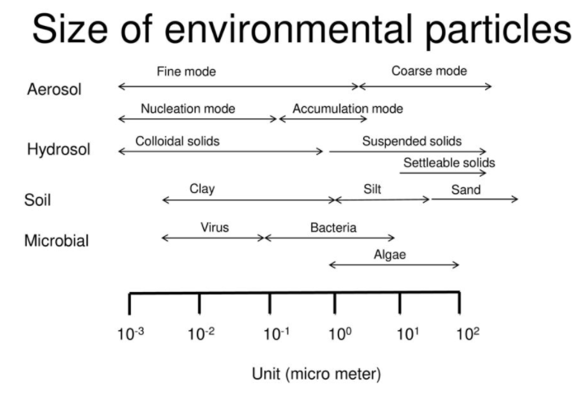

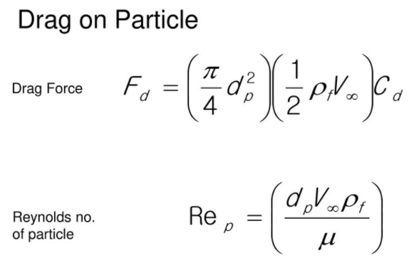

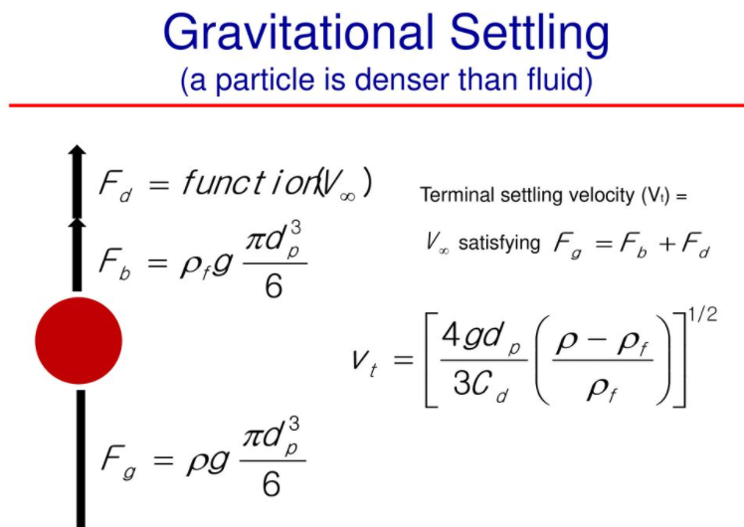

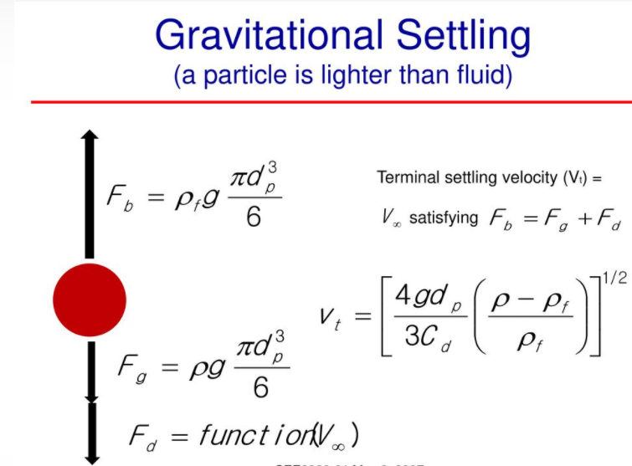

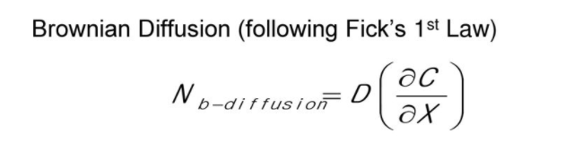

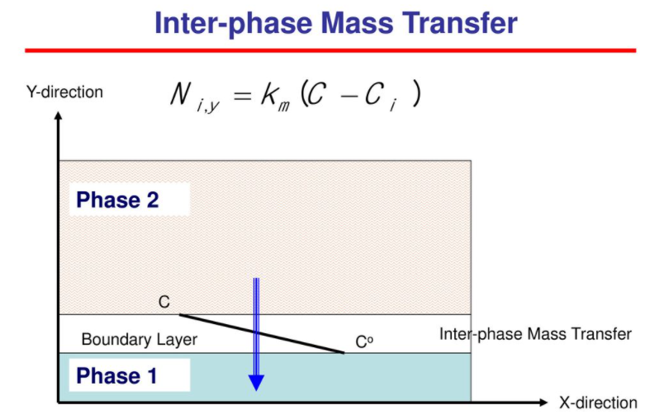

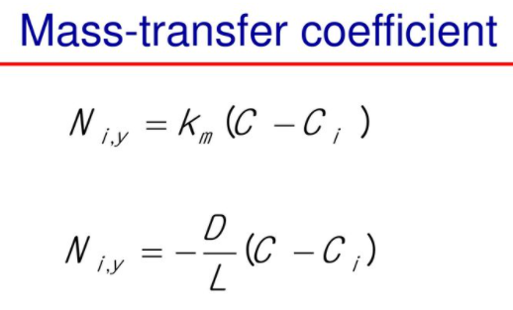

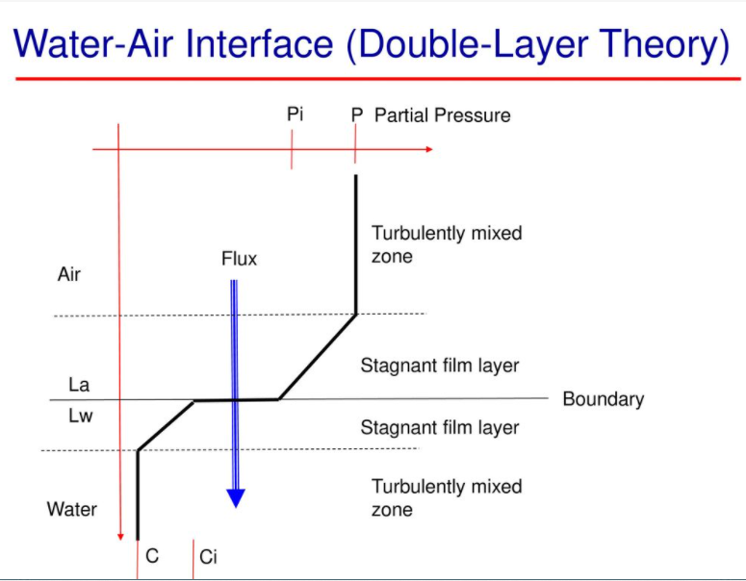

**Transport in porous Media**

The physiochemical elements of mass transfer in rigid and flexible porous media are discussed in Transport in Porous. These phenomena, which occur in separate and multiphase movement in porous surfaces, can be regulated by a wide range of variables, including fluid phase mass, component phase mass, momentum, and energy. Furthermore, porous media deformations can be caused by transport phenomena, chemical and electrochemical processes like swelling, or external loading via forces and displacements.

**Water, Air, and their Impurities**

* Water and Hydrosphere

The hydrosphere is a layer of water that exists at or near the Earth's surface. All liquid and frozen ground waters, groundwater in rock and soil, and atmospheric moisture are included. At the surface of the Earth, water is the most common substance. Seas, lakes, rivers, glaciers, and groundwater systems total about 1.4 billion cubic kilometers of liquid and frozen water.

* Types of water impurities
* Water biological impurities

The existence of living creatures in water causes biological pollutants. Algae, pathogens, protozoa, bacteria, microorganisms, viruses and parasites, and their cysts (eggs) in contaminated water, fall into this category. Germs, or microorganisms that reproduce at an alarming rate, are the latter.

* Water colloidal impurities

Organic waste materials and amino acids are examples of colloidal contaminants in water. Contact with suspended materials and elements such as sand, boulders, and biological matter in rivers, streams, and lakes causes water to become undrinkable or non-pure.

Chemical contaminants in water can come from a variety of sources, including:

* Gases that rains and severe downpours pick up from the surroundings
* Animals and plants that have decomposed along streams, rivers, and lakes
* sewage and wastewater from industry
* River water contains high magnesium, iron, calcium, saline, and chlorides.
* Domestic and agricultural industrial waste produces organic chemicals. Anthropogenic pollutants can be detected in both raw and drinking water.
* Medical effluent and equipment systems contain inorganic substances.
* Solutions for impure water

With so many contaminants in raw and drinking water, having the correct municipal treatment process in place is one of the most excellent options for communities. Using water treatment technologies, aluminum, chlorides, and other hidden chemicals and elements are removed from drinking water sources.

* Air and the Atmosphere

The atmosphere is just a thin layer of gases and particles surrounding the Earth. Several of the gases are required for life support in all living beings. The abundance of liquid water on Earth's surface and the planet's atmosphere are the critical factors to its unique position in the planetary system. Living creatures require a lot of atmospheric gases, mainly carbon dioxide and oxygen. Plants make O2 from CO2 during photosynthesis. Nearly 90% of the oxygen in the atmosphere is produced by photosynthesis. Plants provide an ecosystem that is beneficial to animals by producing oxygen and food. Animals use oxygen during respiration to transform sugar into usable energy. Plants use part of the carbohydrates they create during respiration.

* Impurities of Air

Particulates, ozone, nitrogen oxides, unburned hydrocarbons, and sulfur dioxide are prevalent air pollutants.

* Methods for Reducing Air Pollution
* People can walk or ride their bikes instead of driving.
* Investing in a more fuel-efficient car.
* Lights and appliances should be switched off while not in use
* Buying less products that are made from fossil fuels.

**Transport and Transformation Models**

**Reactor models**

In designed systems, biochemical and physical reactions often occur in reactors. An actual or imagined limit that physically restricts the processes defines a reactor. Reactors include lakes, river segments, and storage tanks in treatment centers. The majority of reactors, but not all, have a continuous flow. Fill, react, and empty are the three states of sequencing batch reactors. The combining level and residence duration in reactors are crucial because they influence the extent of process action when the water and its components move through the reactor.

**Classification of Reactors**

**Dispersion**

There are three types of reactors based on mixing levels: mixed flow reactors, plug flow reactors, and flow with dispersing reactors. The plug flow reactor is an idealistic version that is impossible to achieve in practice. All genuine reactors are classified as either F.D.R. or CMFR.

Thoroughly mixed flow reactors may be approximated pretty precisely. Because there is no analytical approach to the advection-dispersion formula for CMFRs, we must rely on an essential mass balance.

Because mass transfer must rely solely on advection, plug flow reactors are challenging to achieve. There is no difference in tracer displacement from the mean advective velocity. In actuality, molecular diffusion, turbulent distribution, and fluid shear will cause some mixing.

When an actual flow reactor is not entirely mixed, it behaves like a plug flow reactor. The intensity of the mixing process compared to the advective flow determines the reactor flow behavior. Analytical solutions that characterize these genuine reactors are more complex, and most dispersion parameters are adapted to the data rather than anticipated a priori.

**Applications of water quality engineering**

**The nature of water quality**

Quality of water is among the most urgent concerns confronting nations in the 21st century, threatening human health, limiting agricultural production, reducing ecological services, and hampering economic growth. The ecosystem, society, and economy are all affected by water quality degradation. The pollution of water sources due to the discharge of massive volumes of improperly treated or uncontrolled wastewater into streams, reservoirs, aquifers, and marine waterways is restricting the world's scarce water resources' accessibility.

**Water Quality Facts**

* One out of every nine people on the planet gets their drinking water from poorly maintained and potentially dangerous sources.
* 2.4 billion people do not have access to sanitation.
* Amongst the most severe sources of water contamination is a lack of hygiene.
* In underdeveloped nations, 90% of sewage is released untreated into bodies of water.
* Two million tonnes of effluent and other effluents are daily discharged into the world's water.
* Every year, industry releases approximately 300-400 megatonnes of garbage into water bodies.
* When combined with manufacturing point source pollution, non-point origin pollution from farmland and urban areas frequently significantly increases the total pollution load.

**Water sampling**

To be safe, water used for preparing fish and creating ice must fulfill drinking water requirements. Contaminated water causes pathogen loading in fish, putting customers' health at risk.

The World Health Organization (WHO) has published drinking water quality guidelines in three volumes. The first volume covers guideline values, the second covers each pollutant, and the third volume covers how to manage water resources in small towns. Because stringent criteria cannot be applied consistently, the WHO has developed a range of recommendation ranges for more than Sixty parameters. Most countries have their own set of rules or norms. Depending on the local Context, the control exercised by local regulatory agencies may change from place to place.

Water quality from various sources of supply must be monitored regularly, which necessitates both qualitative and quantitative measurements. When the water supply is polluted, the harbormaster should ensure proper treatment within the commercial fishing harbor complex and initiate corrective action with the suppliers.

ISO-certified laboratories should sample and analyze water. Wherever local laboratories are not ISO-certified, it is recommended that they have their quality evaluated by an ISO-certified research lab through participatory tests to ensure that the variation in the reliability of the results is kept to a minimum. When corrective action is not taken promptly, unreliable results worsen pollution problems. Professional technicians should conduct the sampling and monitoring tests.

**Testing Procedures**

While the specifics of sampling, testing, and analysis are outside the scope of this manual, the following is a basic overview of the relevance of the most common water quality tests.

Physical, chemical, bacteriological, and microscopic categories can categorize testing techniques and criteria.

**Physical test**

Minerals like iron and manganese and plant-based compounds like algae and weeds may cause water to turn a specific color. The effectiveness of a water treatment system is determined using color tests.

Turbidity in water is caused by suspended matter and colloidal particles. It might be the consequence of dredging soil eroding or the development of microorganisms. When turbidity is high, filtration is expensive. If pathogens are present, they may be trapped in sewage sediments and avoid the disinfection activity of chlorine.

Odor and taste are connected to tiny organisms or decaying organic compounds, like weeds and algae, as well as industrial wastes containing ammonia, phenols, halides, and hydrocarbons.

**Chemical tests**

pH is used to determine the concentration of hydrogen ions in a solution. It's a measurement of the comparative acidity or alkalinity of water. Values of 9.5 and above indicate high alkalinity, whereas readings of Three or below suggests acidity. Low pH levels help with chlorination, but they can cause corrosion. In the maritime environment, values below four are frequently insufficient to support living species. Drinking water should have a pH between 6.5 and 8.5. The harbor basin's water level can vary from 6 to 9.

The quantity of oxygen required by microorganisms to stabilize readily biodegradable organic matter in aerobic circumstances is referred to as B.O.D. Organic pollution is indicated by a high B.O.D., which shows insufficient oxygen to support life.

**Bacteriological tests**

Analytical techniques for identifying hazardous elements are unfeasible for regular water quality surveillance for technical and financial reasons. It must be understood that bacteriological examination can only show if contaminants or bacteria indication of faecal pollution might or might not be established in a particular water sample using defined culture procedures at the time of inspection. Furthermore, the findings of routine bacteriological testing must be interpreted in light of a complete understanding of the water supply, including its source, purification, and distribution.

The frequency of bacteriological examination should be increased whenever changes in conditions end up causing the quality of water provided to degrade, or even if they imply an increased contamination levels, so that a series of samples from carefully selected areas can recognize the hazard and allow remedial action to be taken. If a sanitary evaluation, including visual examination, indicates that a water supply is contaminated, remedial action needs to be taken regardless of the results of a bacteriological investigation. Sanitary inspections may be the only type of evaluation that can be done on a regular basis for non-piped rural sources.

**Application of Hazardous Waste Management**

Inappropriate hazardous-waste treatment or disposal pollutes soil and groundwater sources on a regular basis, as well as contaminating hazardous land. People who live near old and abandoned garbage dumps may be particularly vulnerable. To solve current concerns and prevent potential suffering from hazardous wastes, governments rigorously regulate the hazardous-waste management process. Hazardous waste management can take a number of forms. The preferred solution is to reduce waste at source or to recycle resources for another useful use.

**Treatment**

Hazardous waste can be remedied using biochemical, thermal, and physical methods. Some of the chemical processes offered are ion exchange, precipitation, redox reactions, and neutralization. One of the thermal procedures accessible is high-temperature incineration, which may cleanse as well as destroy some organic pollutants. Using specialized thermal equipment, waste that is liquid, solid, or sludge is burnt.

Many organic wastes, such as those from the oil and gas industry, can also be biologically handled. Hazardous waste is treated biologically through land cropping. On an appropriate plot of land, the procedure entails correctly combining trash with surface soil. It is also possible to introduce microorganisms that can digest waste and also nutrition. A bacterial strain which has been genetically engineered is used in particular situations.  Bioremediation, or the use of microbes to moderate hazardous waste on formerly polluted areas, is another option.

**Land disposal and surface storage**

The two most frequent methods of land disposal are landfilling and subsurface injection. Surface confinement or containment procedures are frequently used as a stopgap measure before dumping the waste on land.

Impermanent on-site trash storage solutions include open garbage piles, ponds, and lagoons. New garbage dumps must be built with care on an impermeable basis and adhere to regulatory regulations similar to landfills. The piles must be protected against wind dispersion and erosion. Monitoring and control procedures must be in place if leachate is created. A fresh rubbish pile can only include non-containerized granular, non-flowing trash goods, and when the heap becomes uncontrollable, the waste must be landfilled. A lagoon is a temporary holding reservoir for hazardous wastewaters. It is an open pit or holding pond.

**Secure Landfills**

The disposal of hazardous waste is more strictly regulated than the disposal of regular garbage. Waste must be disposed of at "safe sites," which have a minimum gap of 3 meters in between landfill's bottom and the underneath foundation or groundwater level. A safe hazardous waste disposal requires two impermeable liners as well as leachate collection systems. The twin leachate collection system has perforated pipes put above each liner. The upper system keeps trapped leachate out of the fill, while the lower system serves as a backup. The collected leachate is brought to a treatment plant. To reduce the amount of liquid in the fill and the potential of environmental impact, a completed landfill is sealed with an impervious top or cover.

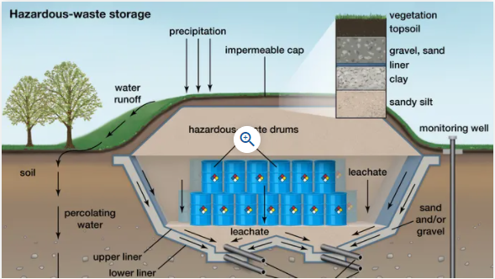

**Figure 1**: Secure hazardous landfill

**Remedial Action**

Many uncontrolled dumping locations have been utilized earlier and decommissioned. Depending on the danger determined, it may be essential to repair certain places. In some circumstances, the threat may need an immediate response. In other cases, biochemical engineering may be necessary to examine the condition before taking remedial action thoroughly.

Removing all of the waste from the region and transporting it to a distant location for treatment or disposal is one technique of cleanup. This so-called "off-site" option is usually the most expensive. On-site cleaning is a method of reducing leachate production and the danger of groundwater pollution. On-site cleaning includes the temporary evacuation of hazardous waste, the construction of a secure landfill in the same area, and proper garbage replacement. Any contaminated soil or groundwater may also need to be treated. Groundwater that has been treated can be pumped deep into the aquifer, and treated soil can be reconstructed on-site.

**Air Quality Engineering**

An air quality engineer's job entails a wide range of responsibilities that may be divided into a few categories:

* Modeling and determining the sources of pollution.
* Emissions are being monitored, and rules are being followed.
* Creating and executing strategies to increase quality.

Engineers use their broad expertise in chemistry, biology, and statistics to help them make judgments across all of these disciplines. Their ultimate purpose is to promote public health by controlling and hopefully reducing pollution.

**References**

Cabezas, H. (2021). 7.4: Government and Laws on the Environment. <https://eng.libretexts.org/Bookshelves/Environmental_Engineering_(Sustainability_and_Conservation)/Book%3A_Sustainability_-_A_Comprehensive_Foundation_(Cabezas)/07%3A_Modern_Environmental_Management/7.04%3A_Government_and_Laws_on_the_Environment>

Curley, R. (2022). hazardous-waste management - Remedial action. <https://www.britannica.com/technology/hazardous-waste-management/Remedial-action>

Fao.org. (2022). Chapter 2 - WATER QUALITY MONITORING, STANDARDS AND TREATMENT. <https://www.fao.org/3/x5624E/x5624e05.htm>

Nazaroff, W., & Alvarez, L. (2001). Environmental Engineering Science. <https://books.google.co.ke/books?id=qpf9DwAAQBAJ&pg=PA77&lpg=PA77&dq=Oxidation-+reduction+reactions+in+transformative+processes+of+environmental+engineering&source=bl&ots=om5bjcaYeS&sig=ACfU3U3UPtjv15Bkwj0ttncvQBPOKMHqsA&hl=en&sa=X&ved=2ahUKEwjhoqaXuJD2AhURuqQKHe69B2sQ6AF6BAgjEAM#v=onepage&q=Oxidation-%20reduction%20reactions%20in%20transformative%20processes%20of%20environmental%20engineering&f=false>

New World Encyclopedia. (2017). Environmental engineering - New World Encyclopedia. <https://www.newworldencyclopedia.org/entry/Environmental_engineering>

Poznyak, T., & Poznyak, A. (2019). Microbial activity in degradation of contaminants. Retrieved 22 February 2022, from <https://www.sciencedirect.com/topics/engineering/contaminant-concentration>

UNESCO. (2022). The global water quality challenge & SDGs. <https://en.unesco.org/waterquality-iiwq/wq-challenge>

Weber, M. (2018). Reactor Characteristics — Environmental Engineering Laboratory Research Textbook v.0.0.50 documentation. <https://monroews.github.io/EnvEngLabTextbook/Reactor_Characteristics/Reactor_Characteristics.html>