WILLY KORIR
ID: UB50187SCI59141
BACHELOR IN CIVIL ENGINEERING

COURSE NAME: STRUCTURAL DYNAMICS FOR CIVIL ENGINEERS

ATLANTIC INTERNATIONAL UNIVERSITY

Structural Dynamics for Civil Engineers

Introduction
Structural dynamics is the study of behavioral structures under time-varying or dynamic loads. In the study of structural dynamics, the focus is given to specific topics, which are; introduction to structural dynamics, modeling of a dynamic system, undamped and damped free vibrations, Coulomb damped free vibrations, forced vibrations (part 1 and 2), energy and damping, response to arbitrary citations and response to pulse excitations. Structural dynamics is primarily used in determining how a physical structure will behave when subjected to various forces. This force is due to dynamic loads, including wind, waves, traffic, blasts, earthquakes, and people. The self-weight of the individual structure is also a dynamic load on the structure. Static and dynamic analyses differ based on the acceleration caused by the applied load compared to the structure's natural frequency. Static analysis is used when the acceleration is relatively slow; hence, following Newton's first law of motion, the internal forces on the structure are ignored.

Static and Dynamic analyses
Static loads change at a very slow rate, while dynamic loads vary relatively faster with time than the structure's natural frequency. For simple structures, dynamic analysis methods are used. However, complex structures require finite element methods to evaluate the frequencies and mode shapes.

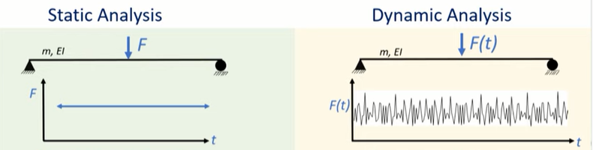
Fig 1; Static and Dynamic Analyses
The simply supported beam above has a flexural rigidity of EI and a mass of m. Force, F, is applied at the mid-span of the structure. The static analysis assumes that the force is constant overtime when the loading rate is relatively low. When solved using the force-displacement method, equilibrium methods, and compatibility equations, the results of strains, deflections, and support conditions obtained are constant over the entire time used. In the dynamic analysis, the force varies over time, and results obtained vary with observation time. This unit, therefore, covers the different methods that can be used to solve for the responses in varied forces over time. The displacement varies with time, creating a velocity that changes over time. Therefore, there will be an acceleration. Because the beam has a uniform mass m, its acceleration will result in inertia. Acceleration has to be considered in the dynamic analysis of structures. Using D Alembert's dynamic equilibrium principle states that if there is an unbalanced force on a body, a fictitious force, equal and opposite to the unbalanced force, is considered and the structure to be in equilibrium, the accelerating factor of the structure can be obtained.
Fictious force= mass* acceleration

Modeling of Dynamic System
Modeling of a dynamic system entails simplifying the components of a structure using mechanical principles for easier analysis. For instance, a diving board will be idealized as a cantilever beam with a load. The structure will have fixed support at one end because it cannot be translated into any direction or rotated. The structure's mechanical properties are also idealized by considering anisotropic material whose strength is known. The load is taken as concentrated when someone is standing on the board, and it can be assumed that the deflections are small. After having a mechanical model, it is possible to have the mathematical model whose equations of the elastic curve can be solved to obtain the deflection, hence the strains, force elements, and strains. After obtaining these responses, it is possible to determine whether the structure is designed correctly. When stresses obtained are high, it can be concluded that the thickness is insufficient and needs to be redesigned.
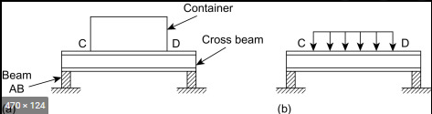
Fig 2; Structural idealization

Elements of a dynamic system
Elements of s dynamic system are the factors that determine the vibrations of the structure. These factors include;
- Mass- generates the inertia force (fictitious force). Distributed mass is distributed along with the entire structure, while lumped mass is concentrated at specific structure points.
- Damping- describes the dissipation of energy in a structure.
- Stiffness- force per unit displacement. It controls the force distribution and displacement correlations in a structure.

Degrees of Freedom
A degree of freedom is the number of autonomous displacements needed to define the positions of all the masses in a system comparative to their original position.
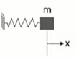Fig3; 1 degree of freedom structure
In the figure above, a spring is tied to amass, and a vibrating load acts upon it in the x-direction. If the displacement of the mass is known in one direction, the remaining structure properties can be calculated.
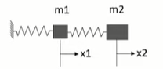fig 4; Two-degrees of freedom structure
Here, both masses have different displacements, and two coordinates are needed to define the structure. So, it is a two-degree freedom structure.
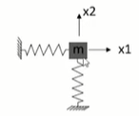Fig 5;
In the figure above, the single mass can move in two directions. Therefore, two coordinates are required to define the structure, making it a two-degree freedom structure.
Degrees of freedom should not be confused with kinematic indeterminacy, which defines the DOF related to the stiffness. For instance, in the figure below;
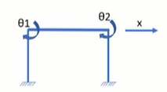Fig 6; Kinematic indeterminacy =3 and stiffness matrix will be 3 * 3

Damping
This is the energy dissipation mechanism in a structure. Some of the sources of damping are;
- Joint friction
- Repeated straining
- Sound energy
- Temperature due to straining a structure
- Opening and closing of cracks in concrete structures
In the damping model;
The energy dissipated due to the model= energy dissipated in the actual structure.
The equivalent viscous damping; Fd= Cx. where
fd- damping force
C- damping coefficient
x- velocity in a cycle
This is represented as;

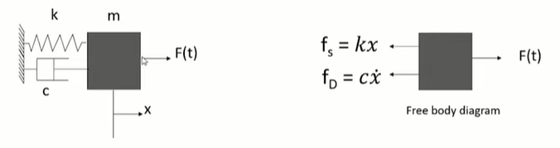

The unbalanced force in this system= F (t)- cx- kx= Mass*acceleration
Therefore, Equation of motion = mx + cx+ kx = F(t)

Free Vibrations
Free vibrations occur when a structure is disturbed from its static equilibrium position without external dynamic excitation.
Threfore, from the equation of motion, = mx + cx+ kx = F(t), the F(t) is 0.
The structure is given some initial conditions for aanalysis;
Initial displacement= 0
Initial velocity = 0
Initial displacement is converted to potential energy, and the initial velocity is converted to kinetic energy.

Undamped Vibrations
Here, it is assumed that there is no damping in the system or when the structure is in simple harmonic motion.
Equation of motion = mx + cx + kx =0. But there is no damping, so; cx= 0 and the equation becomes;
Equation of motion = mx + kx = 0
The equation above is a linear, second-order homogeneous equation with constant coefficients.
To solve this equation,
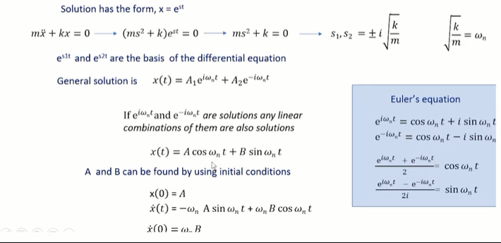
Natural Period and Frequency
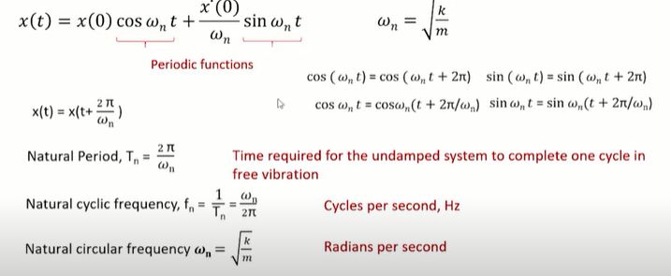
Natural frequencies and periods depend on the stiffness and mass of the structure and not the initialized conditions. In this first method, they are obtained from free vibrations of the structure.
- Natural implies that the structure vibrates freely without an external force.
- Omega, n, represents the natural circular frequency of the structure.
Alternatively, natural frequency and period can be calculated using the measurement from the static response.
Assuming a single degree freedom structure with stiffness and mass, the calculation of static displacement of the structure due to acceleration due to gravity;

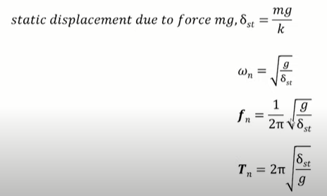
Where;
n- omega
fn- cyclic frequency
After obtaining the static deflection, it is possible to calculate the system's natural frequency and natural period.
Comparing two structures of different stiffness, the stiffer one will have a higher natural frequency. Similarly, heavier structures have larger natural periods (more flexible) and lower natural frequencies.
To calculate the amplitude of a system in vibration,
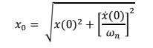
Since there is no damping in the structure, the kinetic energy and the strain energy will change at every position without changing their sum, which equals the input energy.
Therefore;

It should be noted that there is no energy dissipation since it is an undamped structure.

Damped Vibrations
Damped vibrations are caused due to energy dissipation following straining activities, sound energy, temperatures due to straining, friction at the joints, or installed damping equipment. The installed equipment allows the absorption of energy when the system is vibrating. A viscous damping model is assumed to show the energy dissipated by the structure. This model assumes that the damping force is equal to the system's velocity. (Refer above for the calculation of damping force).
The energy dissipated due to the model is equivalent to the energy dissipated in the actual structure. The energy dissipated when the system makes a cycle of vibrations is shown as C.
Rearranging this equation,
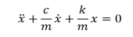
The critical damping coefficient, Cr = 2m w_{n}
There are three types of damping;
- Overdamping; damping ratio > 1
Damping coefficient > Cr
- Critical damping; damping ratio = 1
Damping coefficient = Cr
- Underdamping; damping ratio < 1
Damping coefficient < Cr
The solution of the equation of motion for a viscously damped free vibration structure is given as;
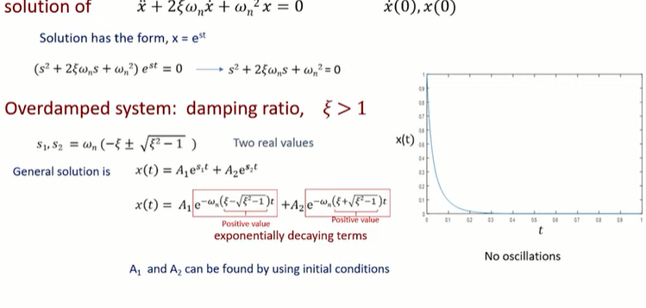
For critically damped system;
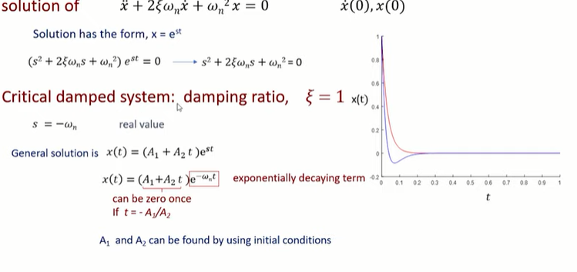
The critical damped systems are used when designing weighing scales.
Underdamped systems;
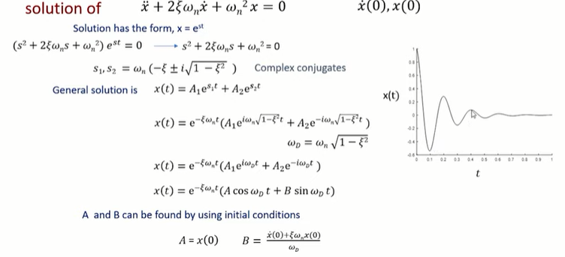
The period and frequency calculation;
The natural period of damped vibrations is more significant than that of undamped vibrations. However, the damped natural frequency is lower than the undamped natural frequency. Damping makes a structure more flexible.
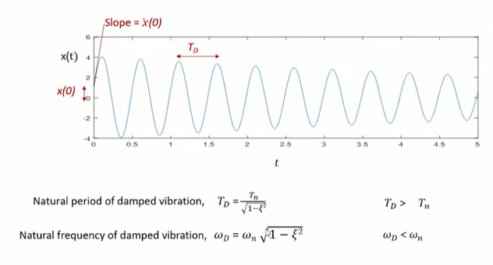
When the system is disturbed, input energy is fed into the system. Damping allows the dissipation of this initial energy with time. The vibration stops when all the energy has been dissipated.

Coulomb Damped Free Vibrations
In coulomb damping, energy dissipation is due to the friction between the two sliding surfaces. A coefficient of friction in the surface is multiplied by the normal force to obtain the frictional force. If the mass travels in the direction given in the figure, the frictional force acts in the opposite path. The frictional force depends on the velocity of the mass, unlike in the other types of damping.
The equation of motion is obtained as follows;
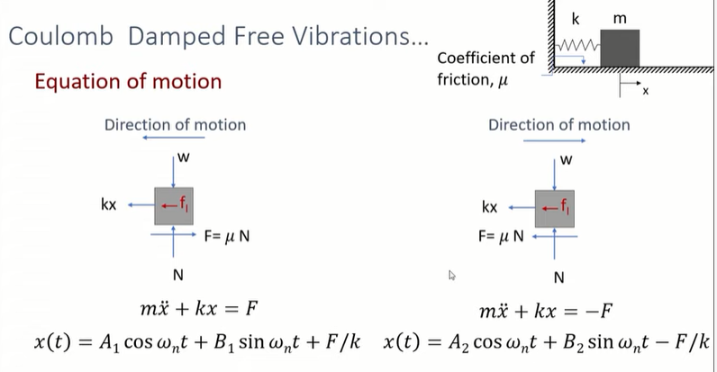
For an initial displacement of 1, the Coulomb damped free vibration structure is solved as follows;
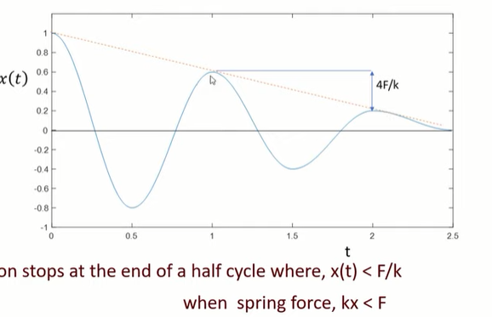
In every cycle, the amplitude of the result reduces by 4F by k if the displacement response is less than F by k. The motion stops when the displacement response is less than the value of F by k.

Forced Vibrations
Forced vibrations occur when a time-varying force acts on the structure, and the structure vibrates under the influence of this force. The initial structure conditions also affect the vibrations. The first type of forced vibrations is harmonic vibrations that occur when a harmonic force acts on the structure.
The equation of s structure under harmonic vibrations is given as;
The harmonic force acting on the system is represented as a cosine or sin function with certain amplitude. The maximum value obtainable for this force is known as p_{0.}
Therefore;
In an undamped harmonic system, there will be particular values for initial velocity and displacement for the system.
Solving this equation gives the undamped responses of the system.
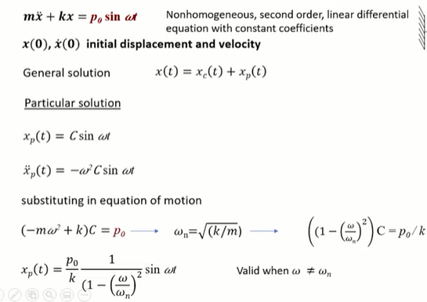

The steady-state response varies so that the amplitude depends on the force amplitude. The normal period is equal to the forcing period. The total response is the sum of the steady-state and transient state responses. The total response has two frequency values. The response repeats itself after a time, t, which is the period of the forcing frequency. The consecutive peaks or local maxima of the response will have a time difference of Tn, the natural period of the system. For harmonic vibrations, the frequency of motion is equivalent to the natural frequency of the structure and the overall time between two peaks in the natural period. The response develops unbounded for undamped structures at resonance, which occurs when the force-frequency is equivalent to the natural frequency. The effect of initial conditions on a system dies with an increase in time. As time is increased, the steady-state response becomes more prominent and increases unboundedly after some time.
For free damped systems, damping is represented by a viscous damper, and the force of damping is equal to the damping coefficient multiplied by the velocity of the mass. The equation of motion is given by;
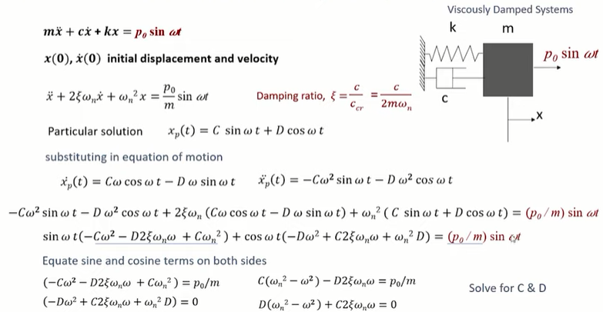
Solving for C and D;
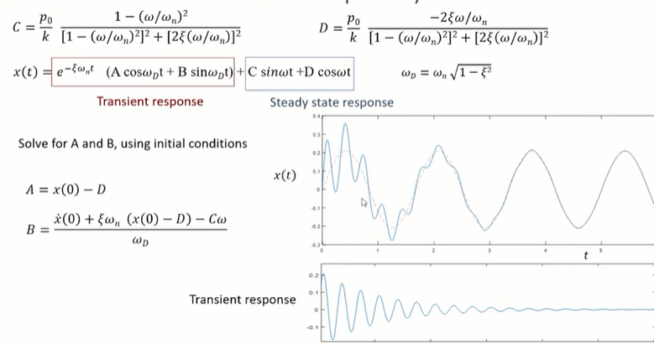
The steady and transient responses decay with time because the exponential function is in terms of t. The predominant response does not decay, provided force is still present in the structure. The steady-state response has abounded response. The amplitude in this response remains constant with change in time. In the beginning, when time is short, the effect of the transient response is visible. However, after some time, the transient response decays and equals 0. Therefore, the total response converges with the steady-state response and continues provided there is force, and the steady-state response amplitude is constant.
It is now possible to determine the effect of damping in systems. For the undamped systems, w = w_{n}, the response increases after every cycle. As time increases, the response also increases. In the case of damped systems, the response is bounded to a value. The amplitude remains the same with a change in time. If the damping is high, the amplitude will be smaller. Similarly, small damping will contribute to a larger amplitude.
When the frequency ratio increases, this response factor will also increase, which will depend upon the damping value. So, for lightly damped systems, this amplification will be larger at a frequency ratio is equal to 1. When the frequency ratio increases beyond one, this factor becomes smaller and smaller. When the frequency ratio is much higher than 1, this becomes 0 irrespective of the damping present in the system. So, the damping controls this factor when the frequency ratio is near 1.

Vibration Under Periodic Forces
In this case, the single degree of freedom system is acted upon by a force which is a periodic function in time. The periodic function has a specific portion of it repeating itself indefinitely within a specific duration. Using the Fourier Series, a periodic function can be represented in terms of harmonic components.
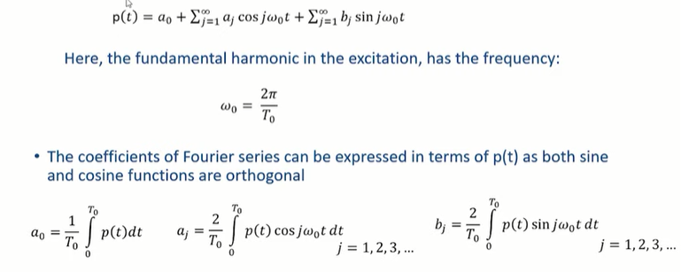

The response of a linear system to a periodic force can be determined just like that of a harmonic system by combining the responses to individual excitation terms in the Fourier series. The periodic function can be separated into different harmonics using the Fourier series. So, the response of the periodic force can also be treated as the sum of the responses of the individual harmonic forces. The response to a periodic force equals some of the responses to many harmonic forces. When a constant force is applied to a single degree of freedom system, the steady-state response is given naught by k. This is like a static response where the force is constant concerning the steady-state response. Therefore, this is equal to the static response of the system that is naught by k. This is the equation of motion of a single degree of freedom systems acted upon by a sin force;
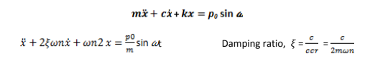
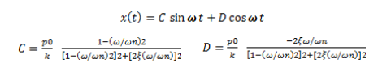
All real systems will have some amount of damping. The steady-state response for any real system will not be unbounded. In this analysis, we will consider only situations where zeta is not equal to 0 and beta j is not equal to 1. If this condition is satisfied, we will never get an unbounded solution from this expression. The steady-state response of the damped system due to a periodic excitation is equal to the combination of responses to the individual terms in the Fourier series. So, the total response equals the sum of the responses to the individual terms in the Fourier series.

Energy and Damping
Based on the energy input and the energy dissipation, this topic tries to understand the displacement growth of a single degree of freedom system when the forcing frequency of the harmonic force is equal to the natural frequency. When omega is equal to omega n and phi is equal to 90 degrees. As described earlier, for an undamped system, when the omega is equal to omega n, the displacement will increase with time, i.e., the displacement will increase unboundedly. But, in damped systems, the displacement will not increase unboundedly because the damping present in the system at omega is equal to omega n. The displacement will grow until a steady state, and after that, the displacement amplitude is constant throughout the time. When the omega is equal to omega n and phi is equal to 90 degrees, the system's input energy is equal to this pi, p₀, x₀, where x₀ is the steady-state amplitude of the system. We know from this expression that this energy input varies linearly with the displacement, which is the dissipated energy.
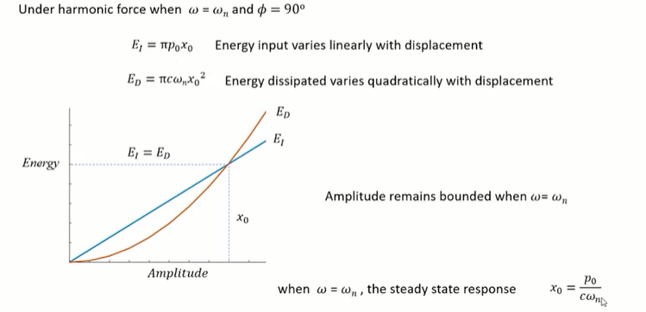

Response to Arbitrary Excitations
If a large force acts on a body for a short time, that is called impulsive force, and the time integral will be finite; that means the force integrated over time will be the constant it will be a finite value. And, the quantity of this impulse is equal to force times time. The displacement before and after the impulse will be equal to 0, so the single degree of freedom system is at rest initially. A unit impulse acting on the single degree of freedom system causes free vibration of the system due to this initial velocity one by m. So, the impulse acting on that body gives it an initial velocity, which will cause that system to vibrate under free vibrations. It is free vibration because, after the impulse, there is no force acting on the system. So, the system is under free vibration.

Response to Pulse Excitations
A pulse excitation is a time-varying force acting for a short duration.

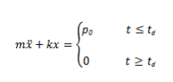
This is the equation of motion of an undamped single degree of freedom system, and the pulse excitation is acting on it; a rectangular pulse is acting on it, so p₀ is the amplitude of the pulse, and it exists for a duration td. It is possible to express the force as equal to p₀ if t is less than td and the force is 0 if it is greater than td.

References
Adams, D. D., & Wood, W. L. (1983). Comparison of Hilber‐Hughes‐Taylor and Bossak ‘α‐methods’ for the numerical integration of vibration equations. International Journal for Numerical Methods in Engineering, 19(5), 765-771.
Catbas, Necati. (2014). Dynamics of Civil Structures.
Craig Jr, R. R., & Kurdila, A. J. (2006). Fundamentals of structural dynamics. John Wiley & Sons.

