

**VIOLA IRENE NANSAMBA**

**UB41283BMA50012**

**MANAGEMENT**

INTRODUCTION TO OCCUPATIONAL HEALTH AND SAFETY MANAGEMENT

**ATLANTIC INTERNATIONAL UNIVERSITY**

**HONOLULU, HAWAII**

**2022**

**DATE October 2022**



**TABLE OF CONTENTS**

Introduction………………………………………..3

Literature review………………………………….3

Components of a successful health and safety management system ……………………………6

ILO Occupational health and safety Convention, 1981(No.155) …………………………………....9

Health and Safety Guidance managing for health and safety (HSG65) ……………………12

Case study ……………………………………...13

Analysis………………………………………….14

Conclusion………………………………………14

Annex…………………………………………….15

Bibliography……………………………………..15



**INTRODUCTION**

“Health is a state of being free from illness or injury”, according to the Oxford dictionary. “Health is a state of complete physical, mental and social well-being and not merely the absence of disease and infirmity”, by the World Health Organization. Synonyms for health include; euphoria, well-being, strength, complexion, fitness, energy, bloom and prime.

“Safety is the condition of being protected from or unlikely to cause danger, risk or injury”, from Oxford dictionary. In HSE(Health, Safety and Environment), “safety is a set of processes and procedures identifying potential hazards to a certain environment, developing best practices to reduce or remove those hazards, and then training employees for accident prevention and accident response”.

The International Labour Organization (ILO) summarizes Health and Safety as the discipline dealing with the prevention of work-related injuries and diseases as well as the protection and promotion of the health of workers.

Health and safety management is a system which has a set of policies, procedures and plans that systematically manages health and safety at work and can help minimize the risk of injury and illness from workplace operations.

**Literature review**

It is everyone’s responsibility to take care of their health and safety, at workplace or at home. The employer is generally responsible for ensuring that the employees are protected from occupational hazards like fire, occupational diseases and injury during the working hours.

Hazard is a source or situation that has potential to cause danger to the safety, health, property and the environment. Hazards can be in form of noise, vibration, heat, cold, heights, electricity, repetitive job, moving machinery, toxic gases and chemicals. All these have potential to cause acute or chronic effects to health, pollution to the environment and corrosion or fires to the equipment.



Acute health effect is the effect that develops immediately or within seconds, minutes, hours or even days after the exposure to the hazard. For example when exposed to Hydrogen Sulphide gas of 1000ppm, the effect is acute toxicity resulting into rapid unconsciousness and death.

Chronic health effect is an adverse health effect as result of prolonged exposure to a substance. The symptoms do not usually subside when the exposure stops but instead the effects are felt. Examples can be asthma, cancer, memory loss, brain damage and organ failure.

Risk is the probability or likelihood and consequences that a person will experience harm or health affects if exposed to a hazard. Examples of risks are damage of fire, floods and other natural disasters. Therefore, risk assessment has to be carried out to control danger to the people’s health and safety.

Risk assessment is a formal process of identifying hazards, evaluating risk and then either eliminating or controlling that risk to as low as reasonably practicable level (ALARP).To achieve this there is a hierarchy of controls that must be used by persons or organizations.

*Fig.1 showing hierarchy of controls*

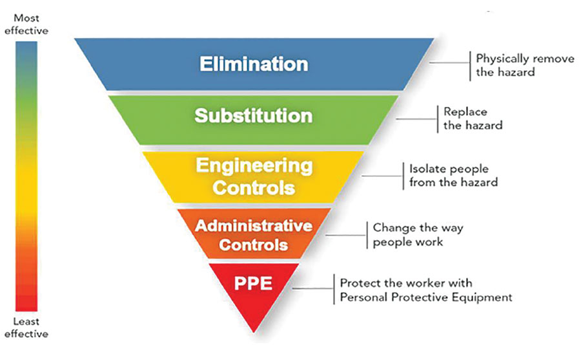



Controls are the measures put in place to prevent unwanted event from occurring or reduce the loss of control of the hazard and reduce effects. There is no safety without controls in place because apparently there is danger everywhere. Danger can cause health problems any day any time that is why it is important to appreciate health and safety and treat them with the utmost importance and care.

Health and safety should have regulations and procedures with the intention to prevent or avoid or reduce to as low as reasonably practicable level accidents or injuries at workplace, home or public environments. This can be achievable through;

* Undertake risk assessments, the purpose of risk assessment is to improve health and safety and to achieve this hazards have to be identified in order to reduce the risk they pose. This should be done by implementing controls, record findings and review the controls in place.
* Provide a safe place to work, safety includes the workplace as well and this is achieved through using labels and signs to inform about danger, reward employees for safe behavior to boost their morale, train employees well on the usage of equipment and encourage good housekeeping.
* Provide training and information on how to carry out work processes safely, instruction is part of training and it can be done on job or away from job. Provision of tool box talks is important for the employees to be aware of the hazards and the emergence response in case something wrong happens.
* Develop a health and safety policy, this is a general approach to health and safety that explains how employers will manage health and safety at work. It clearly outlines everyone’s responsibilities in the policy of the company and requires everyone to stay within their scope of work to avoid unnecessary incidents and accidents at work.
* Adequately maintaining equipment and other systems to ensure safety, every place of work should have adequate equipment to avoid accidental activation that can lead to injuries or illness to the employees. This can be done through having safe systems of work in place. Equipment that is under maintenance should be locked and tagged out.

A good health and safety management system should be in place to reduce the likelihood of accident causations in both homes and work places not forgetting the public areas as well. Risk assessments would go a long way in ensuring safety of the people, property and environment.



Components of a successful health and safety management system

An occupation health and safety (OHS) management system involves much more than just the health and safety program. It must include health and safety policies, systems, records and standards. This includes incorporating health and safety activities and programs in the business processes. Having a system in place helps improve the ability to continuously identify hazards and also control risks at the workplace.

The author, Naeem Sadiq (2019) wrote down the effort that was put in when coming up with the ISO 45001: 2018 developed by experts from more than 60 countries for a period of over five years. It was developed to help businesses reduce workplace injuries, incidents of ill-health and death at work every year.

All governments all over the world have laws on protection of workers from occupational hazards for example in United Arab Emirates; “Ministerial Order, 32 of 1982,” in summary stating that employers shall provide appropriate preventive measures to protect the workers from risk of injury and occupational diseases and also from any fire risk that may result from the use of machinery.

Clarke Sharon and Burke Ronald J (2011) quoted a study by the World Health Organization (WHO) that almost 1.3 million people are killed and between 20 -50 million people are injured on the roads. They further quoted that in Northern China, February 2009 at least 74 miners were killed and 114 hospitalized due to a gas explosion and again in China there was a mine explosion in 2007 that left 105 miners dead when gas exploded in an unventilated tunnel. Furthermore, they quoted that ILO estimated that 2.2 million people die every year from accidents at work or occupational diseases and that the numbers may increase. In addition ILO estimates that there are 270 million non-fatal accidents every year causing injury all over the world.

The examples shown above about the fatalities and non-fatalities are aimed at creating awareness that if there is no good health and safety system in place, people will be affected both directly and indirectly. According to Snyder Paul R and Ulrich Gary M (2019) ,the components of the system should have the following;



* System audit, Certificate of Recognition (COR) auditor should review the key aspects of the OHS management system and ensure that its quality and effectiveness meets the expectations of COR standards and guidelines. This is to help maintain credibility and value of certifications.
* Program administration, having regular assessment on how well the business is doing in meeting the target of improving the health and safety goals. Useful information helps to continually improve the management system if accurate records are maintained.
* Identifying hazards and minimizing risks, it’s essential to identify hazards, assess the risks those hazards present. The hierarchy of control of risk should be adhered to in order to prevent workers from getting injured.
* Health and safety training and instruction, it is everyone’s responsibility when it comes to implementation and maintaining of a healthy and safe workplace. The senior management should understand their role in establishing policies. Employers must ensure that employees are trained, qualified and competent to perform their tasks. Supervisors must provide adequate instruction to employees in order to perform their duties safely.
* Safe work procedures and written instructions, procedures and practices should be safe in the business and everyone must know their responsibilities so that they can perform their duties with effectiveness. There should be procedures in place like communication on a worker’s level as well such as how to respond in case of an emergency.
* Occupational health and safety programs, these are aimed at ensuring workers are protected and the risks are minimized. This is a very important part of the OHS management system. Employers must establish a form of health and safety program at the workplace and this type of program should depend on the number of employees and the work associated risks.
* Joint health and safety committee and representatives, these should be in place in order to assist the business in bringing the employers and employees together to identify and resolve the health and safety issues at the workplace. They should also participate in developing and implementation of the OHS management system.
* Inspection of premises, equipment, workplaces and work practices, this is a chance to identify hazards and risks on a continuous basis at the workplace. Inspections reveal the current state of the workplace because they are a part of a proactive injury-prevention process. This helps to prevent unsafe conditions.



* Management leadership and commitment, health and safety starts with the top most senior management members. They have to demonstrate that they take safety seriously through provision of vision and establishing goals and supporting implementation of the OHS management programs.Mangement has to be committed to ensure that workers stay safe on the job by continuously improving health and safety culture.
* Investigating of incidents, this is done to identify root causes of unsafe conditions. Incident investigation documentation and reporting should be done as well in order to prevent similar incidents from happening in the future.

*Fig.2 shows components and elements of SMS by the International Civil Aviation Organization (ICAO)*

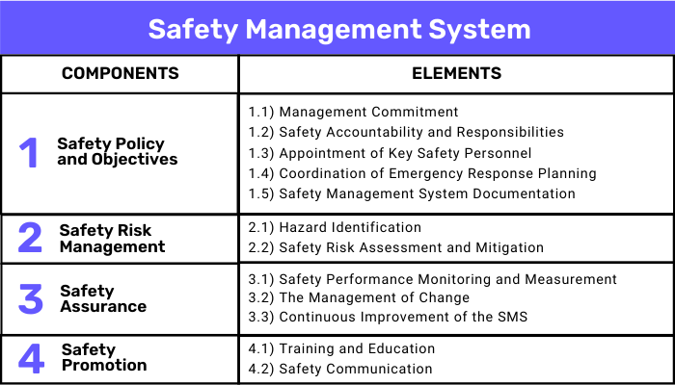



ILO Occupational health and safety Convention, 1981(No.155)

The International Labour Organization (ILO) founded in 1919 became a part of the United Nations in 1946 and its mandate was to deal with labour issues. ILO has a tripartite structure which makes it unique in the United Nations system and all adopted standards have broad support from all ILO constituents.

The ILO promotes decent work for all and advocates for elimination of all forms of forced labour or compulsory labour, abolition of child labour and discrimination in respect of employment and occupation. ILO defines labour as, “work that deprives children (any person under 18) of their childhood, their potential and their dignity, and that is harmful to their physical and /or mental development”.

The ILO is the first and oldest specialized agency of the UN and currently has 190 Conventions and 206 Recommendations dating as far back as 1919.The ILO has instruments in place such as the Conventions, Codes of Practice, guidelines and handbooks that are reference points for businesses, organizations and governments to ensure what is required for health and safety at work.

For the purpose of this essay, the emphasis is on the Convention No.155 about occupational health and safety. This entry came into force on 11th August 1983. This Convention targets both employers and employees and the basis is prevention.

C155 stipulates that, “each member shall, in the light of national conditions and practice, and in consultation with the most representative organizations of employers and workers, formulate, implement and periodically review a coherent national policy on occupational safety, occupational health and the working environment”.

The aim of the policy is to prevent accidents and injury to health arising out of, linked with or occurring in the course of work by minimizing, so far as is reasonably practicable (ALARP concept) ,the causes of hazards inherent in the working environment. The ILO is not aiming at elimination of the hazards because that is not practical but the aim is to lower or reduce the chances or likelihood for the hazard to cause danger.

The competent authorities (legislature) who have the power to legislate or take action in order to implement Conventions and Recommendations shall determine conditions governing the design, construction and layout of undertakings.



The competent authorities will further determine the work processes and substances and agents the exposure to which is to be prohibited or limited. For example; if toxic chemicals are to be used, there should be safety data sheets available, the permissible exposure limits stipulated, medical surveillance in place and all personal protective equipment in place.

The authorities must also establish and apply procedures for the notification of occupational accidents and diseases and production of annual statistics on them. All employers must have a reporting system in place and the time when the official report has to be submitted. For example in airline business, an official incident/accident report has to be submitted within 72 hours.

Competent authorities must hold inquiries of occupational accidents, occupational diseases or injuries which reflect serious situations and must include occupational safety and health and the working environment issues at all levels of education and training. It is very important to report accidents, this helps to carry out investigation and come up with better control measures. The purpose is to stop these accidents from happening again and also to clear the air on what caused the danger. No one is guilty until there is proof and evidence after the investigation.

The legislature must make arrangements to ensure the necessary co-ordination between various authorities and bodies. For example, when someone is injured at work, the police should coordinate with the judicial system to really come up with the best decision as to what led to the accident.

For employers obligation, Workplaces that have machinery, equipment and processes must ensure that they are safe and without risk to health. It is stipulated that control measures should be put in place in order to avoid workplace illness like dusts, fumes, vapors that can have chronic effect like asthma on the employees.

The employers must ensure that the chemical, physical and biological substances and agents under their control are without risk to health when the appropriate measures of protection are taken. They should provide where necessary adequate protective clothing and protective equipment to the workers. Employees have a right to protection from occupational hazards like exposure to elements of heat or cold, contact with chemicals in order to avoid illness and injuries from their workplace.



Employers must provide where necessary, for measures to deal with emergencies and accidents, including adequate first-aid arrangements. It is necessary to have a contingency plan in place that must include alarms, assembly points, emergency rescue teams, equipment like firefighting, life-saving appliances, detectors, tool box talks and a specialist in first aid treatment with a fully equipped first aid box.

Workers and their representatives must co-operate with their employer in fulfillment of the obligations placed upon them. They should report to their supervisors any situation which they have reasonable justification to believe presents an imminent and serious danger to their life or health. The workers’ representatives in undertaking are to co-operate with the employer in the field of occupational safety and health.

The protocol of 2002 to the convention155 has establishment and periodical review of requirements and procedures for the creation of a system for recording and notification of occupational accidents and occupational diseases and dangerous occurrences and annual statistics.

The government is obliged to put in place requirements and procedures for recording and notification of occupational accidents and diseases. Analysis and annual publication of statistics concerning occupational accidents, occupational diseases and commuting accidents should be in place as well.

The employers’ responsibilities are to record occupational accidents, occupational diseases and dangerous occurrences. They must provide appropriate information to the workers and their representatives concerning the recording system. Furthermore they should ensure appropriate maintenance of these records and their use for the establishment of preventive measures.

The employers must refrain from instituting retaliatory or disciplinary measures against a worker for reporting an occupational accident, occupational disease or dangerous occurance.This builds trust and vigilance among the workers and reduces risk of hazards. The employers must notify the competent authorities of the occurrences and provide appropriate information to workers and their representatives concerning the notified cases.

The C155 when adhered to helps to streamline safe workplaces policies and involves all parties concerned like the government, the employers and the workers to ensure good health and safety is in place.



Health and Safety Guidance managing for health and safety (HSG65)

The guidance clearly explains the Plan,Do,Check,Act approach and shows how it can help the business achieve balance between the systems and behavior aspects of management.HSG65 also treats health and safety management as an important part of good management rather than a stand alone system.

The guidance is to focus on senior management leadership, workforce involvement and occupational health. It has advice on the core elements of managing health and safety, deciding if the business is doing what needs to be done, delivering effective arrangements and the useful resources required.

*Fig.3 shows the HSG65 summary*

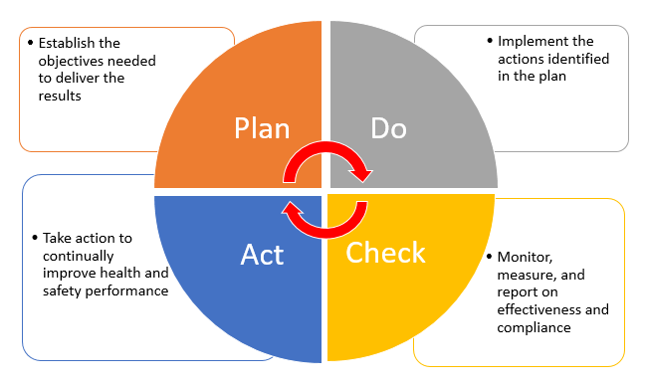



**Case study**

Case study of the Royal Mail Ship, RMS Titanic (1912) from *Wikipedia* ,was a British passenger liner operated by White Star Line which sunk in the North Atlantic ocean on April 15th 1912.The ship struck an iceberg on her maiden voyage from Southampton to New York City and more than 1500 people died in that tragedy.

Constructing the massive ship was difficult and dangerous work. Harland and Wolff Company had 15,000 men assigned to work on the construction of the ship. The safety precautions were rudimentary and a lot of work was carried out without proper equipment like hand guards on machinery or hard hats. There was a record of 246 injuries and 28 of them classified as severe such as severed arms and legs. Six people died on the ship during construction and two died in the shipyard workshops and sheds and right before the launch another worker was killed by wood that fell over him.

On 23rd April 1912, the Daily mail reported, “Late in the afternoon hope died out”, the relatives and friends who had been waiting for news of their people thinned out and broken men and women silently left for their homes. There was hardly a humble family in Southampton that did not lose a relative or friend.

*Fig.4 shows illustrations of the RMS Titanic before and after.*

|  |  |
| --- | --- |
| Photos of the Titanic Tragedy From 101 Years Ago | History| Smithsonian  Magazine | Wreck of the Titanic - Wikipedia |



**The analysis**

The Titanic disaster was a hard pill to swallow, too much blame to take in and too much pain for everyone but the lesson was learned. The recommendations were done and put in place to avoid such a catastrophe again. Looking back cannot change what happened but effort has been enforced as seen below;

After the Titanic disaster, ships were refitted for increased safety with double bottoms and extended up the sides of their hulls, their waterlines, to give them double hulls. The Jones Act or Merchant Marine Act was enacted in 1920 to allow a ship’s employee or seaman file a lawsuit against the employer for rightful compensation and recovery.

The International Ice Patrol an agency of the United States Coast Guard was founded in 1914 to monitor and report on the location of North Atlantic icebergs that could pose a threat to transatlantic sea traffic.

The International Convention for the Safety of Life at Sea (SOLAS) was passed in 1914 to ensure that ships should carry enough life-saving appliances and mandatory drills be implemented and inspections to be conducted. The United States government passed the Radio Act of 1912 stating that radio communications on passenger ships would be operated 24 hours a day, along with a secondary power supply so as not to miss distress calls.

**Conclusion**

The government having the laws in place is not enough but they should strictly be adhered to. It is not okay to have thousands and millions of court cases due to workplaces injury or illness. Health and safety is not an option and neither should it be an experiment. The truth is that, it is reality and requires effort from both the employers and employees.

Let safety become a personal matter of life and death; let it be emphasized at home, schools and at work. Having health and safety management systems in place does not take away the danger of the hazards but being complacent is the actual danger that causes illness,injury,pollution and damage to the equipment.



**Annex**

Fig.1 showing hierarchy of controls…………………………………………………………...4

Fig.2 shows components and elements of SMS by the International Civil Aviation Organization (ICAO) ………………………………………………………………………….. 8

Fig.3 shows the HSG65 summary…………………………………………………………...12

Fig.4 shows illustrations of the RMS Titanic before and after…………………………….13

**Bibliography**

1. Clarke Sharon and Burke Ronald J (2011) Occupational Health and Safety, page 4-5 ,published by Routledge,Farnham,England
2. C155-Occupational Safety and Health Convention,1981 (No.155) <https://www.ilo.org>
3. Levinson Martin H (2012) A General Semantics Analysis of the RMS Titanic Disaster page 144-154
4. Managing for Health and Safety (HSG65) (2013) Health and Safety Executive (HSE)
5. Naeem Sadiq (2019) Establishing an Occupational Health and Safety Management System based on ISO 45001 page 18-19
6. Snyder Paul R and Ullrich Gary M (2019)Practical Safety Management Systems : A Practical Guide to Transform your Safety Program into a Functioning Safety Management System page 13-37
7. Titanic (1912) <https://en.wikipedia.org>
8. United Arab Emirates, Ministerial Order N0.32 ,1982 Determining Prevention Strategies and Methods for Protecting Workers from work hazards, Articles 1-20 <https://www.mohre.gov.ae>