Your name
Your student ID number
Keza Nea Vanelli
UB37331HPS45905

Write here a name for
your Work or Academic Experience (This will be the name of the course)
Special needs Instructor

ATLANTIC INTERNATIONAL UNIVERSITY
Month/year
02/2018

Answer the following questions that apply to your work or academic experience:
(You can include photos, graphs or other illustrations, if you have them.)
In the following questions, the word “project” refers to your experience. Some examples of experience are work experience, job training, academic research, publication, recognition of community service, completed course and a conference presentation. There are many more options for you to receive course credits. Describe your experience in the answers below.

- Describe the project?
The project I created and I’ve been working on it called’’ Light of Life’’ it is a project that help children with mental disabilities like Autism, downsyndrom, ADHA (attention deficit hyperactivity disorder) in Rwanda. whose goal is to integrate the children with disabilities into Rwandan community through education that enriches academic achievement in key areas of literacy and math, develops life skills that can increase independence and provide opportunities that will help students make a living in the future, increase awareness about disabilities to the Rwandan community, and help educate families to help support their children.
Some of our activities will include: - creating greater awareness and acceptance of children with disabilities and working towards inclusive practices in schools and community, motivate, train and teach children with different disabilities like:
- Intellectual disability,
- Emotionally Disturbed and
- Specific learning disabilities as well as other health/behavioural impairments.

2.Are you currently working on the project? What are the dates in which you worked on this project? I worked on this project on 2017 and 2018 it still continues.
Here is the certificate
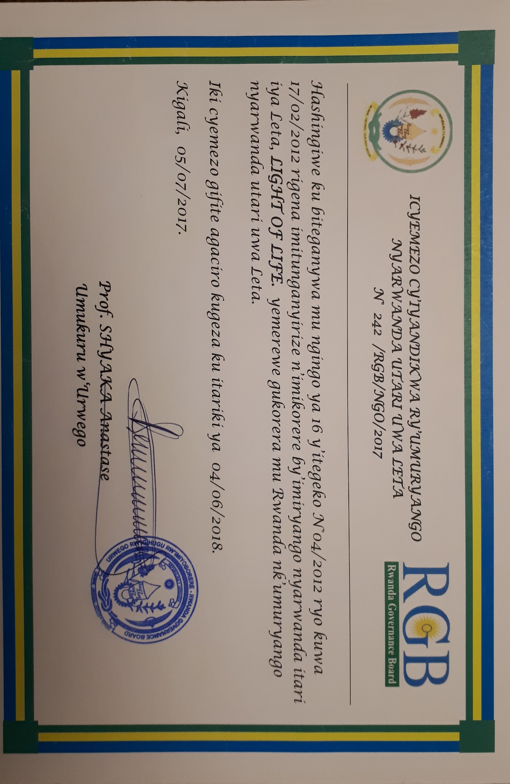
3. What activities did you do in the project?
- Made research to find out the percentage of vulnerable families that have children with disabilities in Rwandan society.
- Raising awareness of mental disabilities in Rwanda society.
- Advocacy for those families.
- mobilized funds
- opening a center where parents and children can meet to be tough and where parents can get advices regarding to the issues of their children.
- train Educator on how to handler different cases regarding the special needs’ education.
- Create IEPs for children.
4. What did you learn in the project?
During the process of this project, I learned and developed valuable skills as:
Communication skills, coordination skills, decision making, directing a project, project management, project implementation, doing Advocacy, research and how to mobilize project funds and negotiation skill.
5. How does this project relate to your major at AIU?
As Psychology is basically a study of social and human; Their behaviors, mentally, physically and their right…, in order to come up with a solution that helps humans on how to improve their lives in different stage, level of life.
And this is a Social and humanity-based project.
as this project description says, it is bringing a way to improve the lives of some category of people (people with mental disabilities) that have been left behind for some reasons. And integrate in our society.
As in this project activities are to identifying the issues that related to humanity, raise the awareness of the issue, finding solution to the issue. By doing all this, I believe that we are fighting for the rights and the well being of these people. And to be successful I needed knowledge in psychology.
6. How can you use the knowledge and experience gained in your project to further human rights and the 17 Goals for a Sustainable World by the United Nations? (Click here to review the Goals)
Giving them the right education, once they are educated, they can be an impact in building the economy of their land.
Giving them same access to medication as others, that is for their health and wellbeing.
Giving them access to the job that they can do. In order to be able to buy their basic needs.
I believe that these two goals are the base to achieve the rest of 17 goals.

7. What more would you like to say about your project?
I can’t wait to see it moving higher.

By; Keza Nea Vanelli

