**Michael Tracey**

**UB75036BSU84213**

COURSE NAME:

**(Bachelors in Logistics and Supply Chain Management)**

Assignment Title:

**(Critical Thinking)**

ATLANTIC INTERNATIONAL UNIVERSITY

**January/2022**

**TABLE OF CONTENTS**

**CONTENT** **PAGES**

**Cover Page 1**

**Table of Contents 2**

**Introduction 3**

**Bases and Exponents 4-5**

**Thinking Skills in Education and Life Thinking Skills 5-6**

**Complex Thinking 6-7**

**Defining Critical Thinking 7-8**

**Six Critical Thinking hats 9-11**

**Thoughts and Knowledge 11-12**

**Immature Behaviors 12**

**Metacognition 13**

**Critical Thinking-General review 14**

**Conclusion 15**

**Biblography 16-17**

**INTRODUCTION**

**WHAT IS CRITICAL THINKING**

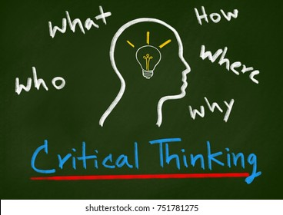

The definition and concept of critical thinking have been explored in many complex ways, especially for those that are new to the concept. Developing critical thinking skills will enable you to learn and evaluate the information retrieved through hearing and writing, dissecting that information, and processing all that you have collected to remove the implicit bias. Simply explaining, critical thinking is thinking and judging for yourself while analyzing the evidence presented to you to examine its authenticity to make sure it is sound (Fleming, 2018).

The term critical thinking had its roots formulated in the mid-late century, which has a rich concept developing for the past 2500 years (Critical Thinking, n.d.). Many complex overlapping terms have been used to give a solid definition to critical thinking, however, we will come to realize that no one term nor definition will give you a clear understanding of critical thinking. It’s with conclusions detailed examination of the information provided that will help to decipher truth from fact.

Critical thinking allows us the opportunity to move away from rash thinking, conclusions, reluctance to questions, and enables us to receive wisdom and conscious authority. Discipline is formed through critical thinking with clear expressions of ideas, with an acceptance of personal responsibilities drawn from our intellectual thinking. Examing and analyzing these core definitions will enable us to concisely interpret the information given to come to a facts-based reasonable conclusion.

With a further examination of the substantive conception of critical thinking, you can draw a clear reflecting fact that its content involves communication, the collaboration of all theoretical explanations of creativity that is complementary to its study, and elements of thoughts using the intellectual tools.

**BASES AND EXPONENTS**

Many of our thinking if left unexamined will vare away from self-improvement and exposed bias or distorted partial decisions which can lead to being uninformed or downright prejudiced. The imposing intellectual standard upon critical thinking must be done by skillfully taking charge of the structures inherent to the thinking process and improving the quality of his or her thinking.

A critical thinker is a well-cultivated thinker who formulates and raises vital questions to the problems clearly and precisely. The information gathered must be assessed as to its authenticity and relevance while using abstract ideas to interpret the information effectively which will eventually lead to well-reasoned conclusions and decisions tested against criteria and standards.

It must not be interpreted as a self-minded, self-motivated process as the effective collaboration of communication with others will help in figuring out the solutions to complex problems. The traits aligned with critical thinking are self-discipline, self-standards of excellence, and mindful command of its use.

The emphasis during the process of critical thinking is often placed on things that are often very different from what they appear to be and that only the trained mind is prepared to see through the way things look on the surface to the way they are beneath the surface. The reasoning must be systematically cultivated and cross-examined. Rejecting established beliefs is not the trait of conscious-minded critical thinkers, only rejecting those beliefs that lack reasonable foundations.

“We now recognize that critical thinking, by its very nature, requires, for example, the systematic monitoring of thought; that thinking, to be critical, must not be accepted at face value but must be analyzed and assessed for its clarity, accuracy, relevance, depth, breadth, and logicalness. We now recognize that critical thinking, by its very nature, requires, for example, the recognition that all reasoning occurs within points of view and frames of reference; that all reasoning proceeds from some goals and objectives, has an informational base; that all data when used in reasoning must be interpreted, that interpretation involves concepts; that concepts entail assumptions, and that all basic inferences in thought have implications. We now recognize that each of these dimensions of thinking needs to be monitored and that problems of thinking can occur in any of them”. (Critical thinking-Bases and Components, n.d.)

**Thinking Skills in Education and Life Thinking Skills**

**Thinking is unique to all human beings as it predominantly involves the activities or processes of critical thinking, which also involves analyzing and manipulating information that is received from the environment. Manipulation of the thinking process occurs by the means of abstracting, reasoning, imagining, problem-solving, judging, and decision-making. One feature that distinguishes human beings from other living things is the thinking process.**

**Critical thinking students are encouraged to think for themselves, to analyze, to question the hypotheses, and synthesize the events by going one step further by developing new hypotheses and testing them against the facts. Students at all levels initiate critical thinking when they, analyze, interpret, or synthesize information and apply creative thought, to form an argument, solve a problem, or reach a conclusion. This is done to establish and promote, independent thinking, personal reasoning, independent reasoning in thought and action.**

**Education is one of the most basic needs for people and is a process that provides the development of the self conscious-minded human being. Education aims to nurture the individual, for him or her to realize the full potential that already exists within him or her. The chief business of schools should be geared towards the strengthening of a child’s thinking and not just be seen as an income. Within this context, students will be able to evaluate what they have learned by manifesting their critical thinking abilities.**

**The aim of educational institutions should be to produce learners, develop student thinking skills, motor skills, and put them in a stage where they are well informed and understand ideas that are helpful, useful, beautiful, and powerful. Students should be able to think analytically and critically and use what they know to enhance their own lives for them to contribute to their society, culture, and civilization.**

**Concluding on the discussion above, it is clear that critical thinking is no doubt necessary in every field of life, especially professions that are people-based. Educationalists, psychologists, and counselors have to be critical thinkers in both practice and management. Teachers and counselors must first be committed to being able to implement critical thinking in their classrooms.** (Lyer, 2019)

**COMPLEX THINKING**

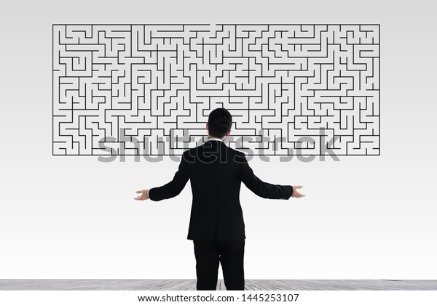

**In today’s world complex thinking involves many key abilities that are important to success in our present modern society. Understanding concepts, generating original ideas, and using logical approaches to address complicated problems is an attribute of sophisticated thinking that is used as a separate set of methods for the complex thinking process.**

**Strong complex thinkers may be good at understanding deeply, ideas put to them through concepts by using information derived from different sources and putting a connection to them by constructing and defending arguments based on facts and evidence, taking risks with new ideas, and drawing references from limited information.**

**In as much, on the flip side challenged complex thinkers will struggle with understanding new ideas and concepts without the requisite support, having trouble reading “between the lines”, and approaching problems haphazardly, not wanting to accept nor rely on the existing ideas but preferring to come up with new ones. They are unable to reason independently even with the information presented before them.**

**Being a complex thinker is not something you can be judged as being good or not because ideally, people think differently. Your degree of knowledge and interest in the matter will affect and dictate how well you understand the concepts as everyone will possess a certain degree of interpretation about his/her creativity and imagination. Content that is abstracted or complexed often involves and supports the complex thinking process.**

**DEFINING CRITICAL THINKING**

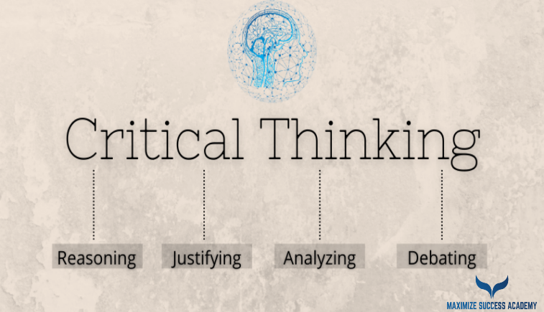

**Forming reasonable judgments that are logical and well-thought-out is an intellectual process of critical thinking. It is a way of actively and skillfully analyzing, applying, synthesizing, and/or evaluating gathered information generated by observation, experience, reflection, reasoning, or communication as a believable action guide. It is based intellectually on a universal set of values such as clarity, accuracy, precision, consistency, relevance, sound evidence,** good reasoning, depth, and fairness.

These structures of thoughts and elements are examined implicitly to entail or incorporate reasoning, purpose, problem, the questionable issue, assumptions, concepts that will lead to conclusions, implications, consequences, and reference frames to form objections from alternate viewpoints. Critical thinking is being responsive to a variety of subject matter, issues, and purposes which argumentatively leads to scientific thinking, mathematical thinking, moral thinking, historical thinking, and economic thinking.

Based on the motivation surrounding it, critical thinking decisions can be seen as being biased. Skillful manipulation of the ideas can be manifested to service one’s idea or group vested interest. In this instance, it is typically flawed regardless of how pragmatically successful it might be. Grounded in fairmindedness and intellectual integrity, critical thinking is of a higher integrity degree though subjected to influence by those habituated to its selfish use.

Individually, critical thinking of any kind is never universal, everyone is subjected to episodes of irrational and indiscipline thoughts. The degree of quality is therefore dependent on among other things to involve the quality and depth of experience in thinking or concerning a particular class of questions. No critical thinker is through, but only to such a degree with such insight, having such tendencies towards self-delusion. For this reason, the development of critical thinking skills is a life-long endeavor.

**“**Critical thinking is self-guided, self-disciplined thinking which attempts to reason at the highest level of quality in a fair-minded way. People who think critically consistently attempt to live rationally, reasonably, empathically. They are keenly aware of the inherently flawed nature of human thinking when left unchecked. They strive to diminish the power of their egocentric and sociocentric tendencies. They use the intellectual tools that critical thinking offers – concepts and principles that enable them to analyze, assess, and improve thinking.

They work diligently to develop the intellectual virtues of intellectual integrity, intellectual humility, intellectual civility, intellectual empathy, intellectual sense of justice, and confidence in reason. They realize that no matter how skilled they are as thinkers, they can always improve their reasoning abilities and they will at times fall prey to mistakes in reasoning, human irrationality, prejudices, biases, distortions, uncritically accepted social rules, taboos, self-interest, and vested interest.

They strive to improve the world in whatever ways they can and contribute to a more rational, civilized society. At the same time, they recognize the complexities often inherent in doing so. They strive never to think simplistically about complicated issues and always consider the rights and needs of relevant others. They recognize the complexities in developing as thinkers and commit themselves to life-long practice toward self-improvement”. (Define Critical Thinking, n.d.)

**SIX CRITICAL THINKING HATS**

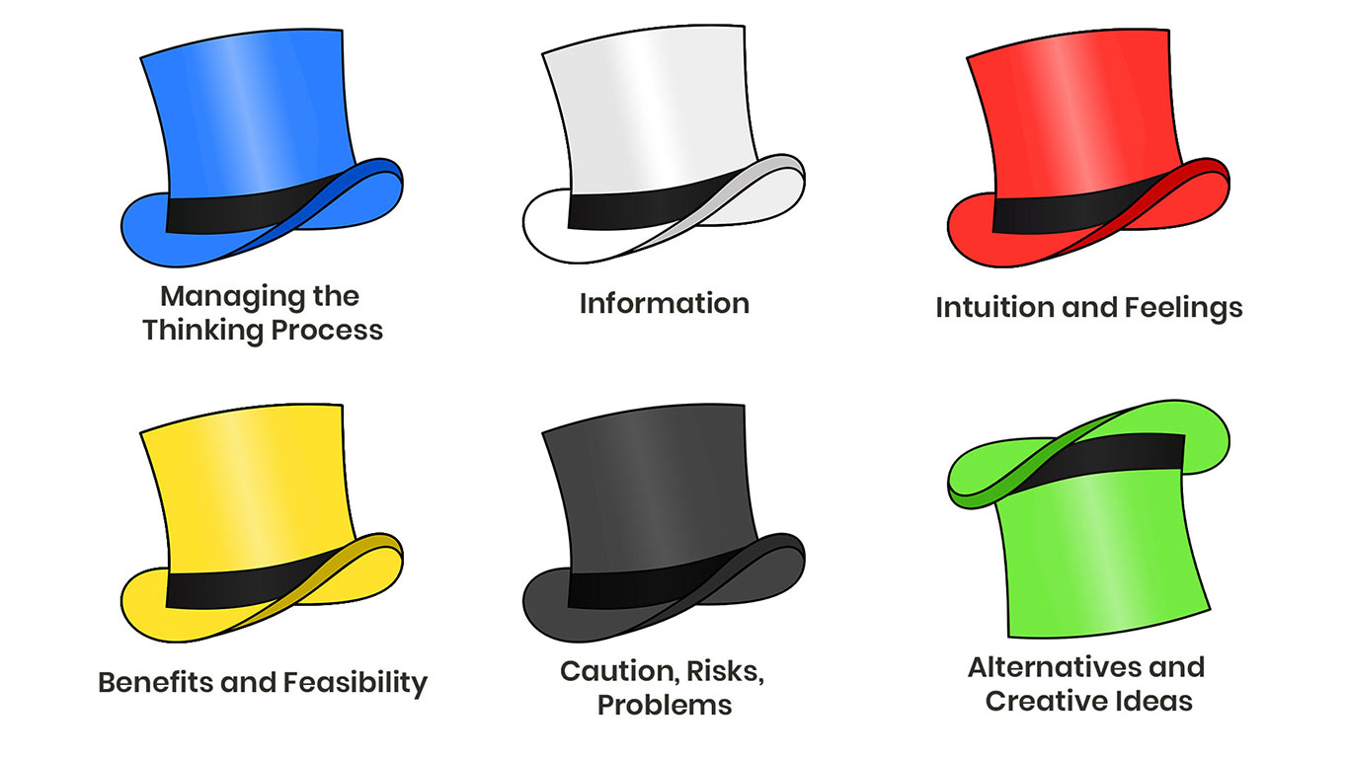

The process of investigating an issue from a variety of perspectives is found in the decision of the six thinking hats, which is an instinctive approach to decision-making in a clear conflict-free way. It is often used by groups to move outside and away from the normal habitual ways of thinking, trying out different approaches and then thinking constructively on how to move forward (Six Thinking Hats, n.d.).

The six thinking hats is an important and powerful technique that was created by the late “Edward De Bono”. Successful people think from a rational point of view that naturally makes them successful, even though they may fail to look at a problem from an intuitive, emotional, creative, or negative viewpoint. Looking at the problem using the six thinking hats technique you will be able to consciously solve it using all six techniques. It will enable you to mix your ambitions, plans, and decisions in such areas as skilled execution, public sensitivity, creativity, and good contingency planning. (Critical Thinking, n.d.)

Getting you to look at a problem in six different ways is the idea and rationale behind the six thinking hats. It takes you and your team beyond a definite position in the thinking process and instinctive position so that a range of perspectives can be explored, allowing you the opportunity to carefully consider each one with arguing or making snap decisions about what is right or what is wrong. (Six Thinking Hats, n.d.)

**WHITE HAT**

This hat is data-driven, information gathering, thinking about the insights and knowledge that you have already collected. This hat allows you to analyze past trends and explore historical data while looking for gaps in the knowledge already attained by either trying to fill them or taking account of them. (Six Thinking Hats, n.d.)

**RED HAT**

This is the instinct and feelings hat. Without having to justify them logically you can express your feelings. With this hat, you look at problems using emotions, intuition, and gut reaction. You can explore this hat by trying to assess how people will react emotionally by putting you in a situation to try and understandthe responsesof peoplewhodon’t fully know your reasoning. (Six Thinking Hats, n.d.)

**BLACK HAT**

Looking at all the bad points of the decision is the role of the black hat while looking at it defensively and cautiously, trying to see why it might not work. The role of the black hat is to highlight the weak points in the plan, which will allow you to alter them, eliminate them, or prepare a plan to counteract them. Fatal flaws and risks are spotted with the black hat, even though it makes your plans tougher before embarking on a plan of action.

**YELLOW HAT**

Positively thinking is the trait of this hat. The viewpoints are optimistic and help you to see all the benefits and rewards of the decisions and the value in them. This hat keeps you going when everything looks gloomy and difficult making you look at the issues in the most positive light possible. (Six Thinking Hats, n.d.)

**GREEN HAT**

Exploring a range of ideas and positive possible ways going forward are the qualities of a green hat thinker. This hat involves creative thinking. Creative solutions to problems are explored and studied with the green hat. The green hat carries with it the free will way of thinking in which your ideas are unlikely to be challenged and criticized. This hat keeps the thinker on his/her feet always exploring new ideas.

**BLUE HAT**

Controlling the process is for the blue hat thinkers. These hats are worn by persons who are chairing or overseeing the meeting or planned discussions. Problems faced by blue hat thinkers will see them seeking refuge with the advice of the green hat thinks, yellow hat think inkers, or black hat tinkers. This allows them to seek assistance when contingency plans are needed. (Six Thinking Hats, n.d.)

Looking at the effects of a decision from several different points of view are the benefits to using the technique to the six thinking processes. What would otherwise be deemed as normal rationale decisions would be sidetracked by allowing skepticism and necessary emotions by the six thinking processes. The opportunity is open for creativity within the thinking process. It allows for persistently pessimistic people to be positive and creative. Plans that incorporate the six thinking hats technique will be sounder and more resilient which would help us avoid public relations mistakes before committing to them. (Six Thinking Hats, n.d.)

**THOUGHT AND KNOWLEDGE**

There is nothing more practical than sound thinking. No matter what problems you face, no matter where you are, your goals, or circumstances, you are better off if your thinking is skilled and organized. As an employee, manager, friend, leader, lover, citizen, and parent, in every realm and situation in life good thinking pays off. Inevitably the problem of the opposite causes confusion. Poor thinking wastes time and energy and invites frustration and pain.

The art of critical thinking is to ensure that you use the best-disciplined thinking process you are consciously capable of in any given circumstance. You have to make learning about thinking a priority to become a good “critic” of your thinking which will make you become a good critic thinker.

It is an important realization that the study of thinking is rear and not taught in most secondary schools and colleges. Everything that you want, do, or think about is influenced by our thinking, which evidentially put forth the assessment that humans show little interest in the thinking and the thinking process. You must be willing to put the work into thinking to become better at thinking.

Vague, misleading, ambiguous, muddled, deceptive thinking are significant problems in human life. We must learn the art of clarifying thinking, of pinning it down, spelling it out, and giving it a definite specific meaning if we are to develop great thinking habits. Critical thinking is like an onion, there are many layers to it. You are to evaluate a rationalize each one to accept its validity before concluding. One of the good hallmarks of a critical thinker is the ability with bias or influence whether negative or positive to change one’s mind when given a valid reason to do so. (Critical Thinking - Thought and Knowledge, n.d.)

**THE IMMATURE BEHAVIORS**

Someone who simply thinks of himself or herself is the trait of someone with immature behavior. In such a situation we might be at loss as to what to do. In itemizing and dealing with a difficult situation, the first thing to do is to understand what is the cause. Seeing it is rather simple, however, we must be able to understand it and see it.

Essentially immaturity is accepted by immature people. Immature people are self-centered, self-absorbed, selfish, uncaring, feeling as if they are better than you, making you out to be different, and being only concerned with what they want without the consideration of others. Everything must be set up to suit and accommodate them never caring about the effects it might have on other people. Although it might harm or be an inconvenience to others, immature person tries to control the environment they are in.

They won’t even try to listen to the opinion of others, thinking only of what they can accomplish with their ideas and thoughts. They are driven by their selfish thoughts, doctrine, identifications, and projections. Someone with such a disposition can’t and won’t listen, can’t see what someone is saying, and has no true value. It’s like talking to a brick wall, behaving childish, and having no respect for someone else thoughts.

They look at your status and respect those of the higher class by looking down on you and labeling other people. They worship people in the higher class and become followers continuing with their abusive behavior while being impossible and stubborn for all the wrong reasons. Fantasies will be held onto for dear life because their fantasies are their security to them. Being self-centered and full of themselves is natural to them, not minding the fact that they are ruining people's lives for their pleasure which is natural to them. (Critical Thinking - The Immature Behavior, n.d.)

**METACOGNITION**

Thinking about one’s thinking is metacognition. In a more direct and precise definition, it refers to the process used to monitor, plan, and assess one’s understanding and performance. The critical awareness of one’s thinking and learning is the absolute trait of metacognition. (Chick, 2013) Even though metacognition is associated with student learning, it can be replicated, explored, and implemented in all areas of life. To one’s professional, social, and personal life.

Study skills, memory capabilities, and the ability to monitor learning effectively is metacognition which also incorporates one’s thinking process. The knowledge of metacognition is about our instinctive cognitive process and the understanding of how to regulate those processes to maximize learning.

Metacognition examines the intricacy of one’s self and is broken down into personal knowledge(declarative knowledge), which is understanding one’s capabilities. Task knowledge(procedural knowledge), is the length, content, and type of assignment where one will perceive it as being difficult. Strategic knowledge(conditional knowledge), explores the capabilities of strategic learning to understand information that is brought forth.

Student abilities to transfer or adapt their learning to new contexts and tasks are increased due to the metacognition practices. It helps them to become aware of their strength and weaknesses as learners, writers, test-takers, group members, and students. The key is to recognize the limitation of one’s knowledge or ability to perform a task and then figure out how to improve and expand on those limitations and abilities through careful examination and action.

Students who know and recognize their strengths and weaknesses in certain areas will be more likely to actively monitor their learning strategies, resources and examine and assess their readiness for a particular task and performance in the area of education understudy or professional expertise. (Chick, 2013)

**CRITICAL THINKING-GENERAL REVIEW**

Thinking involves such skills as analyzing, integrating, and evaluating what is read and heard. To become a truly effective critical thinker you must be able to decide whether the author’s opinion is true or false, whether it’s misleading, or has he/she adequately defended the ideas put forth, is the recommendation put forth practical, as well as will the solutions be effective.

Critical thinking has certain dispositions and concepts that are skills that must be mastered to build upon each other. Only by practicing and concentrating on these basic skills can the mastery of critical thinking can be achieved. Reasoning is one of the core traits of critical thinkers. Critical thinking also involves reflection, the evaluation, and examination of our own and others' thoughts and ideas in any given situation.

The deliberation to determine whether we should accept or reject a given judgment about the truth of a claim or recommendation, or to act in a certain way is embedded in the philosophy of critical thinking. Breaking down the material into its components, observing the relationships between the ideas, or looking for organization patternsand principles in what others present to them can be attributed to the process of the critical thinker.

Critical thinking is nothing more than a mode of thinking. There are many ways to come to a truthful conclusion through reasonable critical thinking content by the way of understanding it through the thought process. Concepts are involved in our everyday lives and can be designed through critical thinking and that’s why we must always remember to structure our thought process to reach a fair, final, beneficial conclusion to all involved. (General Review, n.d.)

**CONCLUSION**

Critical thinking, without us, even realizing it has been around for decades. Deciding our daily lives, from going to work, taking the children to school, to going to the supermarket, and attending social meetings and clubs has exposed us to the critical thinking concept. Even within those groups just mentioned we have learned and been exposed to recognizing appraising and building arguments.

Through the process of critical thinking, we cannot systematically teach and approach each person we interact with to use critical thinking as a basis to come to a fair conclusion about an argument or decision that will affect the process. It is left up to the individual to read, examine, and execute effectively the processes involved when using critical thinking to come to a consistent justifiable decision.

Critical thinking will be around for many more decades to come and it is being studied both presents and in the past by scholars and universities all around the world. It’s an ongoing process that will always be taught and examined to its full core of potential to captivate and push the thoughts of our intellectually curious minds to the limit.

Engaging with this assignment, the critical thinking process has opened a door of understanding to me, allowing me to be aware of my thoughts during the thinking process in any given situation. I now realized that in the past I had made some rash decisions not fully examining the situation in a complete critical thinking context. Now my ability to summarise, analyze, and identify logical situations using the process of critical thinking has increased.

Thanks to this assignment, with critical thinking I’m able to think more clearly and rationally. No longer will I be swayed by one-sided argument but be able to cipher through the information received and identify inconsistencies and errors in reasoning. Solve problems systematically rather than through bias or wavered thinking. Now I feel more confident in listening to ideas, arguments, and statements and coming to a conscious relevant decision that is fair to all.

**BIBLIOGRAPHY**

Chick, N. (2013). *Metacognition-Thinking About One's Thinking*. Retrieved from https://cft.vanderbilt.edu: https://cft.vanderbilt.edu/guides-sub-pages/metacognition/

*Critical Thinking*. (n.d.). Retrieved from https://students.aiu.edu: https://students.aiu.edu/Dashboard/OpenCourse?lang=1&fileName=Critical%20Thinking.html

*Critical Thinking - The Immature Behavior*. (n.d.). Retrieved from https://courses.aiu.edu: https://courses.aiu.edu/CRITICAL%20THINKING/8/SESSION%208%20the%20immature%20behaviors.pdf

*Critical Thinking - Thought and Knowledge*. (n.d.). Retrieved from https://courses.aiu.edu: https://courses.aiu.edu/CRITICAL%20THINKING/7/thought%20and%20knowledge.pdf

*Critical thinking-Bases and Components*. (n.d.). Retrieved from https://courses.aiu.edu: https://courses.aiu.edu/CRITICAL%20THINKING/1/SESSION%201%20BASES%20EXPONENTS.pdf

*Define Critical Thinking*. (n.d.). Retrieved from https://courses.aiu.edu: https://courses.aiu.edu/CRITICAL%20THINKING/5/SESSION%205%20CRITICAL%20THINKING.pdf

Fleming, G. (2018, September 23). *Introduction to Critical Thinking*. Retrieved from https://www.thoughtco.com: https://www.thoughtco.com/introduction-to-critical-thinking-1857079

Fleuridor, M. (n.d.). *Critical Thinking*. Retrieved from https://videos.i.edu.mx: https://videos.i.edu.mx/default.aspx?action=play&conferenceGUID=1044ec90-1a10-4519-92c9-4a3a315dea53

*General Review*. (n.d.). Retrieved from https://courses.aiu.edu: https://courses.aiu.edu/CRITICAL%20THINKING/10/SESSION%2010%20GENERAL%20REVIEW.pdf

Lyer, L. (2019, July). *Critical Thinking and its Importance in Education*. Retrieved from https://www.researchgate.net: https://www.researchgate.net/publication/339433132_Critical_Thinking_and_it's_Importance_in_Education

*Six Thinking Hats*. (n.d.). Retrieved from https://www.mindtools.com: https://www.mindtools.com/pages/article/newTED_07.htm

*Training and Development*. (n.d.). Retrieved from https://courses.aiu.edu/Creativity: https://courses.aiu.edu/Creativity%20and%20Innovation/7/WORD-PDF/07.Creativity%20and%20Innovation.Traing%20&%20Development.pdf