**Michael Tracey**

**UB75036BSU84213**

COURSE NAME:

**( Bachelors in Logistics and Supply Chain Management)**

Assignment Title:

**(Principles of Supply Chain Management)**

ATLANTIC INTERNATIONAL UNIVERSITY

**December/2021**

**Table of Contents**

**CONTENT PAGES**

Cover Page 1

Introduction 3

Traditional business paradigm and the integrated supply chain Concept 4 Total System Approach to Supply Chain Management 5 Supply Chain Management Verses Logistics Management 6-7 The Semantic differences between the demand, supply and value chain 7-8 The role of supply chain management in creating and adding value for customers 8-9 The importance of Supply Chain Management as a field of study 9-10

The driving force behind the supply chain concept 10-11

Supply chain management impacting the bottom line of the organization 11-12

The major challenges for integrated business functions and inter-organizational

Efforts across the supply chain 12-13

Business processes being integrated among supply chain partners 13-14

The link between Purchasing and Logistics 14

The link between Manufacturing and logistics 15-16

Identifying and selecting the right Supply Chain Partner 16

The potential barriers to forming the supply chain partnership 16-17

Business processes that links throughout the supply chain 17-19

Benefits of the supply chain partnership 19-20

Theory of Constraints. How is it related to supply chain management, and how can it help to manage the supply chain better 20-21

Prepare for changes in business practices by taking the supply chain initiative 21-22

The Suppy chain map of my organization 22

Conclusion 23

Biblography 24-25

**INTRODUCTION**

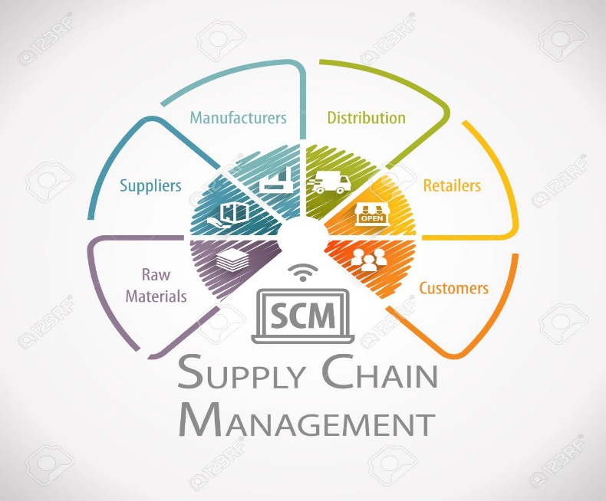

Supply chain management is the integration of key business processes from the suppliers that provide, products, services, and information to add value to the customers and other stakeholders. (Min, 2015). In the early 1940s, 50’s and 60’s, the military was the only organization using the term logistics in its defense mechanism. Departmental responsibility concerning material handling, warehousing, machining, accounting, and marketing was the acceptable norm. (Frazelle, 2002)

Supply chain management can be considered to be placed in context has having a relationship with another, just as humans would have a relationship with their family members such as a cousin, brother, sister, or mother. Supply chain management's younger cousin in the business of inter-functional concept is logistics. Supply chain management and logistics are new concepts in the private industry, they are also popular but greatly misunderstood topics. (Frazelle, 2002).

Over the years efficiency and effectiveness have been the main focus of most firms and businesses in the separation of business functions such as purchasing, production, marketing, sales, inventory, financing, and logistics. However, connectivity confusion involving these functions has to lead to below-standard organizational goals, causing integrated distortion within the supply chain management system leading to the depleting and duplication of vital resources. (Min, 2015).

**TRADITIONAL BUSINESS PARADIGM AND THE INTEGRATED SUPPLY CHAIN CONCEPT**

Logistics and supply chain management is now being significantly recognized and earmarked as the new and last frontier for major corporations in today's manufacturing and business society to increase shareholders and customer value. An increased number of firms have now started to realize the strategic importance of planning, controlling, and designing a supply chain as a whole that would incorporate the supply chain management system which draws from personnel in a complex multiplicity of disciplines. (Frazelle, 2002).

The methodological integrated confusion of individual departments within an organization operating independently whilst being consciously or unconsciously absent-minded about the operations in other departments without considering the affected entities or result brought birth to the study and educational development of logistics and supply chain management.

The strategic importance of controlling, designing, and planning a supply chain has now started to become a realization for most firms. The competitive independence amongst individual firms in the global marketplace is no longer an acceptable operation but now cooperates as an integrated aspect of the supply chain management system. Now a business's success will depend on its managerial ability to integrate and coordinate the vast network of business relationships amongst supply chain partners.

The main objective of supply chain management is to increase or enhance the effectiveness, efficiency, and profitability of the operational aspect of the business to hold a competitive position of a firm and its supply chain partners. It has moved away from and does not represent a one on one business relationship, but has incorporated communication and has a span of multiple business networks and relationships.

The evolution surrounding supply chain management has evolved around a customer-based operation and co-operate vision which invites the internal and external synergy of the business capturing the integration and coordination of the business. The benefits that can be attained from the integrated network supply chain solutions are improved customer service, increase capital, and increased sales. (Min, 2015).

**TOTAL SYSTEM APPROACH TO SUPPLY CHAIN MANAGEMENT**

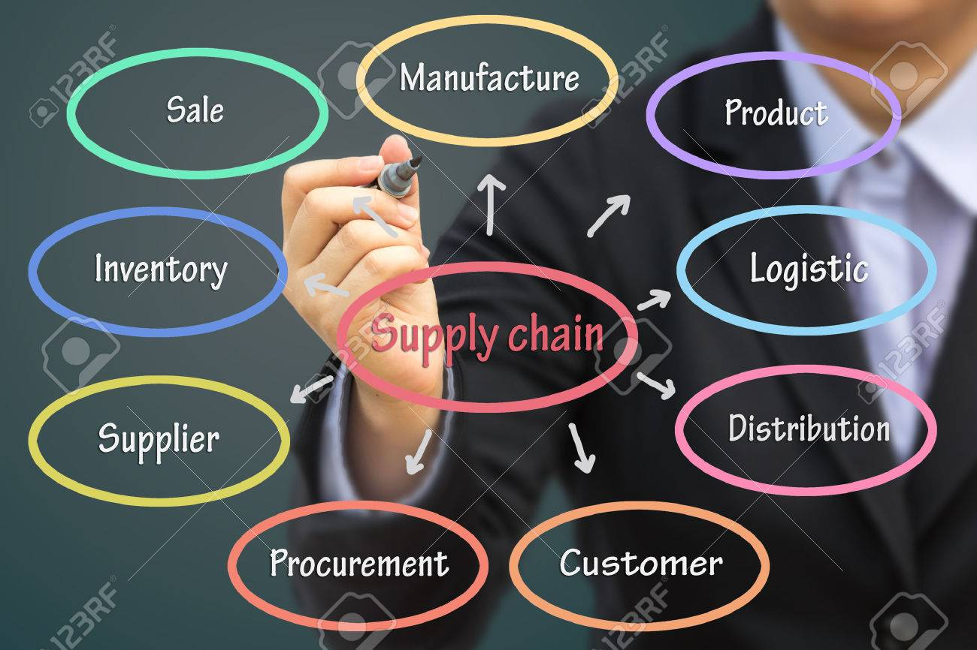

To integrate the activities of each segment of the business to optimize the system-wide strategic objectives regarding the supply chain as an entity that is composed of interdependent or interrelated subsystems, each with its own define goals, is the total system approach to supply chain management. With this inter-functional coordination, the total approach is considered a major foundation for the supply chain concept.

With the total system approach business processes involving, purchasing, production, transportation, warehousing, demand planning, and marketing are organized and coordinated to affect the best outcome and tradeoffs within them to achieve the optimal outcome for the whole system. To continue to improve the business process the total system approach should be a key implementation that creates a whole greater than the sum of its parts.

A business decision made in one function of the supply chain can impact other functions of the organization and this is what is recognized by the total system approach. This system allows the firm to assess how changes in business strategy, functions and decisions affect the firm across-the-board total cost and benefits. (Min, 2015)

**SUPPLY CHAIN MANAGEMENT VERSES LOGISTICS MANAGEMENT**

Supply Chain Management is the “integration of key business processes from end-user through original suppliers that provide products, services, and information that add value for customers and other stakeholders”. (Larson and Haldorsson, 2004). It is an integration of the main processes that manages materials and information flow in both directions until it reaches the final customer. It also includes collaboration and coordination with channeled partners

Supply chain management is based upon a set of calculated decisions and activities implemented strategies to enhance the experience of suppliers, manufactures, the warehouse, the transporters, the retailers, and the final customers. It encompasses a series of activities and organizations that allow materials and processes to move through their cycle from the initial suppliers to the customers and also manage the activities which involve sourcing and procurement.

Supply Chain Management involves the managing of the chain by coordinating and collaborating with the ones involved in the chain like suppliers, distributors, intermediaries, and customers to bring the right product, at the right time, to the right place, at the right place, and all of this with the help of logistics management.

Even though not wrong, the terms logistics and transportation are often used interchangeably as transportation is part of it but logistics is a much broader subject. Logistic Management encompasses a comprehensive that dictates and supervises various other sub-processes. Transportation of physical resources, inventory control, storage control, and procurement all fall under the logistical managerial portfolio.

Logistic management not only involves the flow of tangible resources, but also integrates, planning, goods, warehouse, warehouse security, and work-in-progress of raw materials from the point of origin to consumption, or the customer. Achieving organizational goals and keeping customers happy is the main goal of the logistical operation, which also incorporates many intricate, interdependent, and crucial business functions. (What is logistics management, 2020)

Logistics Management's main function is to fulfill customer satisfaction and is also a part of that function that is responsible for the flow of materials from the suppliers into the organization, through operations within the organization, and then to customers. It aims to create a single route for the flow of products and information in a business, that is sustainable for the businesses along the supply chain. (Logistics and Supply Chain Management: An Overview, 2021).

Logistic Management directs or drives its functions through its objectives. This logistical management process involves these main objectives, minimizing manufacturing cost, efficient flow of the operations, improving communication flow, increasing competitive edge, better inventory management, and adapting to logistics management solutions. Improving and mastering these objectives will improve the efficiency and decrease the consumption of the process and will give better insights into the logistics management process.

**THE SEMANTIC DIFFERENCES BETWEEN THE DEMAND, VALUE, AND SUPPLY CHAIN**

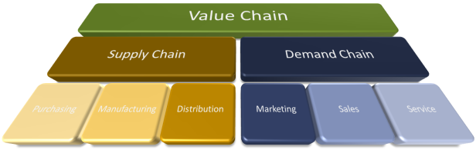

The process through which businesses receive raw materials and add value to them through, production, manufacturing, and other processes to create a finished product and then sell the finished product to customers is a representation of the value chain. The steps taken to get the product or service to the market are represented and identified by the supply chain which normally involves OEM (Original Equipment manufacturer) and after-the-market products. (Business Essentials, 2021)

All the activities undertaken by an organization or firm to generate the demands for goods and services are the inter-functionality responsibility of the demand chain. These include the departments of marketing, sales, and service. The demand chain firm endorses the process that generates the demand for its goods and services. The demand chain is initiated by the demands of the customers. Customers must be directly and successfully by demand chain activities.

The supply change which is the other half of the demand chain encompasses those activities, such as purchasing, manufacturing, and distribution undertaken by companies and people that are needed to transfer products from the suppliers to the customers. The supply chain streamlines its activities by turning natural resources, such as raw materials and components into finished products that are eventually delivered to customers. (Designing Buildings, 2021)

We can now examine the view that there are semantic differences between the value, supply, and demand chain which is the case even though their fundamental concepts and ultimate goals are customer orienteered which coordinates and establishes linkages between business activities to increase the firm strategic competitiveness. Each chain has its independent function geared towards customer satisfaction, however strategical they are interdependent of each other with the organizational goal projection of the total system approach. Based on the explanation these three terms can be established as having semantic differences. (Min, 2015).

**THE ROLE OF SUPPLY CHAIN MANAGEMENT IN CREATING AND ADDING VALUE FOR CUSTOMERS**

The sale or retail Products must not be promised by retailers that they can’t deliver and deliveries must not be promised by salespeople that they can’t deliver. There will always be a disgruntled, which can lead to the loss of many more customers when there are broken promises and late deliveries. The key to any successful product is embedded in good business ethics and practices, such as timely billing, accurate order filling, timely deliveries, and goods arriving in good condition without any defects.

Supply chain management's definitive goal is to create customer satisfaction by seamlessly coordinating all of the activities of the supply chain members, therefore making that element of the supply chain management completely customer-driven. A unique product configuration trigger by the demand from a customer allows the supply chain management to respond effectively and on time.

Many portfolios fall under the guidance of the supply chain managers, such as managing information flow through the supply chain, making channel strategy decisions, the procurement and sourcing of raw materials, processing orders, scheduling production, transportation, managing inventory, finished goods, storing supplies, and customer service activities. Coordinating the relationships between the company and its external partners such as vendors, transporters, and third-party companies is also a critical function of supply-chain management.

Supply chain management managers are responsible for the entire organizational process from start to finish which eventually ends up with customer satisfaction, due to a systematical collaboration of interdependent cooperation of all involved. Supply chain managers are more valuable to the industry today more than ever due to the critical role they play in cost control and customer satisfaction.

**THE IMPORTANCE OF SUPPLY CHAIN MANAGEMENT AS A FIELD OF STUDY**

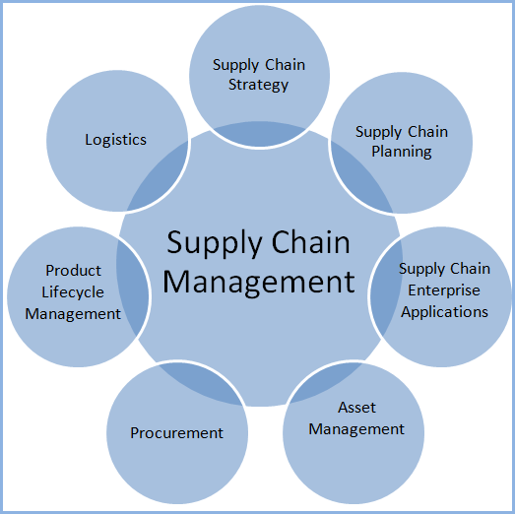

Supply chain management deals with the movement and storing of materials needed to create a product as well as managing inventory, and keeping track of finished goods from where they are to where they must go to. Supply chain management is an important part of every organization and business whether small or large and is the task of managing the activities of the supply chain to maximize customer value and achieve sustainable competitive advantage. (Vernall, 2020). It has emerged as an important activity amongst business organizations.

As depicted in the diagram above supply chain management is the central governing body that extends its tentacles to manage several processes such as supply chain strategy, supply chain planning, logistics, procurement, asset management, supply chain enterprise applications, and product lifecycle management. “Several traditional areas of business education are now incorporating the term supply chain management: purchasing, logistics, and operations”. (Websters 2008)

Supply chain management has become an important field of study in logistics and due to its embedded inter-functional nature of networking that encompasses all departments within the business organization, such as shipping, warehousing, sales, manufacturing, wholesaling, and retailing. It represents the central nervous system needed to coordinate, implement and execute, systems and processes involved in the receival of raw material through to manufacturing and eventually the end-users such as retailers and customers.

**THE DRIVING FORCE BEHIND THE SUPPLY CHAIN CONCEPT**

Supply chain management must establish a common set of goals orienteered to the supply chain partnership for successful strategic alliances that will be the major driving forces behind the supply chain linkages. The driving force behind these linkages is customer service initiatives, financial, information transactions, knowledge, product availability, response time, transactions, risk management elements, and government policies and regulations. Though difficult to examine due to its vast networking capabilities, the ultimate goal of the supply chain is customer satisfaction. (Min, 2015).

One of the main driving forces behind the supply chain concept is technology. The constant change in technology and the changing consumer preferences are forcing companies to implement multiple strategies to streamline operations across the supply chain for profit optimization. The traditional manual process has become outdated and is no longer embraced within the industry. Automation and software concepts in the supply chain are technology-driven services aimed at increasing profitability whilst ensuring continuous customer satisfaction. (The Driving Force Behind an Efficient Supply Chain is Technology, 2020).

The ultimate goal of a supply chain is customer satisfaction, though difficult to quantify. Putting into context and simplifying it, customer satisfaction is the degree to which customers are satisfied with a product and/or service received. This indicates and shows that customer service initiative is one of the driving forces behind the supply chain concept.

Another driving force behind the supply chain concept is monetary value. Monetary value can be enhanced through a supply chain by monetary value through increase sales, revenue, market share, and labor productivity while reducing expenditures, defects, and duplication. More specifically, the monetary value is an important factor behind the supply chain concept. (Principles of Supply Chain Management, 2015)

**SUPPLY CHAIN MANAGEMENT IMPACTS THE BOTTOM LINE OF THE BUSINESS ORGANIZATION**

The intricate network of operations in the supply chain management oversees each segment of a company’s product or services, from initial creation to the final sale. Many elements along the supply chain can add value through efficiencies or lost value through increased expense. Effective Supply Chain Management can increase revenues, decrease costs, which will eventually impact the company's bottom line. (Fernando, 2021).

Supply chain management-controlled dynamics leave little room for mistakes whilst welcoming efficiencies and reliability throughout the process. Plans drawn up for new businesses or lingering issues must be proactively addressed before they become unmanageable and hurt the company’s bottom line.

Several factors can affect a company’s bottom line if not managed properly. These are not limited to but include, lack of inventory management, imbalances in inventory whether too large or too small can hurt supply chain performance. Inflexible operations. The weather won’t always be good and there can be a traffic pileup. The supply chain must be able to react to these disturbances without creating a major disturbance. (6 Bottom Line Supply Chain Issues!, 2021)

**THE MAJOR CHALLENGES FOR INTEGRATING BUSINESS FUNCTIONS AND**

**INTER-ORGANIZATIONAL EFFORTS ACROSS THE SUPPLY CHAIN**

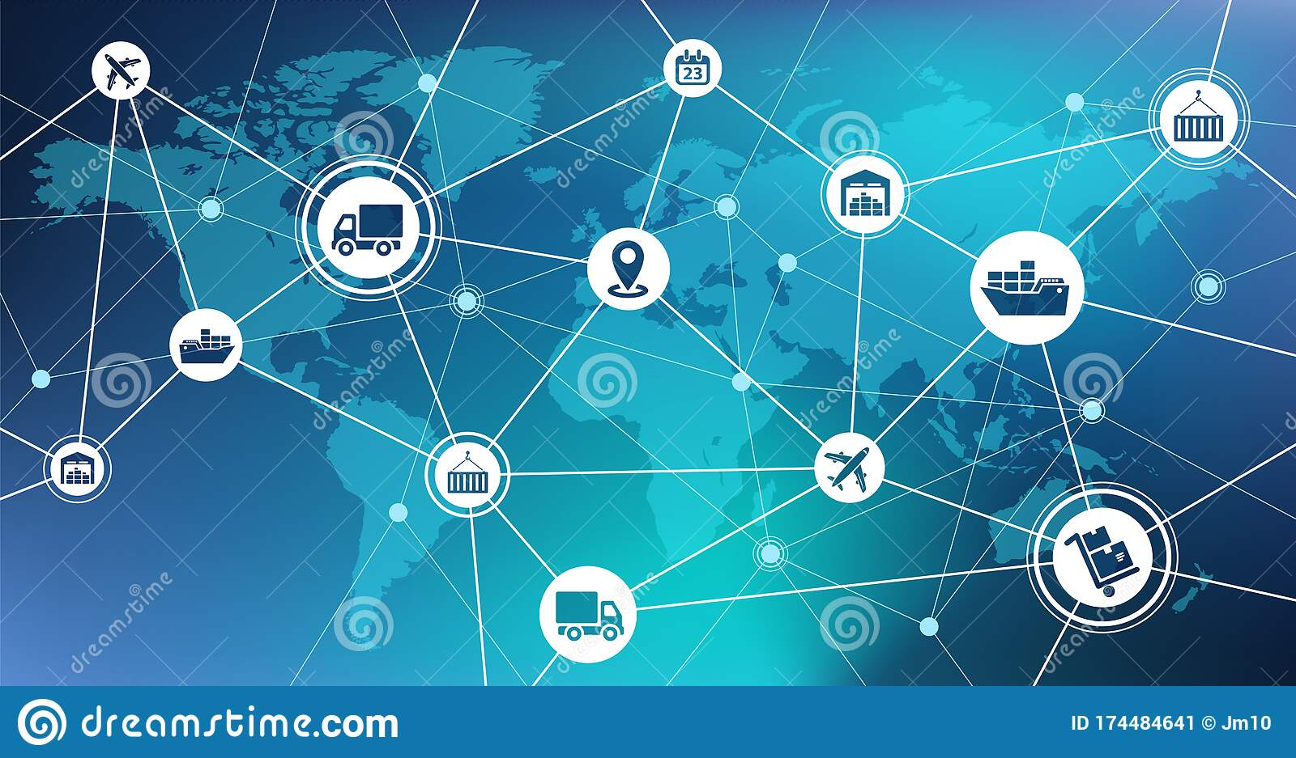

All supply chain partners are joined together in the value delivery network of a company that no one can perform better without the support of others. The ultimate objective of this cohesive relationship is to deliver value to customers and gets desired state of customer satisfaction & loyalty for the organization. For this purpose, it is necessary to integrate the internal and external partners of the Supply chain at different levels. The need for the supply chain integration is to make efficiencies, effectiveness, and accuracy in the overall operations of the company.

Integrated business functions and inter-organizational efforts will always face challenges across the supply change if these elements are not overcome. Lack of information technology and sharing, lack of trust, system incompatibility, lack of knowledge, and cost of integration The truth is that integration is challenging and requires significant work to overcome traditional barriers. (Irfan, 2014)

Less than one-third of all logistics projects are ever successful. This is due to the major challenges for integrating business functions and inter-organizational efforts across the supply chain. This means the goals developed at the beginning of the project were never met at some point. These can include, logistics reengineering efforts, facility reconfiguration, out-sourcing to third-party logistics providers, and restructuring of the transportation network.

The most obvious reason for the challenges is organizational dysfunction. The barrier for implementation of cooperation and communication was more often an inadequate organizational structure in nature. These inter-organizational efforts can include inadequate communication, improper outsourcing, improper coordination, improper planning, forecasting, and replenishment. (Frazelle E. , 2002).

**BUSINESS PROCESSES BEING INTEGRATED AMONG SUPPLY CHAIN PARTNERS**

Today’s competition is increasingly knowledged based and because of this unavoidable innovation it can be a key productive resource of the company. Because of the opportunity to grasp and embrace knowledge as a competitive differentiator, many companies that are strategically aligned to other companies across the supply chain may be interested in learning about customer needs, market forces, industry dynamics, business strategies, and technological know-how from their supply chain partners.

Organizational learning is one of the incentives for forming strategic alliances among supply chain partners. Organizational learning is defined as the unconscious or deliberate development of new knowledge that has the potential to improve organizational capabilities in the short and long run. Whatever organization learning is implemented, the effectiveness and the extent of the organizational learning may be influenced by the level of trust between partnering organizations.

Organizations in the supply chain may be unwilling to share their information without mutual trust and thus unwilling to expose their innovations and technology to their supply chain partners. Before strategic alliances can be formed, it is better to build trust amongst the supply chain partners and then exploit the opportunity to learn from each other. (Min, 2015).

Another key business process that can be used as a form of integration among supply chain partners is supplier partnership. It is the ultimate expression of supplier's integration by the sharing in profits and losses stemming from changes in materials, information, or cash flow between two organizations. This kind of partnership requires regular ongoing meetings focused on streamlining and standardizing products, information, and cash flows between the two parties. (Frazelle E. H., 2002).

**LINKING PURCHASING AND LOGISTICS**

Two functions within a company that has gained increased importance are purchasing and logistics. Fundamentally and clinically, purchasing and logistics have both contributed to the competitiveness of an organization by independently conduction value-adding activities. The potential is huge for increased benefits once a high degree of integration excits between the two functions.

Historically evidence has shown that purchasing and logistics have been working together for many years, however, the operational focus of logistics and the commercial focus of purchasing has created a tension between the two functions. It has been assessed and identified that some purchasing managers have been most committed to reducing price, while the logistics functions have had to at times deal with late deliveries and inferior quality from suppliers. (Integrating Purchasing and Logistics, 2006)

Emphasis will always be placed on the inter-functional coordination between several business functions. Finished production goods require access to raw materials, parts, and components, which triggers a set of logistic purchasing activities. The viability and quality of the incoming materials and parts obtained through purchasing often determine the quality of the finished goods for sale and distribution. Therefore it is obvious that purchasing is tied to production, marketing, and logistics. (Frazelle E. , 2002).

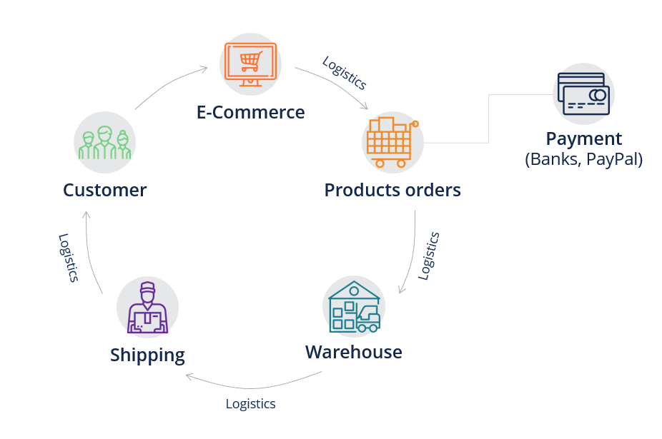

**THE LINK BETWEEN MANUFACTURING AND LOGISTICS**

Manufacturing and logistics go hand in hand. Inherently from a traditional viewpoint of manufactures reveals many flaws in the efficiencies of standard shipping, transportation, and other logistics process. Materials are received inbound by manufacturers and products sent outbound to the customers whilst keeping in mind that logistics is the forward and reverse flow of goods and services to retailers, businesses, and consumers.

Manufacturers are now starting to incorporate logistics in their manufacturing operations to reduce transportation and fuel cost. Some will outsource to a logistic provider to be to concentrate on their manufacturing operations. This will decrease the shipping cost by outsourcing to third-party logistics providers. With this option, manufacturers can eliminate costs such as payroll, taxes, and workers comp insurance.

The efficiencies of manufacturing and logistics are the ability to eliminate the cost of operational processes and operations which span across an entire organization. The efficiency and effectiveness of the current operation must be assessed by the manufacturers which should effectively through a logistic management program increase revenue, reduce cost structure, improve the cost structure of shipping processes, reduce cost in transportation management, and increase customer service and satisfaction. (Manufacturing and Logistics: Manufacturers Look towards Logistics Efficiency to Stay Competitive, 2016).

**IDENTIFYING AND SELECTING THE RIGHT SUPPLY CHAIN PARTNER**

For the integration of business functions and activities, some businesses have made a conscious effort to form alliances or partnerships with other businesses. This type of partnership is a voluntary relationship between two or more organizations that are formed based on the mutual needs of these independent organizations without being constrained by ownership, control, equity investment, or legal ramifications.

In identifying and selecting the right supply chain partner should be done with a strategic view of increasing the business market position in the present market and bringing credibility to the business, which should be beneficial to all parties in the alliance. Forming these alliances would identify partners that could generate and substantiate a long-term contract, being equally beneficial to the business partnership. Each being in a strategic location beneficial to the distribution, inventory, and storage of products.

The supply chain partnership must create trust and establish ambiguous commitments, clear communications, and responsibilities. Corporate cultural differences and lack of strategic fit between two companies will create an atmosphere of mistrust and lead to the dissolve of the supply chain partnership. To mitigate these risks and challenges firms entering into strategic partnerships must examine and identify the type of partnership they are forming, what kind of role each partner should play, and how they should manage the partnership. (Min, 2015).

**THE POTENTIAL BARRIERS TO FORMING THE SUPPLY CHAIN PARTNERS**

Despite the numerous benefits of forming a supply chain partnership, inter-organizational alliances have been plagued by Ambiguities in response to the level of commitment or responsibilities from each partner. These initial barriers will invite other barriers to form the supply chain partnership.

Other potential barriers in deterring the supply chain partnership are the lack of mutual trust between partners and the subsequent lack of information sharing, imbalances in channel sharing, power and risk-sharing, and differences in organizational and strategic focus.

“For example, GM and the now-defunct Korean automaker Daewoo signed a deal in 1999 that would help GM’s effort to double its share of sales in the Asian market to 10% in five years while helping Daewoo bring in much-needed capital and radically streamlining its sprawling global production operations. In addition, this alliance was intended to help GM gain access to “cheap” labor in Korea, while it allowed Daewoo to gain access to GM’s “superior” engineering skills and an entry into the U.S. auto market. Unfortunately, this alliance failed mainly due to corporate cultural differences and a lack of strategic fit between the two companies—Daewoo was known for its aggressive market expansion strategy whereas GM was in the process of downsizing its production capacity. To make matters worse, labor in Korea was no longer cheap, owing to rapid economic growth and the presence of a strong labor union, thus causing an unexpected cost increase in this alliance’s Korean operations”. (Min, 2015).

**BUSINESS PROCESSES THAT LINK THROUGHOUT THE SUPPLY CHAIN**

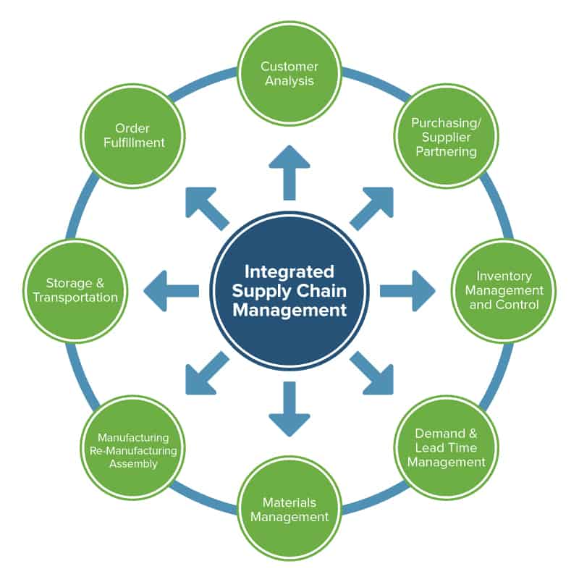

The entire supply chain acquires business processes that link throughout the organization. This is to say that we will consider the organization of the activities within the logistics, which encompasses customer response and satisfaction, inventory management, supply, transportation, and warehousing. These unique activities within the supply chain call for tailored management approaches.

Customer responses are clinically unique to the logistic activities of the supply chain as this is where most customers communication takes place. The customer communication interface goes a long way in determining customer overall satisfaction levels. Customers have always increasingly appreciated dedicated and personal responses to their issues, carried out by individuals or groups of individuals who are familiar with their concerns.

Inventory investment aligned with inventory management and its availability is crucial and critical to the overall success of the supply chain logistics-oriented enterprise. The inventory management organizational activity is crucial to the success of the organization as a whole within the inventory management activity. The tradeoff in inventory management are many, varied, and are oftentimes counter-productive. There will always be a dual objective in inventory management, which is maximizing service levels and minimizing inventory investment.

The satisfaction of the customer service policy is the responsibility of the inventory management organization which is to establish inventory targets throughout the supply chain. The supply organization is responsible for acquiring the inventory that will meet the target levels established in the inventory plan, within the response time requirements of the customer service policy, at the quality levels established by the quality organization, and at the lowest possible total acquisition cost. Suppliers' choices including their location, and their system/logistics capabilities have major impacts on total logistics costs, inventory investment, and customer satisfaction.

Before any other day in recent memory, the transportation industry and the transportation activity within the most major enterprise are stressed beyond comprehension. Lack of strategic planning and organizational development within transportation companies to delays in the delivery of goods to the customer. Transportation has become the least developed acquisition within the transportation companies. Transportation management remains will always be transparent to the public, customers, and internal organizations, making it an added valued activity.

Significant savings in freight payments can be achieved if the purchase and negotiation of transportation services are consolidated across inbound/outbound transportation activities within a business unit, across business units, and even with noncompetitors servicing similar markets.

The plight of a warehouse manager is not much better and if not worse than the plight of a transportation manager. The warehouse manager’s role has risen to critical levels within the management structure due to the resulting fact that he/she is required to execute more transactions, in less time, with more items, with less margin for error, and with less skilled labor. In the face of e-commerce, the supporting information system is lacking in the warehouse workforces. Warehouse activities have become more and more complex over the years due to the demand being placed on the supply chain organization to stock, maintain, and formalize the inventory process. (Frazelle E. , 2002)

**BENEFITS OF THE SUPPLY CHAIN PARTNERSHIP**



The supply chain partnership is one of the most talked-about business topics today. Dynamic collaboration has been identified as being important in improving supply chain performance. Supply chain collaboration can share organizational functions such as large investments, pool risks, share resources, and returns on investment. Collaboration due to its dynamic positive capabilities can be referred to as the driving force behind effective supply chain management to include risk-sharing and complementary sharing of resources.

The operational context through which the supply chain partnership operates formalizes the competitive advantages and benefits to be derived such as premium pricing, competitive pricing, improved value to customer quality, faster dependable delivery, and product innovation. These benefits extend beyond improved efficiency and effectiveness to include helping all the supply chain members meet customer demands, grow markets, and increase competitive market share.

The supply chain partnership has always been seen as a new necessary strategy for businesses to create a competitive advantage. It can increase joint competitive advantage, ease of information sharing, and synchronization of the decision-making process. These advantage capabilities will lead to the enhancement of the overall performance of the organization through the supply chain partnership. (Mathuramaytha, 2011).

**THEORY OF CONSTRAINTS (TOC). HOW IS IT RELATED TO SUPPLY CHAIN MANAGEMENT, AND HOW IT CAN HELP TO MANAGE THE SUPPLY CHAIN BETTER**

The effectiveness and the efficiency of the supply chain link can dictate the strength of the supply chain partnership and the ultimate success of the supply chain. Maximizing the benefits of the supply chain collaboration should be done with a mythological view of the supply chain partners to uncover weak links in the partnership and prevent variation in the logistic operation and supply chain performances. Theory of Constraints (TOC) has been seen as one of the ways to accomplish this optimization. A constraint is anything in an organization that hampers the organization’s progress or increased throughput.

It is based on the principle that every profit-making organization must have at least one constraint that limits the organization from getting more of what it strives for thus consequently determining the output of the manufacturing process. The inability or failure to manage this constraint can lead to a significant decline in productivity at all levels. The Theory of Constraint would protect against variability at the constraint and ensure the continuous improvement of the supply chain process.

To examine and consider the usefulness of TOC thinking to the supply chain management, the supply chain partners may consider optimizing the following factors within the process: Identification of the weakest link in the supply chain, extracting effectively and efficiently the greatest benefit out of the weakest link (TOC) without committing to potentially expensive changes, applying whatever measure is needed to illuminate the constraint, and once the constraint is controlled, broken, or illuminated, look for other constraints to continuously improve the supply chain performance. (Principles of Supply Chain Management, 2015).

We can now see that the variables surrounding TOC are critical to the operation of the organization through supply chain management as it will be clinically helpful in the optimization of the internal and external processes thus providing continuously improved performance in the organization. Organizations operating with the TOC factory will expose themselves to negative conditions and variables that will eventually lead to inconsistencies in their operation hence leading to a deterioration in customer's services and satisfaction.

**PREPARING FOR CHANGES IN BUSINESS PRACTICES BY TAKING THE SUPPLY CHAIN INITIATIVE**

Changes from the traditional business practices in the supply chain require traumatic changes in the organizational structure, cultures, and business strategies. Without managing these changes effectively can and will lead to degrading employee morale, frequent bottlenecks, and increased resistance to supply chain transformation. Without a proper change of management in the supply, chain transformation will defeat the purpose of the supply chain initiative.

The changes that must be sought after and challenge the status quo encompassing a change of the management transformation will include, unfreezing, tossing out old ideas and habits, while preparing for the change. Changing the management structure which initiates a new system or major process transformation and creates a team to facilitate the needed transformation throughout the organization.

Following up on the implementation of the unfreezing and changing process, the refreezing of the management process would involve practicing what was implemented, learned, and accepted by the main management team and the impacted organizational units. This will also require feedback from all the stakeholders included affected employees. The supply chain initiative implies a visionary picture of the future with some implicit or explicit commentary on what people should strive for to create that future. (Min, 2015).

**THE SUPPLY CHAIN MAP OF MY ORGANIZATION**

**International providers of four 40ft egg containers**

**Two containers sent to old habour hatchery**

**Two containers sent to Linstead hatchery**

**Young Chicken Farmers**

**Young Chicken Farmers**

**Young Chicken Farmers**

**Young Chicken Farmers**

**Young Chicken Farmers.**

**Arnold road cold storage facility**

**St. Anns Bay cold storage facility**

**Mature chickens transported to the chicken processing factory**

**Freetown cold storage facility**

**The frozen birds are then distributed to customers throughout the country. Both wholesalers and retailers**

**CONCLUSION**

Supply chain management is more than just a fad and is made up of many diffident disciplines and syllabus. It’s an integrated network of the key business process being independent of each other while working interdependently for the optimization of the supply chain while utilizing the total systems approach. The effective and efficient managing of the supply chain will be determined by its ability or inability to incorporate all factors of the supply chain systems and manage them in such a clinical way for customer satisfaction.

The appreciation and insight to the logistics and supply chain management concept are and must not be interpreted as a stand-alone educational value. History has proven and shown that logistics and supply chain management systems, such as software optimization, physical and non-physical infrastructure, systems, and processes have evolved to incorporate the improvement and fine-tuning through the various combination of applied inter-organizational coordination.

This identifies the need for constant education to keep up with the organizational changes both physical and non-physical. We must continue to educate ourselves through reading, attending logistics meetings, supply chain seminars, joining logistics and supply chain organizations, and continuing to read accessible materials to continue to improve our knowledge in the logistics and supply chain management field.

In taking this opportunity to reiterate what I’ve expressed in my previous assignments, through knowledge that has been gained in this course, I've visioned the possibility of improving the supply chain infrastructure within the company I’m presently working for. Ideas have been visioned on how to improve the brand, customer input, project vision, employee morales, how to improve on the present logistics and supply chain systems. A plan has already been formulated on how to implement these visions once given the opportunity by the management team of my company.

**BIBLIOGRAPHY**

*6 Bottom Line Supply Chain Issues!* (2021, November 4). Retrieved from https://supplychaingamechanger.com: https://supplychaingamechanger.com/6-supply-chain-issues-that-hurt-your-bottom-line/

*Business Essentials*. (2021, August 02). Retrieved from investopedia.com: https://www.investopedia.com/ask/answers/043015/what-difference-between-value-chain-and-supply-chain.asp

*Designing Buildings*. (2021, February 20). Retrieved from designingbuildings.co.uk: https://www.designingbuildings.co.uk/wiki/Demand_chain

Fernando, J. (2021, October 19). *Supply Chain Management*. Retrieved from https://www.investopedia.com: https://www.investopedia.com/terms/s/scm.asp

Frazelle, E. (2002). Supply Chain Strategy. In M. Hill, *Supply Chain Strategy* (pp. 311-312).

Frazelle, E. H. (2002). *Supply Chain Strategy.* Logistics Management Library.

*https://opentextbc.ca/*. (n.d.). Retrieved from INTRODUCTION TO BUSINESS-Distributing and Promoting Products and Services: https://opentextbc.ca/businessopenstax/chapter/using-supply-chain-management-to-increase-efficiency-and-customer-satisfaction/

*Integrating Purchasing and Logistics*. (2006, May 16). Retrieved from https://www.diva-portal.org: https://www.diva-portal.org/smash/get/diva2:207173/FULLTEXT01.pdf

Irfan, M. (2014, December). *Levels & Barriers to Supply Chain Integration: a Conceptual Model of Supply Chain Performance*. Retrieved from https://researchleap.com: https://researchleap.com/levels-barriers-to-supply-chain-integration-a-conceptual-model-of-supply-chain-performance/

*Logistics and Supply Chain Management: An Overview*. (2021, May). Retrieved from Researchgate.net: https://www.researchgate.net/publication/335871510_Logistics_and_Supply_Chain_Management_An_Overview

*Manufacturing and Logistics: Manufacturers Look towards Logistics Efficiency to Stay Competitive*. (2016, February 03). Retrieved from https://www.globaltranz.com: https://www.globaltranz.com/manufacturing-and-logistics/

Mathuramaytha, C. (2011). Supply Chain Collaboration – What’s an outcome? A Theoretical Model. , Burapha University, Thailand, Thailand.

Min, H. (2015). *The Essentials of Supply Chain Management.* Paul Boger.

*Principles of Supply Chain Management*. (2015, June 25). Retrieved from https://www.informit.com: https://www.informit.com/articles/article.aspx?p=2359420&seqNum=5

*The Driving Force Behind an Efficient Supply Chain is Technology*. (2020, June 19). Retrieved from https://www.dispatchtrack.com: https://www.dispatchtrack.com/blog/driving-force-efficient-supply-chain

Vernall, M. (2020, August 10). *Why has supply chain management emerged as a field of important study and practice?* Retrieved from https://www.quora.com: https://www.quora.com/Why-has-supply-chain-management-emerged-as-a-field-of-important-study-and-practice

*What is logistics management*? (2020, February 25). Retrieved from to-increase.com: https://www.to-increase.com/business-productivity/blog/what-is-logistics-management