Michael Tracey
UB75036BSU84213

COURSE NAME:
(Bachelors in Logistics and Supply Chain Management)

Assignment Title:
(Transportation Planning)

ATLANTIC INTERNATIONAL UNIVERSITY
March/2022

TABLE OF CONTENTS

CONTENT PAGES

Cover Page 1

Table of Contents 2-5

The Importance of Transportation in our daily Lives &
The National Economy 6-7
Different Forms of Transportation Carriers-Pros & Cons 7-9
Factors to Consider when choosing a carrier-Which of these
Factors should be weighed more than others? 10-11

Discuss the pros and cons of the different modes of
transportation 11-13

Which factors have accelerated the evolution of the
Intermodal transportation 13-14

What are the benefits of intermodal transportation? 15-16
How would you estimate the total transportation cost?
What comprises transportation costs? What are hidden
Transportation cost elements (such as accessorial charges)?
Develop a detailed worksheet for transportation cost elements. 16-18

Who are the major transportation agencies? Explain the specific
Roles of each transportation agency. 18-22

Discuss the history of transportation regulations in the
The United States. 22-23

What are the impacts of transportation deregulation on the
Transportation industry? How did the transportation reforms
Reshape the transportation industry and alter transportation
Practices? Who are the proponents or the opponents of
Transportation deregulation? 23-26

Explain how class and commodity rates are determined. 26-27

What is a bill of lading(B/L)? Why is it needed? 27-28

How can you improve transportation productivity? 28-29
How has information technology been used by carriers as
Means of improving their productivity? Which information
Technology is popular among the carriers? 30

What are the most viable transportation strategies in times
Of world financial crisis? How do you come up with the “blue
Ocean strategy” for transportation carriers? 31-32

What are the potential measures that would help enhance
Transportation security and safety? Discuss how 9/11 impacts
The importance of transportation security and safety. Also,
Discuss how the transportation industry can act as a security
In case of supply chain disruptions. 32-35

How do you file freight claims when there are in-transit loss
And damage? What are the proper steps to take for filing a
Freight claim? 36-37

Under what conditions could mergers/acquisitions in the
The transportation industry be considered successful in improving
Transportation efficiency? 38

Identify the major sources of truck driver turnover and asses
Their importance on transportation productivity. Also, discuss
Ways to reduce truck driver turnover. 39-40

Discuss the role of a Transportation Management System in
Enhancing transportation productivity. Also, explain the key
The functionality of TMS. What are the selected criteria for TMS
Software? What are the challenges for implementing TMS and
Integrating it with other supply chain execution systems such
Enterprise Resource Planning(ERP) and Warehouse Management Systems(WMS)?. 41-42

What impact did the oils spills in the Gulf Coast and Alaska have
On the transportation industry? 43-44

What factors have driven motor carriers out of the trucking
Business? What have caused high trucking failures for the
Last decade? 45-46

Why did many airlines offer discriminator pricing on airfare? 47-48

Estimate the price sensitivity of airline passengers. 48-49

Discuss ways to increase the profitability of the fiercely
Competitive U.S airline industry. 49-50

Why do transportation carriers expand their business scope?
(For example, many trucking firms began to offer warehousing
Or third part logistics services in addition to their traditional
Trucking services). 50-51

What are the environmental implications of transportation
Activities? How can we reduce the carbon footprint resulting
From transportation activities? 52-53

Conclusion 53-54

Bibliography 56-58

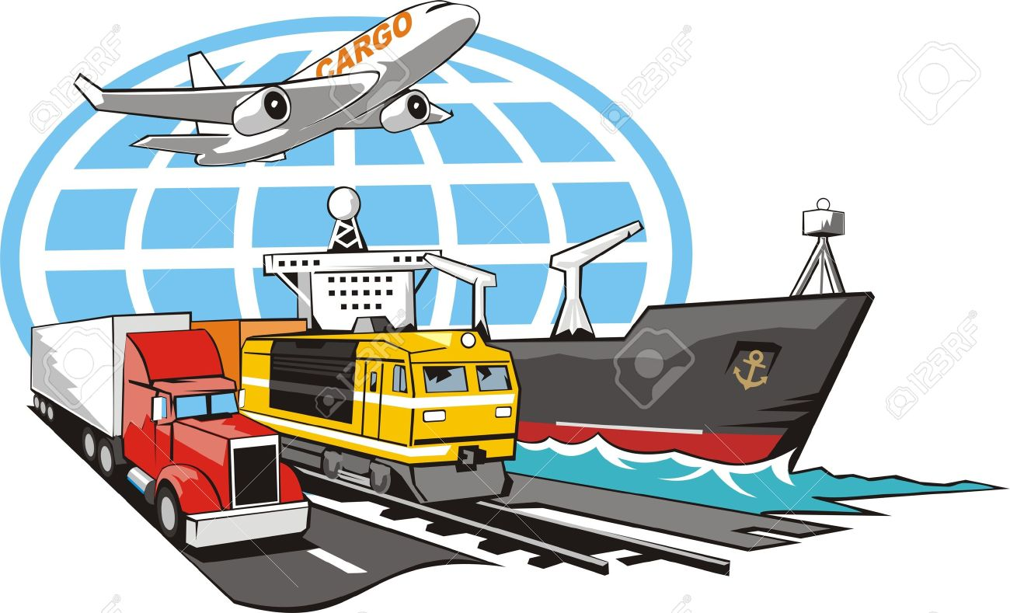
The Importance of Transportation in our Daily Lives & National Economy
From the dawn of civilization and existence, humans have sought to traverse the earth and move to new locations, whether by land, sea, or air. The evolution of transportation has brought us from simple canoes to space travel. (Nguyen, 2020) The means of carrying people as well as goods and animals from one location to another is the literal concept of transportation. (Bhasin, 2020)
Transportation started with the use of donkeys, wooden carts, bulls, and horses which were exclusively used in the earlier stages of transportation. With increased modernization, we saw numerous inventions taking place which resulted in the invention of cars, buses, trucks, spacecraft, helicopters, submarines, trains, ships, and airplanes taking the place of earlier transportation. With these variations of transportation methods available to the world, millions if not billions of goods services, and people are moved all around the world.
Economically and in our everyday daily lives transportation is of the utmost importance as it enables us to trade, commerce, and communicate in our established civilization. Traffic flow with the use of transportation if managed properly will allow steady and undisturbed movement from one place to another. Transportation is the vital link between, manufacturing facilities, consumer markets, and technological-based business. It is also a critical component of our everyday lives, and without effective and affordable transportation it becomes impossible for any kind of movement from one place to another.
Everything and anything that you can think of can become crippled and create a devastating effect without the use of transportation. It is an all-important factor of all the nations in peace times and war and at every stage of civilization in the world. Transportation helps in economic development, allowing human beings to garner natural resources and materialistic goods to satisfy the needs and wants in their everyday lives. The world market is now linked due to the evolution and modernization due to advanced transportation possibilities.
Transportation offers numerous opportunities, by allowing ordinary people to transverse their country or other countries in search of a better job. It helps in social development as new laws have been discovered and have been utilized to gain optimal benefits. It helps in industrial and agricultural development as farming machines and seeds and fertilizers can be transported all over the world for the better growth of the economy. In the world market transportation is the key critical factor in the development and growth of business organizations by moving resources, raw materials, equipment, goods, and services in the reach of the consumers on time. (Bhasin, 2020)

Different Forms of Transportation Carriers-Pros & Cons
Transportation success starts with carrier management which is vital to the supply chain because it directly affects a company’s logistic cost and the subsequent bottom line. Setting appropriate prices for transportation services and meeting the customer service needs is the primary task of carrier management. Carrier management is vast and encompasses many different responsibilities, such as carrier/modal selection, carrier route/scheduling, dispatching, staffing, pick-up/delivery arrangements, financing, rate negotiations, documentation, shipment tracking, claims tracking, carrier safety, and billing payment. One of the most important issues to tackle is carrier selection, therefore carrier management is complex by nature. (Min, 2015)
LTL CARRIER – LTL Carrier collects freight from (100 to 100,000 lbs) from various shippers and consolidates that freight onto enclosed trailers for line-haul to delivery terminal or to a hub terminal where the freight will be further sorted and consolidated for additional line haul. (Min, 2015). This carrier method is used for the transportation of small freight or when the freight doesn’t require the use of an entire trailer.
The benefits that can be derived from this type of carrier shipping is the overall reduction in cost as you will only pay for the portion of the trailer that your goods occupy, increase security as shipments are packaged onto a pallet before being loaded onto a truck, and being on a pallet offers it more security than other items packed in smaller groups, tracking as this will allow the tracking of the shipment with a bill of laden number or shipment reference number to give you an idea when your shipment will arrive.
The disadvantage to this type of carrier shipping is that you will have increased cost due to the distance required to deliver the goods, the dimension and weight of the shipment will determine the freight class which will directly affect the shipment rates, the shipment might require special handling or equipment, such as perishable items, fragile, hazardous items, which will lead to higher costs. When utilizing the LTL carrier you must make sure the shipping company receives the right measurement of the package, that the bill of laden information is correct to avoid delays and labeling is placed where it is easily identified. (Robinson, n.d.)
Parcel Carrier – Packages that are below 150lbs and can be lifted without assistance are normally handled by parcel shipping. These packages are smaller than other shipment items and require little or no palettization. With parcel shipping, multiple items can be shipped in larger volumes and be lifted without help. Due to the higher volume, it offers parcel shipping offers a cost advantage and is an economical choice if you are sending a few smaller lightweight packages. Another benefit to using a parcel carrier is the on-time scheduling of pickups. This method also allows you to drop off your packages at a business place other than your home address to prevent delivery personnel from knowing where you live.
Even with its benefits parcel shipping has its disadvantages. Parcel shipping normally carries a higher risk because of lost or damaged packages due to size. It also requires more checkpoints and possible transfer of these packages to another location unknown to the shipper which can lead to a higher delivery cost. Parcel shipping at times doesn’t palletize the packages which can cause damages to delicate items, such as wooden and glass items being shipped. (Robinson, n.d.)
TL CARRIER – This type of carrier moves freight load into semi-trailer which is typically between 26 and 53 feet which therefore requires a substantial amount of freight to make such transportation economical. TL carriers transport freight at an average rate of 47 miles per hour keeping in mind traffic jams and queues at intersections. It’s beneficial to customers that require the space of a whole truckload to deliver their goods, which allows the freight to be time-sensitive. This means that your carrier will not be making any stops to pick up or drop off any other loads along the way. This makes truckload shipping a more reliable option for shippers with hard delivery times or special handling needs.
This transportation method allows the weight to be more cost-sensitive and allows room for price negotiations. TL delivery times are often accurate and fast due to the shipment traveling on only one truck to one destination. This shipment method decreases the chances of damages to the shipment goods due to less handling of the freight than those with multiple stops. TL loads are more rationally used when the freight weighs more than 15,000lbs or the company has more than 10 pallets worth of goods to transport.
One of the disadvantages derived from this transportation method is that you will have to pay for the unused space in the truck or trailer if your shipment does not occupy the entire truck/trailer. TL shipment the maximum size of the load will be limited by the dimensions and carrying capacity of the truck and costs can vary from carrier to carrier and the costs are quite often dictated by the market structure with no assistance from regulatory bodies. (Full Truckload vs. Less-than-Truckload Shipping: Which is Right for You?, n.d.)

Factors to Consider When choosing a carrier-Which of those factors Should be Weighed more than the others
The process of selecting the right carrier is by choosing the right transportation service provider that best meets the shipper’s service needs and requirements. The criteria fitting proper carrier selection are to minimize transportation cost, minimize in-transit inventories, and minimize transit variabilities. The overall structure of carrier selection was based on three basic yet significant criteria, cost, time, accessibility, and dependability. These criteria only head the extended set of criteria that falls beneath them. (Min, 2015)
In transportation strategic planning, carrier selection is one of the most important decisions because it affects both logistics costs and customer service. The decision process should incorporate all the factors in the chain, including transportation, inventory, and facility costs, and also some qualitative criteria like customer service since the entire chain will be affected by carrier selection. Market trends such as shrinking capacity, tightening cost structures, and the growing importance of environmental friendliness all will be shown to play a significant role in this decision-making process. (Teimoury, 2008)
In weighing the factors that affect the carrier selection as mentioned above, the most important factor crucial to carrier selection would be cost. Managers are always interested in making sure that they leverage transportation costs in line with spending to the highest extent possible. Keeping cost to a minimum is at the top if not the near top of most business industries when choosing a carrier. The bottom line which is the cost is what keeps the business afloat.
To grow and to stay tough in a competitive environment, a business must always remain focused on increasing profitability. Every avenue must be looked at to cut costs, and always transportation will be one of the first functional areas where companies look for dollars, spendable cash. Transportation cost will always be one of the primary factors in making a carrier selection. Managers make this factor a priority on their list when meeting with business partners or having internal meetings. Given the current market conditions, it has proven to be difficult, specific to transportation to continue reducing costs while adapting to growing volumes and shrinking capacity.
Companies are now looking at how they can shave costs away from transportation and improve their bottom line. However, the importance of cutting costs has been challenged by a multitude of other factors affecting transportation selection. (Roberts, 200)

Discuss the Pros and Cons of the Different Modes of Transportation
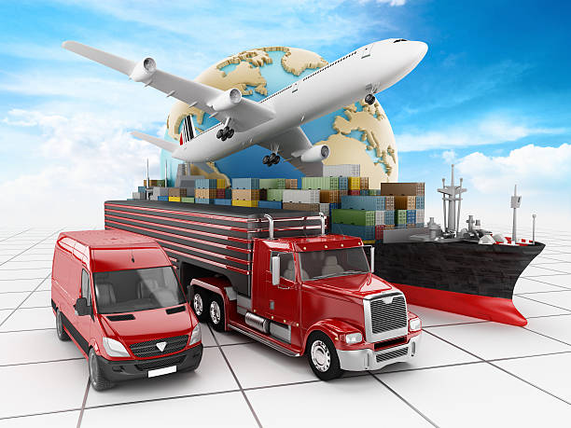
Demand for surface freight transportation has risen steadily over the past two decades and the forecast shows continuous growth at least over the next several decades despite the recent economic downturn. Surface transportation modes such as trucks and railways continue to capture a large portion of the domestic freight market which is measured in tons per mile. (Min, 2015) Different modes of transportation are used by logistics providers to move goods. Such modes include rail, road, sea, and air transport. All of these modes have pros and cons, in terms of safety, speed, reliability, and risk of damages.
Rail Transport – Examining other options rail freights has many benefits over other transportation options. One is that’s it’s a cost-effective solution for long-distance transit. Because rail transportation emits 77 percent less than road freight, it is classified as a green logistics solution. In bad weather such as snowfall or heavy rain. The disadvantages are that delays may occur depending on the country of departure, transit route, and country of arrival. Rail freight is sometimes avoided by logistics service providers because of inflexibility, and the fact that schedule departures and routes cannot be changed to meet the requirements of the customer.
Road Transportation – Multiple benefits are derived from road transportation, such as speed, flexibility, and the possibility to track shipments, packages, and their progress. With road transportation, goods are shipped at points of convenience and as scheduled, making road transportation a flexible option and having the added benefit of being a cost-effective solution for short distances compared to railroads. Additionally, it has a door to door delivery options for customers who benefit from shipment tracking. The downside to this mode of transportation is that the cargo is often targeted by thieves, and if not properly secure, packages can be damaged on it’s way to delivery. Wheather can also be a negative factor to rod transportation when there are heavy rains and snowfall that can cause delays due to the blocking or flooding of roads. (Pros and Cons of Different Types of Freight Transport, 2019)
Sea Transport - A key benefit to sea transportation is that it is hardly ever affected by weather conditions, which makes it a dependable transportation option. Additional benefits that sea transportation offers are cost, capacity to ship large quantities, port infrastructure, and the ability to carry large heavy cargo, and large volumes of bulk commodities. Water carriers are typically far more fuel-efficient and consequentially more environmentally friendly than other modes of transportation. Furthermore, water carriers are free from any traffic congestion unlike road transportation such as trucks. The disadvantage is that sea transportation will take a longer time to reach its destination due to the slow speed of travel and the involvement of local, state, and federal governments in promoting and subsidizing water carriers. Additional disadvantages are the dependency of inland waterways on locks and dams, and the increased environmental concerns over dredged materials extracted from inland waterways.
Air Transportation – Air carriers have not been heavily used for freight transportation, but instead primarily used for passenger transportation. When it comes to the fast shipment of time-sensitive or valuable orders or receipt of a critical component for your production, an air carrier may be the best mode of transportation. (Min, 2015). Air transportation offers safe and fast transport of fragile and high-cost goods, on service regular services, and physical barriers such as lakes and mountains. Air transportation also offers fast delivery of goods which reduces warehouse costs. The main disadvantage to this type of carrier service is that it is costly when compared to sea transportation. Another downside is that airplanes have a limited carry capacity compared to ships, which makes sea freight a preferred choice for shipping oversize cargo. Air transportation is less reliable in bad weather when flights often get delayed, which normally doesn’t affect sea transportation. (Pros and Cons of Different Types of Freight Transport, 2019)

Which factors have accelerated the evolution of intermodal transportation?
Because of the shortcomings of each mode, an effort was made to make up for that shortcoming of each mode of transportation without separating each. This saw the birth of intermodalism, which involved the transportation of cargo or passengers using mixed multiple modes of transportation without separating each. Intermodalism is the transportation of cargo or passengers using multiple modes under a single freight bill. With Intermodalism, shippers can use rail for long-hauls and then switch to trucks for shorter distances at either end of the trip. The combination of trucks and rails is not limited to a mix of intermodalism. Several factors led to and accelerated the evolution of intermodalism. (Min, 2015)
Intermodal shipping goes back as far as the 1780s. Intermodal shipping was not considered a very practical approach when transporting cargo. During the 1780s coal had to be transported in bulk in containers called loose boxes or tubs and were transported by horse-drawn carriages and shipping crafts. Once the train system came into existence, iron or wooden containers were attached to the train cars for a new mode of travel. However, this technique or mode of transportation was not preferred in the 1800s.
Intermodal transportation of cargo was not considered a practical approach until World War 2 when U.S Military troops used intermodal pallets to transport their equipment and ammunition in bulk. The need for intermodal transportation was soon recognized and in the 1950s a proper standard shipping container was designed for intermodal transportation purposes. Containerized intermodalism transportation now plays a crucial role in sustaining the world’s economy and makes trading possible between countries that are far off and makes it also cost-effective.
It has gone to show that a few decades ago there was the non-existence of cargo containers therefore there was the non-recognition of intermodalism. The transportation of goods was done in sacks, crates, and barrels, with its history stretching as far back as 3000BC. Horses were used for the inland transportation of goods and longer distances, ships, and boats were used. The idea of piling containers on top of one another came about in the 18TH century and in the 19TH-century intermodalism transportation came about and thus gave birth to intermodal shipping containers.
The dawn and the birth of intermodal shipping containers came into existence by the legendary Malcolm McLean in 1956. Born in 1914 in the state of North Carolina Malcolm contemplated on how to make the transportation of cargo much more effective and efficient with the loading and off-loading of cargo. This was when inspiration struck him, and he had the brilliant idea to create a standard-sized unit that could be loaded on marine transport mediums, as well as land transport. In the 1960s, intermodal shipping containers had become the ideal way for shipping freight all around the world. This called for the standardization of cargo containers of sizes and categories of weight across international boundaries.
With intermodal transportation revolutionized, shipping containers had become the ideal way for shipping containers all around the world. This revolution now called for the standardization of cargo containers of sizes and categories of weight across international boundaries. Shipping costs plummeted, and it became inexpensive to produce goods in another corner of the world. Containerization has revolutionized ports, rail networks, ships, and countries all over the world as transportation has become cheap, being a cost-saving measure for the consumer and customer. (The Evolution of Intermodal Transportation and Intermodal Container, 2021)

What are the benefits of intermodal transportation?
The movement of freight using two or more modes of transportation from the shipper to the consignee refers to intermodal transportation. Standardize intermodal containers that can seamlessly be transferred among different modes such as ships, trucks, and rail are used to transport freight. There are two types of intermodal shipments, domestic shipments that utilize the 53FT container for inland intermodal shipping and international shipping that uses the 20FT or 40 FT containers. Internation intermodal containers can be interchanged between, ships, trucks, and rails, however, the domestic intermodal containers can only interchange between rails and trucks, they do not get loaded onto ships. Intermodal transportation offer certain benefits to intermodal transportation that helps shippers improve their entire transportation process efficiency, The advantages are:
- Reduced Cost- Intermodal can offer considerable cost savings due to the railroad being used for land transportation, which is dependent upon the length of the haul and the distance of the shipper.
- Lower Fuel Cost- Rail is utilized for freight transportation over land, therefore this makes it the most fuel-efficient of land transportation, which amounts to lower fuel costs.
- Lower Handling Charges- Goods do not leave the container until they reach their destination with intermodal transportation, this translates to lesser handling, and, consequently, lesser handling charges.
- Increased Cost Efficiency- Intermodal transportation uses the rail, therefore the cost per ton of moving freight is reduced, thus increasing cost-efficiency.
- Greater Access to Capacity- Massive amount of capacity is involved with intermodal transportation, especially on high-volume freight lanes. It can offer a significant advantage in capacity in times of tight truck capacity or driver shortages.
- Increased Safety- Increased safety advantages are created in intermodal transportation by reducing the chances of theft, accidents, or damages. Theft is reduced because the rail is used for a majority of the land journey with intermodal transportation. Further advantages are, the train will constantly be moving during delivery, the load is always being monitored by someone, heightened security at times is placed by the intermodal transportation in line with the sensitive nature of the cargo. In addition constant security at the railroad docks and yards.
- Sustainability- The use of rail in intermodal gives it sustainability advantages in terms of high fuel efficiency, high freight efficiency, and reduced environmental impact, which is a sustainable way to transport freight using intermodal transportation. Rail is a more efficient form of land transportation, unlike trucks rail Is more freight efficient, and by using rail ease to the amount of carbon dioxide released to the atmosphere is decreased. (Magill, n.d.)

How would you estimate total transportation costs? What comprises transportation costs? What are hidden transportation cost elements (such as accessorial charges)? Develop a detailed worksheet for transportation cost elements.

Early in the 1980s, transportation or freight rate was often determined by a fixed rate published by rate bureaus. Transportation price structures were eventually deregulated and this provided room for and facilitated more competition among the carriers and provided greater flexibility because of this change. Since the deregulation transportation prices have become more dynamic and complicated.
A dimensional shipping weight or volume, the form of cargo, the mode of transportation, accessorial charges, and the quality of service in terms of speed, accessibility, reliability, frequency, rhythm, and punctuality all play an important role in transportation price and the estimated total transportation cost. The distance, the weight, and the class that categorizes the type of cargo are among the most dominant price factors. (Min, 2015)
To first understand and elaborate on what compromises transportation cost, we first have to look at the tariffs that are contained by fixed prices. The tariffs include rate classifications, numbers assigned to different shipments based on their handling characteristics, passenger fare table, route guides, and so forth. These tariffs are known as rate tariffs and supporting tariffs.
This type of classification will affect and compromise transportation costs, such as freight characteristics, which encompasses trade conditions, competition with other commodities transported, the quality offered as a single consignment, and the value of service required. By measuring shipping weight per cubic foot and the value per pound is attributed to the transportation density as another factor that compromises the transportation cost. Liability, as measured by value per pound, susceptibility to theft, liability to damage, perishability, the propensity to damage other freight with which it is shipped, and propensity to spontaneous combustion or explosion.
Excessive weight and length of the cargo for transport is attributed to stowability which is also associated with one of the factors contributing to transportation cost being compromised. The extent of handling including loading and unloading, which includes special care and attention necessary to handle goods will affect the overall transportation cost. (Min, 2015)
Additional charges can be incurred during inland transportation of materials, equipment, or perishable goods. Understanding the nature of accessorial charges and when your shipment is likely to arrive will allow you to better predict your shipment's final cost. Accessorial charges come in many forms and impact all the modes of freight transportation services. These fees can be quite contentious because they are the fee that has a direct impact on the shipper’s bottom line.
Some of these charges are in transit delivery charges, which are common and typically occur when a delivery window is missed, administrative charges when there is an error with the Bill of Laden, layovers or redelivery charges when a shipment was never picked up or does not make it to its final destination during it’s slated window, this will cause a layover and it will have to be redelivered, and detention charge when a shipment is held up at either the initial or final destination.
Freight accessorial fee will be added to the shipper's invoice upfront once it is determined. Accessorial fees can also be added at the time of billing. Accessorial fee most often occurs when the shipment is not planned properly and effectively. (Robinson, What is a freight accessorial?, n.d.)

Who are major transportation agencies? Explain the specific roles of each transportation agency.
FEDEX
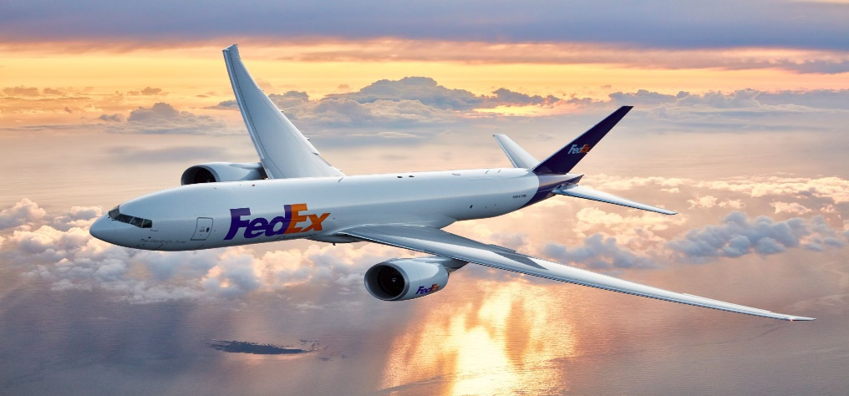
In 1965, Yale’s University undergraduate Fredrick W. Smith saw the logistical problems facing pioneering firms in the information technology industry wrote a paper that invented an industry that changed the way packages were delivered logistically. He created a system specifically designed to accommodate time-sensitive shipments such as medicine, computer parts, and electronics. After a brief stint in the military in 1971 Smith bought a controlling interest in Arkansas Aviation sales.
With the opportunity to operate his new firm Smith saw how hard it was for packages and other air freight to be delivered within one to two days. This difficulty in freight delivery time brought to life ant the birth of the company we know today as FEDEX. The FedEx company has revolutionized global business practices and that now defines speed and reliability. The company's headquarters was later moved to Memphis, Tennessee, as this was chosen as a strategic central location within the USA.
The official operation of the FedEx company started in 1973 with 389 team members. FedEx's status eventually became the premier carrier of high-priority goods in the marketplace and lead to setting the standards for the express shipping industry it established. The air cargo deregulation that was lobbied for in 1977 assisted the FedEx company as it allowed FedEx to acquire large aircrafts such as Boeing 727s, and McDonnell-Douglas DC10s, which led to rapid growth in the shipping industry. Today FedEx Express has the world’s largest all-cargo air fleet, including Boeing 777s, 767s, 757s, MD-11s, and Airbus A-300s and A-310s.
During its operation as a logistical giant delivering packages all over the world, FedEx acquired several other businesses along the way. One such business was Tiger International Inc, acquired in 1989. The acquisition boosted its fleet of planes and routes to 21 countries throughout the world as Tigers Expertise in International Airfreight.
After adopting the official FedEx name and brand in 1994 it became the sole U.S.A-based all-cargo carrier with aviation rights to the world's most populous nations. With its giant logistical arms, FedEx has continued to expand into what is now an unsurpassed network, delivering to customers in more than 220 countries and territories. FedEx utilizes logistically, land, sea, and air transportation carriers to provide reliable delivery service to its customers all around the world, by adjusting its operations to meet the size of the cargo regardless of the size.
FedEx through its subsidiaries offers small package ground services, by centralizing, sales, marketing, customer service, and information technology support for FedEx Express. With this, it has started the process of transforming its technology and delivery service into a portfolio of shipping and business solutions. The many acquisitions by FedEx complemented an alliance with the U.S postal service providing customers in the e-commerce and catalog segments with a proven, cost-effective solution for low-weight time residential shipments.
With its inception in the 1970s and today in the modern era, FedEx has worked to make international shipping as easy as possible for customers who want to connect with the global opportunity in the global market. FedEx trade networks now FedEx Logistics is one of North America's largest volume customs entry filers and a leader in international ocean and air freight forwarding and trade facility. With global trade at more than 18 Trillion, and projected worldwide growth continuing to increase, FedEx has continued to transform its business to better align and provide better service to its customers. (FedEx history, n.d.)
DHL
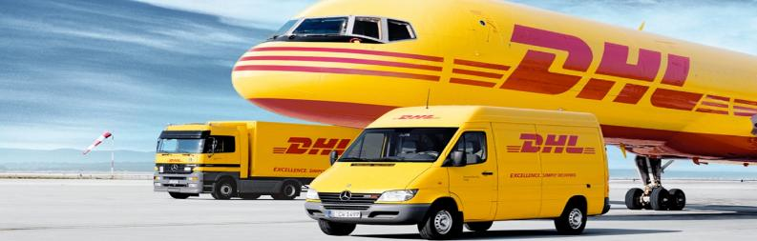
DHL is the acronym for the original founders' Sir names, Dasley, Hillblom, and Lynn. DHL is a German logistics company, providing courier, package delivery, and express mail service to customers all over the world. 1.6 Billion parcels are delivered every year, making DHL Express the market leader for parcel service in Europe and Germany's main courier and parcel service.
The DHL company was founded in San Fransisco, United States in 1969, and by the late seventies it had expanded its services throughout the world. By 1983 the company was primarily interested in offshore and intercontinental deliveries but the success of FedEx prompted DHL's domestic expansion. In the 1970s DHL became an international delivery company and tapped into the domestic market that was extremely profitable and wore the title of the third-largest logistics company behind FedEx and UPS. (DHL, 2022)
DHL offers worldwide services including parcel deliveries to countries throughout the world, such as Iraq, Afghanistan, and Myanmar. DHL uses its logistics service to connect people and enable the flow of goods and trade to every corner of the world. DHL is the logistical specialist for delivering global events all around the world. They are dedicated to offering innovative solutions for complex logistical challenges in the sports, arts, and culture arenas. DHL is no longer allowed to make domestic flights between U.S airports. These services are contracted out to other logistic service providers. (DHL, 2022)

UPS

Two teenage entrepreneurs in 1970 created what would become the world's largest package delivery service. Starting with a $100 loan, Claude Ryan and Jim Casey opened the American Messenger Company in a Seattle Basement. Its first expansion was made beyond Seattle and California in 1919 when the name United Parcel Service was born. Its first expansion in the East Coast Metropolitan New York City was done in 1930, where it moved its cooperate office from Los Angeles to 331 East 38TH Street, in New York City.
In 1953 UPS began common carrier operations, serving commercial and residential shippers to major east coast and west coast shippers. UPS offers next-day air delivery services for packages and cargo to local shippers in the 48 contiguous states. Having a vision and becoming a true enabler of global commerce UPS has tapped into the logistic field with a variety of logistical operations to meet the customer's needs. By the end of the decade, UPS was operating all over the West Coast.
By entering the retail business and acquiring Mail Boxes Etc, UPS became the world's largest franchiser of retail shipping, postal and business service centers. Due to this acquisition UPS was able to offer lower UPS-direct shipping rates. UPS has made and concreted its name in the logistics industry by offering Saturday drop off and Saturday pick up of packages which gives it a competitive edge over its business rivals. (More than 100 years of innovation, n.d.)
UPS is known for its ground shipping services and makes it possible for any person to send a letter, package, or parcel to any addressee in the same country or abroad, with the expectation that it will be conveyed according to certain established standards of regularity, speed, and security. UPS's main aim is to provide for the collection, transport, and delivery of letters throughout a country. (Lewis, n.d.)

Discuss the history of transportation regulation in the United States.
In 1966 the Department of Transportation Act predicated in large part of Congress findings that America required the development of national transportation policies and programs conducive to the provision of fast, safe, efficient, and convenient transportation at the lowest cost consistent therein. With different agencies regulating different modes of transportation, an effort by the different regulatory bodies to work with each other had become excessively complicated and inefficient, therefore President Johnson aimed to phase out independent agencys' authority.
The act implemented says it necessary to establish the new agency to make easier the development and improvement of coordinated transportation service to be provided by private enterprises to the greatest extent feasible, and provide general leadership in identifying and solving transportation problems. Before the transportation deregulation, a lot of transportation policy was being made by three independent regulatory agencies, the Interstate Commerce Commission, the Civil Aeronautics Board, and the Federal Maritime Commission.
Many wanted the term “Deregulation” taken out of the proposed transportation bill, however, in 1966 President Johnson explained that he would not alter the regulatory functions of the independent agencies. This led to the Department of Transportation Act being passed within a matter of months, however, deregulation would not happen for a dozen more years. Alan Boyd was nominated as President Johnson's first Secretary of Transportation and he took up office on April 01ST, 1967, and initiated a more rational approach to the regulation of the transportation industry. (Shane, n.d.)
Transportation had a lasting impact on the nation's economy, which saw the Federal Government getting deeply involved in transportation activities. Through the regulatory acts, the government was able to dictate and control some of the transportation activities which saw many reforms being established.
During the nineteenth century the transportation industry, especially the railroads were heavily regulated. This continued into the late twentieth century, allowing the transportation industry to mature and saw the need for the government not to involve itself in the transportation industry. Several landmark reforms were established during the deregulation era including the Airline Deregulation Act of 1978, the Motor Carrier Act of 1980, the Staggers Rail Act of 1980, and the Shipping Act of 1984. Dramatically, these reforms altered transportation practices by providing transportation carriers with a lot more freedom to enter/exit the market and set transportation prices. (Min, 2015)

What are the impacts of transportation deregulation on the transportation industry? How did transportation reforms reshape the transportation industry and alter transportation practices? Who are the proponents or the opponents of transportation deregulation?
The transportation acts regulated by reforms saw greater freedom of entry into the industries, greater freedom of entry into, and exit from a particular market, and greater freedom of individual rate making. This significantly increased the influence of the market on prices charged for air and truck services, and the profitability of the individual carriers. The regulatory reforms bill was passed as it aimed to increase completion among the carriers in the industry which would lead to more efficient operations and lower rates in the industries while not compromising safety, or seriously compromising the quality of service. It has been estimated that regulatory reforms have brought significant logistical benefits to shippers.
The impact of deregulation on the industry is that it brought about $16 Billion annual benefits in the current dollar term, however, it has been shown that deregulation has reduced the profitability of the largest trucking firms. Deregulation brought on the hazards of travel and increased significantly the fear of airline passengers to travel and the uneasiness of the automobile users. Even though many were against it, many saw that the deregulation of the airlines would increase competition and help reduce the cost of airfares. However, this did not come without consequences as safety and the quality of service came into question. The reduction of comfort in traveling has been reduced due to the deregulation reforms implemented in the industry. (Shane, n.d.)
Deregulation of the transportation industry also brought about less control of entry requirements for carriers, increased the number of motor carriers, rate, and service flexibility as deep discounting became a practice among many carriers. Labor conflicts increased in the aftermath due to merges and bankruptcies. Contract carriers became increasingly utilized due to allowances for special individual contracts between carriers and shippers. Freight consolidation throughout was started to be used by several freight carriers. Piggyback and do-it-yourself transportation became popular.
Carriers tried to find their niches in the transportation market to survive in the competitive market due to unstable carrier earnings. Transportation cost savings became the top priority for many struggling carriers at the expense of deteriorated service quality. Also, the safety, maintenance, and age of carriers received less attention than before deregulation due to mounting cost pressures. To save labor costs, many carriers began to employ a “two-tier” wage system, where new employees earned less in a given work category. Labor unions began to lose their footing in the industry. (Min, 2015)
In 1956 President Dwight Eisenhower signed the Federal-Aid Highway Act, creating the Interstate Highway Program, the largest public works program in our nation’s history. But today, a decade after the completion of this vast network of highways, the country’s transportation policy is languishing. The result has been the literal transformation of American life. The reform of the transportation industry brought on many challenges, such as traffic congestion, worsened air quality leading to serious health concerns. This has led to poor roads in both the urban and metropolitan areas, and many of the urban bridges are rated structurally deficient or functionally obsolete.
Congress has further laid out that the present metropolitan transportation infrastructure must be maintained and that the states need to attend to the needs of their metropolitan areas. Emphasis was placed on system rehabilitation, maintenance, improved operations, and alternative transportation development. This would backed by the law allow the state departments to make decisions on transportation, even though local governments with metropolitan areas own and maintained the vast majority of the transportation infrastructure.
The current approach to the transportation system was found to be narrowed and outmoded. The new reforms encouraged the use of market mechanisms such as the use of toll roads, and congestion pricing to ease congestions on major thoroughfares during peak hours. The reforms also led to the examining of the financial aspect of the transportation system which saw legislators in congress debating on the taxes that should be assigned at the gas pumps in each state as there was much confusion as to how the gas tax is to be added to the pumps on each state. It has been undoubtedly argued that user fees remain the most promising way to promote equity and efficiency in transportation finance.
Transportation reforms were not limited to only, metropolitan and rural variables but also transportation accessibility of working families and the elderly. The transportation reform debated and allowed for the implementation of policies and procedures to provide attention and safety to these road users. But in the end, it was the transformation reform strategies interventions that no doubtlessly enhanced the geographic access to employment.
Further reform will not come easily to the transportation sector. The deficiencies in transportation policies and practices are deeply rooted, in constituency and money politics, state governance, and the history of metropolitan development. Transformation reform in the U.S.A must be reviewed and supported if the nation is going to have livable communities, competitive economies, a healthy environment, and fiscal responsibility. The country faces multiple transportation challenges that will not be resolved by pouring more and more money into an already broken system. Systemic reform is needed and probably will only happen if transportation policy is vigorously debated in the public realm. Worldwide, transportation reform is too important to get the silent treatment. (Puentes, n.d.)
Transportation draws more attention from the Federal Government than any other logistics function due to the heavy influence of transportation on the national defense, the national economy, and the daily lives of the American people. Based on the previous statement it can be argued that the opposition to the deregulation of the transportation system would be the federal government. This shows that the federal government is deeply involved in transportation affairs and has extensively controlled transportation activities. Furthermore, this ensures that neither transportation carriers nor shippers are free to operate without the intervention of the government.
It aims to ensure that adequate transportation services are provided to any potential users and protect those users from excessive prices, unfair practices, and focuses on correcting market imperfections, safety enhancement, and environmental practices. The most well-documented interventions are transportation regulations that set many ground rules for transportation activities and then control both economic and safety issues associated with transportation activities. (Min, 2015)

Explain how class and commodity rates are determined
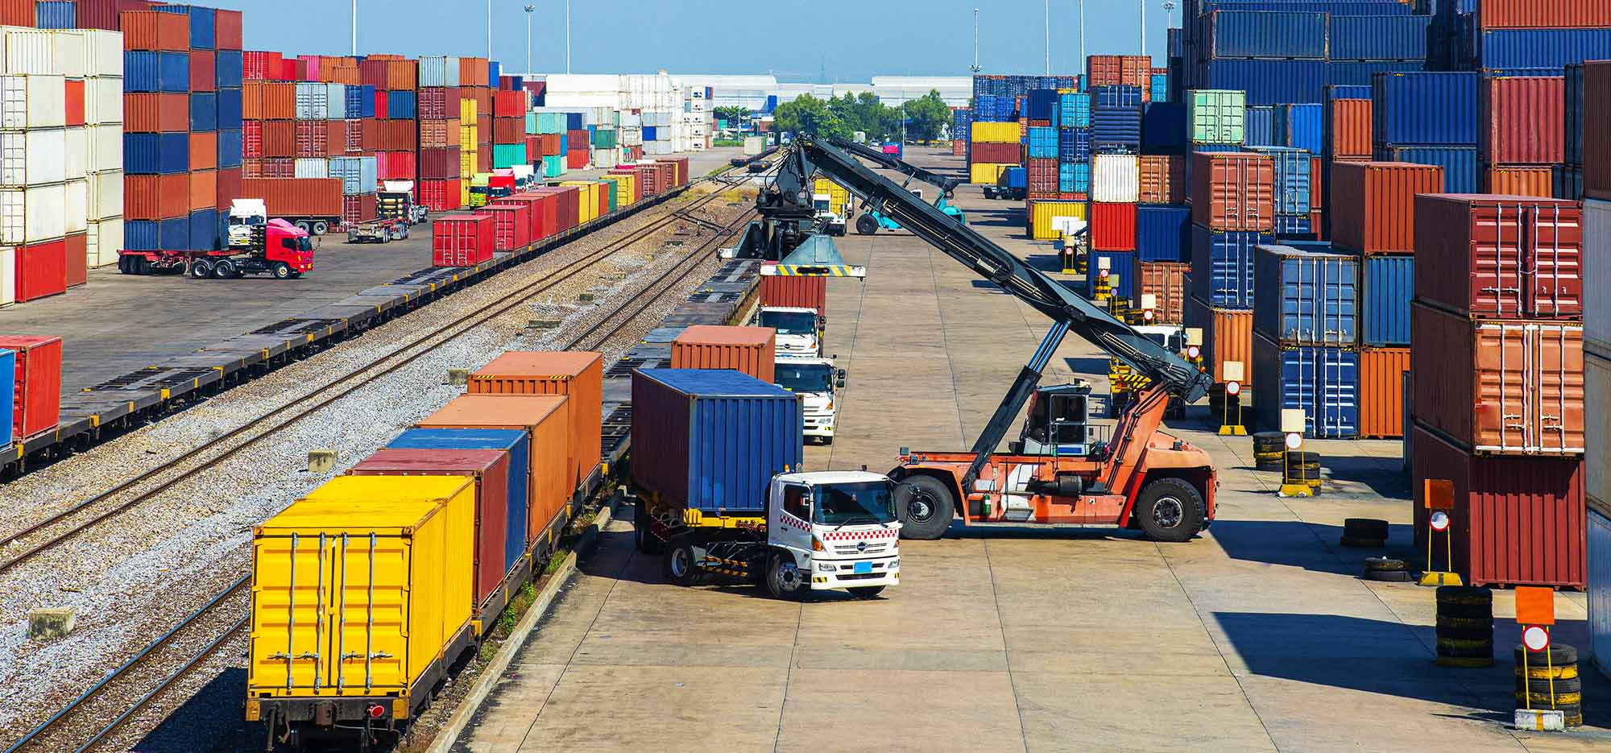
Within the shipping industry, the freight class is a standardized operation. Uniform parameters are established for price classification and are also used for commerce between multiple brokers, warehouses, and carriers. There are a range of factors that affect rate charges, including, ease of handling, value, weight, length, height, density, and liability. This system helps to facilitate a smooth and productive freight rate, negotiations, and logistics.
Freight class classification is necessary comparative simplification and evaluation of the billions of different products annually shipped within today's globally competitive market. Freight class describes a commodity’s overall transportability. The four main conditions that affect transportability as discussed earlier are density ease of handling, liability, and stowability. Products being shipped on a single pallet do not all share liability and density values, nor do they necessarily require equal handling and stowing efforts, and therefore, must be priced differently. Stowability involves freight that cannot be loaded with other packages such as certain hazardous materials, freight that is particularly massive, or that protrudes in a fixed inconvenient direction.
Other market factors such as distance and volume may also affect how your freight is classified. Density in the shipping industry is defined as the space an item occupies concerning its weight. Depending on the type of handling such as manual lifting or the requirement for machine lifting such as a forklift will affect your rate charge and warrant a change in rate classification. Liability will also be an important factor in and rate commodity classification due to the possibility of theft or accidental damage and carrying perishable goods and dangerous chemicals.
There are beneficial advantages for shippers and carriers alike to partner with 3PL (Third-party logistics providers) who care enough to know precisely what it is you are shipping. Being made aware of the exact commodity could inform and influence package decisions which help to influence freight class classification. Smart packaging could mean a lower, and therefore more cost-effective freight class, thus saving you from potential damages, and in turn costs. (https://www.cafworldwide.com, 2018)

What is a bill of lading (B/L)? Why is it needed?
Transportation carriers often haul valuable goods, the movements and transfer of these goods should be traced and documented properly. Before and after shipment various documents are needed to verify the acceptance and receipt of the goods and clarify the owners of these goods. Among these documents is a document called a “Bill of Lading” which is one of the most important documents.
The “B/L” as it is called is the document issued to a consignor, shipper by a carrier listing and acknowledging that specified goods have been received on board as cargo as a conveyance to a specific destination for delivery to a consignee in that destination. Other typical shipping documents could include, a carriers’ certificate, delivery receipts, freight bills, shipping manifest, shipper’s declaration for dangerous goods, and shippers certification for live animals, including other documents for possible freight claims which all are part of the shipping process.
Bill of lading is classified into four different categories, straight consignment bill of lading is used for already paid for goods, is non-negotiable, contains terms of the sale, including time/place of the title transfer, and on the presentation of identification under the B/L a carrier can deliver it’s shipment to a consignee. Order of bill of lading is typically used in letter of credit transactions where goods have not been paid for in advance and are negotiable. Ownership of goods under this B/L can be transferred from one party to another by the signature (endorsement) and delivery of this B/L.
Under the bearer of the bill of lading, delivery will be made to whomever holds the bill of lading which is also negotiable. The surrender bill of laden does not pay the bank until the maturity of the draft under the relative credit. Depending on the transportation mode being used, a B/L can be further subclassified into in-land B/L, ocean B/L, through B/L, or airway B/L. (Min, 2015)

How can you improve transportation productivity?
America needs to start directing traffic. More than $150 Billion is spent each year by the public sector on transportation and more money is forecast to be spent on the battered infrastructure in the coming years. A clear-cut vision is needed in transportation for the nation and should make sure all those billions of dollars help to achieve the economic and environmental goals. This is evident with the border crossings, crucial to the nation’s exports, are chronically congested, and not much effort is being made to unblock them.
For the servicing of the American economy, transportation needs to be put at the forefront. Efforts must be made to coordinate the private and public sectors, to make it easier to move freight, by finding ways to cut carbon emissions, integrate new technologies into daily commutes, and connect workers to jobs that are far away from their homes. Smarter alternatives can be explored, such as rerouting flights instead of building new airports. The country needs to become more export-oriented for the future health of the economy.
There’s a duplication of efforts and a duplication of subsidies that hurts the economy given scarce resources without an overall strategy. Collaboration between the federal government, states, metro areas, freight industries, and shippers is needed. A comprehensive plan is needed that identifies the best ways to help the flow of freight. The plan should include identifying the most important corridors for freight, such as targeting investments to improve safety, relieve bottlenecks, and provide better access to ports.
To further improve the productivity of transportation the government could look at building new roads leading to the ports or, in some instances, truck-only lanes on existing roads. In collaboration for better transportation, U.S, Mexico, and Canada could come together to study the infrastructure needed at the land borders and along the corridors that link the two borders together.
In Detroit for example, the U.S government and Canada with lawmakers in Michigan and Toronto are trying to build a new bridge across the Detroit River to help keep trade flowing. In as much the World Trade Bridge in Laredo Texas has introduced tags for electronic toll collection to speed traffic and reduce waiting times. Another milestone to be accomplished is the use of electric vehicles to cut down on carbon emissions, which would make these vehicles environmental friendly.
There is tremendous technology available to the government that could help make transportation smoother and more efficient. Traffic signals that are centrally controlled by a computer can optimize the flow of traffic. Electronic toll-collection tags let drivers pay without stopping. Changeable signs can provide information about the next bus or train, or rough traffic conditions ahead. Freeway-management centers can spot roadway incidents, dispatch service vehicles to clear accidents, and get traffic moving again.
By using the ideas listed above transportation productivity can be improved through the collaboration of the government bodies responsible for reviewing, maintaining, and developing the transportation infrastructure. Financing should be a crucial part of the government's plan to mobilize and utilize all the necessary resources to have this be a reality in now and future generations. (Puentes R. , 2011)

How has information technology been used by carriers as means of improving their productivity? Which information technology is popular among the carriers?
A growing need for streamlining all the areas of the transportation operations, identifying any cost-saving opportunities, and elevating supply chain visibility through transparent transportation planning became evident with the mounting transportation costs resulting from unstable fuel prices and higher labor costs. To counter this unstable factor in transportation a “Transportation Management System” that fits the bill for such a need was introduced.
TMS as it’s called is a software application that helps to manage all aspects of inbound and outbound transportation activities including, order processing, load planning, carrier selection, vehicle routing/scheduling, freight consolidation, claims management, freight bill payment, and auditing.
The capabilities of the TMS application software have been expanded to include the use of real-time asset management, yard management, event management with shipment tracking, shipping demand forecasting, palettization, import/export documentation, multimodal operations, hazardous materials transportation, reverse logistics, and performance management. These functions make up the heart of the TMS application software has become an integral tool in the operation of the transportation industry.
The most popular information technology used by the transportation carriers in today's era is “E-Commerce”. E-commerce compromises both business-to-consumer and business-to-business operations and transactions. E-commerce is mostly used today to research vendor and product information on websites on the internet. E-commerce since its inception has gained some important crucial benefits over the years including, improved productivity, improved quality, improved customer service, reduced cost, shortened supply chain, faster product development, access to new markets, and improved cash flow.
All of these benefits will allow the transportation industry to collaborate with the shippers in increasing customer savings while providing better quality service through innovations aligned with the information technology market. (Googlesir, 2020)
What are the most viable transportation strategies in times of worldwide financial crisis? How do you come up with a “blue-ocean” strategy for transportation carriers?
Shippers are continuing to navigate the challenges of the worldwide pandemic, and many are finding that the strategies they used to deal with past supply chain disruptions are not the same ones needed to be successful in today’s marketplace. Savvy shippers developed transportation strategies that are successful now and will protect them in times of future disruptions come rain or shine while they wait for the pandemic to blow over.
In exploring the most viable transportation strategies in times of worldwide financial crisis, shippers developed relationships with key carriers while also looking at ways to create capacity, shifting modes, analyzing routes to reduce empty miles, and even adding private fleets or turning to dedicated contract carriage providers. Shippers have to become strategic in all aspects of managing their supply chain including their approach to carrier relationships.
Shippers are also being impacted financially, budgeting for freight across all modes is more challenging than in the past, especially regarding offshore sourcing, however, many have developed strategies to be successful even in turbulent times. Many shippers are finding alternative suppliers in different geographies by building and strengthening partnerships with a variety of supply chain partners. Some look to stock more in-house products or at the vendor to have it more readily accessible in case of another disruption.
Some have utilized the Transportation management System for outbound and inbound LTL shipments and by finding the best carriers to match its network needs, however, it becomes clear that while transportation technology is important and necessary, it becomes clear that you cannot purchase a high-value asset, human beings the same way you buy staplers. Having a solid relationship involving communication is necessary to be put in place well before a crisis of any kind should occur. Shippers should now look at immediate ways to challenge and find ways to improve all aspects of its supply chain, including questioning past practices and thinking. (Transportation Strategies: Weathering the Storm, 2021)
Focusing on shifting from existing markets to new opportunities to move to a smarter future should become a campaign for better transportation. This type of strategic thinking is an example of the blue ocean strategy for transportation. Focusing on creating demand and a new market rather than competing with the existing market is a concept of the blue-ocean strategy for those industries not in existence today. Blue oceans could come from changes in the boundaries of existing industries or the creation of a new industry.
Innovations, such as the smart ticket system, are the driving force behind the creation of new markets and in how the products or services are made attractive and pleasing to customers this evidentially leads to new demand being created in a new marketplace rather than contested in the existing one. Some examples of blue-ocean strategy disrupters are Ford, by displacing the horse-drawn carriages and creating an entirely new mass market for cars. With the development of smart transport and the future of mobility as a new market, space could be created that harnesses technological innovations, there are parallels to consider.
Blue-ocean strategy for the transportation industry should be focusing on fostering technological advancements and innovations, and not be overly concerned about how these are being brought to the market. Businesses should be free to create the product or service in a way that will appeal to consumers and define a new market space for themselves. They should have the freedom to create the blue oceans that will transform our transport system into a more sustainable one. (Shirley, 2020)

What are potential measures that would help enhance transportation security and safety? Discuss how 9/11 impacts the importance of transportation security and safety. Also, discuss how the transportation industry can work as a security buffer in case of supply chain disruptions.
Since there happen to be more passengers in one car, public transportation poses a higher risk of safety and security. Because of the lack of integrated approaches, the problem becomes worst in developing countries. The understanding and awareness of the user, including the driver, is the most important variable to improve transportation safety and security.
The study of safety and security in the transportation industry has been very limited, especially in developing countries. Approximately one million road accident fatalities and ten million people are injured annually, many with long-term disabilities. Safety and security aspect in transportation is very important, as public transportation is closely associated with human lives on a larger scale as many passengers happen to be riding in one car.
The existence of public transportation is a key to solving the problems. High capital intensive and low capital intensive are two options to overcome these problems. Improvement to the transportation system should be conducted using existing resources to solve the problems at a low cost. The existing urban transportation modes' performance needs to improve. The presence of Police, lighting, and visible monitoring of the sector is a productive start to transportation safety and security.
To enhance the safety and security in the transportation industry, such as funding for road safety education, several other factors can be implemented such as road safety education for children, research into road safety, traffic regulations, Traffic policing and law enforcement, and training and testing for drivers. The action plan to tackle transportation and safety should compromise a wide range of initiatives to include the sector in formulating a plan. The strategic goal concerning safety and security is to promote public health and safety by working toward the elimination of transit-related deaths, injuries, property damage, and the improvement of personal security and property protection. The resulting goal is the success in achieving the safety and security goal, which will be measured by the following goals, namely a) reducing the number of transportation-related fatalities, injuries, and incidents; and b) reducing the vulnerability of the transit infrastructure to consequences of intentional harm to the system, its employees and its users. (Kubota, 2006)
The Transportation Security Act, TSA was created to safeguard the United States against another 9/11-type attack by strengthening the security of our Nation’s transportation systems while also ensuring freedom of movement for people and commerce. The agency was created to oversee security in all modes of transportation, but aviation security was at the forefront of the Nation’s mind after the 9/11 attack. ATSA, (Aviation and Transportation Security Act), required TSA to deploy federal security screeners to inspect airline passengers, their baggage, and air cargo, which uses state of the art technologies to screen passengers, baggage, and air cargo; expanded the Federal Air Marshal Service, and required reinforced cockpit doors among many things designed to enhance transportation security.
One hundred percent air cargo screening was required on passenger aircraft departing the country. The usage of canines increased, enhanced public security, and improve the security of passengers, cargo, cockpits, cabins, surface transportation, and foreign airports. TSA works closely with transportation, law enforcement, intelligent partners to set international standards for transportation security. It also relies on intelligence to develop and implement its approach to security.
TSA is known best for its aviation policies, however. It also plays a key role in protecting the nation's surface transportation, including, passenger rail, freight rail, highway and motor carrier, pipeline, and maritime. Front line screening officers have been employed to help with the screen of all and anyone traveling locally and internationally. They include federal air marshalls, inspectors, canine handlers, and vetting personnel.
In addition to new and improved screening technologies, TSA also investing in biometric technology, which adds an important layer to its security procedures. Biometrics is a powerful tool, such as to improve identity verification performance, but must be used carefully and with the utmost respect and safeguarding of passenger privacy. It also uses facial recognition technology that compares the live image of a passenger with the image on the passenger's photo Id. Along with biometrics development, digital credentials, such as mobile driver’s licenses and digital passports, are becoming increasingly common. Mobile driver’s license technology can enable a more seamless airport security screening experience for travelers.
These security and safety measures are explored and used to pursue innovative solutions that will help to enhance security ann transportation safety. TSA has continued to reaffirm its commitment to the security and safety of all those who rely on the transportation industry for their natural livelihood. (Peksoke, 2021)
Risk management strategies must be leveraged, to achieve true operational excellence. The COVID-19 pandemic has tested the ingenuity, resilience, and flexibility of supply chain leaders globally, as they have sought to maintain essential operations. Corporate values and purpose have also been tested, transportation viability in preventing disruptions has also been tested. Consumers, investors, governments, and communities may ultimately judge companies on how they respond to this period of disruption.
The supply chain will be critical to supplying goods and services quickly, safely, and securely to the consumers. Rapid decisions must be made by business leaders to take immediate action to sustain business operations, to serve their clients, communities, as well as to protect and support their workers. Manage and mitigate supply uncertainties with suppliers of all sizes using their transportation network. (Supply chain disruption, n.d.)
Within the concept of the supply chain, the transportation industry can work as a security buffer in times of supply chain disruptions by aligning itself with its supply chain partners and increasing product delivery through increased truck mobility across the industry. Supply chain planning is a proactive approach to preparing for and marshaling resources in anticipation of future demand.
In transportation buffering, drivers are required to reach a destination a full twenty-four hours before delivery. In some cases on longer transits, they may be required to be there forty-eight hours ahead of the scheduled opening of the business. This allows the guarantee of on-time delivery. The buffer allows for repair time, and for the load to be repowered if necessary.
Transportation buffering is just one of many behind-the-scenes strategies to ensure that the carriers arrive with their goods on time to their destination and ensure the clients have a smooth and pleasant freight shipping experience every time. (FREIGHT TRANSIT BUFFER & WHY YOU NEED IT, 2020)

How do you file freight claims when there are in-transit losses and damage? What are the proper steps to take for filing freight claims?
Unless you have a formal transportation agreement, that contract will be the bill of lading, which probably be some form of the “Uniform Straight Bill of Lading”, a claim against a motor carrier is a legal demand for the payment of money arising from the breach of the “contract of carriage”. A transportation contract normally governs a shipment, and the terms of that agreement will govern the carrier’s liability.
For a claim to be processed and filed several conditions must have occurred. The shipment must be identified for the carrier to carry out an investigation. The type of loss or damage must be stated, the amount of the claim must be stated or estimated, and a demand for payment by the carrier must be made. The shipper’s bill of lading number, the carrier’s “Pro-number”, the name and address of the consignor and consignee, the shipping date and delivery date, and commodity description.
The claimant should be the person who has risk at loss in transit. The claim can be filed against either the receiving carrier, the delivery carrier or the carrier in possession of the goods at the time of the loss. Physical writing to process a claim is the normal route to go, however, it can be done electronically only if both parties agree, and a phone call is not accepted as a legal claim as documentation is always necessary for a claim to be processed.
Claims can be filed up to nine 9 months after delivery, and the claim should be addressed to the carrier’s claim manager at the carrier's home office, and not to the carrier's insurance company. A detailed description of the type of loss or damage should be clearly stated, setting for the specific commodities, the number of units of each type, extent of loss suffered, the value of each unit, the amount of salvage realized, the net loss, and a description of events that resulted in the loss.
Claims should be numbered, (BOL number, etc), by the claimant and recorded in a claim log or computer system. A claim number should also be assigned by the carrier and acknowledge receipt of the claim within 30 days. The carrier must then pay, offer to compromise, or disallow the claim in 120 days or prived status report every 60 days. (HOW TO FILE A FREIGHT CLAIM FOR LOSS OR DAMAGE, n.d.)
In filing a freight claim, there are six steps to complete the process to ensure transparency and accountability. These steps are:
- Freight Damaged or lost- Before the driver leaves the consignee should inspect the load as it arrives. A carrier is responsible for shipment loss and damage with a few exceptions.
- Sipper Notates Bill of Lading- Documentation of all visible and concealed damages must be done. A shipper with the help of the Bill of Lading should make specific notes of damages and shortages if any. Photos should be taken if possible of the damaged freight. The golden rule is to never sign a BOL until the documentation of the damaged freight.
- Consignee Contacts PLS- The investigation stage begins when the shipper has notated the BOL and passes freight claim handling to the PLS claim process department.
- Inspection Request- PLS contacts the carrier, asks for inspection, and ensures that all parties follow policies and regulations.
- Carrier Schedules or Waives the Inspection- If the freight value is under $500, then the carrier has the option to waive the inspection.
- Claim Handling- 90 days is normally the turnover time for processing a claim. Plus PLS controls process follows up on claim status and makes sure the claim is paid on time.
It is always advisable to have all the necessary documents at had to file an efficient freight claim, such as the BOL, copy of paid freight bill, copy of invoice showing amount paid for goods, copy of package slip, and standard claim for. These steps including the above-listed documents should ensure that the freight claim is filed on time with little or no bottlenecks. (The 6 Step Freight Claim Process, 2015)

Under what circumstances could mergers/acquisitions in the transportation industry (e.g., airline, rail) be considered successful in improving transportation efficiency?
Due to the effects of the COVID-19 pandemic a renewed need for transportation providers to consider strengthening operation platforms by expanding into new markets, integrating new offerings or adjacent services, or growing the enterprise footprint by partnering with other companies in the industry. In unpredictable demanding times like these especially when the competition is tough, the way forward for all businesses includes achieving competitive advantage, and market differentiation.
To conquer these objectives it’s highly recommended for companies to form mergers or acquisitions of a potential business partner. The benefits that can be gained from these mergers are a stronger company, both operationally and financially, and more valuable than what the two previously separated enterprises could have achieved independently.
Unforeseen risks are involved when a merger is about to take place in the transportation industry, that requires close attention and experience. The degree of regulation that transportation providers experience, their varied and complex operating models, the need to update regulators before or after certain changes, and the sometimes hidden risks associated with services that impact public safety are all factors contributing factors in mergers and acquisitions.
Due to mergers and acquisitions, the industry has remained ripe for innovations and is highly fragmented. There are financial and strategic deals that still make sense and carry great potential benefits to the transportation users in the form of competitive pricing, extended routes, n increase in the number of vehicles, highly trained drivers, and overall customer satisfaction in a highly monitored transportation system.
There will be a more robust scheduling system in the transportation sector due to mergers/acquisitions. Increasing market share by accessing a wider customer base to complement the increased number of vehicles. Increasing purchasing power whilst lowering the overhead cost. Industry operating structures can also shape deals in the transportation space. (Benesch, 2022)
Identify the major sources of truck driver turnover and assess their impact on transportation productivity. Also, discuss ways to reduce truck driver turnover.
The demand for surface transportation has risen over the last two decades and the forecast shows continuous growth at least over the next several decades. A large portion of the domestic freight market as measured by tons-miles are captured by transportation modes such as trucks and railroads. The trucking market share rose from 28% in 1990 to 33% in 2001 and then 41% in 2010. As shown by the sizeable market share, trucks and rails are the two most dominant modes of transportation in the United States.
Even though having the title of the most dominant transportation mode, this has not necessarily translated into success. An example is the trucking industry which has suffered from increased business failures for the last two decades, even though those declines started in 2011. Bankruptcies peaked in the U.S trucking industry in 2008 and then escalated again in 2010 as higher diesel fuel prices and excess capacity squeezed already thin profit margins further and lenders started to tighten their noose on the sector.
To further complicate the deficiencies in the industry, the transportation industry was more vulnerable to intense competition created by transportation deregulation and overcapacity in the trucking industry. There were key issues that contributed to truck driver turnover which harmed the transportation industry. To survive in an increasingly competitive market and overcome the economic downturn the trucking industry has to mitigate the following challenges, labor issues leading to high driver turnover, based working shifts on the driver's demographic location, and the need for better transportation equipment.
Other factors that added to the driver turnovers involve, a decrease in order size and frequency due to more online retail orders, which saw limited freight consolidation opportunities which led to an increase in the freight cost. Rising energy costs led to the search for alternate fuel and led to a significant increase in fuel cost. Stringent load planning and uneven order volume. Forecasting further challenges and difficulties in the transportation system steps will have to be taken to improve the industry.
To improve on their transportation productivity and to cope with challenges trucking companies can incorporate certain strategies in their operations by eliminating or reducing partial trips, which can lead to driver frustration, consolidating outbound shipments, reducing empty backhauls, using optimal routine scheduling to reduce driver’s fatigue, use furl saving devices, make preventative vehicle maintenance a priority by setting up in-house maintenance shops, try and illuminate or reduce rush deliveries.
Adding to the strategies above there can be fuel-saving devices, employe trailers that have double decks to carry more loads, boosts driver performance by linking driver pay to productivity, install electronic trip recorders, reduce driver waiting time during loading/unloading, have the industrial engineers and dispatcher accompany the drivers occasionally to evaluate their performance on the road. The measures above along with other strategies will decrease driver turnover in the transportation industry. (Min, 2015)

Discuss the role of a transport management system (TMS) in enhancing transportation productivity. Also, explain the key functionality of TMS. What are the selection criteria for TMS software? What are the challenges for implementing TMS and integrating it with other supply chain execution systems such as enterprise resource planning (ERP) and a warehouse management system (WMS)?
With the increase in transportation prices due to the unstable fuel prices and higher labor costs there is a growing need to streamline all the elements of transportation operations, by identifying any cost-saving solutions and elevating supply chain visibility through transparent transportation planning. This led to the discovery and implementation of the “Transportation Management System” (TMS) which fir the criteria for such a need.
The Transportation Management System or TMS as it’s called is a software application that helps to manage all aspects of inbound and outbound transportation activities, including but not limited to order processing, load planning, carrier selection, vehicle routing/scheduling, freight consolidation, claims management, freight bill payment, and auditing are some of the functions of the Transportation management system.
With the globalization of the transportation system and its increased complexity, TMS has expanded to include additional features that can handle real-time asset management, yard management, event management with shipment tracking, shipping demand forecasting, palletization, import/export documentation, multimodal operations, hazardous material transportation, reverse logistics and performance management.
If properly executed, a TMS brings numerous managerial benefits. These benefits can be identified as transportation cost savings, using optimal route scheduling/configurations, delivery conformation, and timely claims processing. Utilizing real-time shipment tracking and advance shipping notices and reducing paperwork which can also be time-consuming and can lead to a nonproductive day. (Min, 2015)
Before selecting a TMS you must first know what you need and what you want from the system, like vendors and start-ups that offer the “end-all solution” to a comprehensive management system. Special attention must be paid to the additional features and their ease of use. By setting the criteria for the TMS you should consider looking at recognizing your current system limits, and long-term TMS goals, identifying the minimum requirements required for the system, requesting a demo to become familiar with the features of the system, and validating the system functions and vendor accessibility.
With all these capabilities embedded in the TMS, it has its challenges that affect its operating capabilities and can, directly and indirectly, affect the WMS and ERP. The inability to utilize vehicle capacity as different vehicles can accommodate different types of goods can affect the WMS through unstable inventory and an increase in the ERP leading to overall increased cost. Inefficient route management is another challenging factor that can impact the delivery time of the products.
Tracking consignments effectively can be another challenge for the TMS, making it necessary to make numerous calls for the day, which will pose an integrated challenge for WMS as the orders will not be tracked to ensure timely delivery for its customers. Transportation costs will also be increased because orders will be manually allocated leading to more manpower hours and higher vehicle maintenance, longer driving time, incomplete vehicle capacity being used. With the WMS these challenges will cause a backlog of orders in turn reducing the warehouse space. ERP will not be able to do much with all the deficiencies listed that need to be rectified for the optimal operation of the industry. (Shipsy, 2020)

What impact did the oil spills in the Gulf Coast and Alaska have on the transportation industry?
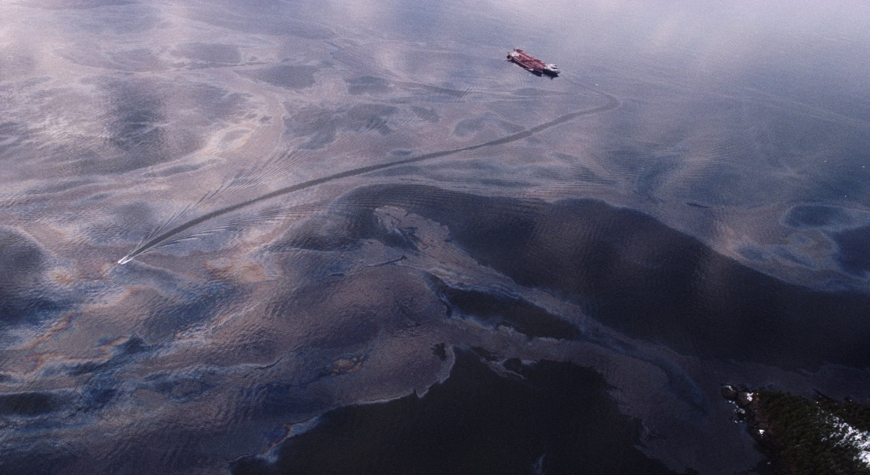
Thirty (30) years ago an oil spill shocked the world. The Exxon Valdez created history and changed the oil industry in the world. Tankers got safer, however, they were not the only risk. The Exxon Valdez was the worst oil spill in U.S. waters until the Deepwater Horizon oil spill in 2010. There was no oil recovery or clean-up equipment in the water during the first few days of the spill, which led to the oil spreading some 1,300 miles along the coast of Alaska.
A massive cleanup was spearheaded involving thousands of people days after but not until the oil spill had cost devastating effects on the sea and marine life. The final death toll included 250,000 seabirds, almost 3,000 sea otters, 300 harbor seals, 250 bald eagles, 22 killer whales, and billions of salmon eggs. Populations of Pacific herring, a cornerstone of the local fishing industry, collapsed. Fishermen went bankrupt.
The transportation industry was affected by this disaster as stricter procedures were put in place to govern the movement of these tankers on the open sea. The disaster caused the U.S to pass a law in 1990 requiring all tankers passing through their waters are required to have double hulls and increased the penalties for oil spills. Today all tankers carrying liquefied natural gas and chemicals are doubled hulled. With better navigation systems and tougher regulations, oil spills reduced from 79 spills per year in the 1970s to six per year in the last few decades.
Given its position in history, the Exxon Valdez oil spill was the 36TH worst oil spill recorded in history. For comparison with other oil spills, the Exxon Valdez spilled 37, 000 tons of oil, with the biggest oil spill happening in 1979 when the “Atlantic Empress” lost 287,000 tons of crude oil in a collision with another tanker. Marine oil spill containment and recovery technology improved tremendously after the Valdez, but not much has changed for at least the last decade, as told by the expert watchdogs. (Leahy, 2019)

What factors have driven many motor carriers out of the trucking business? What has caused high trucking failures for the last decade?
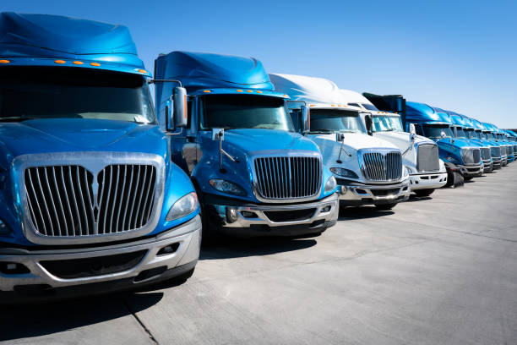
Experiencing a steady influx of revenue, 2018 saw a boom for trucking companies, However, by the end of 2019, these companies found themselves in the red, and some have to close shop. There are many reasons why a trucking company would have to close down, however, there are some main contributing factors that cannot be overlooked leading up to those closers.
When the management of a company fails to manage what is necessary to keep the trucking company afloat, it will only lead to poor decision-making due to poor management. Bad managers scare off good employees and cause them to leave. Truck drivers will leave because they don’t like the fleet manager or dispatcher. Bad managers will make bad decisions by mismanaging the company’s resources. This will decrease employees' morals. What’s more significant is that the trucking industry has been experiencing a shortage of drivers.
The trouble with finances is another crucial factor that will cause a trucking company to close down, such as cash flow problems. Finances are not being planned and monitored carefully which eventually leads to bankruptcy. Some trucking business owners don’t even know how much it would cost before seeing a profit and sometimes charge the wrong rate for services. The operational cost must be examined carefully to understand and know the outlook for a profit margin to be gained. Contributing factors to these financial problems are fuel, lease, and purchase payments, repair and maintenance, truck insurance premiums, permits and licenses, tires, and tolls.
Other contributing factors that can lead to closer are, not being compliant with state regulations and rules, as violating these rules can lead to hefty fines which will pose a further financial burden to the trucking company. Not seeking professional help and advice in difficult times, not investing, or keeping abreast of the ever-changing technology. New tools and technologies often cost money, but they do bring about some benefits to the trucking business. Not meeting customers' expectations by not meeting the delivery schedule, while expecting them to arrive safe and sound. From the onset, the demand for heavy-duty trucks has declined over the years. (Brumleve, 2020)
The U.S trucking industry is in a precarious position today. Many factors cause bottlenecks within this industry, resulting in rate fluctuations and hikes affecting all who are involved in moving goods domestically or internationally across borders such as Canada in this volatile world we live in today. It is also critical that shippers plan accordingly to ensure they can absorb potential additional transportation costs due to these fluctuating industry and market trends. Even with all these insights, there are still contributing factors that lead to trucking failure in today's market.
One of these factors affecting the trucking industry is the truck driver shortage, which is making it difficult for carriers to find qualified drivers. Diesel costs, as the price of diesel, have been steadily going up over the past few months. Carrier capacity, When the larger carriers are raising driver pay by more than 10% in many cases, the smaller carriers are finding it hard to follow suit. Rate hikes will be harder to avoid in the future due to the overall squeeze on carrier capacity. New regulations dictate how many hours a driver should be on the road before taking a break.
Influenced by the factors above the trucking industry has some hurdles to overcome, which for the most part are unpredictable and very hard to address are some of the overall challenges the trucking industry has to overcome. This will for most shippers translate into rate fluctuations and increases from the carriers that can cope without going bankrupt. (TOP 6 FACTORS IMPACTING THE TRUCKING INDUSTRY IN NORTH AMERICA, n.d.)

Why did many airlines offer discriminatory pricing on airfare?
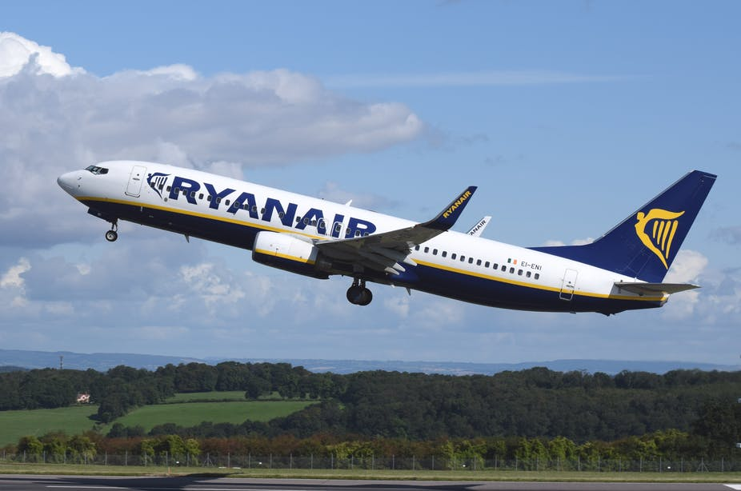
Have you ever wondered, why would airlines discriminate between consumers in the first place and what are they trying to gain? The answer lies with the economic concept called “price discrimination”. Price discrimination is a pricing strategy that involves firms charging different prices to consumers for the same or similar products or services.
The goal and motivation behind this practice are simple. It is the desire to sell more units and make more money. Airline companies can grab the maximum consumer surplus available in the market by charging different prices to different customers. This allows them to maximize their sales output while increasing the airline’s revenues.
The practice is more common than you think and it’s spread across different industries. In reality, it is an accepted practice by most companies. Every time you a “two-for-one special”, student discount, reduction coupon, or voucher, you’re witnessing price discrimination in action. Price discrimination has been successfully implemented across a wide range of services to include, including air, train, and car services, tourism, and hospitality industries.
Price discrimination will affect you depending on the time you place on trying to buy your airline ticket. Booking closer to departure time can cost you more money than those persons who plan their vacations and family gatherings well in advance. As a consequence, airlines use the mechanism known as inter-temporal pricing, which allows them to target both “price-sensitive” and “price insensitive” consumers. Timing is the key to cheap airline prices. Everything depends on when you purchase your ticket.
Chances are you’ll get a cheap fare if you book early. Booking a late ticket means you are desperate to get on a flight, which will lead to a higher-priced ticket. A frustrating situation can be experienced when the price of airfare changes from one day to another or even on an hourly basis. The strategy behind attracting price-sensitive customers, airlines retain a certain number of their economy tickets to be sold at lower prices. If these seats start filling up quickly, the airline will boost the price for those that remain. (Stanisljevic, 2018)

Estimate the price sensitivity of airline passengers
By proactively managing it, price elasticity can be effectively measured by airlines in which they could gain significant commercial value. Price elasticity is a hot topic that has been much debated in the airline industry. Price elasticity is a representation of how many more passengers would fly in percentage if the price drops by a certain amount in percentage. By understanding, price elasticity airlines can reduce or remove a significant amount of risk from their business plan.
Price Elasticity is that it needs to be derived from the number of people who did not end up traveling at a certain price point, rather than those who did. Some advanced algorithms to measure the number of passengers that have flown have been developed by the airline industry, however, most models have generally disregarded information on the number of passengers who did not fly.
The best indicator for this concept is measuring the number of travelers searching for a route who choose not to proceed further down the funnel. Price is the only visible difference to the user when a traveler is presented with a consistent set of carriers with a specific route over a season.
A strong Price Elasticity indicates that lower than average fares can be offset by more passengers on-board to result in higher revenue, as most travelers are price-sensitive and the price is almost always the first criteria considered when comparing. Without having much success in the past, most carriers have tried low-cost hauling to appease their airline customers. Now with the intervention of new modern aircraft, they are trying to modernize and execute the strategy.
Even though not yet being fully part of the airline's planning, price elasticity is recognized as a valuable measure. Comprehending this measure, however, is key to understanding where commercial opportunities lie - especially when offering low fares. With low-cost long hauling seeking to be explored by carriers looking to expand their offerings in the transatlantic market, price elasticity is an ideal opportunity to exploit/explore for the benefit of their airline. (Skyscanner, 2022)

Discuss ways to increase the profitability of the fiercely competitive U.S. airline industry.
With the COVID-19 pandemic, airlines are now grappling with liquidity issues by taking on nearly $40B in debt. The focus is now on reducing cash expenditure by 5o% while investors are waiting on the airlines to rebuild their balance sheets by paying off this debt as soon as possible. The need to restore capacity quickly and flexibly to meet demand, while aggressively downsizing overhead to survive if demand recovers more slowly and unevenly than forecast, is another critical challenge faced by the airlines.
Airlines will have to adjust to an increasingly uncertain future for recovery to take shape, this includes strategizing their operations to stay competitive. In the case where travelers will return slower or less evenly as expected overhead cost will have to be reduced and capacity will have to be restored when the demand rebounds. Balancing the cost in a ratio to customers will be challenging, however, the airline industry does have options to consider.
Prioritize profitability over revenue growth. It is expected that investors will continue to reward airlines that focus on profitability over revenue growth, which will require painful cuts to the industry’s pre-COVID-19 network of airline hubs, especially across international markets that are expected to lag during the recovery. Cut fixed and structural costs. To generate enough cash to repay higher debt burdens. Airlines must reduce fixed costs to levels that can not only allow them to continue operating with lower revenue
The restructuring of the whole fleet and not just the older aircraft. To help airlines lower operational maintenance costs and reduce training overheads., whole fleets including some before their time should be removed. Investing in new aircraft should be assessed thoroughly to decided whether new orders should be canceled.
Adopt a dynamic network structure. This is possible by illuminating stations and their facility and management overheads, by concentrating service in fewer airports in a region. They can also explore the opportunity of eliminating hubs. Revenue-related considerations include overlap with other hubs and preservation of key corporate markets; cost analyses should include lease commitments, planned capital expenditures, labor costs, and airport fees.
In looking ahead and moving forward carriers will continue to fight for survival, while investors being more cautious today due to airlines loading up on debt to stay afloat amidst the COVID-19 outbreak are being more selective when making their aviation investment. Airlines will face continued challenges to their financial stability, as seen clearly that the damage has already been done. Network decisions that manage short-term cost reduction will have to be explored without jeopardizing long-term airport efficiency and network growth strategies. (Wysong, n.d.)

Why do many transportation carriers expand their business scope? (For example, many trucking firms began to offer warehousing or third-party logistics services in addition to their traditional trucking services.)
Transportation carriers expand their business scope to gain a better advantage in the growing transportation industry. This involves attracting new customers through third-party logistics and offering additional warehouse accommodation to ease the influx of goods for delivery. In the supply chain, 3PL enables enterprises to outsource or make use of third-party businesses to carry out the task in the completion of its supply chain.
By expanding their business scope transportation carriers gain new customers, venture into new markets, create a positive consumer experience, and gain a competitive edge in the transportation industry. Through this venture, greater volume discounts can be offered to clients, which is a drive for cost-saving measures, which can minimize overhead costs.
By further expanding their transportation scope carriers can offer enterprises the flexibility and scalability to utilize supply and distribution resources based on current business needs. Thus, when sales are down, there are no redundant investments and unutilized resources, and when there’s a surge in demand, enterprises can upscale. This will also enable business growth and market expansion by allowing careful handling of inventory in new markets without having to spend money on warehousing, equipment, and labor.
An added benefit to this transportation expansion is improved customer satisfaction, which will lead to improved services and response time, timely deliveries, and greater brand reliability. The fundamental goal of all businesses is complete customer satisfaction. Superior customer service will be attained and will allow the industry to offer end-to-end supply chain solutions. (6 KEY BENEFITS OF THIRD-PARTY LOGISTICS (3PL) IN SUPPLY CHAIN MANAGEMENT, n.d.)
Management teams have realized the transportation shortfalls and mistakes in the past and dear not repeat them. By expanding they will encourage new investment with improved financial pricing affordable to the consumers. The COVID-19 pandemic has turned disaster into a business opportunity for many trucking companies and based on the present market tren it does not seem to be heading anywhere but up. The trucking companies will always be looking for new business and gathering them up where ever they go, so in a direct conscious perspective, the expanding scope will become a normal operating factor for the trucking companies.

What are the environmental implications of transportation activities? How can we reduce the carbon footprint resulting from transportation activities?
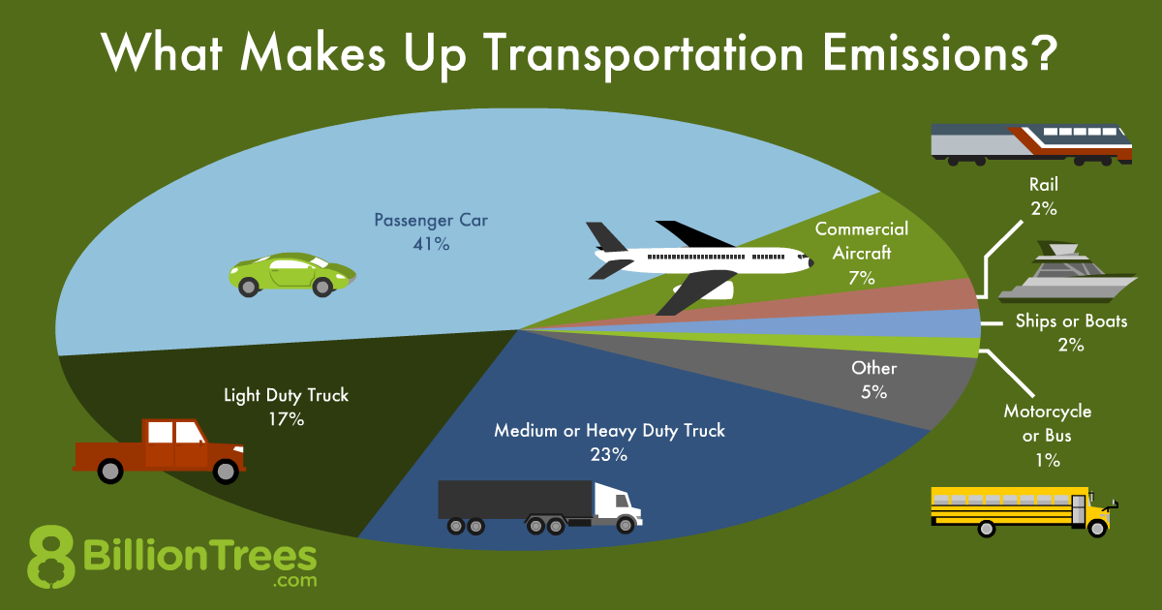
Transportation is now the greatest source of carbon emissions in the United States. The personal automobile has become the single most polluter of carbon emissions on the road due to the millions of vehicles that traverse back and forth every day. From transit biking to walking, individuals can use cleaner modes of transportation to move around to reduce greenhouse gas emissions.
Passenger cars and light-duty trucks such as sports vehicles, pickup trucks, and minivans have contributed to half of the carbon dioxide emissions in the US transportation sector, however, we can do a lot to reduce the negative impact that driving has on the environment, and by helping we can pick the most efficient, least-polluting vehicle that meets your needs.
In helping to reduce the carbon footprint due to transportation activities electric vehicles are now being introduced into the transportation market. They offer alow carbon alternative to gasoline-powered vehicles. Your carbon footprint can be reduced over time by using your electric vehicle and also save you money over the lifetime of the vehicle. Bicycling and walking are more than just recreational activities; these options help to reduce greenhouse gas emissions, traffic congestion, and our oil demand. Additional benefits include having a good cardiovascular system and reducing other environmental impacts of motorized transportation, such as noise and the destruction of open space, wetlands, and other habitats.
Cutting carbon emissions can also be done by optimal driving techniques and saving money in gasoline-powered cars. You can also lower impacts by reducing time spent idling, and using overdrive and cruise control. And because a properly-maintained vehicle can improve your gas mileage and fuel economy by 4 percent, remember to have your vehicle tuned up, tires inflated, and oil and air filter cleaned out regularly.
By taking public transportation and carpooling you can significantly reduce the transportation carbon footprint. This mode of transportation can lead to substantial environmental benefits. Households that take public transportation contributes more to the reduction of carbon emissions. 37 Million metric tons can be reduced by communities with a strong public transportation system. Good public transportation options are good for any community and business establishment. The benefits to the reduction of carbon emissions can be gained through the cooperation of all, including governments, business places, and the local community. (Reducing Your Transportation Footprint, n.d.)

CONCLUSION
Since the dawn of the transportation era, it has played a significantly important role in the development of the world. Transportation has brought ideas, goods, physical services, and equipment to different countries all over the world. It has allowed leaders of nations to meet to iron out their differences. It has allowed products not available in a local country to reach their residence on time. Because of the transportation era, developing countries can introduce new ideas and products to the market. Without transportation, there would almost if not possible a complete standstill in the movements of goods and people around the world.
The importance of transportation is now being played out in the Russian and Ukraine present war in which the Ukraine arm has been self-bombing their roads to the main city of Kyiv to slow down the movement of the Russian troops and armored patrolling vehicles including tanks. Russia in turn has been bombing the runways of the Ukrain arm to prevent fighter jets from taking off to bomb the advancing Russian troops. What we are experiencing here today's in this 21ST first-century war between Ukraine and Russia is only one of many battles fought by countries who relied on the transportation of ammunition, soldiers, and other crucial pieces of equipment to win a war.
Because of this assignment, I now clearly see the deficiencies in the transportation operation of my company. Maintenance costs are high and the trucks are not being utilized to their full capacity. Gas consumption continues to be a nagging concern for the fleet manager of my company. I wish to approach them one day and offer my help with what I’ve learned. I see the opportunity to reduce their maintenance cost and gas consumption by offering alternative delivery options to our customers. This assignment has opened my eyes to the possibility of a new and improved transportation system in my company.

BIBLIOGRAPHY

(2018, March 19). Retrieved from https://www.cafworldwide.com: https://www.cafworldwide.com/blog/what-is-freight-class-and-how-do-you-determine-yours
6 KEY BENEFITS OF THIRD-PARTY LOGISTICS (3PL) IN SUPPLY CHAIN MANAGEMENT. (n.d.). Retrieved from https://www.gep.com: https://www.gep.com/blog/mind/6-key-benefits-of-third-party-logistics-3pl-in-supply-chain-management
Benesch. (2022). Mergers and Acquisitions in the Transportation Sector. Retrieved from https://www.jdsupra.com: https://www.jdsupra.com/legalnews/mergers-and-acquisitions-in-the-14123/
Bhasin, H. (2020, January 20). The Importance of Transportation Explained. Retrieved from https://www.marketing91.com: https://www.marketing91.com/importance-of-transportation/
Brumleve, B. (2020, April 11). 8 Reasons Trucking Companies Fail. Retrieved from https://digitaldispatch.io: https://digitaldispatch.io/8-reasons-trucking-companies-fail/
DHL. (2022, March 3). Retrieved from https://en.wikipedia.org/wiki/DHL: https://en.wikipedia.org/wiki/DHL#:~:text=The%20company%20DHL%20itself%20was,and%20four%20DC%2D6%20aircraft.
DHL. (2022). Retrieved from https://www.dhl.com/: https://www.dhl.com/global-en/home/about-us/partnerships.html
FedEx history. (n.d.). Retrieved from https://www.fedex.com: https://www.fedex.com/en-us/about/history.html
FREIGHT TRANSIT BUFFER & WHY YOU NEED IT. (2020, June 15). Retrieved from https://streamlogistics.com: https://streamlogistics.com/freight-transit-buffer-why-you-need-it/
Full Truckload vs. Less-than-Truckload Shipping: Which is Right for You? (n.d.). Retrieved from https://blog.pantero.com/: https://blog.pantero.com/full-truckload-vs.-less-than-truckload-shipping-which-is-right-for-you#:~:text=The%20primary%20disadvantage%20of%20TL,hike%20up%20your%20freight%20costs.
Googlesir. (2020, September 3). Retrieved from https://www.googlesir.com: https://www.googlesir.com/information-technologies-used-in-supply-chain/
HOW TO FILE A FREIGHT CLAIM FOR LOSS OR DAMAGE. (n.d.). Retrieved from https://www.tlcouncil.org: https://www.tlcouncil.org/sites/default/files/how_to_file_a_claim.pdf
Kubota, B. J. (2006). TRANSPORTATION. Retrieved from https://www.sciencedirect.com: https://www.sciencedirect.com/science/article/pii/S038611121460159X#bib11
Leahy, S. (2019, March 22). Exxon Valdez changed the oil industry forever—but new threats emerge. Retrieved from https://www.nationalgeographic.com: https://www.nationalgeographic.com/environment/article/oil-spills-30-years-after-exxon-valdez
Lewis, R. (n.d.). United Parcel Service. Retrieved from https://www.britannica.com: https://www.britannica.com/topic/United-Parcel-Service
Magill, P. (n.d.). The Top 4 Advantages of Intermodal Transportation. Retrieved from https://www.tms-transportation.com: https://www.tms-transportation.com/blogs/advantages-of-intermodal-transportation/
Min, H. (2015). The Essentials of Supply Chain Management. Paul Boger.
More than 100 years of innovation. (n.d.). Retrieved from https://about.ups.com: https://about.ups.com/mx/en/our-company/our-history.html
Nguyen, T. C. (2020, January 09). The History of Transportation. Retrieved from https://www.thoughtco.com: https://www.thoughtco.com/history-of-transportation-4067885
Peksoke, D. D. (2021, September 2021). 20 Years After 9/11: The State of the Transportation Security Administration. Retrieved from https://www.tsa.gov: https://www.tsa.gov/news/press/testimony/2021/09/29/20-years-after-911-state-transportation-security-administration
Pros and Cons of Different Types of Freight Transport. (2019, June 12). Retrieved from https://ifa-forwarding.net/blog/international-freight-forwarding/pros-and-cons-of-different-types-of-freight-transport/
Puentes, B. K. (n.d.). Transportation Reform. Retrieved from https://www.brookings.edu: https://www.brookings.edu/wp-content/uploads/2016/07/takingthehighroad_chapter.pdf
Puentes, R. (2011, May 23). Move It: How the U.S. Can Improve Transportation Policy. Retrieved from https://www.brookings.edu: https://www.brookings.edu/opinions/move-it-how-the-u-s-can-improve-transportation-policy/
Reducing Your Transportation Footprint. (n.d.). Retrieved from https://www.c2es.org: https://www.c2es.org/content/reducing-your-transportation-footprint/
Roberts, K. W. (200). Key Factors and Tors and Trends in T ends in Transportation Mode and Carrier tation Mode and Carrier. Retrieved from https://trace.tennessee.edu: https://trace.tennessee.edu/cgi/viewcontent.cgi?referer=https://www.google.com/&httpsredir=1&article=2496&context=utk_chanhonoproj#:~:text=There%20surely%20are%20a%20number,characteristics%2C%20relationships%2C%20and%20capacity.
Robinson, C. (n.d.). What is a freight accessorial? Retrieved from https://www.freightquote.com: https://www.freightquote.com/define/what-is-a-freight-accessorial/#:~:text=Freight%20accessorial%20definition.&text=Robinson%2C%20we%20define%20freight%20accessorial,inside%20pickup%20and%2For%20delivery.
Robinson, C. (n.d.). What is LTL freight shipping? Retrieved from https://www.freightquote.com: https://www.freightquote.com/define/what-is-ltl-freight-shipping/
Shane, J. N. (n.d.). The Regulatory Era. Retrieved from https://www.transportation.gov: https://www.transportation.gov/sites/dot.gov/files/docs/50/308721/regulatory-era.pdf
Shipsy. (2020, December 7). 5 Key Challenges in Transportation Management System. Retrieved from https://shipsy.io: https://shipsy.io/blogs/5-key-challenges-in-transportation-management-system/
Shirley, D. (2020, January 27). Why transport providers should adopt ‘blue ocean’ thinking. Retrieved from https://www.smarttransport.org.uk: https://www.smarttransport.org.uk/features/why-transport-providers-should-adopt-blue-ocean-thinking
Skyscanner. (2022). Price Elasticity & Air Fares. Retrieved from https://www.partners.skyscanner.net: https://www.partners.skyscanner.net/price-elasticity-a-long-haul-low-cost-opportunity-awaits/thought-leadership
Stanisljevic, J. (2018, June 26). A traveler’s guide to airline price discrimination. Retrieved from https://theconversation.com: https://theconversation.com/a-travellers-guide-to-airline-price-discrimination-98329
Supply chain disruption. (n.d.). Retrieved from https://www.accenture.com: https://www.accenture.com/us-en/insights/consulting/coronavirus-supply-chain-disruption
Teimoury, D. M. (2008). Integrated Freight Transportation Carrier Selection and Network Flow Assignment: Methodology and Case study. Retrieved from https://scialert.net: https://scialert.net/fulltext/?doi=jas.2008.2928.2938#:~:text=In%20the%20first%20phase%2C%20after,customer%20service%20and%20strategic%20compatibility.
The 6 Step Freight Claim Process. (2015, August 25). Retrieved from https://www.plslogistics.com: https://www.plslogistics.com/blog/the-6-step-freight-claim-process
The Evolution of Intermodal Transportation and Intermodal Container. (2021, September 8). Retrieved from https://www.lotus-containers.com/: https://www.lotus-containers.com/en/blog/news/the-evolution-of-intermodal-transportation-and-intermodal-container/#:~:text=The%20notion%20of%20intermodal%20shipping,drawn%20carriages%20and%20shipping%20crafts.
TOP 6 FACTORS IMPACTING THE TRUCKING INDUSTRY IN NORTH AMERICA. (n.d.). Retrieved from https://mantoria.com: https://mantoria.com/blog/blogtop-6-factors-impacting-trucking-industry-north-america/
Transportation Strategies: Weathering the Storm. (2021, April 14). Retrieved from https://www.inboundlogistics.com: https://www.inboundlogistics.com/cms/article/transportation-strategies-weathering-the-storm/
Wysong, R. (n.d.). How can airlines return to profitability? By following these 5 steps. Retrieved from https://www.pwc.com: https://www.pwc.com/us/en/industries/consumer-markets/library/how-can-airlines-return-to-profitability.html

