**Your name**

**UB70199BBU79348**

Your Work or Academic Experience for QALP

**BEING AN AMBASSADOR OF GLOBAL YOUTH REPRESENTATIVES OF NIGERIA.**

ATLANTIC INTERNATIONAL UNIVERSITY

**April 2022**

Answer the following questions that apply to your work or academic experience:

(Please include photos, graphs or other illustrations, if you have them.)

In the following questions, the word “project” refers to your experience. Some examples are academic research, publication, recognition of community service, course, conference presentation, work experience. There are many more options for you to receive QALP credits. Describe your experience in the answers below.

1. Describe the project that you want credits for?

**Ans: The project I would like to describe credit for is my role for being an African Ambassador of Global Youth Representatives of the Federal Republic of Nigeria after holding in different project capacity. I have attached pictures of the award ceremony below where I have been recognized for all my recognition in the last years with the Organization**

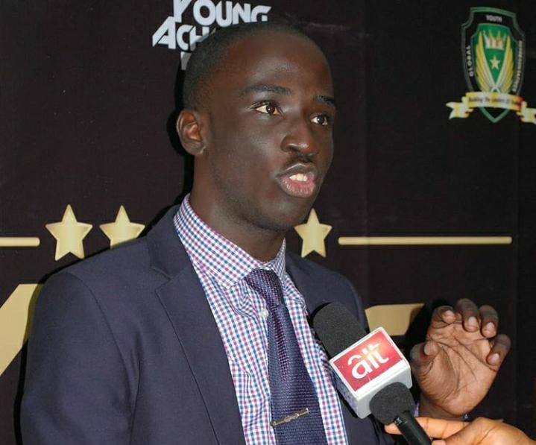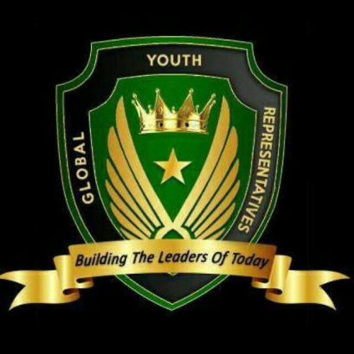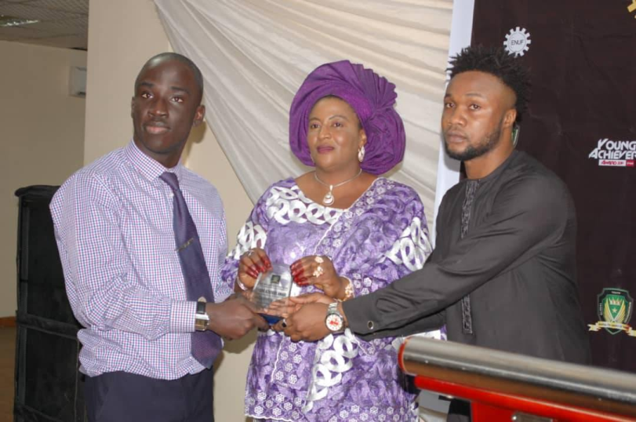

2.Are you currently working on the project? What are the dates in which you worked on this project?

**Ans: I have been working on this particular project for the past 6 years from 2016 to date and I hope to officially resign from this particular volunteering for the project in 2022 September.**

1. What activities did you do in the project?

**Ans: During the cause of this project, I had contributed my finance to support peoples live, organized programmes across the world towards a better future as well as hosted series of meetings with my colleagues and seniors with the hope of leaving some of my legacy which at a certain point of life is that regardless of whatever you do in your career there are some people that would still betray you for one fake reasons or the other.**

4. What did you learn in the project?

**Ans: From this project, Some of the things that I have officially learnt in this particular project is that no matter how much you show up there are still some people who would still betray you for your actions and would still want to portray you in a bad image without them doing any research or investigation of the story but it has made me to be able to realize that there is no success without distraction and this is why I have decided I must be able to know how to be able to make my inner decisions regardless the traditions philosophy that has been designed around the African Continent.**

5. What did you do to complete the project?

**Ans: The project was derived towards being able to create a quality education and participating in Good Governance across the Federal Republic of Nigeria and knowing how can we make Nigerian Youths to be able to also benefit from this designed opportunity after organizing local meets ups, online webinars and having series of Whatsapp discussions that is related to the future.**

6. How does this project relate to your major at AIU?

**Ans: This project retains to some of the details transformation of certain part of my courses at the Atlantic International University Honolulu because it has been able to give me more practical knowledge to be able to use my operations management, Principles of Management and accounting skills to have been able to work with people from different diverse Nigerian Culture regardless the fact that most of this people are faced with a lot of challenges and they don’t really have access to opportunities in the society than I officially do.**

7. How can you use the knowledge and experience gained in your project to further human rights and the 17 Goals for a Sustainable World by the United Nations? ([Click here](https://sdgs.un.org/goals) to review the Goals)

**Ans: The first thing that I would like to share is that this particular assignment was officially related to Goal 1,4,8,11,16 and 17 of the United Nations and this knowledge would help me to be able to expand on creating sustainable opportunities for people by me helping them find the right kind of network that they would need to be able to further expand and grow the kind of career that they want to see for their future.**

Include a bibliography of any references that would support this report. This is not required but it helps us document your experience.