Your name
UB70199BBU79348

Your Work or Academic Experience for QALP My Internship Experience with the International Institute for Tropical Agriculture (IITA) Ibadan

ATLANTIC INTERNATIONAL UNIVERSITY
February 2022

Answer the following questions that apply to your work or academic experience:
(Please include photos, graphs or other illustrations, if you have them.)
In the following questions, the word “project” refers to your experience. Some examples are academic research, publication, recognition of community service, course, conference presentation, work experience. There are many more options for you to receive QALP credits. Describe your experience in the answers below.

1. Describe the project that you want credits for?
Ans: The project I would like to ask for credit experience through volunteerism knowledge is my internship experience with the International Institute for Tropical Agriculture (IITA) Ibadan Nigeria where I got the chance to be part of the Farm Research Member to be able to sharpen my agricultural skills and get to see more realities of the international world.
The pictures that are being attached below were taken by me during the process of getting involved in the farm work at the institute which you can also find in the mail trail also a recommendation letter from the authorities recommending me towards being able to get agricultural knowledge also in any parts of the world:-
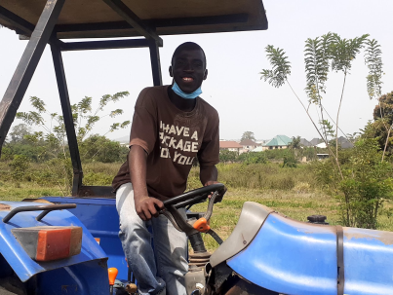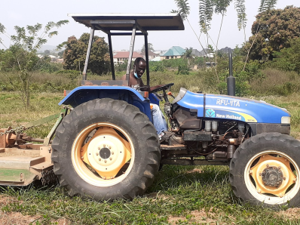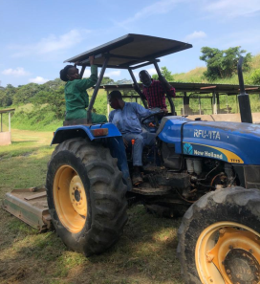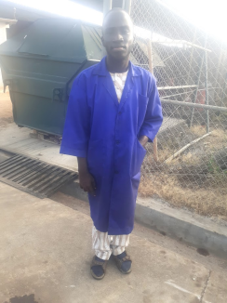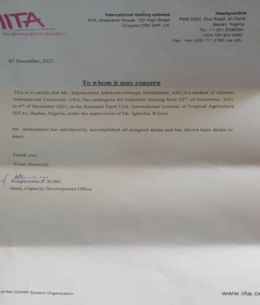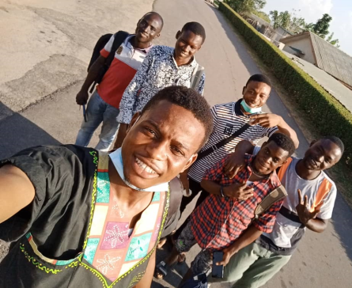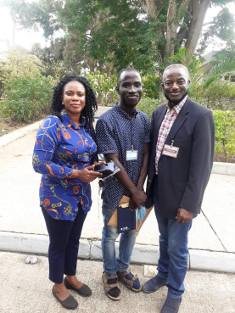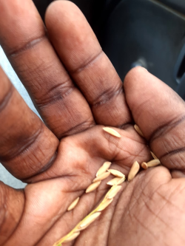
2. Are you currently working on the project? What are the dates in which you worked on this project?
Ans: I only used 2 weeks in working on this particular project in Ibadan Nigeria which was last year November to December 2021 so I have finished working on this particular mission.
3. What activities did you do in the project?
Ans: during the course of this project, I had the cause of getting involved in some of the activities that has to do with the farm such as Planting, Irritigation, Fabricating, and tour of different plant where I was also given the chance to be able to drive tractors across the farm
4. What did you learn in the project?
Ans: I have firstly been deceived that Agriculture is difficult that it cannot be achievable but it is so sad as easy it might look through the procedures and steps that I have been able to get in the journey Nigerian Government has killed it due to the lack of quality of leadership management and the fact we are unable to use project management skills to be able to solve problems that are present in this current generation which is leading a lot of youths in this generation to get themselves in theft and other fraudulent activities which is damaging the image of the country.
5. What did you do to complete the project?
Ans: In Order to be able to complete this particular project some of the particular things that I have done to make the end of this project is that I went to officially sign out with members of the institute through their respective departments in the institution
6. How does this project relate to your major at AIU?
Ans: I have come to realize along the way that in Business Administration is a wide scope course that one way or the other we need to be able to use several parts of the skills to be able to solve problems in the society. This relates to my major as I have used my leadership, team building with other interns from the institute as well as Project Management to be able to create proffer solutions in adding value to the brand with my presence and goals set to be able to achieve in the workplace for the period two weeks at the institute.
7. How can you use the knowledge and experience gained in your project to further human rights and the 17 Goals for a Sustainable World by the United Nations? (Click here to review the Goals)
Ans: Let me say that this particular project has a lot of knowledge that can be used towards being able to achieve the sustainable development goals (SDG) of the United Nations but I would firstly talk about the major areas that this particular thing affects for the future. Zero Hunger, Gender Equality, Good Health and Well being along with Decent work and Economic Growth are the goals that works along the line of this particular assignment that I have taken and this knowledge would be used as an opportunity to remind people not to give up that they have the power to create the future and they must be ready to learn and be able to explore new things for the future that they want to create regardless of how hard no matter the sector that you belong to.
Include a bibliography of any references that would support this report. This is not required but it helps us document your experience.

