**Your name**

**UB70199BBU79348**

Your Work or Academic Experience for QALP

**STUDENT AMBASSADOR @ WIFI COMBAT ACADEMY.**

ATLANTIC INTERNATIONAL UNIVERSITY

**May 2022**

Answer the following questions that apply to your work or academic experience:

(Please include photos, graphs or other illustrations, if you have them.)

In the following questions, the word “project” refers to your experience. Some examples are academic research, publication, recognition of community service, course, conference presentation, work experience. There are many more options for you to receive QALP credits. Describe your experience in the answers below.

1. Describe the project that you want credits for?

**Ans: The Project I would like to request credit for is my experience with Wifi Combat Academy, a coding company in Nigeria which I have been for the past 6 years and I have had different amazing outreach and opportunities from different places through this organization. This organization was the foundation of where my career journey had began to through which the opportunity had come from my dad when the executive director, Mrs. Dele Tejuoso made an appearance in Channels Nigeria back then. Below are some of the captured moments that was taken during my time as a student of the Wifi Combat Academy across different locations in the world performing different activities:**

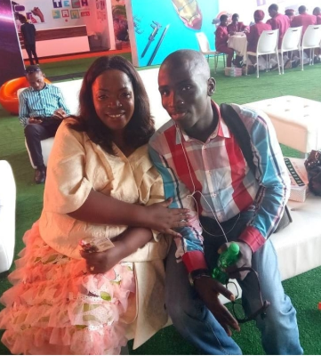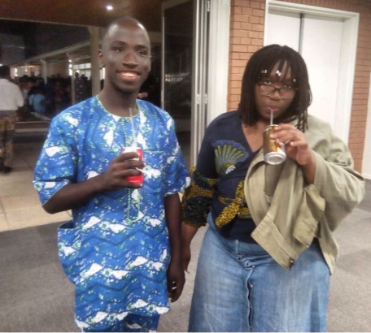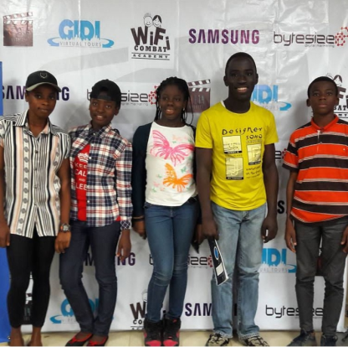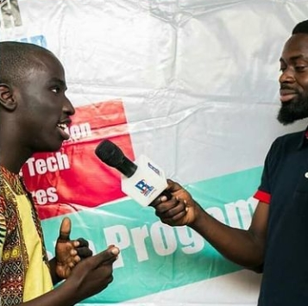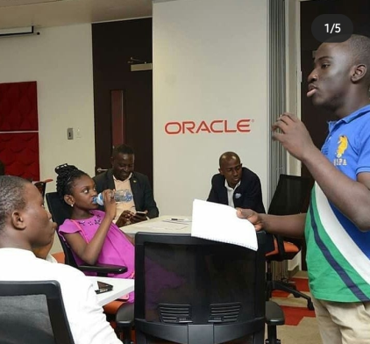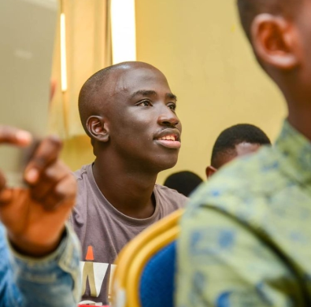

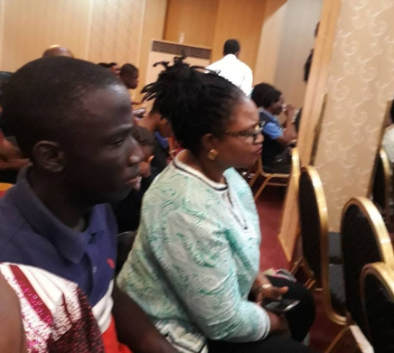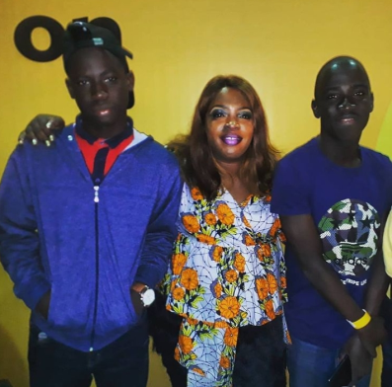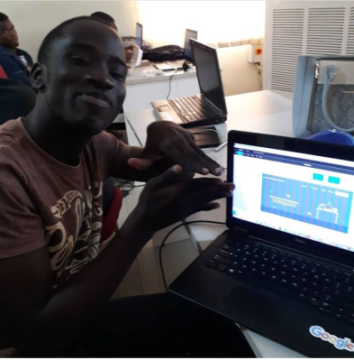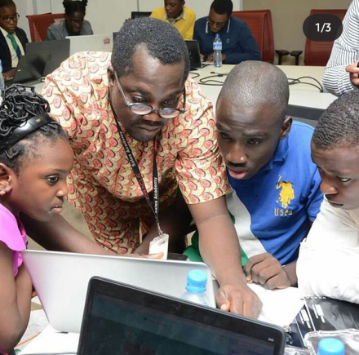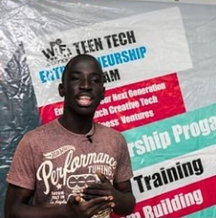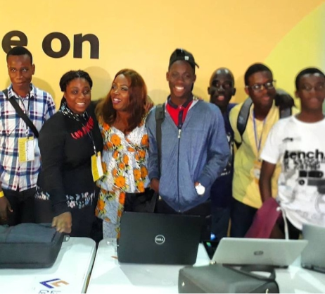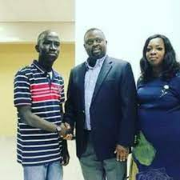

**There are more pictures and information than this that I would love to have shared about my time with Wifi Combat Academy but this is some of the ones that can be reach from their social media accounts. I would like to say that this report would be officially brief as the academy can be contacted at** [**wificombatacademy@gmail.com**](mailto:wificombatacademy@gmail.com) **for information that is necessary about me during my period in the academy.**

1. Are you currently working on the project? What are the dates in which you worked on this project?

**Ans: Wifi Combat Academy is a project that I was involved in during my period as a student within the year 2015-2021 as I am now alumni with the academy due to the age range. Tentatively I am might not be fully active but I am still within this particular community.**

1. What activities did you do in the project?

**Ans: This particular organization was a memorable tour for me as a person which I call Home from different aspect even though I had wished that some of the things I would have spoken about earlier was my mental health probably at point I would not have diverted to entrepreneurship but rather focus on my goals on technology the more. During my time with the academy Two people that I have to admit today that working with them was amazing but didn’t understand much of the situation then was Ayomide Tejuoso and Temitayo Asuni they were amazing as some of the notes that they shared back I just keep seeing them each time I look back in my hackive and its happening. I had worked on different series of project especially the fact when I am able to learn about some of my skills about the world of technology especially the first opportunity where I had the privileged to meet with entrepreneurs like Mr. Nndubusi Arinze, Mrs. Adetoun Disu, Mr. Ike Okosa, Mr Toyin Tejuoso (who is actually the spouse to the executive director of the academy) and Mr. Sharif Oluwole Gbadamosi. I presented and made different projects at this particular time where I presented in different places as the first picture in the statement in No 1 was a picture of myself and the Executive Director Mrs. Dele Tejuoso after a presentation at a# GTB Bank Conference in 2017. I had also the opportunity through this organization to attend the ALAMAU in South Africa as though the wish of the ED was for me to do their diploma programme but I wasn’t admitted then but the picture indicated above which is the 2nd picture was taken having myself and her daughter Ayomide Tejuoso who had the privilege to the diploma but didn’t partake in the ALAMAU. I got the opportunity to be featured in interviews where I was able to share some of my experience during the period of being with the academy in the fact of getting a recognition from a former commissioner in a state in the Federal Republic of Nigeria. Wifi Combat Academy remains a home that I would forever grateful that I passed through as I meant great men and women aspiring for a great career.**

1. What did you learn in the project?

**Ans: Some of the things that I was able to learn from this project is some of the principles of entrepreneurship which some of the handout that were issued to us back then from the workshop taught by Mr Gbadamosi back then are still with me which I still look back to share and use some of these to currently build the African Village Project. One thing that I have learnt from this project wish I would have done is by sharing the report and information of insecurity started especially with the Founder and Mrs. Adetoun Disu maybe there would have been better positions to have resolved some of the things I faced which I should not have faced in my career especially in their different technology field. Mrs. Adetoun Disu was one major person that was a coach and acted as a mother in support of Mrs. Tejuoso knowing the fact that they saw something that was a gift they were the major people who went far to be able to build which I might not be able to complete due to certain diversion principle which I am sure that they have already seen so far in my journey. My time on this project was were I was able to learn some of the principles that are related to coding as well as some of the recognition that I earned and see of what added value can I use it to be able to drive my society currently today.**

1. What did you do to complete the project?

**Ans Some of the things that I did to complete this was I had the opportunity to be able to practicalize some of these things that was officially taught in some of the coding class I had previously built website due to the fact that I had to let people go due to my mental health and the fact that so many bridges were officially burnt back then an example was a website I built for UNESCO but due to so many harassment that would not have allowed me to focus on this career happened back then and people were fed with a lot of wrong information until they took time to start apologizing back where I was at the point of already giving up which some came in the name of Yoruba tradition back then which my family lawyer is showing some of the realities of life at the current moment. Another thing that I had to do to complete this project is to be able to give back and share some of my experience on this project**

1. How does this project relate to your major at AIU?

**Ans: This particular project of Wifi Combat Academy was a pathway towards helping me to answer and develop some of my assignment that were related to my future plan career as this particular assignment would have to officially trace me back to some of the things that I have put in my hack hive as well as some of my learnings that were officially done with the Institution on the part of the issue of Investment Management knowing the fact that I must take the point of my course of Business Administration to be able to do a particular technology course before I officially graduate from the institution.**

1. How can you use the knowledge and experience gained in your project to further human rights and the 17 Goals for a Sustainable World by the United Nations? ([Click here](https://sdgs.un.org/goals) to review the Goals)

**Ans: My knowledge and experience during my time with the Wifi Combat Academy Organization would be a blessing to many people across the world as the fact that this was one of my best serving organization in I wish I could have turned my experience then with the company to a profit for myself today if I only was in the position to have shared some of the right information that was needed to the academy. This is a way I would use to help and remind the society that you can be who you want to be regardless of what the world officially has to say about you as sometimes you have just got to do something that would shame people for you to move to the next level of your career for you to be able to progress in your life and career. Let me add to addition that the SDG goals that are related to the journey of Wifi Combat Academy are: Goal 2,3,4,5,9,10,11 and 16 as a person for me generally.**

Include a bibliography of any references that would support this report. This is not required but it helps us document your experience.