Bornark Chekerai

UB77256SOC86461

SYSTEMIC FAMILY COUNSELLING

ATLANTIC INTERNATIONAL UNIVERSITY
05/2022

Answer the following questions that apply to your work or academic experience:
1. Describe the project or course?
Systemic Family Counselling is formal, and training based, incorporating various attributes, skills and experiences from the informal and cultural approach used since time immemorial
The training adopted the Systems thinking as a theory to inform its teaching and clinical practice
Biologist Griffin (1993) says, for the practicing counsellor that the whole family is significant to counselling process more than individual members as advocated for the individual psychotherapists

2.Are you currently working on the project or course? What are the dates in which you worked on this project?
I did the course between April 2015 and October 2016

3. What activities did you do in the project or course?
- Concept of counselling
- Systems theory
- Counselling techniques
- The practice of counselling
- Systemic HIV/AIDS counselling
- Genograms
- Marital issues
- Dealing with suicide attempts
- Bereavement
- Working with children and adolescents
- Communicating with children
- Child development
- Child abuse
- Domestic violence
- Alcohol and drugs

4. What did you learn in the project or course?

To become a successful and effective counsellor, all activities need to be incorporated in day-to-day living. Counselling is a profession and so demanding, emotion-laden, and often frustrating experience. It involves self-examination, as well as defining one’s personal philosophy in relation to what clients presents. In many ways counselling experience fits into the counselor’s lived experiences and life perspectives in relation to personal life views, hence skills and experiences gained during training are likely to bring a reward if well implemented

5. How does this project or course relate to your major at AIU?
Performance of an employee is somehow linked to his life out of work environment. He/She doesn’ t live in a vacuum but within the society.
The problem is not a problem in itself, but is part of a larger process involving many other people, other behaviors and meanings.
Counsellor should consider a bigger picture as illustrated below (adopted from Zimbabwe Institute of systemic counselling manual)
Such challenges can affect individual concentration at work resulting in injuries or damage to property

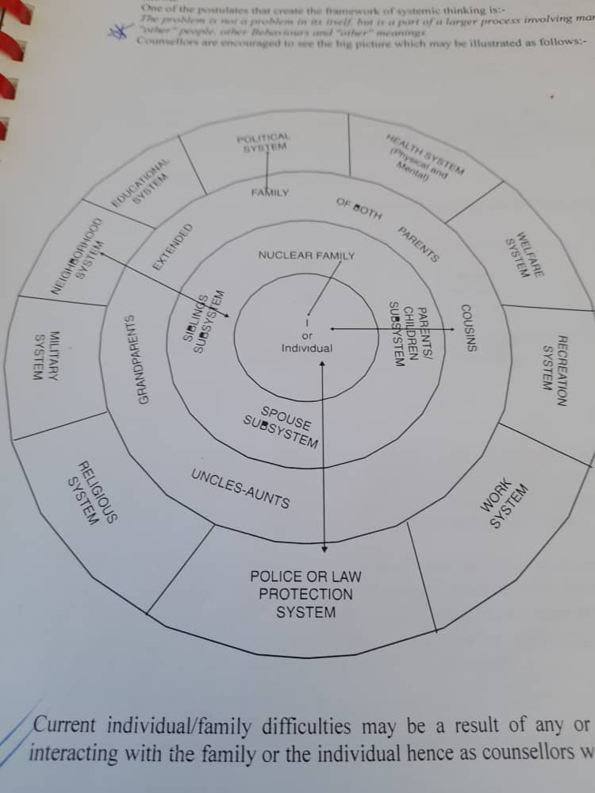
6. In the future, how do you plan to benefit from the knowledge gained? Will you make more money, improve your life and/or improve the life in your community?

I intend to improve the lifestyle in the community by offering counselling services in different setups like schools, colleges, companies, hospitals, clinics and many more.
Most people have never experienced professional counselling. This does not mean they have never experienced difficulties, but have been adapting to life’s challenges using personal, cultural, and religious faith among others. However, even with these resources, life challenges may require a skilled helper to facilitate the process of growth and adaptation to these challenges

7. How can you use the knowledge and experience gained in your project to further human rights and the 17 Goals for a Sustainable World by the United Nations? (Click here to review the Goals)
Systemic Family counselling involves common life experiences. It covers marriage counselling and gender-based violence, girl child from abuse which advocated for by United Nations in Goal 5. It offers health education focusing more on HIV/AIDS, early child marriages and sexually transmitted infections (Goal 3: Good health and wellbeing)

