**Rogers Nsubuga.**

**UM77059BBU86262**

COURSE NAME:

**(Social Responsibility and Ethics)**

Assignment Title:

**(Ethics and Social corporate responsibility in decision making )**

ATLANTIC INTERNATIONAL UNIVERSITY

**May/2022**

**Table of Contents**

**1.** **Introduction.** 3

**2.** **Body of Assignment.** 3

2.1. Question 1. 3

What is hyper-competition? Is the outcome positive for corporations in the IT industry? 3

2.2. Question 2. 5

What is your opinion of Apple having a code of conduct for its suppliers? What would Milton Friedman say? Contrast his view with Archie Carroll’s view. 5

2.3. Question 3. 6

Does a company have to act selflessly to be considered socially responsible? For example, when building a new plant, a corporation voluntarily invested in additional equipment that enabled it to reduce its pollution emissions beyond any current laws. Knowing that it would be very expensive for its competitors to do the same, the firm lobbied the government to make pollution regulations more restrictive on the entire industry. Is this company socially responsible? Were its managers acting ethically? 6

2.4. Question 4. 7

What is stakeholder analysis? Explain the steps taken to achieve the identification and evaluation. 7

Figure1; Stakeholders chart 8

2.5. Question5. 9

Given that people rarely use a company’s code of ethics to guide their decision making, what good are the codes? 9

**3. Conclusion** 10

**4. STRATEGIC PRACTICE EXERCISES** 11

4.1. What should the manager do? 12

4.2. Why do you believe so? 12

4.3. What are the ethical implications of your decision? 12

**5. Bibliography** 13

# **Introduction.**

The easy will discuss social responsibility and ethics in business environment. The easy begins with definition of hyper competition and its positive outcomes to corporations in the IT industry. It further discusses the code of conduct in a firm’s operations and contrasts the views of Milton Friedman and Archie Carroll.

The easy will continue to discuss social corporate responsibility of organization’s and review ethical behaviors for managers in their decision making. Define stakeholder analysis and the steps taken to identify and evaluate the different groups of stakeholders.

Lastly, the easy will discuss the code of ethics, its importance and close with a case analysis.

# **Body of Assignment.**

## 2.1. Question 1.

## What is hyper-competition? Is the outcome positive for corporations in the IT industry?

Hyper competition is defined as the firms use of strategies to disrupt the competitive advantage enjoyed by industry leaders and players .It creates an environment of uncertainty and not easily sustainable (Philip Kotler).For example MTN Uganda is an industry leader in the telecommunication followed by Airtel Uganda, there is aggressive response to innovations of each, given the technological developments, there is replication of products which in turn gives a short product life cycle. They have both competed on cost and quality of products, transcend to untapped markets and later raising entry barriers for new firms and finally encroaching on the strongholds of small players like Warid Telecom, Africell who have ended up merging or being sold.

Corporations in the IT industry have to be more informed with technological trends and activities of their competitors if they are maintain competitive relevance, the disruption in the industry has been advantageous as highlighted below;

Reduced costs with new technology acquired. This means that new technology improves output by enabling firm operate with a higher output capacity to meet demand thus reducing on the cost incurred previously when production was low.

Corporations have over time gained access to new technology given the constant innovations taking shape. The new technology has an effect of improving user experience. Companies that develop CRM systems have continuously improved or created systems that enhance information access for frontline staff which eventually improves customer experience.

Customers get improved quality of products as corporations compete. For example the competition and innovation in the Television industry between LG and Hisense has resulted into better television sets for the market. Today TV sets are smart and can be connected to the internet.

Hyper competition facilitates quick imitation of the successful strategies of market leaders. Airtel Uganda has often imitated the innovations done by MTN Uganda within 12 hours. Prices changes are easily responded to maintain the equilibrium and keep pace with the competitiveness.

According to D’Aveni, firms experiencing hyper competition raise entry barriers to limit

Competitors. Limiting competitors allows corporations enjoy benefits of being the only industry players.

## 2.2. Question 2.

## What is your opinion of Apple having a code of conduct for its suppliers? What would Milton Friedman say? Contrast his view with Archie Carroll’s view.

Apple has a strong code of conduct for its suppliers, this is a good business practice and internationally recognized to prevent harm to a corporation’s reputation. The firm strived to ensure that business performance is done ethically with a high regard for standard and environmental sustainability and has compelled all suppliers to breathe the code of conduct in its communications and acknowledgements with the suppliers.

The suppliers being legal entities entering into a contractual obligation with apple need not only to adopt the code of conduct for apple but implement codes for the entity they operate. Apples business model to outsource some parts of production does not erode the supremacy enjoyed by the outsourced entity and thus cannot be held responsible for actions of a separate company. Contracting supply of some parts doesn’t not take away the autonomy and thus Apple would act in violation to take over accountability of the entities it contracted.

Milton Friedman acknowledges that business primarily exist for economic reasons through exploitation of resources and engage in activities designed to increase its profits so long as it stays within the rules of the game, which is to say, engages in open and free competition without fraud. This can be construed to mean that a supplier's legal responsibility to follow the rules established within that country without governments interruption.

Carroll elaborated the business responsibilities not only have to be economical and legal, but be ethically accountable to the society in which they conduct business and asserted that once ethical values are satisfied, then discriminatory actions are looked at.

In my view, Milton Friedman would perhaps be in contradiction of Apple’s interfering with the privileges of its suppliers to without restrictions deal with their employees and in the environment it operates while Carroll would advocate for ethical consideration from the suppliers.

## 2.3. Question 3.

## Does a company have to act selflessly to be considered socially responsible? For example, when building a new plant, a corporation voluntarily invested in additional equipment that enabled it to reduce its pollution emissions beyond any current laws. Knowing that it would be very expensive for its competitors to do the same, the firm lobbied the government to make pollution regulations more restrictive on the entire industry. Is this company socially responsible? Were its managers acting ethically?

The concept of social responsibility proposes that a private corporation has responsibilities to society beyond making a profit. The company’s strategic decisions often affect more than just the corporation.

A decision to invest in equipment’s that reduce pollution was not only creating efficiency for the organization but also contributes to the UN 2030 goals of zero pollution. This was operating with asocial concise. In reaching the government to regulate pollution, the firm used its competitive advantage over others as well as promote zero pollution on the state where other players contributed to pollution. Carroll argued that business managers have a responsibility beyond economic and legal to acknowledge discretionary or ethical responsibilities and to leave them to the governments. By combating pollution in the areas of the business operations was an ethical decision by the managers.

## 2.4. Question 4.

## What is stakeholder analysis? Explain the steps taken to achieve the identification and evaluation.

Stakeholders are all groups of people with interests in a business operation within the environment. This is so because they are directly or indirectly affected by the firm’s activities to achieve its objectives. This is the group that business are socially responsible for. Stakeholder analysis is the process of identifying and evaluating of corporate stakeholders. By classifying the stakeholders the company defines its scope of responsibility to each stakeholder. For example the concerns of coca cola suppliers differ from concerns of the shareholders, thus management needs to conduct an analysis to classify the stake holders with importance at each stage of business operations.

### Figure1; Stakeholders chart

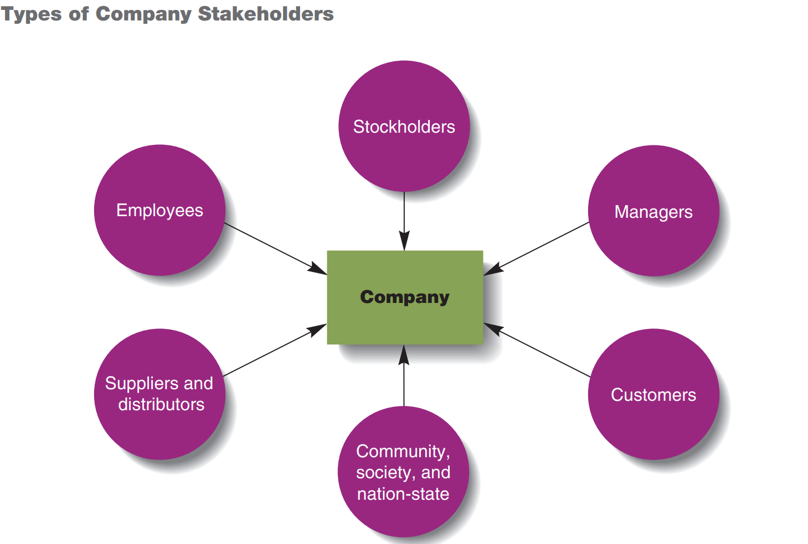

To conduct a stakeholder’s analysis, there is need to identify the primary and secondary stake holders and what effect each group forms on any strategic decision.

Primary stakeholders constitute shareholders, employees, suppliers, customers, and creditors. These are primary stakeholders because they are directly affected by or connected to the firm’s decision and are perceived to have a high influence or bargaining power to the firm’s decisions.

Secondary stake holders have an indirect connection with the firm’s activities but are affected by the firm’s decision. These include governments, local communities, competitors, activists and trade associations. This group of stake holders come onboard when they are affected but usually stay silent towards the firm’s activities. The existing relationship with each of these stakeholders is usually not covered by any written or verbal agreement, there is room for misunderstanding. For example the change by MTN Uganda from selling physical scratch cards to e-wallet airtime purchase affects each group of stake holders in a certain way but have no greater influence in the decision making.

The last stage in stakeholder analysis is to evaluation the effect on each stakeholder group on any particular strategic decision. Since the primary decision principles used by management is generally economic, secondary stakeholders may be disregarded as insignificant. For any firm to satisfy both ethical and discretionary responsibilities, wishes and wants of the secondary stake holders need to be considered.

## 2.5. Question5.

## Given that people rarely use a company’s code of ethics to guide their decision making, what good are the codes?

Ethics refer to the inner guiding moral principles, values, and beliefs that people use to analyze or interpret a situation and then decide on the right or appropriate way to behave or course of action. A code of ethics describes how an organization expects its employees to behave while delivering at the assignments and further asserts that organization expect the managers to consider the codes in any decision making.

An organization with a code of conduct stands out, as it has a commitment to ethical behaviors. Companies with strong ethical cultures and enforced codes of conduct have numerous benefits as listed below;

* An organization with a code of ethical behavior improves supplier relationship along the distribution chain.
* Attracts stakeholder buy in which supports growth and expansion overtime.
* Ethical behavior builds good reputation.
* Promotes ease to access resources and promotes utilization to the benefit of the company and stakeholders.
* Attracts new shareholders at the stock trading.
* Applicant’s skilled managers and employees to the company.
* Avoids churn -customers turning to the products of more reputable companies
* Increases national standard of living, well-being, and prosperity.
* Increases company performance.
* Increases efficiency and effectiveness of production and trade.

# **3. Conclusion**

The business environment is becoming complex and dynamic and players have to constantly engage in industry trends and innovations to sustain any competitive advantage. This is called for due to the hyper competition that barely allows any organization to hold on to the competitive advantage.

Another learning is that of ethical decision dilemmas faced by managers while performing their roles. Managers are tasked to act ethically to the benefit of all stakeholders, this calls for stakeholder analysis and evaluation to identify the primary and secondary stakeholders .For Managers to behave similarly, in a guided way of doing business, managers must establish a code of conduct and cascade it the company employees through coaching’s, trainings and seminars.

Lastly, businesses operate with core values of making profit and reporting to shareholders. They however need to operate responsibly and fulfil obligations a company has toward the people and groups affected by its activities for example; employees, customers, suppliers, government or the cities in which it operates.

# **4. STRATEGIC PRACTICE EXERCISES**

It was certainly not the first time it had happened to the new social gaming company, but it was more of a worry this time. It was taking a lot longer to release the first version of the game being designed than had ever been anticipated. The firm had raised money four times already, but this round was more of an issue. The company probably needed an additional US$25 million, and more and more it was looking like the sales projections were far too optimistic.

The original idea for the game had morphed quite a bit and now was slated to use Facebook as its platform. The problem had occurred during the almost three years it had taken to bring the product to market. Two other games had been released that had taken the wind out of the new offering. Knowing this, the company had quietly begun work on a new gaming platform. The problem was that it would take another 18 months before it has any marketability, and investors were unlikely to provide the type of valuations the company needed to keep afloat. The key to raising the funds needed was to keep talking about the existing game and getting it released into the market. Private company valuations and market potential is difficult under the best circumstances. They are not required to provide audited financials, the risk of failure is quite high, and sales projections are at best a guess. They do not exist in the marketplace, so there is no history from which to judge their performance. In addition, competitor reactions to their entry is unknown. All of this is hard enough for investors, let alone the issue of management trying to hide known issues. The management of the business is convinced that they can be a big player in the market with their newer product, however to get there they need the finances that may only be available if they act as if the product closer to release will be THE ONE.

## 4.1. What should the manager do?

Manager should set priorities and use resources in order to strengthen the operations and plan the release of the game that was financed. Investors need true feedback to re-judge their decision of reinvestment. The managers should release the draft and remold the existing product to accommodate the new features anticipated to outmatch the current competition. This way investors will be quick to commit funds.

## 4.2. Why do you believe so?

Investment is information based, with the right set of information on the business status and transparency of how funds committed have been utilized. The funders will act on the availed truth of and the managers will have acted ethical.

## 4.3. What are the ethical implications of your decision?

Financial transparency

Its good practice for all Managers to play transparently when dealing with the organization’s funds and those from the fundraising source. The managers are encouraged to share accountability by disclosing the expenses against the collections. This supports to show the position from the projections and allows basis for managers to ask investors to add additional capital.

Implementing the code of Ethics; In order to build investor confidence, the managers need to establish a code of conduct to lay out guiding principles to be followed in the execution of business goals. This portrays the managers as trust worthy and honest which builds confidence and attract support from the investors.

Curbing aggressive tendencies, Managers should reach out to the public and promote the cause. If the managers come out for another call for money, it will be a very aggressive and assertive move. Too much focus on money may lead to the collapse of the goal.

# **5. Bibliography**

D'Aveni, Richard A. *Hypercompetition Drives Business into the 21st Century* Kevin C. Naff. April 1995.

Gareth R Jones, Jennifer M George. *Contemporary Management*. New York: McGraw-Hill Education, 2016.

Philip Kotler, John A. Caslione. *Chaotics : The Business of Managing and Marketing in the Age of Turbulence*. New York: American Management Association, 2009.

Thomas L. Wheelen, J David Hunger, Allan N Hoffman, Charles E Bamford. *Strategic Management and Business Policy. Globalisation,Innovation and Sustainability*. Harlow: Pearson Education Limited, 2015.