**Your name**

**UB70199BBU79348**

Your Work or Academic Experience for QALP

**BEING THE DIRECTOR OF GROWTH FOR MIMA4U BRAND**

ATLANTIC INTERNATIONAL UNIVERSITY

**April 2022**

Answer the following questions that apply to your work or academic experience:

(Please include photos, graphs or other illustrations, if you have them.)

In the following questions, the word “project” refers to your experience. Some examples are academic research, publication, recognition of community service, course, conference presentation, work experience. There are many more options for you to receive QALP credits. Describe your experience in the answers below.

1. Describe the project that you want credits for?

**Ans: I would like to request for credits for being the Growth Director for Mima4U Brand a consulting and snacks Production Company in Nigeria to my results. The pictures that I have attached below are I with the founder of the organization as well as some of the flyer of the snacks that is being produced in the Organization.**

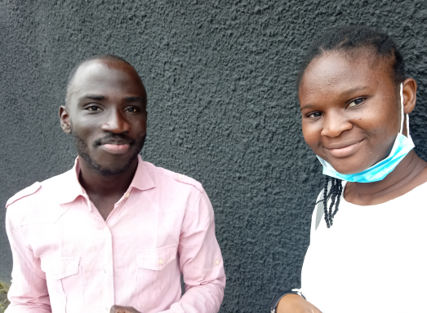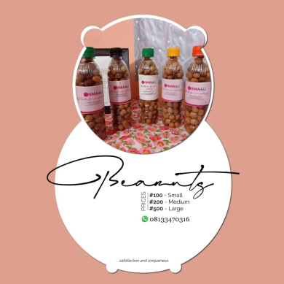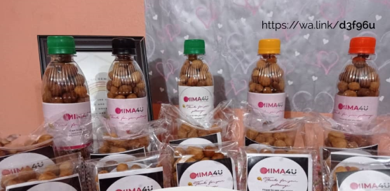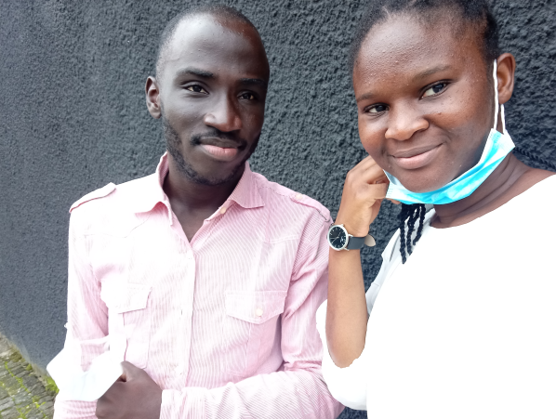

2.Are you currently working on the project? What are the dates in which you worked on this project?

**Ans: Yes I am currently working on this project role and I have been on this journey for almost the last year till now despite my busy schedule I hope to make this journey continue to last for the next 4 years in building and watching this brand expand.**

1. What activities did you do in the project?

**Ans: Mima4u is one experience that I had enjoyed especially being able to contribute to a project that has the effect of Sustainable Development Goals in one way or the other. I contributed to the part of the growth and expansion plan, helping to share my knowledge into some of the capstone project that needs to be addressed to different organizations that needs to see some of the effects of things that we officially do in the organization. In the picture train below you would find some screenshots of the different pages of things that I have shared with the founder of the organization together**

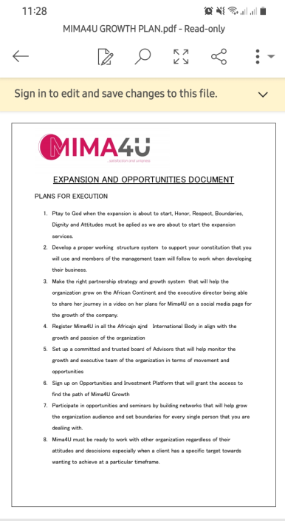 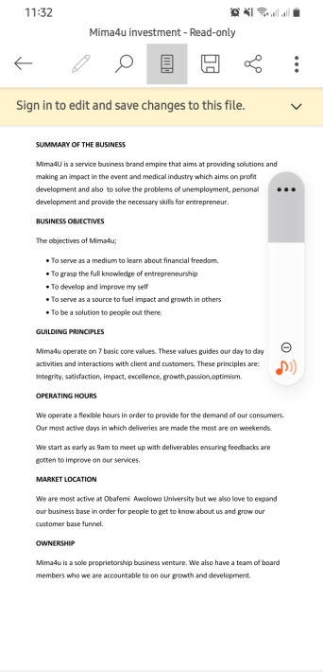 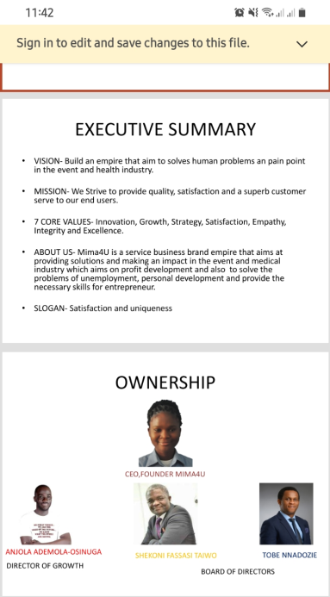 **For more information related to the organization. They can be emailed on** [**mima4uempire@gmail.com**](mailto:mima4uempire@gmail.com)

4. What did you learn in the project?

**Ans: One thing that I have learnt from this project is that giving people the necessary information that they need to be able to grow their journey is very important in ones career as you proceed which was the greatest example that the founder has officially displayed especially when you are someone that your team mates can understand your perspective. One thing I have also learnt never give people full conclusion of an assignment when you still do not have some of the necessary information that is necessary for you to have in order to grow your career.**

5. What did you do to complete the project?

**Ans: This project is on and still not complete yet until the day I decide to step down from this particular project but one thing I still intend to do with her is to be able to explore solutions on different steps that I can leave my legacy behind for my name to always be remembered wherever she and the entire team goes to as a trusted partner because I understand that people find it hard in the aspect of building relationships with one another in their different criteria sector as the organization proceed for growth**

6. How does this project relate to your major at AIU?

**Ans: Mima4U relates to my major of Business Administration at AIU Because my experience with the Organization has challenged some of my course review analysis like some of the things she speaks on when it comes to Total Quality, Strategy Directives and how she continues to speaks into the future plan development goal of the Organization especially setting out to be able to understand some of the analysis of how she chooses to be different from amongst other women in the organization**

7. How can you use the knowledge and experience gained in your project to further human rights and the 17 Goals for a Sustainable World by the United Nations? ([Click here](https://sdgs.un.org/goals) to review the Goals)

**Ans: The first thing that I would like to say that this organization is specifically related to the sustainable development goal 1,2,3,4,5,7 and my experience would help me towards being able to look for sustainable partnership opportunities for the future to be able to expand the plan to grow the business as well and being able to create relevance to the community.**

Include a bibliography of any references that would support this report. This is not required but it helps us document your experience.

**Wena.org.ng. 2021. *Mima4U Entrepreneur Details Page*. [online] Available at: <https://www.wena.org.ng/entrepreneur-details-page?id=1d89c246-e89c-4cb6-b760-3b12acb1d549> [Accessed 19 April 2022].**