Student name: Joseph Omani

Student ID: UD38794SEL47456

Prorogram: Doctrate in Electrical Engineering

Advisor: Dr. Kanbiro Orkaido

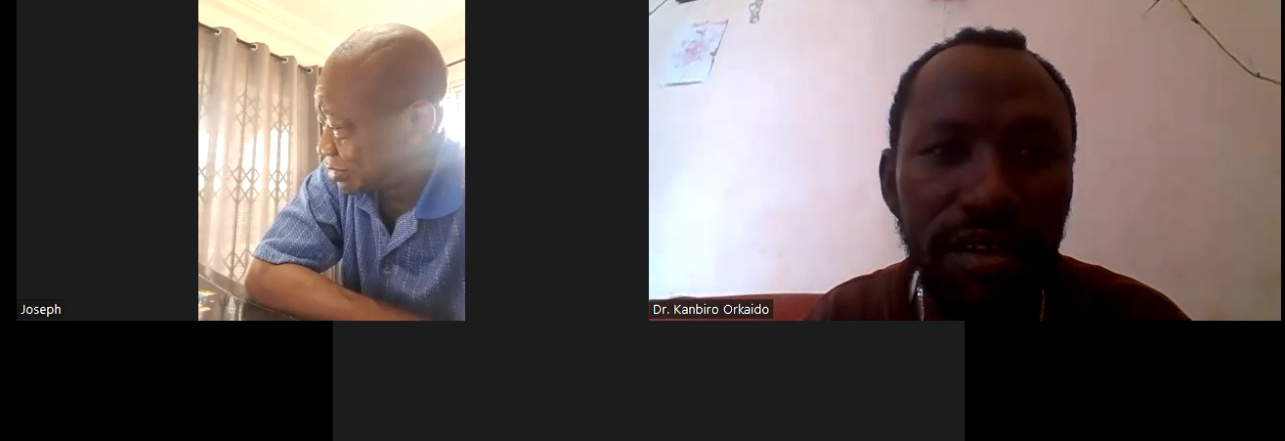

Course evaluated in QALP: Engineering Research Publications

Course Objective for Engineering Publications:

To develop the necessary skills and knowledge required for effective engineering publications, including technical writing, editing, and presentation of engineering reports, papers, and other documents.

Course Description:

The course on engineering publications focuses on equipping students with the essential skills and techniques needed to create and present engineering documentation. It covers fundamental concepts of technical writing, editing, formatting, and organizing information for various engineering publications. Students will learn how to communicate complex engineering ideas and concepts through effective written and visual communication. The course also emphasizes the ethical considerations and standards related to engineering publications.

Here are 20 multiple-choice questions with their corresponding answers for engineering publications:

1. Which of the following is a key objective of engineering publications?

a. Exploring theoretical concepts

b. Developing practical skills

c. Enhancing teamwork abilities

d. Improving physical fitness

Answer: b. Developing practical skills

2. What is the purpose of technical writing in engineering publications?

a. To confuse the readers with complex terminology

b. To provide precise and concise information

c. To entertain readers with anecdotes

d. To promote personal opinions

Answer: b. To provide precise and concise information

3. Which of the following is an example of an engineering publication?

a. Novels

b. Research papers

c. Poetry collections

d. Short stories

Answer: b. Research papers

4. Which of the following should be considered when formatting engineering publications?

a. Using informal language

b. Overusing jargon and acronyms

c. Inconsistent font styles and sizes

d. Plagiarizing from other sources

Answer: c. Inconsistent font styles and sizes

5. What should be included in the introduction of an engineering publication?

a. Detailed experimental results

b. Personal anecdotes

c. Clear objectives and background information

d. Casual conversation with readers

Answer: c. Clear objectives and background information

6. What is the purpose of citing sources in engineering publications?

a. To make the paper seem more professional

b. To acknowledge the original authors' work

c. To fill up space in the references section

d. To confuse the readers with excessive references

Answer: b. To acknowledge the original authors' work

7. What is the recommended tense to use in engineering publications?

a. Present tense

b. Future tense

c. Past tense

d. All tenses can be used interchangeably

Answer: a. Present tense

8. Which of the following is an example of a primary engineering source?

a. A popular science article discussing a research paper

b. A conference paper presenting original research findings

c. A textbook summarizing various engineering principles

d. A blog post written by an engineering enthusiast

Answer: b. A conference paper presenting original research findings

9. Why is it important to proofread engineering publications before submission?

a. To make the paper longer

b. To eliminate typographical errors and grammatical mistakes

c. To add more complex technical terms

d. To ensure plagiarism is included

Answer: b. To eliminate typographical errors and grammatical mistakes

10. What is the purpose of an abstract in an engineering publication?

a. To include a table of contents

b. To highlight key findings and conclusions

c. To express personal opinions

d. To include personal contact information

Answer: b. To highlight key findings and conclusions

11. Which of the following is an example of a data visualization technique in engineering publications?

a. Line chart

b. Novel excerpt

c. Rhetorical question

d. Personal anecdote

Answer: a. Line chart

12. How should equations be presented in engineering publications?

a. In a handwritten format for authenticity

b. With multiple different fonts

c. In a consistent and standardized manner

d. Without any mathematical operations

Answer: c. In a consistent and standardized manner

13. When using images and figures in engineering publications, what is the appropriate way to credit the source?

a. No need to credit the source

b. Provide a detailed caption without citation

c. Include the source in the reference section

d. Manipulate the images to avoid copyright issues

Answer: c. Include the source in the reference section

14. What is the purpose of an executive summary in an engineering publication?

a. To include an anecdote related to the research

b. To outline the experimental methodology in detail

c. To provide a concise overview of the entire publication

d. To highlight the limitations of the research

Answer: c. To provide a concise overview of the entire publication

15. Which of the following is an example of a secondary engineering source?

a. A research paper presenting original findings

b. A textbook summarizing various engineering principles

c. A blog post written by an engineering enthusiast

d. A newspaper article discussing the latest engineering breakthroughs

Answer: d. A newspaper article discussing the latest engineering breakthroughs

16. What is the purpose of conclusions and recommendations in engineering publications?

a. To provide an overview of the research topic

b. To present potential areas for future investigations

c. To include personal opinions about the research

d. To criticize the methods used in the research

Answer: b. To present potential areas for future investigations

17. How can one improve the readability of engineering publications?

a. Using excessive jargon

b. Including long paragraphs without breaks

c. Providing relevant headings and subheadings

d. Avoiding any visual aids or illustrations

Answer: c. Providing relevant headings and subheadings

18. Which of the following is an example of an ethics consideration in engineering publications?

a. Including personal beliefs without evidence

b. Using technical terms without

c. Plagiarizing content from various sources

d. Citing original ideas and providing proper credit

Answer: d. Citing original ideas and providing proper credit

19. How can feedback be beneficial for improving engineering publications?

a. By ignoring any feedback received

b. By blindly accepting all suggested changes

c. By evaluating feedback and making necessary revisions

d. By arguing against any criticism received

Answer: c. By evaluating feedback and making necessary revisions

20. Which of the following software tools can assist in creating professional engineering publications?

a. Spreadsheet software

b. Graphic design software

c. Social media platforms

d. Video editing software

Answer: b. Graphic design software