Student name: Watts Elliot Mwila

Student ID: UM70759BCO79912

Masters in communication management

Advisor: Dr. Kanbiro Orkaido

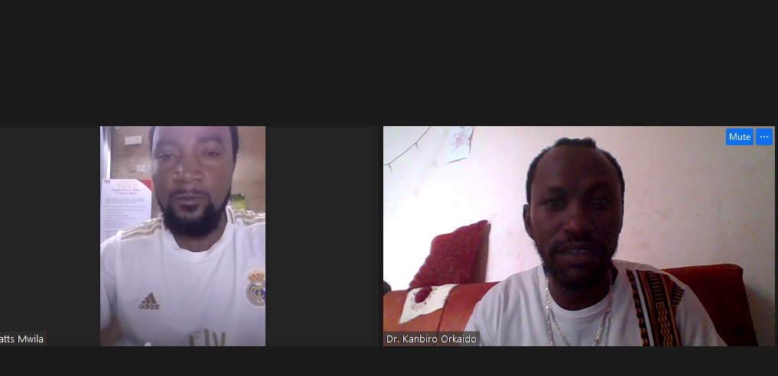

Course: Final Evaluation Project (TDF 330)

1. Hello, my name is Watts Elliot Mwila, and I am from Zambia. I am a Advertising businessman. I earned diploma in marketing and journalism I now am studying Masters in communication management at AIU.
2. This program has greatly improved my career and income. The knowledge and skills I gained from my degree have helped me become more effective in managing advertising business. I have been able to apply various business strategies taught in the program, resulting in increased profits and growth for my company.
3. Reaching my maximum potential represents the achievement of my highest level of success and personal growth. It means pushing me to excel in all areas of my life, both personally and professionally.
4. I plan to apply the expertise I gained from my AIU program in every aspect of my life and work. I will utilize the business knowledge and skills to make informed decisions, manage my resources effectively, and identify and seize opportunities for growth.
5. The AIU program has brought about significant positive changes in my life. It has not only broadened my knowledge in business administration but also improved my critical thinking, problem-solving, and communication skills. These changes have empowered me to overcome challenges more effectively and make well-informed decisions in both my personal and professional life.
6. My next goal for exponential growth is to expand my real-estate business internationally. I aim to establish partnerships with international investors and ventures that will enable me to diversify my communication and increase my global presence.
7. In the next year, I have three goals I wish to accomplish:
8. Increase my advertising business revenue by 20% through effective marketing strategies and successful property acquisitions.
9. Develop and implement a sustainable corporate social responsibility program for my company to give back to the community and make a positive impact.
10. Acquire additional professional certifications and attend industry conferences to stay updated with the latest trends and advancements in the communication industry.
11. Success is an ongoing journey, and I believe it is not about a specific timeline. Rather, it is about consistently working towards my goals, evolving, and continuously improving myself and my business.
12. For graduation, I plan to participate in the AIU graduation ceremony when the schedule aligns with my availability. As for when I see myself graduating from AIU, I aim to complete my PhD degree within the next two years, considering my current progress and dedication to my studies.

Thank you so much.