**Osondu Godwin Atagbuzia**

**ID: UD76399HHi85586**

COURSE NAME:

**Using Excel for Statistics**

Assignment Title:

**Regression Line Analysis**

ATLANTIC INTERNATIONAL UNIVERSITY

**03/2022**

**Introduction**

This work is to show how easy it is to analyse data using regression analysis.

Create both independent and Dependent columns, x and y.

**Body of Assignment**

The Independent and Dependent data were created using a random dependent data, and plotted as shown in the scattered plot below.

A trendline was determined, showing the linear equation and the r-squared. Statistical data analysis was done using regression, and the analysis results are exactly similar to the trendline linear equation obtained.

From the regression analysis of the data, it could be seen that as move 3 feet away from he hat, the dependent data declines by 51%.

|  |  |  |  |  |  |  |  |  |  |  |  |  |  |  |  |
| --- | --- | --- | --- | --- | --- | --- | --- | --- | --- | --- | --- | --- | --- | --- | --- |
| |  |  | | --- | --- | | x (ft) (Ind) | y (Dep) | | 3 | 9 | | 6 | 7 | | 9 | 6 | | 12 | 4 | | 15 | 3 | | 18 | 1 | |  |
|  |  |

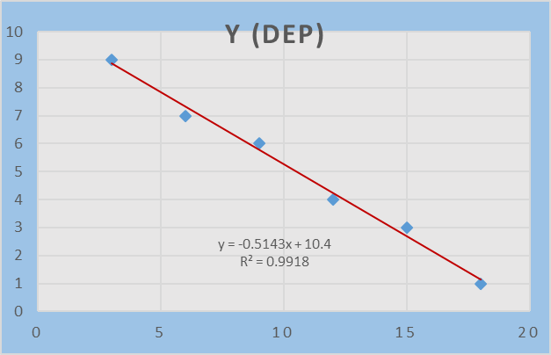

|  |  |  |  |  |  |  |
| --- | --- | --- | --- | --- | --- | --- |
| SUMMARY OUTPUT | |  |  |  |  |  |
|  |  |  |  |  |  |  |
| *Regression Statistics* | |  |  |  |  |  |
| Multiple R | 0.99591 |  |  |  |  |  |
| R Square | 0.991837 |  |  |  |  |  |
| Adjusted R Square | 0.989796 |  |  |  |  |  |
| Standard Error | 0.29277 |  |  |  |  |  |
| Observations | 6 |  |  |  |  |  |
|  |  |  |  |  |  |  |
| ANOVA |  |  |  |  |  |  |
|  | *df* | *SS* | *MS* | *F* | *Significance F* |  |
| Regression | 1 | 41.65714 | 41.65714 | 486 | 2.51E-05 |  |
| Residual | 4 | 0.342857 | 0.085714 |  |  |  |
| Total | 5 | 42 |  |  |  |  |
|  |  |  |  |  |  |  |
|  | *Coefficients* | *Standard Error* | *t Stat* | *P-value* | *Lower 95%* | *Upper 95%* |
| Intercept | 10.4 | 0.272554 | 38.15757 | 2.82E-06 | 9.643269 | 11.15673 |
| x (ft) (Ind) | -0.5143 | 0.023328 | -22.0454 | 2.51E-05 | -0.57906 | -0.44952 |
|  |  |  |  |  |  |  |
|  |  |  |  |  |  |  |
|  |  |  |  |  |  |  |
| RESIDUAL OUTPUT | |  |  |  |  |  |
|  |  |  |  |  |  |  |
| *Observation* | *Predicted y (Dep)* | *Residuals* |  |  |  |  |
| 1 | 8.857143 | 0.142857 |  |  |  |  |
| 2 | 7.314286 | -0.31429 |  |  |  |  |
| 3 | 5.771429 | 0.228571 |  |  |  |  |
| 4 | 4.228571 | -0.22857 |  |  |  |  |
| 5 | 2.685714 | 0.314286 |  |  |  |  |
| 6 | 1.142857 | -0.14286 |  |  |  |  |

**Conclusion**

This is how to use Excel for statistical data analysis.

**Bibliography**

Webinar Video, 2021