**Student Name: Quist Mirable Jethro**

**Student ID Number: UD66933SC175995**

COURSE NAME: **Nutrition and Mental Health**

Assignment Title: **Nutrition and Mental Health**

ATLANTIC INTERNATIONAL UNIVERSITY

**DECEMBER /2021.**

**Introduction**

The direct relationship between good nutritional quality, psychological well-being and the development of our brain is increasingly evident. A poor diet can be associated with the development of certain mental illnesses. In people with some type of mental illness, there is a lack of certain nutrients.

Mental illnesses, such as depression, are disorders with multifactorial etiology, which we could not say that they only depend on one factor. However, the influence of diet on these diseases has been ignored for a long time, and there are more and more studies that directly link these conditions with diet.

Study reveals a link between certain diets and their impact on mental health. Poor diets, researchers say, play a role in worsening mood disorders, such as anxiety and depression. However, diets rich in vegetables and olive oil, such as the Mediterranean diet, can improve symptoms of depression and anxiety.

**Source:**ECNP

**A new expert review confirms that diet significantly influences mental health and wellbeing, but cautions that the evidence for many diets is comparatively weak. This, the most up to date overview of the new field of Nutritional Psychiatry, is produced, by the Nutrition Network of the ECNP and is published in the peer-reviewed journal *European Neuropsychopharmacology*.**

Lead author, Professor Suzanne Dickson (University of Gothenburg, Sweden) said:

“We have found that there is increasing evidence of a link between a poor diet and the worsening of mood disorders, including anxiety and depression. However, many common beliefs about the health effects of certain foods are not supported by solid evidence”.

The researchers found that there are some areas where this link between diet and mental health is firmly established, such as the ability of a high fat and low carbohydrate diet (a ketogenic diet) to help children with epilepsy, and the effect of vitamin B12 deficiency on fatigue, poor memory, and depression.

They also found that there is good evidence that a Mediterranean diet, rich in vegetables and olive oil, shows mental health benefits, such as giving some protection against depression and anxiety. However, for many foods or supplements, the evidence is inconclusive, as for example with the use of vitamin D supplements, or with foods believed to be associated with ADHD or autism.

“With individual conditions, we often found very mixed evidence”, said Suzanne Dickson. “With ADHD for example, we can see an increase in the quantity of refined sugar in the diet seems to increase ADHD and hyperactivity, whereas eating more fresh fruit and vegetables seems to protect against these conditions. But there are comparatively few studies, and many of them don’t last long enough to show long-term effects”.

The study confirms that while certain foods can be associated with a mental health condition, this tells us little about why the food causes this effect. It concludes that the need to link mental health effects with provable dietary causes needs to be the main focus of future research in nutritional psychiatry.

Professor Dickson continued:

“There is a general belief that dietary advice for mental health is based on solid scientific evidence. In reality, it is very difficult to prove that specific diets or specific dietary components contribute to mental health.

The scientists confirmed that some foods had readily provable links to mental health, for example, that nutrition in the womb and in early life can have significant effects on brain function in later life. Proving the effect of diet on mental health in the general population was more difficult.

Suzanne Dickson said “In healthy adults dietary effects on mental health are fairly small, and that makes detecting these effects difficult: it may be that dietary supplementation only works if there are deficiencies due to a poor diet. We also need to consider genetics: subtle differences in metabolism may mean that some people respond better to changes in diet that others.

There are also practical difficulties which need to be overcome in testing diets. A food is not a drug, so it needs to be tested differently to a drug. We can give someone a dummy pill to see if there is an improvement due to the placebo effect, but you can’t easily give people dummy food. Nutritional psychiatry is a new field. The message of this paper is that the effects of diet on mental health are real, but that we need to be careful about jumping to conclusions on the base of provisional evidence. We need more studies on the long-term effects of everyday diets”.

[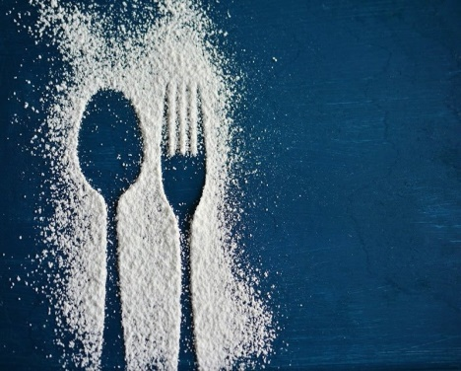](https://neurosciencenews.com/files/2020/01/diet-mental-health-neurosciecnenews-public.jpg)

The scientists confirmed that some foods had readily provable links to mental health, for example, that nutrition in the womb and in early life can have significant effects on brain function in later life. Proving the effect of diet on mental health in the general population was more difficult. Image is in the public domain.

<https://neurosciencenews.com/files/2020/01/diet-mental-health-neurosciecnenews-public.jpg>

“The interface between gut and the brain on the one side and diet and mental health on the other side is one of the most debated issues in biological psychiatry at the moment, and is an exciting development which has gained momentum in the last decade. Many high-quality findings (mainly from animal studies) have been published in top notch journals in recent years, but this contrasts with the comparative shortage of hard evidence on how nutrition and mental health are connected in humans. This leaves room for speculation and flawed science. This comprehensive review is therefore much-needed as it sheds light on hypes and hopes, facts and fiction in the new field of Nutritional Psychiatry. As the potential societal impact of this rapidly developing field is enormous, we must be scientifically sound in making our recommendations. This review is an important and scholarly contribution”.

**What is the relationship between poor nutrition and mental health?**

Both these inequality factors have also been shown to have a complex relationship with poor nutrition 4. Experience of a mental health problem may also be associated with poorer diet and physical health.

How are nutrition and mental health linked?

Healthy eating helps children and young people cope more effectively with stress, better manage their emotions and get a good sleep – all of which assist learning.

Most research about nutrition and mental health has focused on adults. I know that good nutrition is associated with better mental health outcomes, whereas a poor diet is associated with a greater risk of depression and anxiety. However, emerging research that focuses on children and young people has also found a relationship between unhealthy diets and poorer mental health outcomes. 

Poor nutrition has been associated with:

* externalising behaviour (such as hyperactivity, aggression, disobedience)
* symptoms of attention deficit hyperactivity disorder
* poor concentration and tiredness, which interfere with learning
* immune system function, which is also linked to mental health
* delayed brain development – high-fat, high-sugar diets can affect proteins in the body that are important for brain development
* iron deficiency, which has been linked to cognitive function impairments associated with learning and memory
* nutrient deficiencies, which have been associated with mental health conditions including depression and anxiety (we know that fruits and vegetables, grains, fish, lean red meats and olive oils are rich in important nutrients such as folate, magnesium, vitamins and zinc which all impact on body and brain functions, including mood regulation).

**Dietary habits are not always a choice**

‘Food insecurity’ – where people do not have enough food due to because of things such as unemployment and poverty – is also a problem for many families in Australia. Food insecurity can result in poorer academic performance, time off from school, stress, depression, anxiety, aggression, and difficulty getting along with others. Food insecurity can result in:

* psychological stress – high levels of ongoing stress have been related to depression and delayed brain development
* poorer academic performance
* time off from school
* anxiety
* aggression
* difficulty getting along with others.

The good news is that improving what I eat can lead to improvements in your mental health, so it’s never too late to encourage healthier eating patterns.

What if I told you that your poor nutrition may be responsible for your mental health issues? Various studies show the link between the two.

Diets have always been discussed and debated as a way to improve health with no clear outcomes. Losing weight, looking and feeling better, **having more energy and sleeping better** are all objectives when starting a diet. But what about the link between poor nutrition and brain health?

Can the foods we eat have an effect on our state of mind? Mental challenges and illnesses seem to be cropping up in the news almost daily.

One famous individual admits to having suffered from a stress disorder, another fought addiction to depression medication. Even some of the horrible crimes that are committed address the fact that the perpetrator was being treated for some type of mental illness.

What is causing these conditions?

More types of depression, anxiety, and diseases of the mind are being discovered at an alarming rate and the medical community is trying to combat them with drugs and chemicals.

Studies are now showing that many of these conditions appear to be linked to poor nutrition. Lack of certain vitamins, minerals, enzymes, amino acids, omega-3 fatty acids and other nutrients can lead to conditions affecting the mind.

This then can cause overmedicating, dependence on [drugs and alcohol](https://www.lifeadvancer.com/alcohol-addiction/), sleeping excessively, and a list of other unfavorable results leading to an even faster downward spiral.

Studies of poor nutrition and mental health

The evidence is suggesting that even before we are born, there may be a link between poor nutrition and mental health. A [study of 23,000 mothers and their children](http://www.jaacap.com/article/S0890-8567%2813%2900449-8/abstract) conducted in 2013 showed that **consuming sugars and processed foods** in the pregnancy stage can affect the mental health and behavior of the child at age five.

Gut bacteria are another aspect being looked at for the causes of mood swings, anxiety, and emotional outbursts. Rebecca Scritchfield, a registered dietician, offers a basic look at the research done on the digestive system and its communication with our brain in a digital series called #OWNSHOW.

Sugar has been identified as detrimental to brain activity in a study done in 2012, which found the evidence that sugar affects memory and the ability to learn.

Past Studies Unreliable

Dr. Gene Bowman of the Oregon Health and Science University states that getting the correct information is causing difficulty in studies which try to clarify what nutrients do and how they affect the brain.

He claims that using dietary surveys is not reliable because people don’t remember what they’ve eaten, especially in cases of those with advanced age or at risk of dementia. Dr. Bowman instead uses blood samples from the participants, which clearly show the nutrients in the bloodstream.

Current Findings Released

Dr. Bowman has attracted attention with two of his findings. One showed that those with high plasma levels of B, D, E and C vitamins showed a total brain volume and better cognitive functioning. Another showed that marine Omega-3 fatty acids in the bloodstream gave people **better executive functioning**.

Most recently, his study called “Nutrient Biomarker Patterns, Cognitive Function, and MRI Measures of Brain Aging” and published in Neurology showed dramatic patterns of what foods people eat and how the brain works.

Another new study showed that [seniors with healthy diets tested better](https://www.huffingtonpost.com/2011/12/29/brain-food-nutrients-sharp-vitamins_n_1173876.html) for mental acuity than those of the same age who had poor nutrition and ate junk food.

Chemicals in the Brain Regulate Mood

Called neurotransmitters, these potent chemicals are affected by certain foods and contribute to their manufacture. Sleep patterns, better moods, higher pain tolerance and even energy levels are all affected by these four neurotransmitters.

* [**Serotonin**](https://www.lifeadvancer.com/low-levels-of-serotonin/) – boosted by eating complex carbohydrates.
* **Dopamine and norepinephrine** – enter the bloodstream by eating proteins.
* **Acetylcholine** – manufactured from choline, a B vitamin, influences memory and learning.

Depression-Fighting Foods

The most recent finding in research about depression and food shows that it’s a nutrient imbalance that might be causing some forms of depression. The most notable lack in diets of people with depression was fish fats.

Oily fish contains Omega-3 fatty acids, eicosatetraenoic acid (EPA) and docosahexaenoic acid (DHA), both highly concentrated in the brain tissue and found to play a significant role in nerve function and mood regulation.

Other foods that combat depression includes:

* Turkey
* Walnuts
* Low-fat dairy
* Whole grains
* Green tea
* Turmeric

Fermented Foods to Combat Low Mental Moods

It is not certain how the connection between food and mood works, but there is evidence that eating fermented foods enhances mental focus and clarity.

Some of these foods are laden with good bacteria for the gut. **The examples include**:

* Yogurt
* Kefir
* Soy Sauce
* Tempeh
* Kimchi

I have to check the labels to be sure they are filled with live and active cultures. Basically, they have been naturally fermented and add to the helpful bacteria in the gut.

I do not Underestimate Poor Nutrition

It is clear that certain foods, according to recent research, contribute to poor mental health, and other foods enhance it.

Serotonin, one of the mood regulators in the body, is made by gut bacteria and so if the gut is unhealthy, **so is the brain**. Eating a healthy diet does not point to curing mental illnesses, but it seems to aid in controlling mood swings and depression.

It does take time to incorporate a healthier diet, but the results are conclusive. I do not have to give up my favorite things either. Dark chocolate is one of the well-known mood enhancers and [one study shows that having ice cream for breakfast](https://www.lifeadvancer.com/eating-ice-cream-make-smarter/) can make me smarter.

• **What is the relationship between poor nutrition and mental health?**

Both these inequality factors have also been shown to have a complex relationship with poor nutrition 4 . Experience of a mental health problem may also be associated with poorer diet and physical health.

[Diet and mental health | Mental Health Foundation](https://www.mentalhealth.org.uk/a-to-z/d/diet-and-mental-health)

www.mentalhealth.org.uk/a-to-z/d/diet-and-mental-health

**Diet can affect my mental health**

Scientists confirmed that some foods had readily provable links to mental health, for example, that nutrition in the womb and in early life can have significant effects on brain function in later life. Proving the effect of diet on mental health in the general population was more difficult. Image is in the public domain.

[How diet affects mental health - Neuroscience News](https://neurosciencenews.com/diet-mental-health-15384/)

neurosciencenews.com/diet-mental-health-15384/

**Effects of a poor diet have on physical health.**

Everyone knows the effects that a poor diet can have on our physical health. In the long term, a diet high in fat and sugar can lead to obesity, diabetes, cardiovascular disease and a huge range of other physical ailments. And in the short term, a poor diet lacking in nutrients can make us fatigued, lethargic and interrupt our ability to concentrate.

[The Role of Diet in Memory and Mental Health](https://www.melbournechildpsychology.com.au/blog/the-role-of-diet-in-memory-and-mental-health/)

www.melbournechildpsychology.com.au/blog/the-role-of-

**There a link between diet and depression**

Study reveals a link between certain diets and their impact on mental health. Researchers say poor diets play a role in worsening mood disorders, such as anxiety and depression. Diets rich in vegetables and olive oil, such as the Mediterranean diet, can improve symptoms of depression and anxiety.

[How diet affects mental health - Neuroscience News](https://neurosciencenews.com/diet-mental-health-15384/)

neurosciencenews.com/diet-mental-health-15384/

**•**  [**Poor Diet Predict Mental Illness - SOVA**](https://sova.pitt.edu/educate-yourself-can-a-poor-diet-predict-mental-illness)

https://sova.pitt.edu/educate-yourself-can-a-poor-diet-predict-mental-illness

14/11/2018 ·

Studies are starting to look at the relationship between food and **mental** health, seeing how one’s **diet** and what they eat **can** affect or even influence the presence of **mental illness.**

Poor Diet Predict Mental Illness

BY [MODERATOR ★](https://sova.pitt.edu/author/moderator) · NOVEMBER 14, 2018



<https://sova.pitt.edu/wp-content/uploads/2018/11/StockSnap_PB8FBPTS2V-768x512.jpg>

**Food**is so much more than gaining energy to get through the day. A lot of people see food as an experience: others see cooking as therapeutic, eating with others as a way to deepen relationships, and taking photos of their food and posting them as a hobby. This does not even account for how *good* food can taste, given the variety in cuisine and combinations.

Because of its importance and presence, especially for adolescents as they enter a rapidly developing stage in their lives, food can also be a huge influence in other parts of our lives. Studies are starting to look at the **relationship between food and mental health**, seeing how one has diet and what they eat can affect or even influence the presence of mental illnesses.

One [recent article](https://health.usnews.com/health-care/for-better/articles/2018-10-24/how-sugar-and-poor-diet-affect-teen-mental-health) explored this, focusing on a poor diet, and particularly how sugar can impact a teenager’s mental health. In it, they explained the results of a study that showed that men who consumed 67 grams of sugar a day were 23% more likely to be diagnosed with depression than those who ate under 40 grams, as well as how teenage girls who consumed fast and processed food were associated with a higher risk of depression. These sorts of results can have a huge impact on adolescents in general, not just because they are more at risk for mental illnesses, but youths are often the key demographic when it comes to marketing. The bright colors and cartoonish imagery in advertisements for sodas, sugary cereals, and processed snacks are meant to target those who are younger.

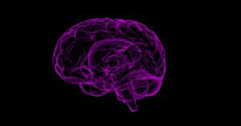

<https://sova.pitt.edu/wp-content/uploads/2018/11/brain-1787622_1920-300x158.jpg>

Another [study](https://www.ncbi.nlm.nih.gov/pmc/articles/PMC4167107/pdf/AJPH.2014.302110.pdf) back in 2014 also looked into previous research to see if there was any overlap between a poor diet and mental health in children and adolescents. While not as strong, the results were still similar, the relationship was still there. This study went into more detail as to why this relationship exists, giving one example that the nutrients found in healthier food, such as magnesium and zinc was inversely associated with depressive disorders. This means that those nutrients were less likely to be consumed by those who have depressive disorders. Another explanation says that high-fat and high-sugar diets can negatively affect proteins that play a huge role in brain development. This sort of impact can affect how our brain processes things, and therefore can make people more susceptible to mental illnesses.

With this information, we must also keep in mind that **some do not have a choice in their diets**. Eating healthy can be a privilege given the costs of organic products and food alternatives, as well as the accessibility and location of certain grocery stores and restaurants. Depression can influence how much and when we want to eat, and some may eat more as a coping mechanism when they are anxious. Though studies have shown a link between mental health and a poor diet, there are still so many factors to consider as to why there is such a connection.

Few people are aware of the connection between nutrition and depression while they easily understand the connection between nutritional deficiencies and physical illness. Depression is more typically thought of as strictly biochemical-based or emotionally-rooted. On the contrary, nutrition can play a key role in the onset as well as severity and duration of depression. Many of the easily noticeable food patterns that precede depression are the same as those that occur during depression. These may include poor appetite, skipping meals, and a dominant desire for sweet foods.

<http://www.healingwell.com/LIBRARY/depression/beardsley/.asp>

Nutritional neuroscience is an emerging discipline shedding light on the fact that nutritional factors are intertwined with human cognition, behavior, and emotions.

The most common mental disorders that are currently prevalent in numerous countries are depression, bipolar disorder, schizophrenia, and obsessive-compulsive disorder (OCD). The dietary intake pattern of the general population in many Asian and American countries reflects that they are often deficient in many nutrients, especially essential vitamins, minerals, and omega-3 fatty acids. A notable feature of the diets of patients suffering from mental disorders is the severity of deficiency in these nutrients. Studies have indicated that daily supplements of vital nutrients are often effective in reducing patients' symptoms. Supplements containing amino acids have also been found to reduce symptoms, as they are converted to neurotransmitters which in turn alleviate depression and other mental health problems. On the basis of accumulating scientific evidence, an effective therapeutic intervention is emerging, namely nutritional supplement/treatment. These may be appropriate for controlling and to some extent, preventing depression, bipolar disorder, schizophrenia, eating disorders and anxiety disorders, attention deficit disorder/attention deficit hyperactivity disorder (ADD/ADHD), autism, and addiction. Most prescription drugs, including the common antidepressants lead to side effects. This usually causes the patients to skip taking their medications. Such noncompliance is a common occurrence encountered by psychiatrists. An important point to remember here is that, such noncompliant patients who have mental disorders are at a higher risk for committing suicide or being institutionalized. In some cases, chronic use or higher doses may lead to drug toxicity, which may become life threatening to the patient. An alternate and effective way for psychiatrists to overcome this noncompliance is to familiarize themselves about alternative or complementary nutritional therapies. Although further research needs to be carried out to determine the best recommended doses of most nutritional supplements in the cases of certain nutrients, psychiatrists can recommend doses of dietary supplements based on previous and current efficacious studies and then adjust the doses based on the results obtained by closely observing the changes in the patient. [Google Scholar](https://scholar.google.com/scholar_lookup?journal=Nutr+Jr&title=Nutritional+therapies+for+mental+disorders&author=SE+Shaheen+Lakhan&author=KF+Vieira&volume=7&publication_year=2008&pages=2&).

When I take a close look at the diet of depressed people, an interesting observation is that their nutrition is far from adequate. They make poor food choices and selecting foods that might actually contribute to depression. Recent evidence suggests a link between low levels of serotonin and suicide. It is implicated that lower levels of this neurotransmitter can, in part, lead to an overall insensitivity to future consequences, triggering risky, impulsive and aggressive behaviors which may culminate in suicide, the ultimate act of inwardly directed impulsive aggression.

[http:/diet.hajimeru.biz/category/health/nutritionj/](http://http/diet.hajimeru.biz/category/health/nutritionj/)

Depression is a disorder associated with major symptoms such as increased sadness and anxiety, loss of appetite, depressed mood, and a loss of interest in pleasurable activities. If there is no timely therapeutic intervention, this disorder can lead to varied consequences. Patients who are suffering from depression exhibit suicidal tendency to a larger degree and hence are usually treated with antidepressants and/or psychotherapy. Deficiencies in neurotransmitters such as serotonin, dopamine, noradrenaline, and γ-aminobutyric acid (GABA) are often associated with depression. As reported in several studies, the amino acids tryptophan, tyrosine, phenylalanine, and methionine are often helpful in treating many mood disorders including depression. When consumed alone on an empty stomach, tryptophan, a precursor of serotonin, is usually converted to serotonin. Hence, tryptophan can induce sleep and tranquility. This implies restoring serotonin levels lead to diminished depression precipitated by serotonin deficiencies.

*National Institute of Mental Health.* 2000.

Tyrosine and sometimes its precursor phenylalanine are converted into dopamine and norepinephrine.

Dietary supplements containing phenyl alanine and/or tyrosine cause alertness and arousal. Methionine combines with adenosine triphosphate (ATP) to produce S-adenosylmethionine (SAM), which facilitates the production of neurotransmitters in the brain.The need of the present paradigm is, more studies shedding light on the daily supplemental doses of these neurochemicals that should be consumed to achieve antidepressant effects. Researchers attribute the decline in the consumption of omega-3 fatty acids from fish and other sources in most populations to an increasing trend in the incidence of major depression.The two omega-3 fatty acids, eicosapentaenoic acid (EPA) which the body converts into docosahexanoic acid (DHA), found in fish oil, have been found to elicit antidepressant effects in human. Many of the proposed mechanisms of this conversion involve neurotransmitters. For instance, antidepressant effects may be due to bioconversion of EPA to leukotrienes, prostaglandins, and other chemicals required by the brain. Others hypothesize that both EPA and DHA influence neuronal signal transduction by activating peroxisomal proliferator-activated receptors (PPARs), inhibiting G-proteins and protein kinase C, in addition to calcium, sodium, and potassium ion channels. Whichever may be the case, epidemiological data and clinical studies have clearly shown that omega-3 fatty acids can effectively treat depression. In depressed patients, daily consumption of dietary supplements of omega-3 fatty acid that contain 1.5-2 g of EPA has been shown to stimulate mood elevation. Nevertheless, doses of omega-3 higher than 3 g do not show better effects than placebos and may be contraindicative in cases, such as those taking anticlotting drugs. In addition to omega–3 fatty acids, vitamin B (e.g., folate) and magnesium deficiencies have been linked to depression.

Randomized, controlled trials that involve folate and vitamin B12 suggest that patients treated with 0.8 mg of folic acid/day or 0.4 mg of vitamin B12/day will exhibit decreased depression symptoms. In addition, the results of several case studies where patients were treated with 125-300 mg of magnesium (as glycinate or taurinate) with each meal and at bedtime led to rapid recovery from major depression in < 7 days for most of the patients. Previous research has revealed the link between nutritional deficiencies and some mental disorders.

The most common nutritional deficiencies seen in patients with mental disorders are of omega–3 fatty acids, B vitamins, minerals, and amino acids that are precursors to neurotransmitters. Accumulating evidence from demographic studies indicates a link between high fish consumption and low incidence of mental disorders; this lower incidence rate being the direct result of omega–3 fatty acid intake.One to two grams of omega-3 fatty acids taken daily is the generally accepted dose for healthy individuals, but for patients with mental disorders, up to 9.6 g has been shown to be safe and effective. Janicak PG, Lipinski , Davis JM, Comaty JE, Waternaux C, Cohen B, et al. S-adenosylmethionine in depression: A literature Review and preliminary report.

Majority of Asian diets are usually also lacking in fruits and vegetables, which further lead to mineral and vitamin deficiencies. The significance of various nutrients in mental health, with special relevance to depression are discussed below.

Carbohydrates

Carbohydrates are naturally occurring polysaccharides and play an important role in structure and function of an organism. In higher organisms (human), they have been found to affect mood and behavior. Eating a meal which is rich in carbohydrates triggers the release of insulin in the body. Insulin helps let blood sugar into cells where it can be used for energy and simultaneously it triggers the entry of tryptophan to brain. Tryptophan in the brain affects the neurotransmitters levels.

Consumption of diets low in carbohydrate tends to precipitate depression, since the production of brain chemicals serotonin and tryptophan that promote the feeling of well being, is triggered by carbohydrate rich foods. It is suggested that low glycemic index (GI) foods such as some fruits and vegetables, whole grains, pasta, etc. are more likely to provide a moderate but lasting effect on brain chemistry, mood, and energy level than the high GI foods - primarily sweets - that tend to provide immediate but temporary relief.

**Proteins**

Proteins are made up of amino acids and are important building blocks of life. As many as 12 amino acids are manufactured in the body itself and remaining 8 (essential amino acids) have to be supplied through diet. A high quality protein diet contains all essential amino acids. Foods rich in high quality protein include meats, milk and other dairy products, and eggs. Plant proteins such as beans, peas, and grains may be low in one or two essential amino acids. Protein intake and in turn the individual amino acids can affect the brain functioning and mental health. Many of the neurotransmitters in the brain are made from amino acids. The neurotransmitter dopamine is made from the amino acid tyrosine and the neurotransmitter serotonin is made from the tryptophan.

[http:/diet.hajimeru.biz/category/health/nutritionj/](http://http/diet.hajimeru.biz/category/health/nutritionj/)

If there is a lack of any of these two amino acids, there will not be enough synthesis of the respective neurotransmitters, which is associated with low mood and aggression in the patients. The excessive buildup of amino acids may also lead to brain damage and mental retardation. For example, excessive buildup of phenylalanine in the individuals with disease called phenylketonuria can cause brain damage and mental retardation.

**Essential fatty acids**

Omega-3 fatty acids

The brain is one of the organs with the highest level of lipids (fats). Brain lipids, composed of fatty acids, are structural constituents of membranes. It has been estimated that gray matter contains 50% fatty acids that are polyunsaturated in nature (about 33% belong to the omega-3 family), and hence are supplied through diet. In one of the first experimental demonstrations of the effect of dietary substances (nutrients) on the structure and function of the brain, the omega-3 fatty acids (specially alpha-linolenic acid, ALA) were the member to take part. An important trend has been observed from the findings of some recent studies that lowering plasma cholesterol by diet and medications increases depression. Among the significant factors involved are the quantity and ratio of omega-6 and omega-3 polyunsaturated fatty acids (PUFA) that affect serum lipids and alter the biochemical and biophysical properties of cell membranes. It has been hypothesized that sufficient long chain PUFAs, especially DHA, may decrease the development of depression.The structural and functional components of membrane in cells of brain which is a lipid-rich organ, include polar phospholipids, spingolipids, and cholesterol. The glycerophospholipids in brain consist of high proportion of PUFA derived from the essential fatty acids (EFAs), linoleic acid and α-linolenic acid. The main PUFA in the brain are DHA, derived from the omega-3 fatty acid α-linolenic acid, arachidonic acid (AA) and docosa tetraenoic acid, both derived from omega-6 fatty acid linoleic acid. Experimental studies have revealed that diets lacking omega-3 PUFA lead to considerable disturbance in neural function. Studies by Marszalek and Lodish indicate that despite their abundance in the nervous system, DHA and AA cannot be synthesized by mammals *de novo* and hence they or their precursors have to be supplied through the diet and transported to the brain. During late gestation and the early postnatal period, neurodevelopment occurs at significantly rapid rates which make the supply of adequate quantity of PUFAs, particularly DHA, imperative to ensure neurite outgrowth in addition to appropriate development of brain and retina.

Bruinsma and Taren of University of Arizona College of Public Health, Tucson, USA explored the involvement of dieting-related psychological factors as potential confounders. They discussed studies that have both supported and contested the proposition that lowering plasma cholesterol by diet and medications contributes to depression. Research findings point out that an imbalance in the ratio of the EFAs, namely the omega-6 and omega-3 fatty acids, and/or a deficiency in omega-3 fatty acids, may be responsible for the heightened depressive symptoms associated with low plasma cholesterol. These relationships may explain the inconsistency in the results of trials on cholesterol-lowering interventions and depression. On similar lines, dieting behaviors have been associated with alterations in moods. Dietary omega-3 fatty acids play a role in the prevention of some disorders including depression. Their deficiency can accelerate cerebral aging by preventing the renewal of membranes. However, the respective roles of the vascular component on one hand (where the omega-3s are active) and the cerebral parenchyma itself on the other, have not yet been clearly resolved. The role of omega–3 in certain diseases such as dyslexia and autism is suggested. It was omega–3 fatty acids that participated in the first coherent experimental demonstration of the effect of dietary substances (nutrients) on the structure and function of the brain. Experiments were first of all carried out on *x-vivo* cultured brain cells (1), then on *in vivo* brain cells (2), finally on physicochemical, biochemical, physiological, neurosensory, and behavioral parameters (3). These findings indicated that the nature of polyunsaturated fatty acids (in particular omega–3) present in formula milks for infants (both premature and term) determines the visual, cerebral, and intellectual abilities.

Agnoli A, Andreoli V, Casacchia M, Cerbo R. Effects of s-adenosyl-l-methionine (SAMe) upon depressive symptoms. *J Psychiatr Res.*1976;13:43–54. [[PubMed](https://www.ncbi.nlm.nih.gov/pubmed/787511)] [[Google Scholar](https://scholar.google.com/scholar_lookup?journal=J+Psychiatr+Res&title=Effects+of+s-adenosyl-l-methionine+(SAMe)+upon+depressive+symptoms&author=A+Agnoli&author=V+Andreoli&author=M+Casacchia&author=R+Cerbo&volume=13&publication_year=1976&pages=43-54&pmid=787511&)]

Vitamine B

B-complex vitamins

Nutrition and depression are intricately and undeniably linked, as suggested by the mounting evidence by researchers in neuropsychiatry. According to a study reported in Neuropsychobiology, supplementation of nine vitamins, 10 times in excess of normal recommended dietary allowance (RDA) for 1 year improved mood in both men and women. The interesting part was that these changes in mood after a year occurred even though the blood status of nine vitamins reached a plateau after 3 months. This mood improvement was particularly associated with improved vitamin B2 and B6 status. In women, baseline vitamin B1 status was linked with poor mood and an improvement in the same after 3 months was associated with improved mood.

Thiamine is known to modulate cognitive performance particularly in the geriatric population.

Vitamin B12 (Cynocobalamin)

Clinical trials have indicated that Vitamin B12 delays the onset of signs of dementia (and blood abnormalities), if it is administered in a precise clinical timing window, before the onset of the first symptoms. Supplementation with cobalamin enhances cerebral and cognitive functions in the elderly; it frequently promotes the functioning of factors related to the frontal lobe, in addition to the language function of people with cognitive disorders. Adolescents who have a borderline level of vitamin B12 deficiency develop signs of cognitive changes.

Folate

It has been observed that patients with depression have blood folate levels, which are, on an average, 25% lower than healthy controls.Low levels of folate have also been identified as a strong predisposing factor of poor outcome with antidepressant therapy. A controlled study has been reported to have shown that 500 mcg of folic acid enhanced the effectiveness of antidepressant medication. Folate's critical role in brain metabolic pathways has been well recognized by various researchers who have noted that depressive symptoms are the most common neuropsychiatric manifestation of folate deficiency. It is not clear yet whether poor nutrition, as a symptom of depression, causes folate deficiency or primary folate deficiency produces depression and its symptoms.

Bourre JM. Effect of nutrients (in food) on the structure and function of the nervous system: Update on dietary requirements for brain, Part 1: Micronutrients. *J Nutr Health Aging.*2006;10:377–85. [[PubMed](https://www.ncbi.nlm.nih.gov/pubmed/17066209)] [[Google Scholar](https://scholar.google.com/scholar_lookup?journal=J+Nutr+Health+Aging&title=Effect+of+nutrients+(in+food)+on+the+structure+and+function+of+the+nervous+system:+Update+on+dietary+requirements+for+brain,+Part+1:+Micronutrients&author=JM+Bourre&volume=10&publication_year=2006&pages=377-85&pmid=17066209&)]

Materials

Calcium

A recent study showed that selective serotonin uptake inhibitors (SSRIs) inhibit absorption of calcium into bones. In addition to this, the SSRIs can also lower blood pressure in people, resulting in falls which may lead to broken bones. Indiscriminate prescription of SSRIs by doctors and ingestion by patients at risk of depression or other mental health problems may put them at increased risk of fractures. Compounded by the fact that they may be aging and already taking other medications, may also predispose them to osteoporosis.

Chromium

Many studies on the association of chromium in humans depression have been recorded[[48](https://www.ncbi.nlm.nih.gov/pmc/articles/PMC2738337/#CIT48),[49](https://www.ncbi.nlm.nih.gov/pmc/articles/PMC2738337/#CIT49)] which indicate the significance of this micronutrient in mental health.

Iodine

Iodine plays an important role in mental health. The iodine provided by the thyroid hormone ensures the energy metabolism of the cerebral cells. During pregnancy, the dietary reduction of iodine induces severe cerebral dysfunction, eventually leading to cretinism.

Iron

Iron is necessary for oxygenation and to produce energy in the cerebral parenchyma (through cytochrome oxidase), and for the synthesis of neurotransmitters and myelin. Iron deficiency is found in children with attention-deficit/hyperactivity disorder. Iron concentrations in the umbilical artery are critical during the development of the foetus, and in relation with the IQ in the child; Infantile anemia with its associated iron deficiency is associated with disturbance in the development of cognitive functions.Research findings pointed out that twice as many women as men are clinically depressed. This gender difference starts in adolescence and becomes more pronounced among married women aged 25-45, with children. Furthermore, women of childbearing age experience more depression than during other times in their lives. These indicate the possible importance of iron in the etiology of depression since its deficiency is known to cause fatigue and depression. Iron deficiency anemia is associated, for instance, with apathy, depression, and rapid fatigue when exercising. Lithium

Lithium, a monovalent cation, was first discovered and defined by Johan August in 1817 while he did an analysis of the mineral petalite. The role of lithium has been well known in psychiatry. Half a century into its use, its choice for bipolar disorder with antimanic, antidepressant, and antisuicidal property. The therapeutic use of lithium also includes its usage as an augmenting agent in depression, scizoaffective disorder, aggression, impulse control disorder, eating disorders, ADDs, and in certain subsets of alcoholism. But adequate care has to be taken while using lithium, the gold standard mood stabilizer, in the mentally ill. Lithium can be used in patients with cardiovascular, renal, endocrine, pulmonary, and dermatological comorbidity. The use of lithium during pregnancy and lactation, in pediatric and geriatric population needs careful observation about its toxicity.

Selenium

In a large review, Dr. David Benton of the university of Wales identified at least five studies, which indicate that low selenium intake is associated with lowered mood status. Intervention studies with selenium with other patient populations reveal that selenium improves mood and diminishes anxiety.

Zinc

Zinc participates among others in the process of gustation (taste perception). At least five studies have shown that zinc levels are lower in those with clinical depression. Furthermore, intervention research shows that oral zinc can influence the effectiveness of antidepressant therapy. Zinc also protects the brain cells against the potential damage caused by free radicals.

Several studies have revealed the full genetic potential of the child for physical development and mental development may be compromised due to deficiency (even subclinical) of micronutrients. When children and adolescents with poor nutritional status are exposed to alterations of mental and behavioral functions, they can be corrected by dietary measures, but only to certain extent. It has been observed that, nutrient composition of diet and meal pattern can have beneficial or adverse, immediate or long-term effects. Dietary deficiencies of antioxidants and nutrients (trace elements, vitamins, and nonessential micronutrients such as polyphenols) during aging may precipitate brain diseases, which may be due to failure for protective mechanism against free radicals.

Other Physiological and Psychological facters.

Another angle of viewing diet and depression involves old age, which is a time of vulnerability to unintentional weight loss, a factor that is often linked to increased morbidity and premature death. Anorexia of aging may play an important role in precipitating this, by either reducing food intake directly or reducing food intake in response to such adverse factors as age-associated reductions in sensory perception (taste and smell), poor dentition, use of multiple prescription drugs, and depression. Marcus and Berry reviewed malnutrition occurring in the elderly, in both institutional and community settings, due to refusal to eat. They suggest physiologic changes associated with aging, mental disorders such as dementia and depression, and medical, social, and environmental as causative factors. Currently to tackle the problem of depression, people are following the alternative and complementary medicine (CAM) interventions. CAM therapies are defined by the National Center for Complementary and Alternative Medicine as a group of diverse medical and health systems, practices, and products that are not currently considered to be a part of conventional medicine. Mental health professionals need to be aware that it is likely that a fair number of their patients with bipolar disorder might use CAM interventions. Some clinicians judge these interventions to be attractive and safe alternatives, or adjuncts to conventional psychotropic medications.

Current research in psychoneuroimmunology and brain biochemistry indicates the possibility of communication pathways that can provide a clearer understanding of the association between nutritional intake, central nervous system, and immune function thereby influencing an individual's psychological health status. These findings may lead to greater acceptance of the therapeutic value of dietary intervention among health practitioners and health care providers addressing depression and other psychological disorders.

REFERENCES

1. Bonny Beardsley. Depression and nutrition. Available from: <http://www.healingwell.com/LIBRARY/depression/beardsley/.asp>.

2. Murray CJL, Lopez AD. The global burden of disease. *World Health Organization.*1996:270. [[Google Scholar](https://scholar.google.com/scholar_lookup?journal=World+Health+Organization&title=The+global+burden+of+disease&author=CJL+Murray&author=AD+Lopez&publication_year=1996&pages=270&)]

3. *American psychiatric A: Diagnostic and statistical manual of mental disorders.* 4th ed. Washington DC: 2000. [[Google Scholar](https://scholar.google.com/scholar_lookup?title=American+psychiatric+A:+Diagnostic+and+statistical+manual+of+mental+disorders&publication_year=2000&)]

4. Shaheen Lakhan SE, Vieira KF. Nutritional therapies for mental disorders. *Nutr Jr.*2008;7:2. [[PMC free article](https://www.ncbi.nlm.nih.gov/pmc/articles/PMC2248201/)] [[PubMed](https://www.ncbi.nlm.nih.gov/pubmed/18208598)] [[Google Scholar](https://scholar.google.com/scholar_lookup?journal=Nutr+Jr&title=Nutritional+therapies+for+mental+disorders&author=SE+Shaheen+Lakhan&author=KF+Vieira&volume=7&publication_year=2008&pages=2&)]

5. Available from: [http:/diet.hajimeru.biz/category/health/nutritionj/](http://http/diet.hajimeru.biz/category/health/nutritionj/)

6. Brown GL, Ebert MH, Gover PH, Jimerson DC, Klein WJ, Bunney WE, et al. Aggression, suicide and serotonin: Relationships to CSF amine metabolites. *Am J Psychiatry.*1982;139:741–6. [[PubMed](https://www.ncbi.nlm.nih.gov/pubmed/6177256)] [[Google Scholar](https://scholar.google.com/scholar_lookup?journal=Am+J+Psychiatry&title=Aggression,+suicide+and+serotonin:+Relationships+to+CSF+amine+metabolites&author=GL+Brown&author=MH+Ebert&author=PH+Gover&author=DC+Jimerson&author=WJ+Klein&volume=139&publication_year=1982&pages=741-6&pmid=6177256&)]

Body

**How a poor diet can impact our mental health**

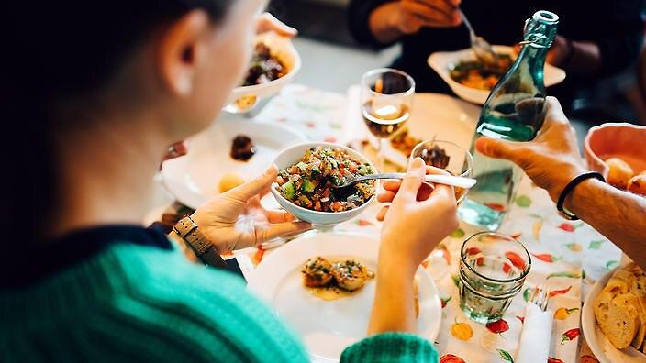

https://www.sbs.com.au/food/sites/sbs.com.au.food/files/styles/full/public/6831261b-5b5b-473d-800e-7046b446fb86_1589689379.jpeg?itok=9LrXRlHI&mtime=1589690652

Eating well supports mental health. (Getty Images)

The food that homeless people can most afford is also what is more likely to negatively affect their mental health.

**By** Alana Schetzer, 26 MAY 2020 - 12:31 PM  UPDATED 26 MAY 2020 - 12:40 PM

The relationship between a good diet and good physical health is generally well known; everything from keeping our weight under control and reducing our risk of diabetes can be connected to eating fresh and healthy food.

The connection between a good diet and good mental health, however, is less understood.

Professor Felice Jacka, director of the Food and Mood Centre at Deakin University, tells SBS Food, "The quality of the diet people eat has a direct link to their risk of depression.

"I see evidence from a number of clinical trials that if you take people with depression and help them to improve their diet, it has a substantive impact on their depressive symptoms, and is a highly cost-effective treatment."

TAKING CARE OF OURSELVES



<https://www.sbs.com.au/food/article/2017/09/14/how-baking-can-improve-your-mental-health?cid=inbody:how-a-poor-diet-can-impact-our-mental-health>

**How baking can improve my mental health**

Calming, rewarding, and providing focus, baking can be a great way to help lift my mood.

Many homeless people, especially those who sleep rough, getting three square meals a day is simply a luxury they cannot afford. Skipping meals is common and when food is available it is often something cheap, which often means junk food high in salt, sugar and fat.

Apart from the impacts on physical health, such as obesity and chronic illnesses, a diet high in sugar can affect [mood disorders](https://www.health.harvard.edu/blog/nutritional-psychiatry-your-brain-on-food-201511168626).

**"**I see evidence from a number of clinical trials that if I take people with depression and help them to improve their diet, it has a substantive impact on their depressive symptoms, and is a highly cost-effective treatment."

The UK's [Mental Health Foundation](https://www.mentalhealth.org.uk/a-to-z/d/diet-and-mental-health) says that a Mediterranean-style diet, which is rich in fresh vegetables and fruit, unsaturated fats such as olive oil, complex carbohydrates, fish, nuts and legumes, can help lessen depressive symptoms. However, that is also an expensive diet and one that requires a kitchen to prepare meals.

The relationship between food, poverty and homelessness is a complex and often cyclical one.

"Poorer physical health, and living in poverty or deprived communities, have been found to be associated with poorer mental health and wellbeing," the Mental Health Foundation [report](https://www.mentalhealth.org.uk/a-to-z/d/diet-and-mental-health) states. "Both these inequality factors have also been shown to have a complex relationship with poor nutrition."

Mental health is intrinsically connected to homelessness, either as a cause or a side effect. According to the [Mental Health Council of Australia](https://mhaustralia.org/sites/default/files/imported/component/rsfiles/publications/MHCA_Home_Truths_Layout_FINAL.pdf), about 20 per cent of the Australian population has a mental illness, but an estimated 75 per cent of homeless people have a mental illness. This makes the need for sufficient support and treatment, including a healthy diet, vital.

How baking can improve your mental health

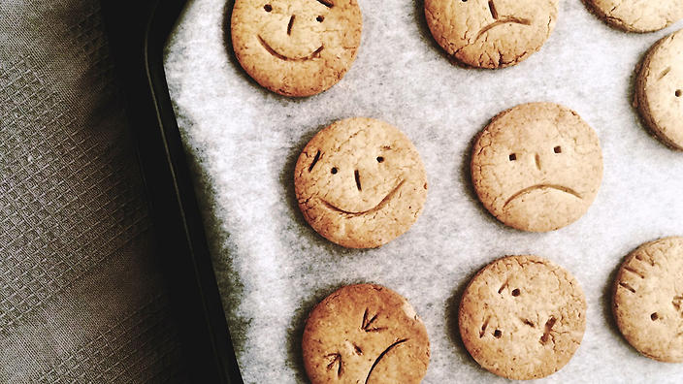

A simple baking task could help lift your mood. (Getty Images / Ami Wakisaka / EyeEm)

Hide Grid

**Calming, rewarding, and providing focus, baking can be a great way to help lift our mood.**

**By** Charmaine Yabsley, 14 SEP 2017 - 12:25 PM  UPDATED 6 OCT 2020 - 10:55 AM

[Tweet](https://twitter.com/share)

When you think of depression the last thing you probably imagine is lovely fluffy cakes, biscuits or desserts. Yet some people are turning to the oven to help lift their moods. “Depression is a very common condition and over one’s lifetime, one in six females, and one in eight males experience depression,” Dr Stephen Carbone, Research and Evaluation Leader with support organisation [beyondblue](https://www.beyondblue.org.au/), tells SBS.

[Symptoms](https://www.beyondblue.org.au/the-facts/depression/signs-and-symptoms) of depression include a persistent low mood, sadness, feeling of emptiness or hollowness that lasts for at least two weeks, a loss of pleasure in life and lack of motivation. “People may also have difficulty sleeping, lose their appetite (or sometimes the reverse), and think negatively about themselves and the future,” Carbone says.

How baking can help

Author [Marian Keyes](https://www.mariankeyes.com/) found that baking helped her enormously during a recent bout of depression, and gave rise to her book,*Saved by the Cake*. When she baked a cake for a friend's birthday, she found that they enjoyed it. “So much that I baked another,” she says in her book. “And another. I could not stop baking... baking may not be for you... and I also need to tell you that baking has not 'cured' me. But it gets me through.

UP FOR A QUICK SESH?



**10 sweets I can bake in under 15 minutes**

Speedy sweets that deliver satisfaction!

"Baking makes me concentrate on what is right in front of my nose," says Keyes. "I have to focus on weighing the sugar. On sieving the flour; I find it calming and rewarding because, in fairness, it is sort of magic – I started with all this disparate stuff, like butter and eggs, and what I ended up with is so totally different. And also delicious.”

There is not a lot of research in this area, but there are many anecdotal reports where baking may play an important part in the recovery of depression, according to Carbone. “Intuitively I could suspect that one of two things: people lose their energy, drive and withdraw socially when they are depressed. Part of the recovery process for depression is to encourage others to get into something relaxing, which keeps them busy and active, to help them out of their state of inertia," I explained.

I find it calming and rewarding because, in fairness, it is sort of magic – I started off with all this disparate stuff, like butter and eggs, and what you end up with is so totally different. And also delicious.

"This recovery process is behavioural activation," Carbone says. “I know that when people get into a state of flow and are immersed in the moment, they are completely focused. This has [positive mental benefits](http://www.tandfonline.com/doi/abs/10.1080/17439760.2016.1257049) as it helps me forget about my worries and cares.”

Of course, there is also the satisfaction I get from baking. “A sense of accomplishment can be a great mood-lifter,” says Carbone. “I can also share with others. This way baking also becomes a social aspect, as I am contributing food and enjoying it with friends.”

**Bake for my health**

A word of warning. Too many cakes could [feed my blues](http://ajcn.nutrition.org/content/early/2015/06/24/ajcn.114.103846.abstract), so if I am going to eat my creations, consume in moderation and look for some healthier recipes. “Good quality diets, based around fresh, whole foods are linked with a [reduced risk of depression](https://www.ncbi.nlm.nih.gov/pmc/articles/PMC2801825/), while a diet high in processed and packaged food is linked with an increased risk of depression and anxiety,” Accredited Practising Dietitian [Rajshri Roy](http://www.rajshriroy.com/) tells SBS Food.

10 sweets I can bake in under 15 minutes



<https://www.sbs.com.au/food/sites/sbs.com.au.food/files/styles/full/public/chocolate-crackle-biscuits-1pick.jpg?itok=zIebxY7m&mtime=1475045395>

Chocolate crackle biscuits (Alan Benson)

**Speedy sweets that deliver satisfaction!**



Here are my short-on-time baking go-tos, from oven to mouth in 15 minutes or under. All winners in our books.

**1.**[**Self-saucing chocolate pudding**](http://www.sbs.com.au/food/recipes/self-saucing-chocolate-pudding)

The ultimate quickie dessert. The quick baking time (only 12 minutes!) is key to an oozing fudgey centre.



<https://www.sbs.com.au/food/sites/sbs.com.au.food/files/styles/full/public/coulant-choco_24.jpg?itok=JbARVh_U&mtime=1471215104>

**2.**[**Christina Tosi's crackle**](http://www.sbs.com.au/food/recipes/crackle)

Brittle meets your favourite snack food: think cereal, pretzels, chips, nuts or seeds. Thanks to the Milk Bar genius Christina Tosi. Ready to chomp in 15 minutes.

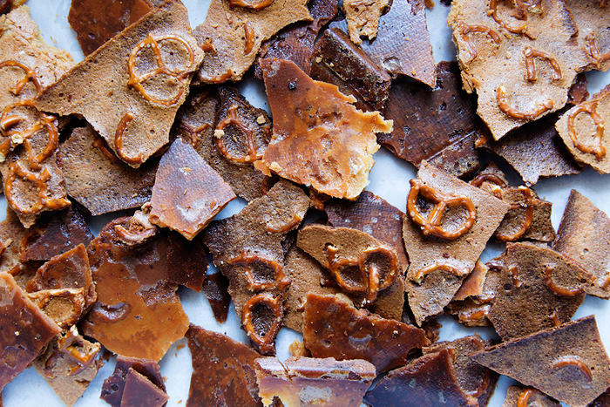

<https://www.sbs.com.au/food/sites/sbs.com.au.food/files/styles/body_image/public/crackle_milkbarlife.jpg?itok=gUV3DgZM&mtime=1506660769>

Source: Christina Tosi

**3.**[**Madeleines**](http://www.sbs.com.au/food/recipes/madeleines-0)

I am onto a winner with this recipe from our Country Women's Association cake champion, [Merle Parrish](http://www.sbs.com.au/food/article/2014/01/04/readable-feasts-merles-country-show-baking). These delicate cakes are ready to pop in my mouth in 8 minutes.



<https://www.sbs.com.au/food/sites/sbs.com.au.food/files/styles/full/public/Madeleines_1.jpg?itok=frsF6UhX&mtime=1389149980>

**4.**[**Polish caramel pine cones**](http://www.sbs.com.au/food/recipes/crunchy-pine-cones)

These crunchy puffed rice bound with hot fudge and sesame torpedos come with advice: roll them quickly before the toffee hardens.

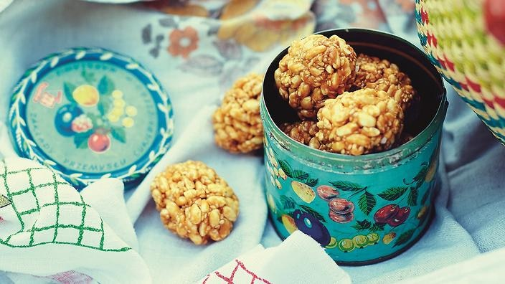

<https://www.sbs.com.au/food/sites/sbs.com.au.food/files/styles/full/public/crunchy_pine_cones.jpg?itok=AfgG95vL&mtime=1530586556>

**5.**[**Vietnamese almond cookies**](http://www.sbs.com.au/food/recipes/biscuit-month-almond-cookies-banh-hanh-nhan)

Melt-in-your mouth (thanks to lard!), these classic South-Asian treats bake in 15 minutes.



<https://www.sbs.com.au/food/sites/sbs.com.au.food/files/styles/full/public/almond-cookie.jpg?itok=euiHsZT4&mtime=1471248097>

**6.**[**Fat rascals**](http://www.sbs.com.au/food/recipes/fat-rascals)

And while I have the lard out, me may as well have a crack at Matthew Evans's Yorkshire classic, fat rascals - a cross between a biscuit and currant scone. Golden from the oven in 14 minutes.

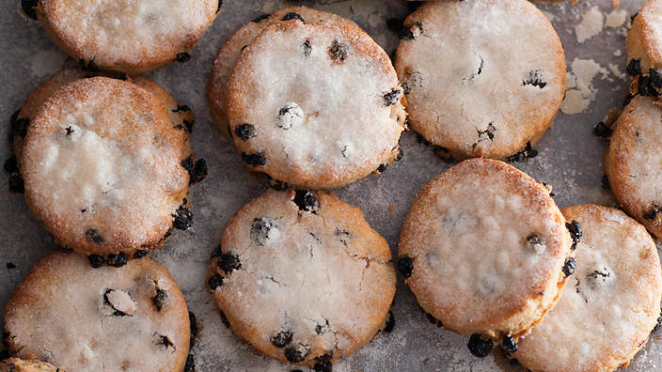

<https://www.sbs.com.au/food/sites/sbs.com.au.food/files/styles/full/public/FAT-RASCALS.jpg?itok=GWSOZZ6I&mtime=1377012084>

**7.**[**Chocolate crackle cookies**](http://www.sbs.com.au/food/recipes/chocolate-crackle-cookies)

These look like rock-hard meteors but are, delightfully, fluffy, and so easy to make. Simply stir, roll and bake. Ready in 12 minutes.



<https://www.sbs.com.au/food/sites/sbs.com.au.food/files/styles/body_image/public/chocolate-crackle-biscuits-1pick.jpg?itok=bCq-YRoc&mtime=1506660768>

Source: Alan Benson

**8.**[**Bosnian kiflice**](http://www.sbs.com.au/food/recipes/sweet-jam-filled-pastries-kiflice)

These sweet jam-filled, buttery pastries are a favourite of my very own Deputy Editor, [Farah Celjo](http://www.sbs.com.au/food/person/farah-celjo). She is been baking them since she was a child, and are yours to try in only 15 minutes.



<https://www.sbs.com.au/food/sites/sbs.com.au.food/files/styles/body_image/public/jam-shortbread-2.jpg?itok=15-iQyqY&mtime=1626100973>

[**9. Cream scones**](http://www.sbs.com.au/food/recipes/cream-scones)

The secret to the lightness of these scones, says our [Bakeproof guru](http://www.sbs.com.au/food/how-to/bakeproof), Anneka Manning, is the addition of cream. Unbeatable warm from the oven in 12 minutes.



<https://www.sbs.com.au/food/sites/sbs.com.au.food/files/styles/body_image/public/Cream-scones.jpg?itok=RUir8MdI&mtime=1506660768>

**10.**[**Campfire toasted bananas**](http://www.sbs.com.au/food/recipes/campfire-toasted-bananas)

Okay, so you first need to build a campfire for these beauties, but then you're in banana-gooey chocolate-marshmallow heaven in 5 minutes, from [Poh & Co](http://www.sbs.com.au/food/programs/poh-and-co).

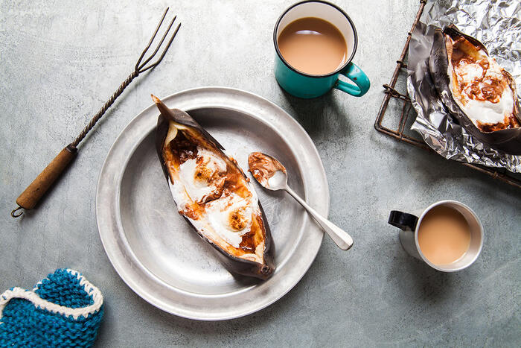

<https://www.sbs.com.au/food/sites/sbs.com.au.food/files/styles/body_image/public/campfire-toasted-bananas-2.jpg?itok=5cJd1jNa&mtime=1632886061>

BAKING IDEA:



**'Naked' celebration cake**

This stunning cake is perfect for a party - and Lyndey's decorating tips make it easy.

“Baking can be a really positive hobby in lifting my mood but it is important to protect my mental health through healthy eating.” I recommend baking miniature-sized desserts to ensure I am not overdoing my portion sizes. “Adding fruit, nuts or vegetable to my baked goods, using whole-grain flour or chickpea flour, using low-fat dairy products, swapping butter for heart-healthy oils such as canola or olive oil and simply reducing the sugar suggested in the recipe will make the recipe healthier.”



<https://www.sbs.com.au/food/sites/sbs.com.au.food/files/styles/full/public/baking-for-depression.jpg?itok=eno1Xzjy&mtime=1505355975>



Starting out with an easy baking recipe, like these Croatian walnut cookies, is a great way to get into baking.

**What else I could try**

Baking not to my taste. There are other similar soothing activities and exercises to try. “Anything which gives me a sense of direction, meaning, and autonomy can positively contribute to my mental wellbeing,” says Carbone.

“Baking is a good analogy for trying something new,” he says. He recommends when trying a new activity, to break it down into doable, bite-sized chunks. “If it is baking, I start by cooking something simple, and which takes just half an hour of my attention, then slowly move onto harder and more focused recipes. The same applies to other activities.”

I suggest combining a mixture of recovery techniques, such as exercising regularly, in nature, listening to music, mindful meditation, or art therapy. “Any sort of activity I find pleasant and enjoyable I will get benefit from. Physical activity is not enough on its own, so I find something else I enjoy. There is no one size fits all, it is about what works for me.”

HAPPY BAKING



<https://www.sbs.com.au/food/recipes/belgian-lemon-tea-cake?cid=inbody:how-baking-can-improve-your-mental-health>

**Belgian lemon tea cake**

This recipe was passed down to me from a friend over a decade ago, and I adjusted the curd to be extra zingy!



<https://www.sbs.com.au/food/recipes/hazelnut-and-raspberry-cake?cid=inbody:how-baking-can-improve-your-mental-health>

**Hazelnut and raspberry cake**

Life is definitely too short not to eat cake! The trick to good health is to eat something I really enjoy, I eat only a small piece, and eat it occasionally, not every day. This cake is made from ground hazelnuts, buckwheat flour and macadamia oil, so it is brimming with healthy fatty acids and  it is both gluten and dairy free. The earthy flavour of buckwheat flour works perfectly with the nuttiness of the hazelnuts and the sweetness of the raspberries. I like to serve this with a dollop of Greek yoghurt or thick coconut yoghurt.



<https://www.sbs.com.au/food/recipes/masala-chai-carrot-cake?cid=inbody:how-baking-can-improve-your-mental-health>

**Masala chai carrot cake**

Carrot cake is one of my favourite ‘vegetable-type’ cakes to make at home; it’s simple to prepare and rather rustic yet absolutely delicious. I have infused this carrot cake with chai (the Hindi word for tea is *chai*) and used a few of my favourite spices that I use when I have a craving for masala chai (the Hindi word for spice is *masala*). I have also skipped the vanilla flavour in the cream cheese frosting in favour of pistachio. This recipe is adapted from one of my favourite cookbooks, *Cook’s Illustrated Baking Book.*

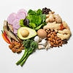

<https://www.sbs.com.au/food/article/2019/03/07/7-ways-eat-boost-your-brainpower-without-taking-supplements?cid=inbody:how-a-poor-diet-can-impact-our-mental-health>

**7 ways I eat to boost my brainpower, without taking supplements**

Naturally enhance cognition, learning and memory with nootropic foods. Here is what they are.

Professor Jacka says that studies from across the world have shown that people with healthier diets are less likely to experience depression.

"Research also shows that people who eat more unhealthy and junk foods are at increased risk of depression. This seems to also be the case in adolescents. Importantly, these relationships are independent of one another," Professor Jacka explains.

"Lack of nutritious food seems to be a problem even when junk food intake is low, while junk and processed foods seem to be problematic even in those who also eat vegetables, legumes and other nutrient-dense foods. We have documented these relationships in adolescents, adults and older adults."

7 ways to eat to boost my brainpower, without taking supplements

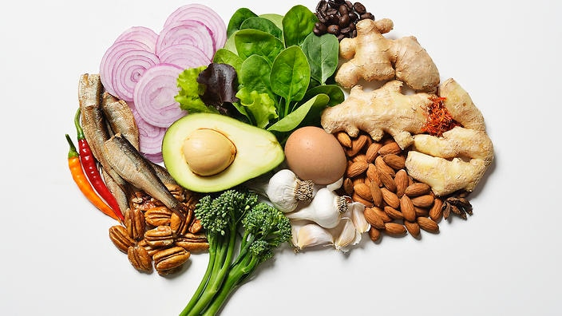

<https://www.sbs.com.au/food/sites/sbs.com.au.food/files/styles/full/public/gettyimages-544340831.jpg?itok=0PQSPmdZ&mtime=1555627927>

**Naturally enhance cognition, learning and memory with nootropic foods. Here's what they are.**

**By** Yasmin Noone, 7 MAR 2019 - 9:45 AM  UPDATED 11 MAR 2019 .

In my recent pursuit to become smarter, faster, a new pharmaceutical market has been born for a type of supplement called ‘nootropics’.

Also known as ‘smart drugs’, nootropic supplements promise to enhance your cognition function and supercharge my memory. I take a nootropic pill regularly, marketing claims suggest, and I will be able to learn new things, feel more motivated, have better memory recall and boosted concentration rates.

Yet the sale of nootropic supplements raises one vital question: do we really need to be taking pills to boost our daily brain performance?

But, for the general population, I believe food should be our main source of our nutritional needs, for all situations including cognitive performance.”

Melanie McGrice, a spokesperson for the [Dietitians Association of Australia](https://daa.asn.au/), tells SBS that we do not need to turn to pills for brainpower. We can boost our memory, concentration and mental performance by eating the right foods: nootropic foods.

“Of course, there are always exceptions to the rule: Those who are unable to meet their nutritional requirements because they have had gastrointestinal surgery, have a food allergy or intolerance, a specific illness or are pregnant,” says McGrice, an Accredited Practising Dietitian.

“But, for the general population, I believe food should be our main source of our nutritional needs, for all situations including cognitive performance.”

Here are nootropic foods – ‘smart foods’ – that McGrice recommends I eat to maximise my brain’s performance.

**1. Caffeine**

Ihave probably already experienced how a cup of coffee or tea has boosted my mental alertness. But research also suggests that caffeine may be able to improve various memory types.

A study conducted by researchers at [John Hopkins University](https://www.nature.com/articles/nn.3623) shows that caffeine enhances certain memories for at least 24 hours after it is consumed.

The research, [published by the journal *Nature Neuroscience* in 2014](https://hub.jhu.edu/2014/01/12/caffeine-enhances-memory/), concluded that caffeine can enhance our brain’s ability to consolidate long-term memories.

[Another study](https://www.verywellhealth.com/working-memory-and-alzheimers-98572) also found caffeine may be able to improve the working memory (part of the short-term memory that deals with immediate conscious and linguistic processing) of older adults.

But let’s not forget that too much caffeine can cause anxiety in some people – your sensitivity levels are personal – and you can consume too much of a good thing.

How coffee make me anxious while others can drink it before bed



<https://www.sbs.com.au/food/sites/sbs.com.au.food/files/styles/full/public/gettyimages-667807196.jpg?itok=wFTZJfUt&mtime=1626334307>

There is a really good reason I can only drink one coffee a day before I get jittery and another person can skull an espresso after dinner and still fall asleep. I have a heightened caffeine sensitivity.

**By**  Yasmin Noone, 14 MAR 2019 - 9:35 AM  UPDATED 14 MAR 2019 . Date accessed, December, 2021.

While I might have a strong coffee in the morning to wake up, there are some caffeine-fiends out there who sip an espresso after dinner to help them relax and go to sleep.

So how can I stimulant drink – coffee – make some people so alert that they feel anxious and wide-eyed awake for hours and perform no observable effect on others?

The answer has to do with my level of caffeine sensitivity. My level of caffeine sensitivity is determined by how efficient my body is in processing and metabolising caffeine.

[Gabrielle Maston](https://www.sbs.com.au/food/article/2019/03/14/gabriellemaston.com/), Accredited Practising Dietitian and Spokesperson for the [Dietitians Association of Australia,](https://daa.asn.au/) explains that my genes determine my individual reaction to caffeine and the impact that a specific amount of coffee has on my body.

“My sensitivity to caffeine varies person-to-person,” says Maston. “So not everyone can consume the same amount of coffee and share the same effect.”

[Around 95 per cent of caffeine](http://www.geneplanet.com/genetic-analysis/list-of-analyses/caffeine-metabolism.html) is metabolised in the liver via an enzyme called CYP1A2, according to the genetics analysis company [Gene Planet online](http://www.geneplanet.com/genetic-analysis/list-of-analyses/caffeine-metabolism.html). The activity of this enzyme is highly variable and is regulated by the CYP1A2 gene.

**“My sensitivity to caffeine varies person-to-person. So not everyone can consume the same amount of coffee and share the same effect.”**

Differences in our DNA will, therefore, produce differences in the rate of our caffeine metabolism – people with more than one C variant in the gene will be more sensitive to coffee and it will yield a stronger effect on them, while those with two copies of a gene present in the A variant will be more tolerant to caffeine.

Maston adds that caffeine sensitivity is also regulated by the [receptors in our brain.](https://www.sciencedirect.com/science/article/abs/pii/0304394094907277)

Caffeine passes through the blood-brain barrier and influences our brain's [adenosine receptors](http://worldofcaffeine.com/caffeine-and-neurotransmitters/). People who lack the correct adenosine receptors may not experience the same caffeine-related effects of alertness that others do, because the receptors are less responsive and the caffeine molecules cannot bind to receptors.

“That is why there are people who drink one cup of coffee and are anxious or shaky while others drink six or seven cups of coffee and are fine,” adds Maston.

Research from [The Harvard School of Public Health](https://www.hsph.harvard.edu/) also shows that our genetic differences change the way that various people process, metabolise and become addicted to coffee. The [study published in 2014](https://www.nature.com/articles/mp2014107) looked at around 100,000 people from European and African-American cultures and found six genetic variants determining the way coffee habits are formed and variability in how coffee affects our health.



<https://www.sbs.com.au/food/article/2018/04/20/why-drinking-3-cups-coffee-and-eating-nuts-may-help-your-heart?cid=inbody:why-does-coffee-make-me-anxious-while-others-can-drink-it-before-bed>

**Why drinking up to 3 cups of coffee and eating nuts may help your heart**

Two separate studies, released this week, offer key nutritional advice on what we should be eating and drinking to protect the rhythm of our hearts.

**I can develop a caffeine tolerance**

Maston explains that separate to caffeine sensitivity (which is hardwired into my genes), we may also develop a habitual caffeine tolerance.

“I can build up a tolerance to caffeine, just like I can build up a tolerance to sweetened foods," Maston says. "I acclimatise MY tastebuds to the taste of sugar and fat to the point that I do not taste the sugar and fat in food as much anymore. It is the same thing with caffeine.

“Take, for example, some people who are Italian or Greek who drink a lot of coffee, socially. Their bodies will most likely become desensitised to the caffeine over time.

“If culturally, I drink coffee at breakfast, lunch and dinner then I will be able to tolerate coffee more than someone who has it sporadically.”

**Caffeine sensitivity is something to worry about**

Maston stresses that caffeine sensitivity is not a health condition.

“There’ is nothing wrong with one person who is sensitive to caffeine and another person who is not – they will just like to drink different levels of coffee.”

However, she says it is wise to be aware of my individual sensitivity levels so I do not experience the unwanted side effects of drinking too much caffeine – irritability, nervousness, anxiety, sleeplessness and diarrhoea.

Maston also advises that people who are very sensitive to caffeine to switch to tea, which has “about 10 per cent of the amount of caffeine that a regular coffee has”.

**“**If, culturally, I drink coffee at breakfast, lunch and dinner then I will be able to tolerate coffee more than someone who has it sporadically.”

**How much coffee I should have**

My recommended level of caffeine consumption is dependent upon the degree of my caffeine sensitivity.

There are three levels of caffeine sensitivity: hypersensitive (very sensitive to caffeine), hyposensitive (minimally or not responsive to caffeine at all) and a ‘normal’ sensitivity to caffeine (which lies somewhere in the middle of the former two categories).

Maston says the majority of people have a normal sensitivity to caffeine and it is upon this level of sensitivity that recommendations for coffee consumption have been set.

“It’s recommended that most people can have 300-400 milligrams a day or less of caffeine,” says Maston.

“That is equivalent to around three-to-four cups of instant coffee a day or less. Or, because espressos have higher levels of caffeine content, it is equal to one-to-two espresso or percolated coffees a day.”

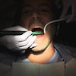

<https://www.sbs.com.au/food/health/article/2018/03/06/energy-drinks-can-rot-your-teenagers-teeth?cid=inbody:why-does-coffee-make-me-anxious-while-others-can-drink-it-before-bed>

**Energy drinks can rot my teenager's teeth**

Teenagers who drink energy drinks may experience more dental problems than those who drink traditional soft drinks, research shows.

Most energy drinks combine high doses of caffeine with sugar: “one of those large cans has around three or four shots of coffee in it”.

“I do not recommend that people drink energy drinks regularly because it can cause issues for their weight control and has strong caffeine content.

“But drinking coffee can be part of a healthy diet and is no problem at all.

“The main message is to have caffeine in moderation. If I am not too sensitive to caffeine, try to stick to the recommended amounts and be sure that I am not adding things like cream and sugary syrups to my coffee because then the sugar content starts to add up.”

**2. Nuts**

Research from [Loma Linda University Health in the US](https://neurosciencenews.com/nuts-brain-waves-7949/) shows that nuts can help with our brainwave function, learning, cognition and sleep.

The scientists found that some nuts like pistachios and peanuts (which are actually legumes but included in the study) stimulated some brain frequencies, required for learning, perception, information processing and function, more than others.

McGrice advises people to have one serve a day, equal to around 30 grams.

“Nuts will not give me a quick fix or a sense of mental alertness in the way that, say, caffeine may, but it will boost my mental performance if I keep including them in my diet on a regular basis.”

**Drinking up to 3 cups of coffee and eating nuts may help my heart**



<https://www.sbs.com.au/food/sites/sbs.com.au.food/files/styles/full/public/gettyimages-548005313.jpg?itok=EwtSw5Ic&mtime=1524185468>

Two separate studies, released this week, offer key nutritional advice on what I should be eating and drinking to protect the rhythm of our hearts.

By Yasmin Noone, 20 APR 2018 - 10:59 AM  UPDATED 20 APR 2018 - 11:33 AM. date accessed, december, 2021.

If eating lots of nuts and drinking up to three coffees a day sounds like music to my ears, then I am in luck. New research shows that eating nuts regularly and drinking moderate amounts of caffeine may help the rhythm of my heart.

Two separate studies, linking what we put in my mouth to heart rhythm irregularities, were released.

Actually first [study from Sweden](http://heart.bmj.com/content/early/2018/03/21/heartjnl-2017-312819) shows that eating nuts several times a week may help reduce the risk of atrial fibrillation (AF) and possibly heart failure. While research from Australia claims that drinking up to [three cups of coffee a day](http://electrophysiology.onlinejacc.org/content/4/4/425) may be safe for people with AF.

An abnormal heart rhythm is called an arrhythmia. Both pieces of research draw attention to the common heart rhythm condition, atrial fibrillation.

AF causes the heart to beat rapidly and skip beats. If left untreated, AF can lead to fatigue, blood clots, stroke, heart failure and other heart-related complications. The [Stroke Foundation](https://strokefoundation.org.au/) estimates that AF impacts 400,000 Australians.

In 2014, almost 330,000 Australians aged over 55 years had AF. More men than women had the condition. Based on these statistics from a [*Medical Journal of Australia*](https://www.mja.com.au/journal/2015/202/1/estimating-current-and-future-prevalence-atrial-fibrillation-australian-adult) paper published in 2015, it’s estimated that the number of people with AF will rise to over 600,000 by 2034.

Here is two new pieces of health advice to help protect the rhythm of my heart.

It is estimated that the number of people with AF will rise to over 600,000 by 2034.

**Go nuts**

The more nuts I eat, the lower my risk of the risk of developing AF, according to the study published online in the journal *Heart*.

The study, from Karolinska Institutet in Sweden, shows that for every additional portion of nuts I eat during the week, I could be actively reducing my AF risk by four per cent.

The researchers made the finding after observing the cardiovascular health of over 61,000 Swedish 45-83 year olds over 17 years (or until death, whichever came first).

Their efforts revealed that nut consumption was associated with a lower risk of heart attack, heart failure, atrial fibrillation and abdominal aortic aneurysm.



<https://www.sbs.com.au/food/health/article/2018/04/05/want-protect-your-heart-eat-less-meat-and-more-nuts?cid=inbody:why-drinking-up-to-3-cups-of-coffee-and-eating-nuts-may-help-your-heart>

**I want to protect my heart. I eat less meat and more nuts**

Eating meat may increase my risk of dying from cardiovascular disease, while eating lots of nuts and seeds could protect my heart, a new study says.

Eating a serving of nuts one-to-three times a month lowered risk by three percent. This figure rose to 12 percent when participants ate nuts once or twice a week. The biggest impact however was shown when participants ate nuts three or more times a week, lowering my risk of AF by 18 percent.

Nuts are a rich source of healthy fats, minerals, and antioxidants, all of which may aid my cardiovascular health.

“Nut consumption or factors associated with this nutritional behaviour may play a role in reducing the risk of atrial fibrillation and possibly heart failure,” the study reads.

“Since only a small proportion of this population had moderate (about five per cent) or high (less than two per cent) nut consumption, even a small increase in nut consumption may have large potential to lead to a reduction in incidence of atrial fibrillation and heart failure.”

The scientists also found that nut fans may be reducing their chances of heart failure, although those results were less conclusive.

**“**Nut consumption or factors associated with this nutritional behaviour may play a role in reducing the risk of atrial fibrillation and possibly heart failure**."**

**So is coffee a good thing?**

Australian shows that a single cup of coffee, containing about 95mg of caffeine, acts as a stimulant to the central nervous system. Once in the body, caffeine blocks the effects of adenosine, a chemical that can facilitate AF.

The review, published in *JACC: Clinical Electrophysiology,*even suggests that drinking up to three cups of coffee a day may be safe for people with arrhythmia. The researchers observed that caffeine doses up to 500 mg daily (equivalent to six cups of coffee) did not increase the severity or rate of ventricular arrhythmias.

**“**Although there is no clearly defined threshold for caffeine harm, a regular intake of up to 300 mg/day appears to be safe and may even be protective against heart rhythm disorders**.”**

“Large-scale population-based studies and randomised controlled trials suggest coffee and tea are safe and may even reduce the incidence of arrhythmia,” the study conducted by [Baker Heart and Diabetes Institute](https://www.baker.edu.au/) and [University of Melbourne](https://www.unimelb.edu.au/), reads. “Although there is no clearly defined threshold for caffeine harm, a regular intake of up to 300 mg/day appears to be safe and may even be protective against heart rhythm disorders.”

The findings challenge the belief that too much coffee can trigger a heart rhythm problem.

“Many clinicians continue to counsel patients with atrial or VAs to avoid all caffeinated beverages, particularly coffee, despite an absence of evidence to support this approach.”



<https://www.sbs.com.au/food/article/2017/11/27/three-or-four-cups-coffee-day-does-you-more-good-harm?cid=inbody:why-drinking-up-to-3-cups-of-coffee-and-eating-nuts-may-help-your-heart>

**Three or four cups of coffee a day does me more good than harm**

A new study cautions it is not suggesting people drink more coffee to get healthy, but the review is good news for coffee lovers.

However, the authors note that different people may have different susceptibilities to the effects of caffeine, which could trigger an arrhythmia. "If, in individual cases where a clear temporal association between arrhythmia episodes and caffeine intake is apparent, then avoidance is sensible."

The researchers say energy drinks containing caffeine should still be avoided by patients with pre-existing heart conditions as they can contain as much caffeine as six cups of coffee in a single drink.

Patients should always consult a qualified medical professional for tailored advice to suit their personalised condition.

**3. I enjoy a low-GI diet and eat often**

I stick to a diet that includes small, regular low-GI meals could help to enhance my brain function, McGrice says. “I have seen it so often in clients that people who do not eat small, regular meals struggle to think clearly. Carbohydrates are a primary fuel source for our brain. Low GI sources give our brain a constant source of energy.”

<https://www.sbs.com.au/food/sites/sbs.com.au.food/files/styles/body_image/public/773c823c-7ff7-4b6a-92fc-e368c941c9f8_1533619225.jpeg?itok=ZfE_JYSX&mtime=1533619334>

**4. I eat leafy greens, avos and eggs**

Leafy greens, including spinach and kale, avocados and eggs are a great source of lutein – a nutrient, which research suggests, can help to keep me cognitively fit.

[A study, published in 2017](https://www.sciencedaily.com/releases/2017/07/170725122004.htm), found that middle-aged participants with higher levels of lutein attained through diet had neural responses that were more on par with younger individuals than with their peers.

**Silverbeet and spinach dumplings**



<https://www.sbs.com.au/food/recipes/silverbeet-and-spinach-dumplings?cid=inbody:7-ways-to-eat-to-boost-your-brainpower-without-taking-supplements>

**5. Berries**

“Berries are one of the richest sources of antioxidants around and have great anti-inflammation properties which can help reduce inflammation in my brain,” McGrice says.

“I am supposed to have two serves of fruit a day. One punnet of strawberries is considered a serve. So I would recommend having a punnet of berries three-to-four times a week, as part of my regular fruit intake.”

**6. Water**

“When I am dehydrated, I am more likely not to be able to think clearly,” McGrice.

“It is recommended that I drink around two litres of water a day, but how much I need may also vary on my weight, and level of my physical activity.”



<https://www.sbs.com.au/food/health/article/2018/03/27/it-possible-not-water?cid=inbody:7-ways-to-eat-to-boost-your-brainpower-without-taking-supplements>

**7. Oily fish**

McGrice explains that the long chain omega 3s in oily fish may improve my learning and memory, and reduce inflammation in my brain.

“[Long chain omega 3s] are important for the functioning of adult brains and the brains of babies as they are developing in the womb during pregnancy,”.

“There is also a fair bit of research around the benefits of omega 3 for brain function, linking it to a decreased risk of Alzheimer’s disease, depression and other mental health conditions.”



<https://www.sbs.com.au/food/article/2020/07/08/what-eat-when-youre-pregnant-not-just-what-avoid?cid=inbody:7-ways-to-eat-to-boost-your-brainpower-without-taking-supplements>

**What to eat when women or pregnant (not just what to avoid)**

McGrice advises that people eat two-to-three serves of oily fish, like salmon, a week.

“However, eating one piece of fish once also is not going to give me a mental edge in that minute.”

“I also cannot eat a terrible diet of pizza and chips and have fish three times a week or nuts or any other food that helps cognitive performance and expect the benefits.

“But by eating these foods on a regular basis, as part of an overall healthy diet, I should have a mental edge and see an improvement in cognitive performance.”

TOP TIPS



<https://www.sbs.com.au/food/article/2018/07/02/busy-nutritionists-tips-eating-well-when-life-frantic?cid=inbody:how-a-poor-diet-can-impact-our-mental-health>

**A busy nutritionist's tips for me eating well when life is frantic**

Or I just do not know where to start.

Ronni Kahn, founder and chief executive of food rescue organisation OzHarvest, says there is "still much work to be done" to make sure this message filters through to families in need.

"OzHarvest's [NEST program](https://www.ozharvest.org/what-we-do/nest-nutrition-education/) was developed to help provide nutrition education and cooking skills to recipients of food relief via the charities that receive our food, in order to facilitate that connection between a healthy diet and a healthy mind,".

"There are often some simple things I could be doing to improve their nutrition, for example, swapping white bread for wholemeal or multigrain and sugary drinks for water is a good place to start, and I try and make sure that I link how important a nutritious diet is to a healthy lifestyle."

https://www.lifeadvancer.com/poor-nutrition-mental-disorders

How diet can affect my mental wellbeing

As the world has changed drastically since the start of the pandemic, it may well be my diet has too. But does the food I eat really affect my mental wellbeing? I asked the experts.

**Eat at regular intervals**

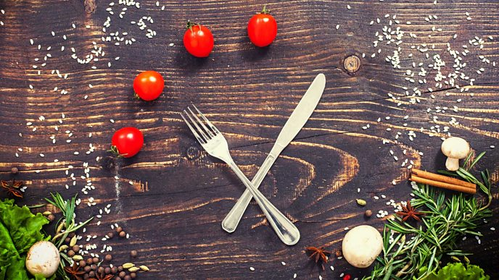

<https://ichef.bbci.co.uk/images/ic/688xn/p08k9y2z.jpg>

By eating regularly, I will keep my blood sugar levels consistent. So why is this a good thing? When blood sugar drops, it leads to tiredness and irritability, and inconsistent blood-sugar levels have [even been linked to mood disorders](https://sph.umich.edu/pursuit/2019posts/mood-blood-sugar-kujawski.html) including depression and anxiety. If my blood sugar spikes, this will be followed by a dip and I will be hit by these issues. So eating erratically might be doing more harm than just leaving my with a rumbly tummy.

Nutritionist Sonal Shah explains, “If I get hungry often in the day and this affects my mood, concentration and energy levels, then eating at regular intervals is important. Eating every three to four hours is fine to prevent ones energy levels dropping as a result of blood-sugar levels dipping”.

But the Nutritionist Resource member warns this does not mean my should eat all the time: “It is not ideal to continuously snack on foods throughout the day, as this grazing does not allow the appetite and insulin hormones to regulate optimally”.

**I drink plenty of fluids**

Dehydration can impact my mental wellbeing by making it harder for me to [think clearly and focus](https://www.nature.com/articles/1601898).

Shah says: “Dehydration is seen by the body as a stressor, leading to symptoms of low energy, poor focus, confusion and irritation. The brain cells require water just as the body does, and this explains why individuals who are dehydrated are more susceptible to mental stress. Water helps blood flow, so if there is not enough water to help clear the toxins out of the body, this leaves me feeling weak.

“Dehydration can also lead to cravings for unhealthy food like crisps, and refined carbohydrates and drinks containing alcohol and caffeine, which have diuretic effects on the body. Alcohol reduces cognitive function by dehydrating the body as it requires water to expel the alcohol from the bloodstream and this leads to the hangover symptoms the next morning. Fizzy drinks containing sugar may give a quick energy high, which mentally alerts me, but this is followed by sugar dip which leads to an energy low and mental tiredness”.

**I eat a balanced diet**

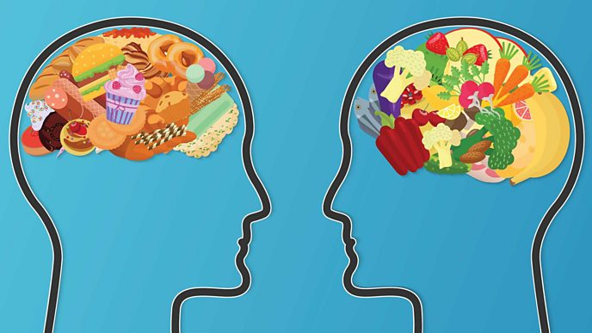

<https://ichef.bbci.co.uk/images/ic/688xn/p08k9xns.jpg>

Felice Jacka, Professor of Nutritional Psychiatry and Director of the Food & Mood Centre at Deakin University, focuses on links between diet, gut health and mental and brain health.

She explains: “Extensive and consistent research tells us that healthier diets protect against depression. Given that depression is the leading cause of global disability, this is critical to understand.

“Indeed, these links are seen after taking into account important factors that can affect both diet and mental health, such as education and income, other health behaviours and body weight. More recently, evidence from randomised controlled trials tells us that helping people with depression to improve the quality of their diets can have a substantial benefit to their mental health and functioning. In these trials, the diet that had the major benefit was one designed to mimic a traditional Mediterranean diet, high in wholegrains, vegetables, fruits, fish and olive oil.”

Shah adds: “A balanced diet feeds the brain, providing it with the nutrients it needs to support a positive mood, and improve signalling pathways between brain cells for optimal brain function. The nutrients required to support a healthy mind and brain are so vast and it is important to consume a varied diet and supplement nutrients that are low or missing in the diet.”

**I try to avoid junk food when I am tired**

[**Recent science**](https://www.bbc.co.uk/food/articles/sleep_and_weight_loss) tells us there’s a reason why we are tempted by those high-carb, sugar and fat products when we’re tired. If this is a short-term problem or one off, it’s not likely to cause issues in the long term, but if it’s ongoing it can become a chicken-and-egg situation.

“Certain foods can impact digestion and make me feel unwell, and this is intricately related to mood”, says Shah. She continues: “An example is feeling uncomfortably bloated, which leads to sluggish feelings accompanied by a brain fog, and this then impairs mental clarity. It swings both ways, so if you feel tired, with this low mental focus, anxiety, irritation and mood, you may reach for refined foods low in vitamins and minerals, which give you a quick high that is short lived.”The same applies to comfort eating when stressed. “Comfort eating is emotional eating, and the triggers and reasons for it vary from individual to individual.... Food should not be used as a way to control emotions. Habits and eating behaviours take time to address, and I would recommend working with therapists to establish the reasons for them and heal them”, continues Shah.

**I cut back on processed food**

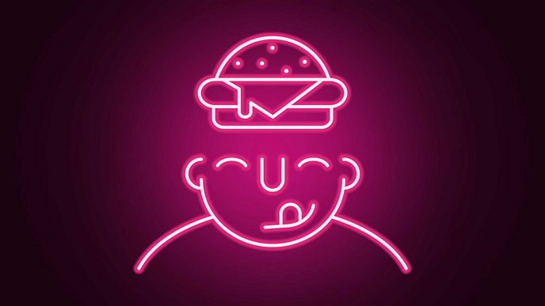

While there is a relationship between regular consumption of [**processed food and low mood**](https://www.nhs.uk/news/mental-health/processed-food-and-low-mood/), it is hard to distinguish between cause and effect.

“Foods and drinks with added sugars, such as soft drinks, are very problematic to health. Many studies from around the world show that diets high in these types of foods – as well as those with added fats, salt and highly-processed flours – are linked to worse mental health as well as obesity, heart disease, diabetes and other conditions”, says Jacka.

Professor Jacka goes further: “In animal studies, sugar and ‘western diets’ lead to problems in both behaviour and cognition, at least partly through a detrimental impact on a part of the brain called the hippocampus. We have also shown that unhealthy diets are closely linked to a smaller hippocampus in humans, while a healthy diet is linked to a larger hippocampus. The hippocampus is a key part of the brain involved in learning and memory, as well as mental health, so this has important implications for people from childhood through to old age.”

Shah adds: “To break away from a processed food diet involves changing the taste buds so they become less tickled by junk food and begin to crave healthier foods.... So it is a change of lifestyle and looking deeper into why the person is reaching for a certain food in the first place. Ask yourself: Is it work stress, anxiety, depression or lack of motivation?”

**I eat a diverse diet for my gut microbes**

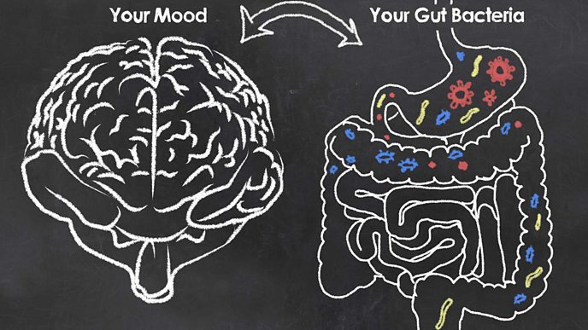

<https://ichef.bbci.co.uk/images/ic/688xn/p08k9yr9.jpg>

There has been a lot of scientific focus on the role of the gut in fighting depression in recent years. A good diet, particularly one that is diverse and high in plants and seeds, has been linked to reduced levels of depression in a number of studies. Conversely, a diet low in variety and fibre has been linked to a greater risk of depression. “The link between food and mood has been confirmed by recent randomised clinical trials in humans”, writes Tim Spector, Professor of Genetic Epidemiology at King’s College London, in his book *Spoon-Fed*.

“There is a huge amount of effort going into research in this field around the world now”, says Professor Jacka. “Diet is one of the most important factors affecting the health of the gut and its bacteria (and it does this very quickly), whilst we also now know that the gut bacteria (microbiota) play a critical role in the health of my immune system, my metabolism, our gene expression, and our mental and brain health.”

**I avoid binge drinking**

One way we know that peoples gut is dramatically affected is through heavy drinking. “Excessive (binge) drinking appears to damage the lining of the gut, which can promote inflammation. Inflammation, in turn, increases the risk of a host of diseases, including depression.”

**I can improve my mental health by eating better**

Professor Jacka describes her work in treating people with depression through diet and lifestyle changes. “In my [**SMILES trial**](https://foodandmoodcentre.com.au/smiles-trial/), which was the first randomised controlled trial of dietary improvement for people with moderate to severe clinical depression, we showed very large benefits to depressive illness of adopting a Mediterranean-style diet over a three-month period. I also showed that the more people improved their diets, the more their depression improved.

“I am now doing a lot of work to support changes to the healthcare system in Australia to ensure that people with depression have access to support to improve their health behaviours – particularly diet and exercise – as a fundamental part of their treatment.”

Should I make changes to my diet if I am concerned about my mental health? “I seek a therapist to help with mental health, working alongside a nutritional therapist who can slowly help me transform my diet, educate me on why a balanced diet is important and unpeel areas of concern”, says Shah. “Changes to a diet cannot be made if the individual does not have the mind-set or motivation to implement them step by step. Keeping a journal helps, as some days an individual may feel more motivated than other days, and logging this alongside a food diary can heighten awareness of areas that need to be worked on.”

The unexpected New Year's resolution that delivers wealth and health



<https://ichef.bbci.co.uk/images/ic/688xn/p0b8qm9n.jpg>

One in six people resolved to reduce their impact on the environment in 2021, according to environmental charity [HubBub](https://www.hubbub.org.uk/blog/is-2021-the-year-green-intentions-turn-to-action). This new player on the resolution scene joins old favourites such as [healthy eating](https://www.bbc.co.uk/food/articles/healthy_eating_resolutions) and [saving money](https://www.bbc.co.uk/food/articles/food_shopping). The good news is that eating more sustainably can help me achieve all these things, while benefiting everyone on the planet.

[Miguel Barclay](https://www.bbc.co.uk/food/chefs/miguel_barclay), also known as the One Pound Chef has written hundreds of budget recipes and knows his way to a bargain. In his new book, Green One Pound Meals, he shares his approach to eating sustainably while still sticking to his signature budget.

Food production [is said to be responsible](https://ora.ox.ac.uk/objects/pubs:854765) for a quarter of all greenhouse gas emissions, contributing significantly to global warming, although the environmental impact of food and cooking practices varies hugely. It is hard to know where to start [calculating my own carbon footprint](https://www.bbc.co.uk/food/articles/carbon_cost_food). Miguel's tips below are a simple starting point for a journey to a lifetime of sustainable eating, long after January is over.

**I plan my meals**

It has been estimated that if food waste was a country, it would be the [third highest emitter of greenhouse gases](https://www.fao.org/3/i3347e/i3347e.pdf) after the US and China, according to the Food and Agriculture Organization (FAO) of the United Nations. When it comes to [reducing your food waste](https://www.bbc.co.uk/food/articles/food_waste_tips), failing to plan is like planning to fail.

“It is terrible for the environment to be throwing food away, but I am first and foremost a budget chef and if I throw half of something away, then really, it is like I bought it for double the price,” says Miguel. By writing a clear shopping list for my weekly meals, specifying how much of each ingredient I need, I will be able to see whether that big bag of potatoes or salad really is good value or not.

By reducing food waste, a family of four could save £60 a month, according to the [Love Food Hate Waste](https://www.lovefoodhatewaste.com/why-save-food) campaign’s calculations.

Miguel's top three tips to use up all the food I buy:

* I pick my first meal, then work in chronological order to plan the rest of the week using any leftover ingredients from the previous recipes.
* I plan to use perishable produce first and move towards tins, frozen and long life produce by the end of the week.
* If a recipe does not use up a whole vegetable I can also double up and batch cook the meal, then freeze the cooked meal in portions to eat later.

I make Miguel's one-pan [gnocchi and veg bake](https://www.bbc.co.uk/food/recipes/gnocchi_pasta_bake_51351) using many frozen and long-life ingredients.

**Changing meat-free Mondays**

Reducing my carbon footprint and weekly shopping spend are two motivations for eating less meat. [One comprehensive study](https://ora.ox.ac.uk/objects/uuid:b0b53649-5e93-4415-bf07-6b0b1227172f) I found meat and other animal products are responsible for over half the food-related greenhouse gas emissions, despite providing only a fifth of the calories I eat and drink.

But switching out meat for more [high**-**fibre](https://www.bbc.co.uk/food/articles/fibre) vegetables and [pulses can also benefit my health](https://www.bbc.co.uk/food/articles/budget_beans). Even without giving up meat entirely, sticking to the healthy diet recommended by the [NHS](https://www.nhs.uk/live-well/eat-well/the-eatwell-guide/), which emphasises eating five fruits and vegetetables a day, while limiting red meat and processed food intake, would [reduce the UK's food-related greenhouse gas emissions by 17%](https://www.pnas.org/content/114/51/13412).

Meat-free Mondays became a popular way to remind people to eat [vegetarian food](https://www.bbc.co.uk/food/diets/vegetarian) on at least one day per week. But Miguel suggests that I swap it around so that I only eat meat on one day of the week instead. Any move toward a more [flexitarian diet](https://www.bbc.co.uk/food/articles/vegan_vs_flexitarian) will have some environmental benefits.

If I eat meat more regularly, Miguel suggests using recipes where it is not a large part of the dinner, but plays a role in adding flavour instead. Adding more beans than meat to [tacos](https://www.bbc.co.uk/food/taco), or using a small amount of [bacon in a lentil soup](https://www.bbc.co.uk/food/recipes/red_lentil_and_bacon_27157) or [chorizo in a bean stew](https://www.bbc.co.uk/food/recipes/chickpea_and_chorizo_36240) gives me a lot of flavour with a lot less meat than a steak or chop.

Some meats can have a higher carbon footprint than others, so I look at including more environmentally-friendly options. Of all the products analysed in [one study](https://ora.ox.ac.uk/objects/uuid:b0b53649-5e93-4415-bf07-6b0b1227172f), beef and lamb were found to have the most damaging effect on the environment, but there are also other considerations, such as [farming methods](https://www.bbc.co.uk/food/articles/food_shop_questions) to take into account when deciding on what to purchase.

I use the [BBC's carbon calculator](https://www.bbc.co.uk/news/science-environment-46459714) to see which foods I eat have high carbon emissions, as meat is not the only food where the choices I make can make a big difference.

**I get personal about food waste**

Food waste comes in many forms and by getting to know my habits, I make a personalised game plan to tackle my food waste.

Some chefs use clear bin liners to find out what the kitchen is not using up, and I can do this at home too, says Miguel. I might be consistently making too much rice or pasta than I need or want to eat. Or I may not know what to do with cooked leftovers or unused fresh food until it is past its best.

Once I have noted where my common problem areas are I can take action to address them. I get in the habit of measuring before I cook so I know exactly how much I need. I do not always need scales - just a mug can be better than eye-balling quantities. If I regularly throw out mouldy bread, I consider slicing and freezing my loaf so I can toast it as I need.

When I am finding that food goes off before I use it, I check the temperature of my fridge. The [Love Food Hate Waste](https://www.lovefoodhatewaste.com/) campaign from WRAP has great tips for maximising my [fridge efficiency](https://www.lovefoodhatewaste.com/article/chill-fridge-out) to keep food fresh for longer. Or perhaps I am better off buying loose vegetables, if I am chucking half the raw potatoes I buy from a bulk bag every week.

I asked other [top chefs to share their leftover tips](https://www.bbc.co.uk/food/articles/chef_waste_tips) to get ideas on how to use everything up, from Nadiya's stock bag to Dr Rupy's [fridge-raid pesto](https://www.bbc.co.uk/food/recipes/fridge_raid_pesto_02851).

**The Imperfect series to fight food waste**

* [How to make vegetables last longer](https://www.bbc.co.uk/food/articles/how_to_make_vegetables_last_longer)
* [How to make salad last longer](https://www.bbc.co.uk/food/articles/how_to_make_salad_last_longer)
* [How to make your root veg last longer](https://www.bbc.co.uk/food/articles/how_to_make_root_veg_last_longer)
* [How to use up leftover tins and jars](https://www.bbc.co.uk/food/articles/how_to_use_up_leftover_tins_and_jars)
* [What to do with stale bread](https://www.bbc.co.uk/food/articles/what_to_do_with_stale_bread)

<https://ichef.bbci.co.uk/images/ic/1280xn/p0b8qms5.jpg>

**Food with extra ap-peel**

There are bits of fruits and vegetables I often throw away for no reason other than habit. The leaves, skins, stalks and peels of fruits, herbs and vegetables can often be used as a "free" flavouring or to add extra nutrition to my diet.

I stop throwing away soft herb stalks, says Miguel. Most stalks on supermarket herbs like parsley and coriander are soft enough to be chopped and used in any dish. Miguel uses them to make flavour-packed [fritter](https://www.bbc.co.uk/food/fritters). Parsley stalks are excellent for flavouring [stock](https://www.bbc.co.uk/food/recipes/lightchickenstock_90221). I save them in a freezer bag until I need them, along with carrot peelings and trimmings, mushroom stalks, celery leaves and leek tops.

I do not always need to peel vegetables such as carrots, potatoes, sweet potatoes when I can just give them a scrub with a brush. The extra fibre and nutrients in the skin is better for my [gut health](https://www.bbc.co.uk/food/articles/gut_bacteria). If I must peel, use squash or potato peelings to make [crisps](https://www.bbc.co.uk/food/recipes/crispy_potato_peelings_07088) as a pre-dinner nibble or crispy garnish.

Broccoli and cauliflower stalks are just as delicious as the florets. They may need peeling if the stalks have a tough skin, but the inside will chop up for use in [vegetable stir-fry](https://www.bbc.co.uk/food/recipes/leftover_stir_fry_14298), or I grate them to make [cauliflower "rice"](https://www.bbc.co.uk/food/techniques/how_to_make_cauliflower_rice). The tender leaves are also excellent and still an edible part of the plant.

If have gotten to the point where I am not throwing away peel, I am probably doing quite well with my food waste already. And remember that inedible food waste like banana peels, egg shells and onions skins can be composted or put into local food recycling bins.

[[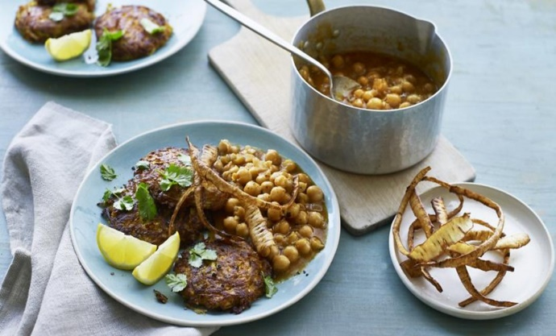](https://www.bbc.co.uk/food/collections/make_the_most_of_your_peelings)](https://www.bbc.co.uk/food/collections/make_the_most_of_your_peelings)

<https://ichef.bbci.co.uk/images/ic/1280xn/p0b8qt7n.jpg>

Is a low-carb diet right for me?

From Atkins to keto, low-carb food regimes are some of the most searched-for diets online. They claim to aid weight loss, reduce blood sugar levels and even reverse type 2 diabetes. But is cutting carbs really a healthy diet to follow?

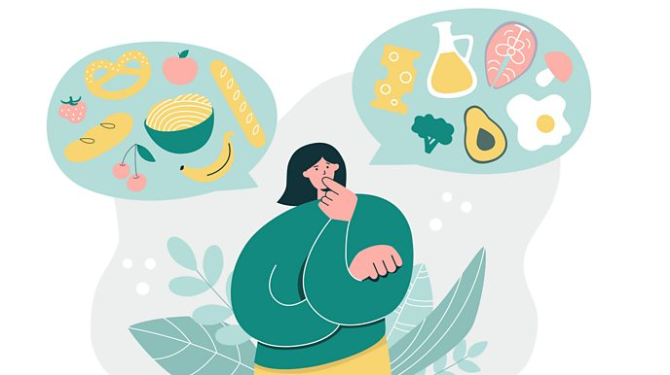

<https://ichef.bbci.co.uk/images/ic/688xn/p0b9pspk.jpg>

**Carbohydrates**

Carbohydrates (carbs) are one of three macronutrients found in food and drink, the other two being protein and fat. My body breaks carbohydrates down into glucose, which provides energy for my body and brain.

“Healthy carbohydrates are essential for my good brain health,” says dietitian Tai Ibitoye. “They are great for my gut and provide my body with a range of vitamins and minerals like calcium, iron, B vitamins and fibre.”

**Are all carbohydrates the same?**

Carbs can be divided into ‘simple’ (also known as ‘refined’), and ‘complex’. As their names suggest, simple carbs have simple molecular structures, whilst complex carbs have more complex ones. This is important because of the way [my body react](https://www.hsph.harvard.edu/nutritionsource/carbohydrates/carbohydrates-and-blood-sugar/) to carbohydrates when it digests them.

Simple carbs are sugars – which include lactose in dairy products, fructose in fruit and [‘free’ sugars](https://www.nhs.uk/live-well/eat-well/how-does-sugar-in-our-diet-affect-our-health/) in sweets, sugary drinks and desserts. When I consume them, their simple molecular structure mean they break down quickly – causing spikes in my blood sugar and my pancreas to release insulin. [Research](https://www.cdc.gov/diabetes/basics/insulin-resistance.html) suggests consuming too much of these is associated with insulin resistance, which can lead to health problems over time, including obesity, Type 2 diabetes and high blood pressure.



<https://ichef.bbci.co.uk/images/ic/688xn/p0b9q3fy.jpg>

Complex carbs on the other hand, are starchy carbohydrates such as pasta, bread and rice. There are fibre-rich options including wholegrain versions of pasta, rice and bread, as well as some vegetables and fruit and pulses.

Their complex molecular structures means they take longer to digest, causing gradual rises in blood sugar and insulin release. This is better for my body, and will also keep me [fuller for longer](https://www.bda.uk.com/resource/wholegrains.html).

**What a low-carb diet is.**

A low-carb diet is one that restricts the consumption of carb-heavy food and drinks (such as juices, beer and sugary sodas), on the basis you replace them with other nutrient-dense ingredients. With less carbs for energy, the body is forced to turn to its fat stores and convert fat into energy instead.

Dr David Unwin, the vice chair of the advisory board for the Public Health Collaboration charity, is well-known for pioneering a low-carb approach with his patients at his GP surgery in Southport, Merseyside: “We are a dual-fuel engine, adapted to burn fat or sugar.’’

Dr Unwin argues: "Weight-for-weight, fat supplies more energy than carbohydrates, and many of us have an overabundance of personal fat reserves we would be better to burn.”

The amount of carbs you eat on a low-carb plan depends on the diet you follow – for example, the[ketogenic diet](https://www.bbc.co.uk/food/articles/keto_diet_weight_loss) suggests people eat just 20-50g carbs a day. “Officially for research purposes a low-carb diet is less than 130g of carbohydrate per day, but for many of my patients it means just cutting back on sugar and the starchy carbs like bread, cereals or potatoes that digest down into significant amounts of sugar, while eating more protein and green veg,” says Dr Unwin.

To put it into context – a slice of white bread is, on average, [16.6g carbs](https://www.diabetes.org.uk/guide-to-diabetes/enjoy-food/carbohydrates-and-diabetes/bread-and-diabetes), a medium banana is 23g carbs and two teaspoons of jam are around [22g carbs](https://cdn.shopify.com/s/files/1/1922/6045/files/A_Carbs-Count-2012-reference-guide.pdf?v=1627891594).

Dr Unwin believes while starchy carbs are complex, they still break down into substantial amounts of glucose. So, the idea is that on a low-carb diet I should replace these with more fibrous vegetables (such as broccoli, kale, sprouts and green beans), meat, fish, eggs and nuts.

**A low-carb diet; is right for me**

If I have Type 2 diabetes (T2D), there is evidence cutting the carbs could help, or even reverse, my condition. [Research](https://pubmed.ncbi.nlm.nih.gov/31357547/) conducted by Dr Unwin of 154 patients with T2D or impaired glucose tolerance showed that following low-carb diets resulted in lower blood pressure, lower cholesterol, an increase in weight loss, as well as less reliance on medication.

Elsewhere, the British Dietitians Association (BDA) say cutting carbs “can be effective in managing weight, improving glycaemic control and cardiovascular risk in people with Type 2 diabetes in the short term,” but impress there has not been enough research done to determine the long term effects of the diet on their blood glucose, and the effects it can have on their heart health by swapping carbs for more fat and [protein](https://www.bda.uk.com/resource/low-carbohydrate-diets-for-the-management-of-type-2-diabetes-in-adults.html).

It is also important to mention that this does not apply to people with Type 1 diabetes, as well as children, teenagers and pregnant women with T2D. Likewise, those with gestational diabetes should seek [help and advice](https://www.nhs.uk/conditions/gestational-diabetes/) from their midwife or doctor to ensure dietary changes help support both themselves and their babies.

“Many of us, would benefit from cutting back on sugar which is just ‘empty’ calories,” says Dr Unwin, “With the epidemic of obesity, prediabetes, T2D and high blood pressure, cutting starchy carbs, possibly replacing with more green veg makes sense for a lot of people… but not all.”

**Low-carb might not be for everyone**

While there is emerging research highlighting the positive impact of low-carb diets on T2D, that does not mean it is suitable for everyone.

The NHS says starchy carbohydrates should make up a third of the food I eat, recommending basing my meals around higher fibre wholegrain varieties of pasta, rice and [bread](https://www.nhs.uk/live-well/eat-well/starchy-foods-and-carbohydrates/). The NHS highlights that if we cut the carbs, we risk missing out on the important energy and nutrients they provide – including fibre, calcium, iron and B vitamins.

“Some people may experience symptoms such as constipation, headaches, nausea and fatigue,” if they stop eating carbs says dietitian Tai.

The [BDA](https://www.bda.uk.com/resource/carbohydrates.html) say restricting a food group is not something recommended "for many reasons, including dietary imbalance, contributing to complex relationships with food and compliance.”

“As low-carb diet is a type of restrictive diet,” agrees Tai, “it may encourage disordered eating and an unhealthy relationship with food.”

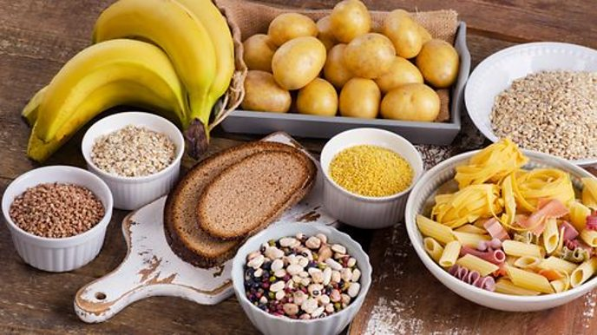

<https://ichef.bbci.co.uk/images/ic/688xn/p0b9r2s2.jpg>

**Can a low-carb diet result in weight loss?**

While some [research](https://pubmed.ncbi.nlm.nih.gov/18635428/) suggests low-carbohydrate diets can aid weight loss (especially for those with T2D), Tai says, “there is no consistent evidence that a low-carb diet is any more effective than other approaches in the long term.”

The BDA add losing weight on the diet is not sustainable for some: “At the moment, there are no clear definitions on what ‘low carbohydrate’ diets are.” This can make it difficult to manage this diet over this long term. For some people, a drastic reduction in their carbohydrate intake does help them to lose weight, but the BDA warns: “Most of the initial weight loss seen is often associated with water/fluid losses.”

**Be balanced**

If I am thinking about going low-carb, it is important to talk to an expert to make sure it is suitable for me and that Iam eating a healthy, balanced diet, and finding alternative sources of fibre, energy and vitamins that carbs provide.

Even if I am not planning on cutting carbs, the BDA recommends being ['carbohydrate aware'](https://www.bda.uk.com/resource/carbohydrates.html), stressing that “it is important to choose the correct portion to suit my needs, less active individuals require less carbohydrates.” They suggest limiting the amount of free sugars I eat, and swapping white pasta, bread and rice for wholegrain versions will provide my body with extra nutrients.

“Low-carb diets should not be seen as a one-size-fits-all diet for everyone,” ends Tai. “Most individuals need a balanced diet that includes a variety of starchy and wholegrain carbohydrates, fruits and vegetables that supports their health and wellbeing. However, if someone has to limit carbs for medical purposes, they should seek tailored dietary advice from their dietitian.”

**A keto diet is the best way to lose weight**

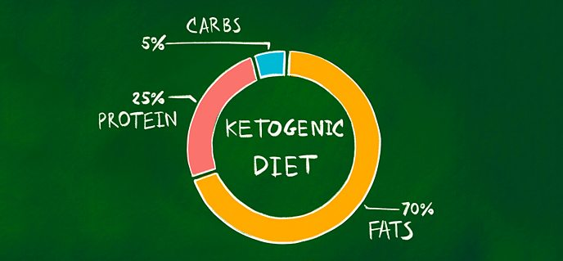<https://ichef.bbci.co.uk/images/ic/688xn/p07ly7bt.jpg>

The low-carb, high-fat ketogenic diet is promoted online and in the media as a weight-loss tool and seemingly all-round magical healer. Yet it was [first developed in the 1920s](https://www.ncbi.nlm.nih.gov/pubmed/19049574) for children with epilepsy.

There is no shortage of celebrity and influencer fans. Jersey Shore star Vinny Guadagnino (or as he calls himself on Instagram ‘Keto Guido’), Kourtney Kardashian and Halle Berry all advocate the keto diet. But even the health and wellness influencers may not be qualified nutritionists or dieticians. “Nutritional advice is highly unregulated, particularly online”, says dietitian Sophie Medlin.

As of now, #keto has around [14 million tags](https://www.instagram.com/explore/tags/keto/) on Instagram.

When I am following a keto diet I aim to be in a state of ‘ketosis’. We ask the experts what ketosis is, if it is worth the effort and if it is safe.

**What to eat on a keto diet**

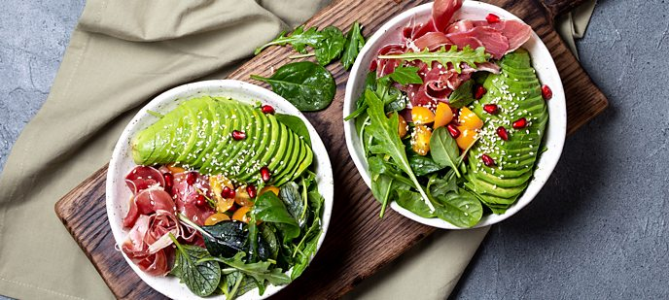

My body uses whichever energy source is most readily available. This is normally glucose (sugar) converted from carbohydrates. If I drastically limit my carbohydrate consumption and replace it with fat, my body is eventually forced to use fat from food or my stores as energy instead. This process is called ‘ketosis’. “It is essentially the Atkins diet repackaged and renamed”, says Medlin.

“Most people calling their diet ‘keto’ are simply following a low or very low-carbohydrate diet”,. The degree to which I need to restrict carbohydrates to be in ketosis “varies from person to person”. In a clinical or therapeutic setting, such as for children with epilepsy, the diet is designed specifically for the individual and support and monitoring are provided.

Low-carb, high-fat ingredients include avocados, meat, fish, eggs, cheese, cream, oil, butter, nuts and seeds. But not all ingredients need to be high in fat – leafy greens and berries are often included, for example. I avoid, or at least heavily restrict, wheat and other grains, potatoes, corn, pulses, beans, milk, most fruit and sugar.

To induce ketosis, a maximum of 20–50g carbohydrates can be consumed daily for someone eating 2,000 calories a day, according to [a 2019 paper](https://www.ncbi.nlm.nih.gov/books/NBK499830/) on the ketogenic diet. To put this into perspective, a banana contains about 20g and a plain bagel 44g. Protein is also usually kept to a moderate amount, as it can encourage the production of glucose and interrupt ketosis.

The keto diet has few rules on which high-fat foods to eat, and ‘dirty keto’ can consist of bacon and sausages fried in butter, as this technically meets the criteria. Medlin says the [healthy eating guidelines](https://www.nhs.uk/live-well/eat-well/) should always roughly apply, even if I limit carbohydrates and regardless of what diet Iam following.

A **keto diet will help me lose weight.**

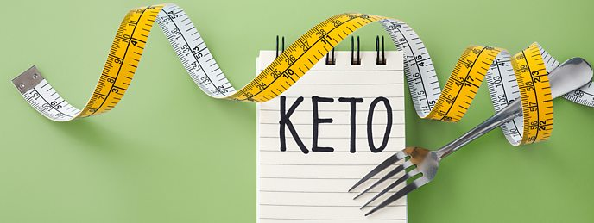

<https://ichef.bbci.co.uk/images/ic/688xn/p07lxlmm.jpg>

Research has shown a ketogenic diet can induce rapid weight loss, partly from water loss but also some fat loss. However, the “weight loss effect becomes similar to other dietary approaches after one year”, according to a [2019 review](https://www.ncbi.nlm.nih.gov/books/NBK537084/) of low-carb diets.

Taking in less energy than I burn will lead to weight loss. The [National Diet and Nutrition Survey](https://www.nutrition.org.uk/nutritionscience/nutrients-food-and-ingredients/carbohydrate.html?start=2) reports, that on average we get almost 50 percent of our energy from carbs. “Cutting this by at least half is likely to reduce total calorie intake, even if it is replaced with fats”, says Medlin. On the other hand, if I eat more calories from fat than Mm body needs it will still be stored as fat.

The ‘eat like me to look like me’ ideology is flawed. “We all have different genetics and lifestyles, which means we cannot all look the same”, says Medlin. [Research shows](https://www.ncbi.nlm.nih.gov/pubmed/29958395) the best weight-loss diet is the one I can stick to for long enough to reduce excess body fat.

[Long-term compliance](https://www.ncbi.nlm.nih.gov/books/NBK499830/) with the keto diet is low. Medlin cites restricting a whole food group, symptoms known as ‘keto flu’ (including headaches, nausea, constipation, tiredness and difficulty sleeping) which can kick in after two to seven days, and the higher-than-average cost of the diet as potential reasons why people might struggle to stick to it.

“The keto diet is used for certain therapeutic situations and is not meant for the mainstream weight-loss market”, says dietitian Priya Tew. “Carbohydrates have an important role in my diets and whilst reducing them may aid weight loss it is not sustainable to reduce them to a very low level.”

**Is a keto diet safe?**



<https://ichef.bbci.co.uk/images/ic/688xn/p07m7gjj.jpg>

“Many of the trials investigating ketogenic diets only follow participants for around six months up to one year at the most”, says nutritionist Emma Thornton, “therefore, the longer term effects... are not well understood.”

Medlin says the health risks also depend on the types of food eaten. Eating an unhealthy diet containing lots of saturated fat may [increase health risks](https://www.nhs.uk/live-well/eat-well/different-fats-nutrition/) such as heart disease and stroke.

Foods containing carbohydrates are often also high in fibre, which is important for a healthy gut microbiome and keeping my fuller for longer. Medlin advises anyone on a low-carb diet to ensure they eat enough fibre-rich foods from leafy greens, broccoli, cauliflower, flax seeds, nuts, coconut and avocado.

The keto diet limits starchy vegetables such as carrots, sweet potatoes, parsnips, pumpkin and squash and eliminates many fruits. This might restrict the amount and variety of nutrients, vitamins and phytochemicals (plant power) me get from my food, especially if I remove them rather than replace them.

People who restrict their carbohydrates and increase fatty foods may develop ‘keto flu’. There is very little medical research on this, but there are thousands of personal testimonies. Though it sounds unpleasant, it is not necessarily unsafe and many reports indicate the discomfort subsides. It is also not clear whether it only occurs on the keto diet or can be caused by other restrictive diets.

**The keto diet might not be for everyone**

If I take any medication or have any medical issues, I consult a doctor or dietitian before starting a keto diet. For some people, a keto diet may cause harm, even with careful monitoring.

**Alternatives ways to lose weight**



<https://ichef.bbci.co.uk/images/ic/288xn/p07m7g5h.jpg>

“I recommend checking my portions sizes are sensible, with potentially a small decrease in these and an increase in my vegetable intake”, says Priya Tew. She does not recommend reducing my carbohydrate intake to less than a quarter of my diet.

“Small steps make a big difference”, says Emma Thornton. She suggests cooking from scratch at home and expanding my knowledge of fresh ingredients is a good starting point. She also says other higher-fat and lower-carb diets, such as the popular Mediterranean-style diet, can be healthy as long as plenty of fish, nuts, seeds, other foods rich in healthy fats and vegetables are on the menu.

A key way to address weight-loss is to look at “why I eat rather than what I eat”, according to Medlin. Stress, poor sleep and choosing unrealistic diets have been identified as some of the main reasons [people discontinue](https://www.bbc.co.uk/food/articles/why_dieting_doesnt_work) their weight-loss diet. An [**indepth review**](https://www.ncbi.nlm.nih.gov/pmc/articles/PMC6163457/) suggests the most effective strategy for long-term weight-loss and heart health is a healthy diet pattern that is compatible with my food preferences and lifestyle. “It is really important not to beat myself up over having some birthday cake or foods I love once in a while”, concludes Medlin.

**How I can reduce my risk of diabetes**

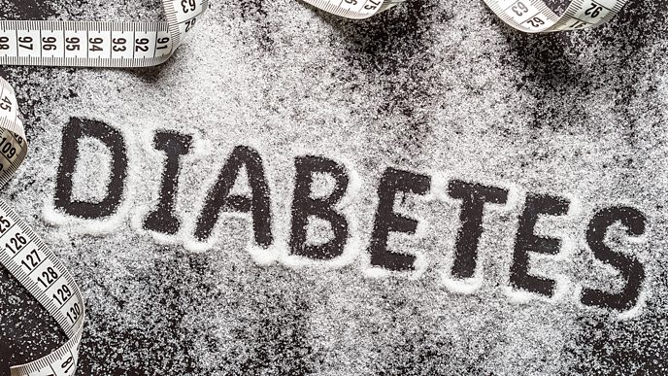

<https://ichef.bbci.co.uk/images/ic/688xn/p072043y.jpg>

[**Diabetes UK says**](https://www.diabetes.org.uk/about_us/news/new-stats-people-living-with-diabetes) that 1 in 10 over 40s has diabetes, a number that has doubled in the last two decades. The research suggests that by 2030, around 5.5 million people will be suffering from the condition, which is fuelled by obesity.

There are two main types of diabetes: Type 1 and Type 2.

**Type 1** is less common and is not preventable.

**Type 2** is predominantly associated with weight gain and a sedentary lifestyle, but there are other risk factors. In the UK, 90 percent of diabetics are Type 2. If my blood sugars are abnormally high, but are not in the diabetic range, I may be diagnosed as prediabetic. This means I have a high risk of developing diabetes.

The good news is that around 80 percent of cases of Type 2 diabetes are preventable.

I calculate my risk

There are four million people with diabetes in the UK – that is one in every 16 people. Type 2 diabetes can come on slowly and the signs may not be obvious, so it is important to understand the risk factors.

Taking the test to find out if I am at risk.



<https://ichef.bbci.co.uk/images/ic/704xn/p03hdt6g.jpg>

People with Type 2 diabetes who have not yet been diagnosed can display symptoms such as extreme thirst, tiredness and needing to go to the toilet more often, but one can also be symptom free and still have Type 2 diabetes or prediabetes.

Eating well to beat diabetes

If I am overweight or have a large waist, Type 2 diabetes can be avoided or delayed by reducing my weight and waist size. Every kilogram lost is associated with a 16 percent reduction in diabetes risk.

Along with increased activity, a healthy diet will help me manage my weight. No single weight-loss plan has been proven to be more effective than any other, so a healthy, balanced diet is recommended. If I have already been diagnosed as prediabetic or have Type 2 diabetes, it is particularly important to control my weight. Being a healthy weight makes diabetes easier to manage and can delay the onset of some of the most unpleasant complications of the disease.

What a healthy diet is.

* **Vegetables** can be eaten in abundance without concern. They are low in calories and can cost very little, so I include them in every meal.
  + Vegetables contain lots of fibre. This is important for good digestion, increases feelings of fullness after eating and slows down the absorption of sugars into the bloodstream.
  + The wider the variety of vegetables I eat the better. However, potatoes, yams, cassava and plantain do not count towards my five-a-day. These are very starchy, so should be enjoyed in moderation.
  + Beans and pulses do count towards my five-a-day, and are a great way to add lean protein to meals.
* **Wholegrains**, such as brown rice and wholemeal bread, are complex carbohydrates. It has been questioned whether people with, or at risk of, Type 2 diabetes should eat carbohydrates at all, but when it comes to carbohydrates, quality counts.
  + It's all too easy to make refined carbohydrates, such as white bread, pasta and most cereals, the foundation of every meal, but this should be avoided.
  + Wholegrains are better than refined grains because the husk of the seed is retained. This is often the most nutritious part of the grain, containing fibre and protein that keep me full for longer.
  + I read food labels carefully: some products boast that they contain 'healthy wholegrains', but are also full of sugar and other additives. Not that long ago, brown bread could just be white bread dyed brown.
* **Protein** is associated with high levels of satiety (feelings of fullness) and can help control my appetite.
  + Some of the best sources of protein also contain fibre, vitamins and/or healthy fats. Other sources can be high in fat and salt; processed meats are a particular concern and should be consumed, at most, infrequently.
  + Good sources of protein include fish, lean unprocessed meats, lentils, low-fat Greek yoghurt, eggs, nuts and many beans (e.g. soya beans used to make tofu).
* **Fruits** are good for me because they contain high levels of vitamins, minerals and fibre. However, some types are high in sugar, so aim to include a wide variety in my diet, but get most of my five-a-day from vegetables. Tropical fruits in particular tend to be high in sugar.
  + I choose whole fruits rather than juices and smoothies. Whole fruits contain fibre, which slows down my body's absorption of sugars and fills me up. Fruit juice has had most of the fibre removed so it is essentially a sugary drink. The same can apply to smoothies, but it depends how they have been made. Juicing also makes it harder to judge portion sizes, so it is easier to overindulge.
  + Dried fruits are typically very sugary and one portion is about a tablespoonful. It is easy to exceed this, so it is better to eat fresh fruits.
* **Fat** is essential to good health, but I do not need much. It is also associated with high levels of satiety (fullness after eating), which helps control my appetite.
  + It’s important to eat the right types of fat. Some fats are bad for my health, for example trans fats, found in processed foods, and saturated fats, found in processed meats, ghee or lard. Other fats have a protective effect. Good fats include extra virgin olive oil and fats found in fish, vegetables and nuts.
  + Foods high in both fat and sugar are very bad for my health and I have to avoid them. I am cautious of foods labelled 'low-fat' because the fat can be replaced with other unhealthy ingredients.
* **Water.** Thirst is often confused with hunger, so it is important to keep hydrated if I am trying to eat better.
  + Water is best because it is calorie-free and there is no doubt that it is good for us. Many other drinks are laden with sugar or contain caffeine and additives; soft drinks, energy drinks and milky coffees are particularly bad.
  + Keep drinks containing artificial sweeteners as an occasional treat (there is evidence to suggest they increase my desire for sweet foods). If I do not enjoy the taste of water, I give it extra flavour by adding healthy ingredients such as citrus fruits, ginger or mint. Alternatively, I try herbal teas.
  + The amount of water I need varies, but clear or very pale urine is a good sign that I am getting enough.

Burning calories: gym v everyday activity

Exercise is essential for good health. It does not only helps to maintain a healthy weight, but can lower blood-sugar levels because it helps my body to use insulin more effectively. I do not need to join the gym, just aim for high levels of everyday activity, including walking, housework, playing with children and hobbies – anything that gets me moving.

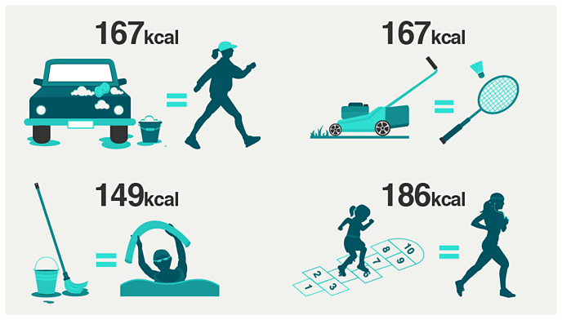

Figures based on calories used by an 11- stone adult during 30 minutes of activity. Infographic

Compares washing car and brisk walk; moving lawn and badminton; playing children’s games and jogging; energetic cleaning and aqua aerobics.

<https://ichef.bbci.co.uk/images/ic/688xn/p063s6yb.png>

**A strict diet can reverse Type 2 diabetes.**

New research has shown that blood-sugar levels in people with Type 2 diabetes can be returned to normal by following a very low-calorie diet. The participants in the studies followed total diet replacement programmes under close medical supervision.

The studies found that significant weight loss reduced the amount of fat present in the liver and pancreas. This in turn caused blood-sugar levels to return to normal and improved insulin function. The results were less encouraging for participants who had had Type 2 diabetes for more than four years and medical supervision was a crucial component of the research.

Surprising things I learned when I gave up sugar for a week by [Sophie Whitbread](https://www.bbc.co.uk/food/chefs/sophie_whitbread). Date accessed, December, 2021.



<https://ichef.bbci.co.uk/images/ic/688xn/p07y8kbk.jpg>

A friend recently told me giving up sugar was one of the hardest things she had ever done. I thought it sounded pretty easy! I do not eat many cakes or sweets (Christmas aside), after all. But not wanting to knock it before I tried it, I decided to go on my own no-added sugar (NAS) mission for a week.

I know cakes, biscuits, chocolates and the like will be off the table, and I will have to alter other parts of my diet slightly. But it turns out I have little idea how many road blocks lie ahead.

**10 minutes in, I stumble at the first hurdle**

It is day one of my challenge. I naively assume I can eat my favourite lunches and dinners without making sacrifices. I am excited about fajitas for dinner tonight... then I discover the shop-bought wraps contain sugar. Noooooo! That is 50 percent of my meals off the menu (yes, I really do eat wraps that often!).

With a rising sense of panic, I checked the labels on the foods in my cupboard – and found many of them contain sugar, even the wholemeal bread! I decide to make lentil dal instead, but then comes the second setback: there was sugar in my stock… STOCK! I make do without it. I will have to put extra effort into flavouring dinner this week.

**Sugar is a master of disguise.**

I nip to the supermarket, expecting it to be a quick visit. How wrong that turns out to be! I scour ingredients lists for added sugar – and added lots of things ending in 'ose' (fructose, glucose, dextrose and maltose). Honey, all kinds of syrup and even fruit juice are classed as free sugars too, so are off the menu.

Iam surprised to find the second ingredient on the label for my favourite massaman curry paste is sugar, with a small jar containing more than 10g. That is around two and a half teaspoons. This means ditching the dish or making my own paste. I decide on the latter. Armed with chillies, lemongrass, galangal, kaffir lime leaves and star anise (I have the remaining ingredients at home), I spend much longer than usual in the shop and cooking, but it is much tastier.

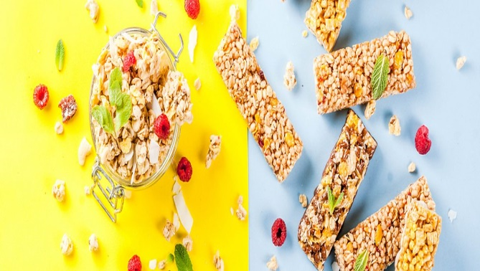

<https://ichef.bbci.co.uk/images/ic/1280xn/p07vffr0.jpg>

Are there good and bad sugars?

**Research suggests that added sugar is now the main source of sugar in our diets.**

The World Health Organisation (WHO) strongly recommends I reduce my daily intake of free sugars to 5% of my total calorie intake (about 7 teaspoons per day).

All sugar that is added to my food is classified as ‘free sugars'. They are easy to eat in excess, for example, I may drink a can of soft drink but I would not eat four apples in one sitting, as the fibre in fresh fruit makes you feel full. Free sugars are not necessary for a balanced diet**.**

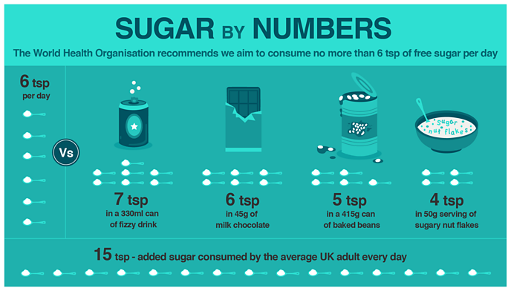

The recent ‘sugar tax’ has resulted in the reformation the reformation of many fizzy drinks, but they are often still relatively high in sugar and some have the levels described above.

<https://ichef.bbci.co.uk/images/ic/688xn/p061qrkz.png>

**Q: Is honey healthier**

**A: No – honey is a free sugar too.**

When I think of sugar, I often think of table sugar, but it is a blanket term for sweet-tasting, energy dense carbohydrates. Table sugar consists of two simple sugars bonded together. These simple sugars are glucose and fructose. Honey is also made up of glucose and fructose. It is commonly believed that honey is a healthier alternative to sugar. This isn't true; honey is a sugar.

Honey, maple syrup, agave nectar and rice malt syrup are all in the ‘free sugars’ club and need to be restricted.

**Q: What's the difference between fructose and glucose.**

**A: The general consensus is that there is no significant difference between fructose and glucose in terms of their implications for health.**

All cells in the body can process glucose, whereas only the liver can process high amounts of fructose, which means that excessive consumption may tax the liver, but this is unlikely from a normal diet. It is suggested fructose interferes with proper functioning of some hormones, specifically ghrelin, which signals hunger to the brain and leptin, which generates a feeling of satiety. This may cause us to over-eat.

Fructose has a lower glycaemic index than glucose, so as of 2015 food manufacturers in Europe who substitute other sugars with fructose can put a health claim on their products.

**Q: Why it is so hard to give up sugar**

**A: I associate sugar with pleasure, due to live experiences and a sugar 'high'.**

Throughout my lives I have associated sugar with pleasure. It is given as a form of reward and I consume it at celebrations. When I consume free sugars, they are quickly absorbed by my bloodstream and I experience pleasure and an energy boost. But then I have a ‘sugar crash’. These make us crave more sugar and the cycle of cravings and crashes continues.

But just as I have learned to derive pleasure from sugar, I can also teach my tastebuds to enjoy foods that are less sweet. But this takes times, so stick with it.

**Q: How I can fend off sugar cravings**

**A: I train my brain to enjoy less sweet foods and have plenty of healthier snack alternatives at hand.**

* I have healthy snacks, such as nuts and seeds, at hand. These are high in fat and protein, and so are useful for keeping hunger at bay.
* I enjoy small amounts of good-quality dark chocolate (at least 70% cocoa solids), which has a lower sugar content than milk or white chocolate.
* I add a sprinkle of cocoa or cinnamon to porridge to please my sweet tooth.
* My sugar alternatives such as stevia can be useful for sugar-free baking. Stevia is a natural sweetener derived from a plant. It is virtually calorie-free, does not affect blood sugar levels and does not cause tooth decay. But have caution that if I continue to eat sweet things, regardless if they are artificially sweetened, I will continue to crave sweet food.
* Often sugar cravings are a mental phenomenon based on the pleasure I get when I eat sugar. I distract myself by taking a short walk, reading or listening to some music.

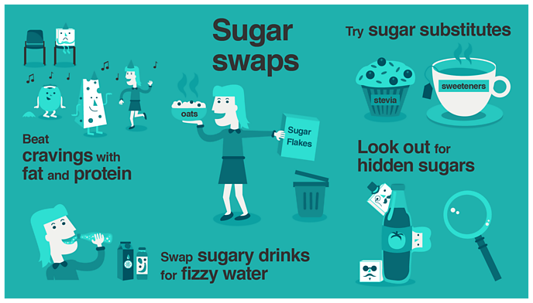<https://ichef.bbci.co.uk/images/ic/688xn/p061qvyv.png>

**Q: How I can check food labels for added sugar**

**A: I read the ingredients list and nutritional information per 100g.**

Food manufacturers don't have to state how much sugar they've added to food, but instead they give a figure for the total sugars.

* The traffic light system can help identify sugary foods; red sugar labels represent food high in sugar, amber represents medium sugar content and green signals low sugar content. But this system is based on total sugars, so some foods such as natural yoghurt may be labelled amber even though they contain no added sugar – just naturally-occuring sugar. I do not rely solely on traffic lights; you also need to look at the ingredients list.
* Look at 'carbohydrates (of which sugars)' on the nutrition label. If the total sugar content is over 22.5g per 100g the food is high in sugar; if it is below 5g per 100g the food is low in sugar.
* I check where sugar appears in the ingredients list. If it is near the beginning of the list then the food is probably high in added sugar.
* I check if sugar is hiding under these names too:
  + Sucrose
  + Glucose
  + Maltose
  + Lactose
  + Fructose
  + Molasses
  + Hydrolysed starch
  + Agave nectar
  + Corn syrup
  + Rice malt syrup
  + Honey
  + Golden syrup

**Day 3: all I can think about is biscuits!**



<https://ichef.bbci.co.uk/images/ic/688xn/p07zc46f.jpg>

It has been 48 hours since I started my NAS mission. I do not make a habit of scoffing biscuits (often), but today I feel like the cookie monster.

I casually eat NAS peanut butter from the jar. I eat way too much and feel a tad sick, but at least I get rid of the craving.

Wanting to know why I have a one-track mind for digestives, I ask dietitian Sophie Medlin. “If I deprive myself of something, I will think about it more often,” she says. “It can work both ways: if I only eat junk food for a week with no access to a homemade healthy meal, you might start craving a salad.”

**EVERYONE tries to give me sugar**

From leftover Christmas chocolates in the office, to biccies in meetings and the free croissant I am given for cycling to work, EVERYONE is giving me sugar! Even the church I walk past at lunchtime is giving away free brownies.

Being a sucker for a freebie, I had usually eat everything without thinking about it. I also feel rude turning things down. I am not sure if it is the universe making my challenge harder or if this is the way it always is and I have never noticed. Either way, avoiding sugar requires a lot more restraint than I had anticipated.

**Day 5: dried fruit is not classed as free sugar, but**

I have never eaten 10 fresh apricots or figs, but pass me a bag of dried fruit and I will tuck in. Dried fruit contains fibre, so it is not classed as a free sugar. But it is so easy to eat loads of it that I decide not to tuck into it this week, as for me it might as well be a bag of sweets.

Some dried fruits, such as some dates and cranberries, do contain added sugar, in the form of sucrose or fruit juice from concentrate.

**I say goodbye to (most) sauces**

Some people cannot do without ketchup, but I have Sriracha or soy sauce with almost every other meal. These generally contain sugar, and finding a replacement can seem impossible. I have found a hot sauce without added sugar, but it is more suited to Mexican than South-East Asian food. There is no good replacement for soy sauce, eliminating some of my favourite dishes.

**And then I reach for the cough sweets**

It is winter, so naturally I have a cold and cough. Normally, I had reach for cough **sweets** or **syrup**, but the clue is in the names, as both are full of sugar. I also realise most of my homemade remedies contain honey, which is off-limits for the week too. Turns out “a spoonful of sugar” really does help the medicine go down! I take uncoated paracetamol with hot ginger water, grab a hot water bottle and hope for the best.

**What the verdict is.**

I have coped with eating no added sugar because I have only done it for a week. There were no birthdays or celebrations. If I had given it up for longer, it would have been tough.

Sophie Medlin says many people who give up sugar might end up replacing it with other foods that should be limited. “Replacing maple syrup pancakes with sausages and bacon will not necessarily be beneficial, though some people may argue with that,” she says. It is important to eat a healthy balanced diet and be mindful that restricting one type of food could lead to over-eating another – or make you crave the banned food so much I eat lots of it.

There is also something that feels a bit intense about obsessively reading ingredients labels. If I ate more fresh food and fewer foods with ingredient labels, it would not be such a challenge. But not everyone has time to make tortilla wraps from scratch!

SACN (Scientific Advisory Commission on Nutrition) defines free sugars as all monosaccharides and disaccharides added to foods by the manufacturer, cook or consumer, plus sugars naturally present in honey, syrups and unsweetened fruit juices. The sugars naturally present in milk and milk products (lactose) and those naturally in foods are excluded.

What a high-protein, low-GI diet is.

When I eat, hormones are released from your gut to signal to my brain that I should stop eating. In the absence of a strong ‘stop eating’ signal I am likely to overeat. When following the high-protein, low-GI (glycaemic index) diet, I alter the types of food I eat in order to increase the gut hormone signal to my brain and trigger the ‘stop eating’ signal. This should help me to avoid eating too much at each meal.

The diet is also based on the principle that some foods are more filling than others. Choosing filling foods such as high-protein ingredients will help me to feel fuller for longer, so I will be less likely to snack between meals. There is no need to count calories on this diet.

The diet involves

* Me increasing the proportion of protein in my diet. For weight maintenance about 20 percent of the energy value of my food should be from protein, for weight loss 25 percent.
* Choosing certain types of carbohydrate foods with a low glycaemic index
* Reducing the amount of fat and sugar in my diet
* Eating more fruit and vegetables



<https://ichef.bbci.co.uk/images/ic/688xn/p061tnkv.jpg>

Principles of the diet

Foods with a low glycaemic index are digested more slowly. They are believed to boost the gut hormone response to food and therefore help me to avoid overeating at each meal. A low-GI diet can also help keep my blood-sugar levels more stable.

It can be difficult to know the GI of a food because it is not shown on the label. A low-GI food has a glycaemic index of less than 55. I can buy a book that lists the GI value of foods or look it up on the internet. I only need to look at the GI for carbohydrate-rich foods. Pasta (especially wholegrain varieties), lentils and basmati rice are low-GI carbohydrates.

In addition, they recommend I reduce the energy density of my diet and increase the amount of fibre. I can do this by eating less fat and sugar and a higher proportion of vegetables and fruit. This will help to reduce hunger between meals.

What I can eat daily

* **A variety of different kinds of protein** including fish, poultry and eggs as well as red meat. Vegetable proteins such as beans and lentils are especially good, as they are low-GI as well as high-protein. I can add beans to stews to help lower the GI.
* **Aim to have three portions of fruit** each day, either as a dessert or snack between meals if I am hungry. I do not add extra sugar to fruit. I can buy fruit fresh, frozen or canned in water or juice (not syrup). I avoid particularly high-GI fruits, such as watermelon and ripe bananas. I can eat fruit with natural yoghurt, but avoid ready-made ‘fruit’ yoghurts, which tend to contain little fruit and lots of added sugar.
* **I aim to have at least two servings of vegetables with each main meal.** One serving is about the size of a handful. Vegetables should cover about half your plate at a main meal. They add bulk to your diet but usually very few calories, so you can use them to fill up your plate and your tummy. You can eat as many vegetables as you wish, except for those with a high GI, such as beetroot and pumpkin. Do not add any fat to vegetables; they should be boiled, steamed or microwaved. I can also have salads without added fat. For the purposes of this diet, **potatoes do not count as a vegetable** – they are a starchy food, high in calories and with a high GI, so should be avoided. If I must have potatoes choose waxy new salad potatoes. Ideally I cook, cool, then reheat thoroughly before serving. Heating and cooling changes the starch structure and lowers the GI.

Foods to avoid

I need to minimise my consumption of foods that are high in fat or sugar. These foods are high in calories and will not help me to feel full. This means I must avoid:

* Sugar-sweetened drinks (diet versions are allowed)
* Confectionery
* Chocolate
* Ice cream
* Biscuits
* Cakes
* Pastries
* Crisps or other savoury snacks
* Jam, marmalade or other preserves

How I can follow the diet when eating out

It is hard to know the GI of foods, so stick with the basic principles of the diet – no potatoes or ordinary bread. Choose low-GI carbs, select meats that have been roasted or grilled rather than fried and avoid creamy sauces.

How much protein is safe to eat



<https://ichef.bbci.co.uk/images/ic/688xn/p0638s5t.jpg>

Once confined to sportsmen and women, high-protein diets are now commonplace – with Paleo, Atkins, Zone and Dukan advocating that people eat large quantities of fish, meat, eggs, nuts and cheese in order to lose weight. But how much protein is it safe to eat?

For weight maintenance it is recommended that 20 percent of my diet is protein, for weight loss up to 25 percent, and this is what our high-protein, low-GI diet is based on.

Protein can help with weight loss because it makes me feel fuller for longer and it has been linked to increasing the release of the gut hormone that triggers the 'stop eating' signal in the brain. But it is important to ensure you are getting all the other essential nutrients, in particular fibre, as a low-fibre diet can lead to complications such as constipation and vitamin deficiency.

However, some scientists suggest that a very high-protein intake could be linked to health risks. So how much protein is it safe to eat and how careful do you need to be when following a high-protein diet?

Why do you need protein?

Protein is in virtually every tissue of the body. At least 10,000 different proteins make you what you are, and protein is essential for your body's growth and repair.

Protein is created from amino acids, which the body makes either from scratch or by modifying other amino acids. Essential amino acids come from food, and animal protein delivers all the amino acids we need.

How much protein I do need

Many people add protein to their diet using powders and shakes, but shakes can contain more than 45g of protein per bottle. So how much protein do you actually need each day, and how much is it safe to consume.

In the UK, adults are advised to eat 0.75g of protein for each kilogram they weigh, based on the Reference Nutrient Intake (RNI). So if you weigh 70kg (11 stone), I should eat about 52.5g of protein a day.

For an easy measure, one protein portion should be roughly the size of my palm. On average, men should eat 55g and women 45g of protein daily. That is about two palm-sized portions of meat, fish, tofu, nuts or pulses.

But people find it easy to eat a lot more. Men and women in the UK eat about 45–55 percent more protein than they need each day, according to the National Diet and Nutrition Survey. Our high-protein, low-GI diet and recipes are designed to keep me within healthy limits.

Eating up to twice the current RNI for protein is generally thought to be safe, but when it comes to packing in excessive amounts of protein, nutritionist Dr Helen Crawley says: "There is no benefit to having *very* high protein intakes."

What can happen if you eat too much protein?

Some high-protein foods are less healthy than others due to additional fat and salt.

Processing excess protein can put pressure on the kidneys, with excess animal protein linked to kidney stones and, in people with a pre-existing condition, kidney disease. Some experts say too much protein may impact bone health and, according to the British Dietetic Association, excessively high levels of protein can cause side effects such as nausea.

Do I need supplements?

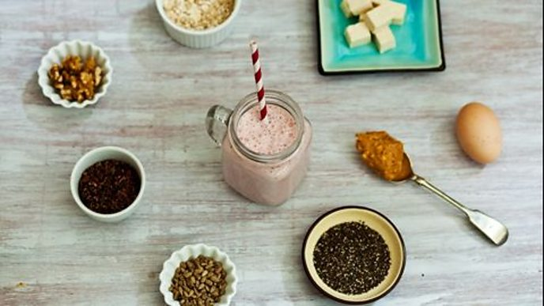

<https://ichef.bbci.co.uk/images/ic/688xn/p060x03z.jpg>

I make my own protein shake using natural ingredients (clockwise from top): Silken to tofu an egg white, peanut butter, china seeds cacao nibs, walnuts or oats to boost the protin content of a smoothie using natural ingredients.

I should be able to get all the protein I need from a healthy diet.

Protein powders like whey isolate and foods marketed as being protein-heavy are now commonplace, and protein shakes can add substantial amounts of extra protein to the diet.

For sportsmen and women, protein helps muscle development and recovery after exercise, but some studies say that a healthy diet alone can provide the protein needed for muscle recovery.

How to be a healthy weight without counting calories by Hattie Ellis

If lockdown weight gain has focused my mind on how to lose extra kilos and maintain a healthy weight, experts now suggest a range of strategies to help me find good daily ways to eat. Calorie counting works for some, but there are other options.

**Real food makes a difference**

“There needs to be a shift towards realising food is more than calories”, says Dr Sally Bell, a GP who specialises in lifestyle medicine. “Different foods do different things to us and carry different messages.”

Nearly 57 percent of the food we eat in Britain is [ultra-processed](https://www.bbc.co.uk/food/articles/what_is_ultra-processed_food). “This is high in calories but lacking in nutrients”, Dr Bell continues. She believes your body instinctively searches for the micronutrients I need and this leads to over-eating. “When we get people switched onto wholefoods and real food, they naturally eat less because they feel more full and get more nutrients”, she says. “We are an obese nation, but some of us are actually malnourished.”

Nutrient-rich foods are best for optimum health and feeling full. Meat, dairy and dark chocolate are examples of satisfying foods that are rich in nutrients and easy to absorb. “I literally prescribe [dark chocolate](https://www.sciencedaily.com/releases/2014/03/140318154725.htm?fbclid=IwAR3cZRQlOBgIumG46lBT0U-vLZeggERS8N_lHa3wbSKAg2-Lc7NEXJCokCc).”

Having [protein](https://www.sciencedaily.com/releases/2016/03/160303083809.htm) at each meal helps make me feel full and stops me eating too much, as well as providing good nutrients. The same is true for [protein-rich snacks](https://nutritionj.biomedcentral.com/articles/10.1186/1475-2891-13-97).



https://ichef.bbci.co.uk/images/ic/688xn/p09czlxb.jpg

I feel full by eating nutrient-dense plant or animal protein

**Fill up on fibre**

As well as lacking some micronutrients, as a nation we are deficient in fibre. The recommended daily intake of [fibre](https://www.bbc.co.uk/food/articles/fibre) for everyone over 16 is 30g a day, but women in the UK eat around 17g and men around 20g. A study at the University of Texas, published in [The Journal of Nutrition](https://academic.oup.com/jn/article/149/10/1742/5512578?login=true), found the amount of fibre eaten was the strongest predictor of losing weight and keeping it off.

Fibre is particularly important for good gut health, which is linked to overall health and weight. “It is well established that for good health I need a diverse gut biome”, says Dr Bell. My [gut microbes](https://www.bbc.com/future/article/20190212-could-gut-bacteria-microbes-make-you-fat) help release nutrients from food, and are linked to hormonal health, which is related to weight loss and gain.

To boost my microbiome, gut-health advocates such as Professor Tim Spector of King’s College London and Dr Megan Rossi, The Gut Health Doctor, advise eating at least 30 different plants over a week – a mixture of nuts, pulses, grains, seeds and herbs, as well as fruit and vegetables. Sprinkle seeds and nuts onto salads and breakfast yoghurt. Fry chopped vegetables and add herbs for an omelette. Make salads with different leaves, raw vegetables and cooked grains. Pile veg into soups. I eat fermented plant foods, such as [kimchi](https://www.bbc.co.uk/food/recipes/kimchi_69909) and [sauerkraut](https://www.bbc.co.uk/food/recipes/sauerkraut_19958).

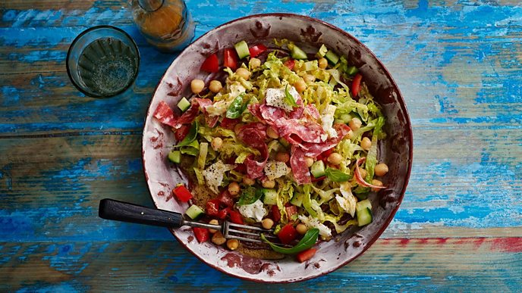<https://ichef.bbci.co.uk/images/ic/688xn/p09czm2r.jpg>

A variety of fibre-rich foods is good news for a healthy weight

**Fasting: A useful biohack.**

Some health professionals think [intermittent fasting](https://www.bbc.co.uk/food/diets/intermittent_5-2_diet) can be useful for losing weight and keeping it off, leading to the rise of the 5:2 diet, with very restricted eating on two days of the week. Then there are time-limited diets, such as the 16:8, when you eat a well-balanced diet within an eight-hour window, for example having supper at 6pm and not eating until 10am the next day (it’s easy to adjust: add four onto the time I ate my evening meal – supper at 7pm or 8pm means I eat your next meal at 11am or 12pm). The 14:10 (eating within a 10-hour time-slot) is another version of this approach. A small [study](https://www.surrey.ac.uk/news/changes-breakfast-and-dinner-timings-can-reduce-body-fat) at the University of Surrey found even moderate adjustments to eating times can be helpful for weight and health.

Such diets may work because they limit the amount I eat and allow my gut microbes to rest and be more responsive to food, increasing my [feelings of fullness](https://www.sciencedaily.com/releases/2015/11/151124143330.htm). But Andrew Hill, Professor of Medical Psychology at Leeds University, thinks most people have an established pattern of eating and that it is better to change what I eat than the timing. “Skipping, avoiding and sacrificing meals is not a good way to manage or lose weight”, he argues.

<https://ichef.bbci.co.uk/images/ic/688xn/p09czlm4.jpg>

When I eat can make a difference to weight loss and gain, and different kinds of fasting are becoming more popular

**I adjust the size of my plate and food shop**

There is a lot of straightforward advice we forget when it comes to weight control, says Professor Hill. One of the best tips is to eat from smaller plates. “The [size of the portions](https://www.bbc.co.uk/food/articles/what_is_a_good_portion_size) I consume on a regular basis is partly dependent on the plate or bowls I serve the food out of”.

I can also think about the amount of food I put in my shopping bags. “During the pandemic I have been told to go out and shop infrequently”, says Professor Hill. But this stockpiling, along with the temptation of multi-buy deals, can be bad news for weight-watchers. “If I have got multiples of food that I am trying to refrain from over-eating, it is far harder to do when they are in the cupboard and easy to get to.

**I am aware of how and where I eat**

Large-scale surveys show how we eat is connected to being overweight. I have my meals at a table and focus on my food rather than partaking in ‘distracted eating’, for example in front of the TV. “I eat slower, take smaller mouthfuls, chew more, in a sense be mindful”, advises Professor Hill.

Variety can stimulate appetite, and a tapas- or mezze-style arrangement can lead people to eat more. “With a variety of flavours and textures there can be a tendency to over-eat”.

Instead of having four types of sandwich on offer, stick to one. I have a single main course and not a starter or pudding.

<https://ichef.bbci.co.uk/images/ic/688xn/p09czmr7.jpg>

I can eat together but have different portion sizes and fulfil varying nutritional need

**Each of us is different**

In the end, we are individuals when it comes to weight-loss and gain, says Tim Spector. In his book Spoon-Fed, he argues calorie counting can be misleading because we do not know how much energy we expend – we have different [metabolic rates](https://www.bbc.co.uk/food/articles/metabolism) as well as levels of physical activity – and our bodies react differently to different foods. Two people can eat the same foods and one will put on weight while the other will not. This is partly down to the individuality of our gut biomes, and underlines why it is important to eat a varied diet.

It is also important to be aware that people around the same table will have different nutritional desires. Someone will want bread with their meal, others will want to avoid it, for example. “Respect the differences and do not feel pressure”, says Professor Hill. I can eat the same meal with others, but serve myself a smaller portion of a dish or some of the foods, such as potatoes, if I want. Diet and weight-loss advice, overall, do not take into account how different we are. “We give out general guidance to tens of millions of people and forget they live in different circumstances and have different needs, and are unable to follow that advice”. One of the reasons weight-loss diets notoriously fail is they promote strict short-term restrictions that are impossible to maintain, rather than a healthy diet that suits us as individuals. Stick to the basic principles of what I am trying to do but stand back from clear rules, advises Professor Hill, as these can set me up for failure.

In 1847 a physician by name of Semmelweis advised that all physicians wash their hands before touching a pregnant woman, in order to prevent child bed fever. His research showed that I could reduce the mortality rates from septicemia, from 18% down to 2%, simply through washing my hands with chlorinated lime. His medical colleagues refused to accept that they themselves were responsible for spreading infection. Semmelweis was ridiculed by his peers, dismissed, and the criticism and backlash broke him down, and he died in an asylum, two weeks later, from septicemia at the age of 47.

What I will say today will sound as radical as hand washing sounded to a mid- 19th century doctor, and yet it is equally scientific. It is the simple idea that optimizing nutrition is a safe and viable way to avoid, treat, or lessen mental illness. Nutrition matters.

Poor nutrition is a significant and modifiable risk factor for development of mental illness. According to the 2013 New Zealand Health survey, the rates of psychiatric illnesses in children doubled over the last five years. Internationally, there has been a 3-fold increase in ADHD, a 20-fold increase in autism, and a 40-fold increase in bipolar disorder in children. And the graph here shows there has been a 4-fold increase in the number of people who have disability as a direct consequence of an underlying psychiatric illness.

The rate of mental illness is on the rise. So how are we dealing with this problem?

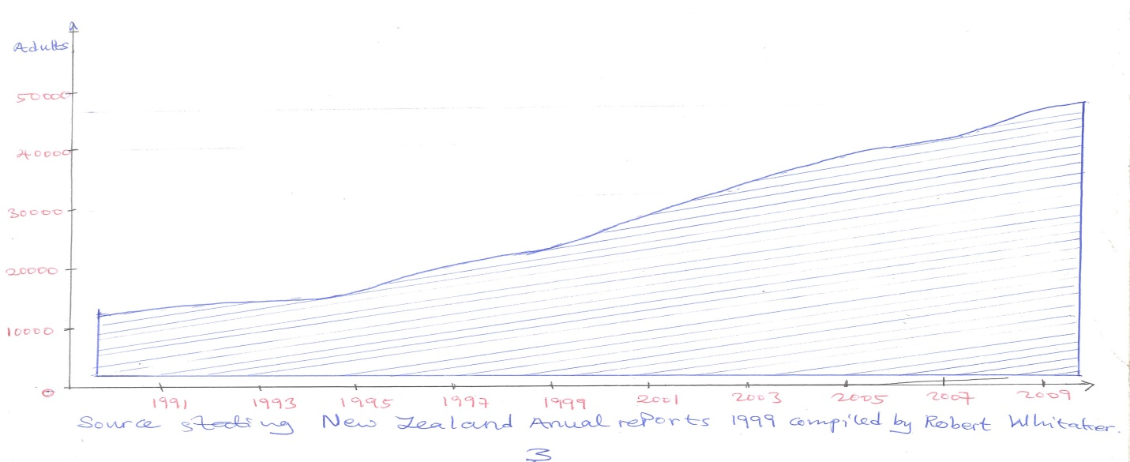

**Conventional medicine**

Therapy

Other

cvc

Medication

cvc

Currently our healthcare system operates within a medical model. Now, this means that one will typically be offered psychiatric medication first, followed by psychological therapies, and other forms of support.

Our reliance on medications as a front-line form of treatment is evident from the increasing rates of prescriptions. For example in 2012, half a million New Zealander’s that is one-eight of them has been prescribed an antidepressant that is 38% higher than five years previously. Similarly, the rates of prescriptions for antipsychotics doubled, from 2006 to 2011. Given that across all western societies, I will rightfully expect that it was working well.

And indeed, in some cases, these treatments save lives. And I am not to dismiss it, altogether. However, if a treatment is truly effective, then should not the rates of disorder and disability as a direct consequence of that illness be decreasing rather than increasing?

That is why I need to consider the role that medication might be playing in some of these outcomes. If I take any class of medication: antipsychotics, anti-anxiety medications, anti-depressants; the pattern is the same. In the short term, these treatments are often very effective, but in longer-term they are not. And in some cases they are making life worse. If I look at fore example studies that are being done on ADHD children, treated with stimulants or Ritalin, in the short term, they are better and responding better responders than any other form of treatment, but in the long-term, they fare less well than the children who were never prescribed these medications.

Another study showed that despite our ever-increasing reliance on antidepressants, the recovery rates and relapse rates are no better now than they were 50 years ago, prior to the advent of these medications. And children with depression, who were treated with antidepressant, are three times more likely to convert to Bipolar disorder than children who were never given these medications. And people who were not randomized to stay on their dose if antipsychotic medications are less likely to recover from Schizophrenia in the long-term than people who had been randomized to a dose reduction or complete elimination of the drug. And it shown that more and more studies all highlighting the same bleak picture so pretty depressing. (Laughter)

Is there another way forward? Almost two decades ago my PHD supervisor at that time, Professor Bonnie Kaplan, told me about some families who were treating themselves with nutrients in southern Alberta, Canada. Now they had bipolar disorder, psychosis, depression. These are serious conditions, and my education in clinical psychology had taught me that nutrition and diet were of trivial significance for mental health, and that only drugs or psychotherapy could treat these serious conditions. But she and others were publishing preliminary data in the earlier part of this century, showing people getting well and staying well. And so, I decide to study the nutrients, and that is what I have done for the last decade.

In 2009, I received some funding to run a randomized placebo-controlled trial, using minerals and vitamins, also known collectively as micronutrients, for the treatment of ADHD in adults. And this study was established in the British journal of psychiatric in April this year and here is what we found within just an 8- week period, twice as many people responded in the micronutrient group compared to placebo; twice as many people went into remission in their depression, in the micronutrient group.

Hyperactivity and Impulsivity reduced into the normal, non- clinical range, and those who were taking the micronutrients were more likely to report that their ADHD symptoms were less impairing and less interfering in their work and social relationship than people who were on the placebo.

And one year later, those people who stayed on the micronutrients maintained their changes or showed further improvement, and those who switched to medications or stopped the micronutrients actually showed worsening of their symptoms.

Now I need to unfold something here, and that is when I see micronutrients, I am actually referring to a dose higher than what I would get out of a vitamin pill purchased on the supermarket.

In this study, participants are given up to 15 pills a day with 36 nutrients. So it would be unlikely see these positive benefits, both because the dose is lower, and the breadth of nutrients is lower. These positive benefits are not confined to a single study

Micronutrients

21

Placebo

18

Rucklidge et al, British Journal of psychiatry 2014

Change in ADHD symptoms over a week

9

12

15

6

0

3

Improvement in Bipolar Disorder in children over a 6 month period

6 months

Baseline

5

10

15

20

Symptom

Severity

Scores

Rucklidge JJ, Gately DKaplan BJ, BMC psychiatry 2010

My lab at the University of counter bury is the Mental Health and Nutrition Research Group and I have published over 20 papers in medical journals, all documenting the benefits of micronutrients. For examples the study here, showed that I could reduce the symptoms of bipolar disorder in children by 50% with the simultaneous reduction of medications. The study showed that one could reduce rates of probable posttraumatic stress disorder from 65% down to 18%, following the Christchurch earthquakes with the one month intervention of micronutrients, with no change in those not taking the nutrients.

Reduction in trauma after earthquakes

PTSD Population Prevalence

0

Controls

Micronutrients

Percentage

Baseline one month one Year

Rucklidge et al, Hum Psychopharmacol 2012, 2014

Even one year later those people who had received the nutrients were doing better than those who did not. And we have just replicated these findings in collaboration with researchers at the University of Calgary, following the floods of June 2013, in Alberta, Canada.

To me the message is clear, that a well-nourished body and brain is better able to withstand ongoing stress and recover from illness. Giving micronutrients in appropriate doses can be an effective and inexpensive public health intervention to improve the mental health of a population following an environmental catastrophe. In once 20-year career, one has rarely seen these dramatic responses from conventional treatments. When one gets well, he/she gets well across the board , not only in the symptoms that has been treated, but also in other areas, like improved sleep, stabilization of mood, reduction in anxiety and the reduction in need for cigarettes, cannabis and alcohol. My research on those around the world, have shown that 60%-80% of people respond to micronutrients, showing just how powerful this intervention is.And internationally, there have now been 20 randomized placebo-controlled trials which is the gold standard that one use to make clinical decisions showing that one can reside aggression in prisoners, slow cognitive decline in the elderly, treat depression, anxiety, stress, autism and ADHD. And they might even be more cost-effective than current conventional treatments. The study here documented the treatment of a 10year-old boy with psychosis. When his 6month impatient treatment with medications was unsuccessful, he was treated with micronutrients. Not only did the micronutrients completely eliminate his hallucinations and delusions changes that were maintained six years later but the cost of the treatment was less than 2% than the cost of the unsuccessful impatient treatment. The cost saving above makes it imperative that our society pay attention to the wider benefits of this approach. And there is more good news.

Rodway et al, BMJ case Reports, 2012

But the cost of the treatment was less than 21%

Cost of conventional inpatient treatment Cost of micronutrient outpatient treatment

Treating – supplementing before mental illness emerges can actually stop these problems from developing in the first place. This fantastic study looked at 81 adolescents at risk for psychosis and randomized them to receive either omega3 fatty acids in the form of fish oils- essential nutrients for brain health- or placebo for a 12- week period.

One year later, 5% of those who received the fish oil had converted to psychosis versus 28% of those on placebo. That represents an 80% reduction of the chances of one converting to psychosis, simply through giving fish oils.

30

Placebo

25

Percentage who converted to psychosis

Fish oils

55555

15

20

10

Amminger et al, Archives of General of Psychiatry, 2010

I wonder if one really knows what others are thinking. I wonder if some people are thinking, hold on! Why don’t we just eat better? “Why don’t we tell others to eat better?

**Tell**

**Everyone to**

**Eat better**

And indeed, there are some fantastic studies that document the strong relationship between dietary patterns and mental health although we are still in very early days of scientific investigation. We do not know who would benefit from dietary manipulation alone, and who may need the additional boost from extra nutrients.

But even in the last five years, there have been II epidemiological studies, cross-sectionally and longitudinally, in large populations around the world, all showing the same thing. The more I eat a prudent or Mediterranean or unprocessed type of diet, the lower my risk of depression. And the more I eat the Western diet or processed food, the higher my risk for depression. I know of only one study that has not found this association, and not a single study shows that the western diet is food for our mental health.

What is the Western diet? Well, it is one that is heavily processed, high in refines grains, sugary drinks, takeaways, and low in fresh produce. And a healthy diet is one that is fresh, high in fruits and vegetables, high in fish, nuts, healthy facts, a low in processed foods. What my grandmother would recognize as food. There are a lot questions remaining about the relationship between mental health and nutrition. What role do genetics play in determining who is going to respond to nutrients and who needs additional nutrients that what they can get out of their diet? What role does an infected, inflamed gut play in the absorption of nutrients?

It is not we are what we eat; it is we are what we absorb. And what role do medications play in determining how effective the nutrients are? Combining medications and nutrients is actually complicated, and I need more research on better understanding these interactions. But ultimately, I need to know how long these good benefits last. So with all this data, this rich data highlighting the power of nutrition, I think I can make some individual and we can make some collative changes now. We could consider our current treatment approach; prioritize lifestyle factors, healthy eating, exercise, supplements, and when necessary, psychological treatments and save medications, for when these approaches do not work.

**Integrative medicine**

**Stress reduction/ therapy**

**Lifestyle/exercise/ supplements**

**Meds**

If nutrients work, then should they not be covered through our healthcare system? I have to take universal prevention seriously by optimizing the nutrition of those who are vulnerable. I do not have to wait for the heart attack to hit; in order for us to modify lifestyle behaviors that I know contribute to heart disease. It should be no different with mental health. An easy way to implement universal prevention would be to have pregnant woman- not pregnant woman: midwives tell pregnant women about the importance of nutrition. Nutrients- depleted mothers produce nutrient- depleted children. Nutrient- poor foods during pregnancy increase the chances that my child will have a mental health problem. I have to learn about the risks of cheap, processed foods. As Michael Poll an stated, cheap food is an illusion; there is no such thing as cheap food. The price is paid somewhere, and if it is not paid at the cash register, then it is charged to the environment and to the public purse in the form of subsidies, and it is charged to my health. All children need to learn how to cook. All children need to know that food does not have to come in a packet. Schools could reflect on the content of their lunch menus. Children are too frequently rewarded with processed foods for good behavior. I need to reflect on whether or not this pairing intuitively makes sense. Ultimately, I have a responsibility to teach them that every time they put something in their mouths, they make a choice to eat something nutritionally depleted.

In the 19th Century, physicians were offended when Semmelweis suggested they wash their hands before delivering babies. We are now asking them to consider whether the medications that the prescribed are contributing to the poor long-term outcome for some people with mental illness.

But eating well and when appropriate, additional nutrients can improve the mental health of many people. Randomized trials in the 1600’s showed that putting limes aboard ships headed out for long voyages completely eliminated the 40% mortality from the scurvy.

But it took 264 years for the British government to mandate that all ships must carry citrus for their sailors. How long will it take our society to pay attention to the research showing that suboptimal epidemic of mental illness?

So this is my idea worth spreading: nutrition matters and if we are really ready to get serious about mental health, we need to get serious about the critical role played by nutrition.

[www.ted.com/tedx](http://www.ted.com/tedx)

Jason Kilderry

One point in our lives we made an assumption. An assumption that we ultimately regret it. But we probably learn from an assumption. I made a lot of those bad assumptions in my life. But there was one that particularly stands out. It actually probably changed my life. So but 7 years ago, I was struggling with a kidney disease. The kidney disease was palities kidney which I inherited from my family. So I was in and out to the hospital in my family. I have to say when you are in a hospital or not it is boring. I can only watch so many books, so what I was doing is walking around where the hall is. My thing I was doing is eavesdropping when the nurses are having conversation with their patients. I got to heard about cardiovascular disease; I never forget one discharged from the hospital. From what I discovered from the conversation was, he did not have to frequently create some forum or kind of heart surgery.

And another said “Are you not excited? I got really excited. What I had to do was to take my wife out of here; she goes out and was going to make a donut. I cannot believe how the nurse was going to respond to this; and she said that was the greatest idea and his response was what changed my life. He said do not worry, I am going to get the fish for life. I immediately I got my ipad and was not happy for real and all the time I spent in the hospital were trials with units, doctors’ offices, all the people I came across were struggling with diseases. I had a very bad attitude towards these people because I know a lot is because of the choice the made about the food they eat. It means inactivities in our lives, but that was not a good thing for me to do because my background as health, exercise science. If people do not know that and I go back and think about his response, and he said do not worry, I am going to give that fish to that man, he actually thought that was a healthy choice. He thought that was a good decision. Thus when I said you know what? If I have recovered from what I am going through, my goal is to reach as many people possible to make sure they understand the simple aspect of nutrition and exercising which will change our lives.

I want to change a lot of lives if possible 315, 091, 138 million people in US in January 2013. Interestingly 315, 091, 138 people have many or more than one chronic diseases that could be ulcer, if they chose better foods 1.5 billion people are either obese or overweight. I can talk statistics of this but I do not want to talk about that. There are many variables that can be used to change these. That is when it comes to statistics. I want to talk about one which is how we get our information simple. We hear about nutrition and exercise every single day, being it on social media or friends in general who talks about nutrition. News, magazines, wherever we may be we hear about what is night and what is wrong about nutrition etc. And then we have all the experts. Most of the time, these experts often raise exercise and does exercise most of the time. Making thing difficult and mostly what they preach is not evidence based. There is no scientific literature that supports that.

I did a lot of boxing and exercise and I saw a lot of instructors and I never forget one of the instructors that I have. He was very good and the reason why I like him was that I learned lot from him. He carried me over into learning a new skill the rest of my life. Most of the instructors that I came about, the first day I learned a lot of punching punches, and the other days I learn a lot of flying jump kicks. I have a great proverb which was feed the men on fish; you feed them on meal. Teaching men to fish, is feeding for a life time. I want to feed people for a life time.

What makes nutrition so specific is so hard to understand and so hard to grasp; the diet aspect. Everyone one point in life has feed on a diet. Unfortunately, diet makes things so difficult. Diet is like religion now a day. We see something about diet on social media every single day. And I hate doing this but it works. And the reason it works is that there are some set principles. One is structured is more structured than a. two it often eliminates process food which is one major macro nutrient; whether is protein, fat , carbohydrate. What it does, is we intake less calories with more structured. Our blood work might be a little bit better but the bad thing about it is quick fixed, it happens over might and this is why we go away with that because they create boundaries. I can eat certain foods and when I have ice cream, I have failed my diet. I have stepped outside my boundaries.

Some nutritional habits that I can instill onto my life every time I go on shopping I have to seek my food with a lot of fiber and the out I drink. I need to seek my healthy facts in healthy oils, nuts, seeds, fish, and avocados. If I want to eat meat, thus fine; I have to make sure I have wide variety of it. I need to have a wide variety about other food I choose as well. Meat is a bag rapped and is ultimately because the average American takes it in probably 72 times a month that we can actually absorb in use. So those four basic principles I have seen it in the past 50 years.

That when I fall off these it leads to certain chronic disease. In Christ about my life is more vitality. There is the need for me to limit use of process food from the super market because there is no nutritional value to this stuff. It is not for me to completely get rid of it but to limit them. The average American spend more than half a day watching television but they spend less than an hour in the kitchen preparing food.

Low CRF

Smoker

Diabetes

Hypertension

Obesity

Woman

Man

Attributable fractions (%)

18

16

14

12

100

8

60

40

2

0

High cholesterol

The predictors of that; the number one predictors of that is low cardio respitory fitness, AKA sitting disease. We have to get up and move more is possible run a marathon, we need to get up 30 to 45 minutes a day and move. Thus walk with my dogs or ride a bicycle; thus 30 to 45 minutes a day, said by the American marathon sports council. For me it is important athletes do five cases or ten case marathon, spring trial forums etc. some of them do not do 45 minutes a day activity but that is a goal and that is something one has to reach for. They may stop at 10minutes a day. Thus 10 minutes in the morning and 10 minutes in the evening; but the key thing is with movement, it should be done frequently. It is not by walking for 30 minutes and then going back to sit down for nine hours. Because what I have seen in literature, that 30minutes is not going to be beneficial for me or us in general. I have and we have to get up and move. Now there are even thread mill music works. I listen and I love this idea.

Kicking outside with walking work is good but looking at the treadmills; it shows how fast people are walking indoors. If I can feed in 10 minutes at night and 10 minutes in the morning without doing it when I am working, I am booking myself two times. I have to work on some time management looking at basic nutrition and exercise. The basic principles are nutrition and exercise Very simple. How do we or I implement them. How do I make them last a lifetime?

When I first started my health company 12 years ago, I was very excited from my first client. I had 30 pages of paper work; I had slim filled out because I want to know everything about this person, and as I was going through, I was seeing a lot of red flags. I said ok over 40 years, 50pounds of weight loss, lot of medication, high blood pressure, risk of cardiovascular disease because it is in the family. There I saw and I was sorry, the person eats six meager balls a day and it was lie. He has to stop eating meager balls and pay me.

**References**: Exercise, Nutrition and health: keeping it simple/ Jason Kildery/ TEDx DrexelU.

Queenstown TEDx NIKI BEZZANT

We are surrounded by vast information more on nutrition. Is even where we go. It is on television, on newspaper, is also about every section of direction we have as well.

The funny thing is hidden. We can list and lost health aids and we are getting more and more confused. Here I have a carrot and cupcakes. All I really need to know about healthy eating, which of them is the healthiest is it the carrot or the cupcake? Looking at the carrot; it is a colorful vegetable, it is full of fiber, it has vitamin A and vitamin C. if I Google carrot and sugar, I might come across people telling me that carrot are high vegetable sugar, and maybe we should limit carrot. Sugar ideally right now is killing us all so is good I kill myself with carrot. What about the cupcake? Well if I say is gluon free, pillion friendly, vegan; what about if I say it has no refined sugar? I think it will bring confusion.

Welcome to the world of health action in 2016 and we may get more and more confused and we need to listen list. We are getting less and less healthy, and more confused!

About 103 million people are obese, I and five of us has gotten pre-diabetes and a lot of us do not know that yet.

One Kiwi dies every 90 minutes from heart disease. Treatment for type two diabetes and obesity cause a billion dollars a year. On top today is over 200 million US dollars in lost productivity. So that means it is costing each one of us at least 200 dollars a year.

Alongside all these ill health, all might be because of that the diet are not sustainable. How many people do we know have been on the same diet for ten years or five? It is just not possible to do. What is popular in a lot of diet is the new delicious breakthrough that newest preferred. But when we look at them, most diet does come along is not much actually new. But all quite look similar when one has a first quick look. When one need a scientist to have a successful diet, this can be based on the theory that, it takes our bodies more energies to metabolize food at cold temperatures.

The thing is diet do not work! If they did she would not be standing there and they would not have a multi- billion dollar work lose industry and there will be no obesity epidemic. We will all be aged in the same way and we will be slim and healthy. Human beings as we are we like the idea of diet.

Human being as we are, we love the idea of diet. We like the promise of quick effect. Moderation is the tower of brilliant section. It is an isolate to say that in the current nutrition environment we are extreme to viral. And if mischief moderation feels reduce, and if moderation draws a little bit behind the time; moderation is what is need. “We have reliable knowledge of lifestyle practices. Including dietary pattern association with the potential to reduce both the public burden of and personal risk for chronic diseases and premature death by as much as 80%- True health initiative.

In other words we only know what we need to know to be healthy. We have just lost sight of it along the way. I would like to present everything about health limitation. I have six points, which can also be called by roles if anyone likes but I really hate the idea of roles when it comes to first but diet is full of them and people call like roles as well.

A first of them one could trace; think of this is reminders because actually one knows them all. The roles or my reminders are not about what to eat but one exception. My roles are about what to think about what to eat and here they are:

1. Food is important

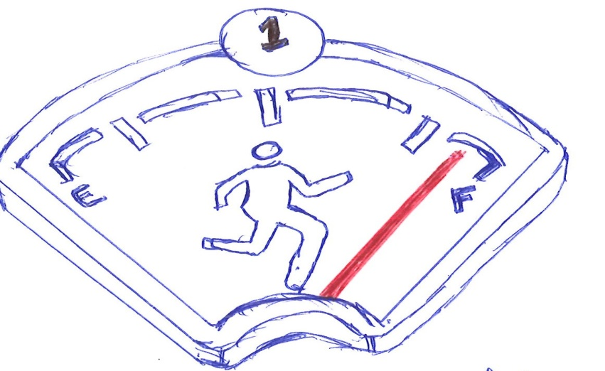

Food is really important; so let us treat it by saying it is moderation what of if I like. I would like to say food is really important and deserve to be given time and importance in our life. I spent most of my time talking and writing about food because it is really important to me but we all eat it. These are fundamental things because we think and feel we eat food in order to determine how long we leave.

So food deserves to be given importance. We also need to relax a little and remember food is just food. Food should not be something that we fix to feel about ourselves. Food should absolutely not make us feel guilty, or ashamed. Thus not the healthy way to think about anything that we eat. The exception element of moral judgment that we take food is that, in almost all the first we judge people on it, and all the time we judge each other. I eat a healthy food as people may see me with ice cream of margarine with bread. I eat a healthy food; it is just human but is not really futile. Food is just food and food is not a guilty pleasure. If we are going to feel emotional about food; let us feel joyful because food is not the life greatest pleasure.

2. The number two is that; “there is no such thing as one ‘perfect’ diet. Anyone who tells me no matter how caress mother they have will how much science they coach. They have got the answer; the one way of eating that works for everyone. Thus trying to sell you something and they are also wrong because there are a lot of ways to eat to be healthy.

The way that I use for you is probably not going to be the same as the way that it works for me. So my life, my family situation, my budget and my personality. The people who laugh the longest and stay the healthiest in the world. The places that I love are known as the blue zones. They all eat really different diets from Okinaway in Japan with fish and rice, to Nicora in South America with that basing name. With that all difference but they are all equally healthy. They all eat moderately. I guarantee that the people in the blue zone are not worrying about what they have to eat is allowed or not allowed and they diet.

3. The number three is “Eat food, not nutrients”. It is really easy to get boredom in the dish hell of nutrients fed cup poison. We eat food but you heard a person saying all is killing us is not sugar, but only one thing is killing us. Only one thing is the answer. Talking about our problems if one finds himself worrying about the sugar in the carrot; will the cupcake for that matter; it must be time to just relax and go outside and have a walk around the sunshine.

If we just concentrate on ancient fish whole good food the nutrients will need whole good food, the nutrients will need to take care of themselves.

4. I eat what makes me happy; thus is eat what makes me happy. It is not license to eat three times a day, and it is not a license to take coke item happiness slogan. But I need to ignore the food that is about pleasure too. I also need to ignore the tick to eat everyday food to but I need to enjoy them moderately and when I have them I really serve and enjoy them and I take pleasure without guilt. Now eating what makes me happy is also about a modern just immediate great vacation so I need to listen to my borders. A big bowl of salad is going to make me happy because it will nourish my body and make me feel happy in a longtime. So moderation here is about thinking about what makes me happy now and also in the future.

5. Eat your veges! I eat my vegetables. I can eat as wide as much as variety of vegetables or veges as possible. But people in the blue zones have these in common like all they eat are planned by style. They eat heaps of veges. They have made these to be in a form of garnish rather than focus on the meal. And I will do really well to follow their advice.

I might find idea probably helpful if it is tomorrow, I might have half the plate divided into carrots and privities’ and if it is going to work and if trust glorifying up in veges.

6. cook. I have to cook as much as I can when I cook I take into control of the organism in my body. I have taken a very important decision, what makes my body happy, to a cheerful or fast-food cook. Go to production with victory. When I cook, I have to sit down, enjoy and share my food with others. Can we tell each other a food has with done away to make us health mentally and physically? Times I have been in kitchen could has just been as valuable as tones been in gym. Sitting down sharing food between families is also a fantastic way of building and training my family of food culture of modeling healthier behavior and of plan health forward to the next generation so that there is no need for trouble health statistics that we have. I would like to embrace moderation using moderation was again something not reduce, but I have to make it something natural. If I have gotten to the point, I will actually eat what makes us feel truly good.

But any monument in the long term a food pleasance is can be looked at and given protein, but I also relax and do not get through a six about it that means it is truly healthy eating and thus what is going to make me happier and healthier people. In case I am wondering probably take more carrot than a cupcake. But both carrot and cupcake can be enjoyed if anyone thinks otherwise because as part of wife is moderation.

NEAL BANARD, M. D. FACC

Physicians Committee for Responsible medicine

Translator: Peter Van de Ven

Reviewer: Denise RQ

NEAL BARNARD M. D. FACC

On February, 8, 2012 my father passed away. The truth is that was the day his heart stopped beating. For all intents and purposes my father had died years earlier. It started with memory lapses, and as time went on, his memory failed more and more, and it got to the point where he did not know his own kids who came to see him. His personality changed, and his ability to take care of himself was completely gone and if I could make a list of all the things that could ever happen to me, the very last thing on my list at the very last thing on my list at the very bottom of the list, the thing I want the least is Alzheimer’s disease, because when I lose my memory, I lose everything, I lose everyone who over mattered to me and if I could look into the brain of a person who has this disease, what I see is between the brain cells are these unusual looking structures.

Beta-amyloid protein comes out of the cells, and accumulates in these little meatball-like structures that are in front of me, on a microscopic slide. They should not be there, and they are hallmark of Alzhemer’s disease. These disease effects about half of Americans by their mid-80’s. I could say to my doctor, “OK, I do not want that. What can I do to stop that?” my doctor will say, “Well, its old age and it is genetics”. There is a gene’ – it is called the APOLE – (epsilon) 4 allele. If I have this gene from one parent. My risk is tripled, if I got it from both parents, my risk is 10 to 15 times higher than it was before what is the answer? Get new parents? No, I do not think so. That is not it. So I am sorry. It is old age, it is genes, period, that is it, there is not a dam thing I can do just I wait for it to happen or maybe not. In Chicago, researchers started something called the Chicago Health and Project. What they did was they looked at what people in Chicago were eating.

They did very careful dietary records in hundreds and hundreds of people, and then they started to see who, as the years go by, stayed mentally clear, and who developed dementia. The first thing they keyed in on was something that I knew about as a kid growing up Fargo, North Dakota – My mom had five kids, we would run down to the kitchen to the smell of bacon. My mom would take a fork, and she had stick it into the frying pan and pull the hot bacon strips out and put them on a paper to well to cool down and when all the bacon was out of the pan, she would carefully life up that hot pan and pour the grease into a jar to save it – that is good bacon grease, I would not want to lose that! My mother would take that jar and she would put it not in the refrigerator but she would put in on the shelf, because my mother knew that as bacon grease cools down what happens to it? It solidifies. And that the fact that it is solid at room temperature is a sign that beacon grease is loaded with saturated fat, bad fat. We have known for a long time that raises cholesterol, and there is a lot of in bacon grease. And by the way, the next day, she would spoon it back into the frying pan and fry eggs in it; it is amazing any of her children lived to adulthood. That is the way we lived. The number one source of saturated fat is actually not bacon, it is dairy product, cheese and milk and so forth, and meat is number two. In Chicago, some people ate relatively little saturated fat, around 13 grams a day, and others ate about twice that much, and the researchers just looked at who developed Alzheimer’s disease. And can I show the figures?

In other words, if I am avoiding the bad fat, my risk was pretty low, but if I were tucking into the cheese and the bacon strips, my risk was two, these or more-fold higher, then I looked not just at saturated fat, I looked at the fat that is in doughnuts and pastries; I know what that is, that is trans facts I will see on the labels. They found the very same pattern in there, two. So the people who tended to avoid the saturated fat and the trans fats, wanted to avoid them for cholesterol and heart disease reasons, but they also seem to affect the brain. Then researchers in Finland said, “Wait a minute, let us go further”. There was a condition we called mild cognitive impairment. I am still myself. I am managing my check book, I am driving my friends know it is me but I am having mental lapses especially for names and for words. They brought in over 1,000 adults, they were 50 years old, and they looked at their diets. Then as time went on, they looked to see, who developed mild cognitive impairment. Some of these people ate relatively little fat, some people ate a fair amount, and then they looked at whose memory started to fail.

The found exactly the same pattern. In order words, it is not just “will I get Alzheimer’s disease?” but will I just have old age memory problem? Will what about that gene, that APOE – [epsilon] 4 allele the one that condemns me to Alzheimer’s disease? Well then redid the study and they focused only on those people, and some of these people ate relatively little fat, some people ate more and exactly the same. In other words, if I am avowing the bad fats, even if I have the gene, my risk of developing memory problems was cut by 80%. And this is my most important point; genes are not destiny.

Let me take another look at those plaques. I know there is beta amyloid protein, but there is also iron and copper, metals in my brain? That is right, there are metals in foods, and they get into the brain.

Now let us think about this: I have a cast-iron pan and I had a backyard barbecue, and a week later, I remember, oh…

I left my frying pan on the picnic table, and it rained last week.”

What happened to my pan?

It rusted, and that rust is oxidation. Or

I take a shiny new penny and does it stay shiny forever?

No it oxidizes too.

Well, iron and copper oxidize in my body and as they do that, they cause the production of what are called free radicals.

I have heard of free radicals. Free radicals are molecules that are swimming around in my blood stream, and they get into the brain, and they act like sparks that seams through the connections between one cell and the next. So how is this happening?

0

1

2

3

4

Where am I getting all this iron?

Where can I getting all this copper?

How can that be?

How many people have a cast iron pan?

If that is someone’s once a month pan.

I am going to say, “who cares?”

But if it is every single day, I am getting the iron into my food, and it is more iron than my body needs.

Or copper pipes, who has copper pipes?

That water sits in the copper pipes all night long, and in the morning it goes into the coffee maker, and I am drinking that copper I get more than I need, and it starts producing these free radicals that go to the brain. If I am a meat eater, of especially liver, there is iron and copper in those foods too. And I used to think, “ is not that great?” until I realized iron is a double-edged sword.

I need a little bit, but if I have too much, it becomes toxic.

Vitamins

Vitamin manufacturers put in vitamin A and the B vitamins, and vitamin C and vitamin D. and then they throw in iron and copper, thinking “well I need these”, not recognizing I am already getting enough in foods and if they added it to my supplement, I am getting to much. Ok so what am I saying?

What I am saying is aside from the fact that the saturated fat and the trans fats will increase our risk, these metals will, too, and they are causing sparks to form in the brain, free radicals to form that seen through the connections. And if that is the case, then I need a fire extinguisher. And we have one, and it is called vitamin E. vitamin E is in spinach, and it is in mangoes, and it is especially in nuts and seeds. And in Chicago, some people eat a little bit of it, and some people eat a lot of it, and the beauty of this is vitamin E and is an antioxidant, it knocks out free radicals. So if what I am saying is true, then the people in Chicago who ate only little bit of vitamin E would be at much higher risk than people who ate a lot. And that is exactly what the research showed. People getting eight milligrams a day of vitamin E, and their risk of Alzheimer’s by about half compared to people getting less than that.

Hmm, ok, how do I get that?

It is very, very easy: I run to the store and I just buy a bottle of vitamin E pills.

No I do not think so, and here is why not.

Nature has eight forms of vitamin E. it is built into nuts and into seeds, but if I put it into m y supplement pill, I can legally call it vitamin E if it has only one form. And if I am eating too much of one form of vitamin E, it reduces my absorption of all the others! So I want to get it from food that is the form that nature has designed for us, and that is the form that we have evolved with. We can go a step further.

Oh, by the way, I forgot to tell you.

How much should I have?

I put some nuts or seeds into the palm of my hand, by the time it hits my fingers, that is just one ounce and that is about five milligrams of vitamin E, right there. They trick is, do not eat it; because if I do, I know what happens.

If I have those diced salty almonds and I have eaten them; I fill my hand again, and then I eat it again.

There is something about salty cashews and almonds, is it just me?

There is something about them, they are a little bit addicting in some way. So in need not to do that, that is going to be way more than I need. The answer is pour them into my hand, and then crumble them up, and put them on my salad, or put them on my oatmeal, or on my pancakes or something. I sue them as a flavouring not as a snack food, then I am going to be ok. All right, researchers at the University of Cincinnati went one step further.

Not just saturated fat, not just trans fats, not just vitamin E, but they said, what about color? Look at blueberries and grapes: that color that they have is dramatic. And the colors of blueberries are not just there to make them pretty, those are called anthocyanin. They brought in a group of individuals into a research study: average age: 78 and everyone was already having memory problems. And what they ask them to do was to have grape juice, a pint a day. A cup in the morning a cup at night. Three months later, they tested everyone and their memory was better, and their recall was better.

Three months?

That sounds too easy. How can that be?

Well, I think about it: a grape has a rough life. A grape has to sit on the vine, all day long under the sun, and exposed to the elements and it has no protection. Or does it? That purple colour, those anthocyanin happen to be powerful antioxidants just like vitamin E. but they are in the grape form and if I consume them, they go into my blood stream. And if that is true, it does not have to be grapes, it could be anything that has that color like blue berries. So back into the laboratory: a new group of patients, they came in they all had memory problems. And three months on blue berry juice. Their memory was better, their recall was better. Now, the moral of the story is not to have grapes and blue berries, and blue berry juice and grape juice. No the answer is color. If I look at the colorful foods, there is an important lesson there for us. I walk in to the grocery store, and from a hundred feet away, looking at the produce department, I can recognize beta-carotene, lycopene, anthocyanins,. My retina can detect them because that is the orange color of a carrot or the red color of a tomato, or the purple color of a grape.

And the brain also tells us they are pretty, they are attractive, I can recognize antioxidants, I am drawn to them. So back into 2009, my organization, the Physicians Committee for Responsible Medicine, went to the Department of Agriculture. I said” This is important. Let us throw out the pyramid”. The pyramid was a nice shape, but it had a meat group, and it had dairy group, despite the fact that people who do not eat meat or dairy products happened to be healthier than people who eat them. And also, who eats off a pyramid anyway? We eat off a plate so we devised a plate that said, fruits and grains, and legumes- that is the bean group- and vegetables, and those should be the staples. Well we gave this to the USDA in 2009, and we did not hear back from them. So in 2011, we sued the federation government, the Physician Committee field a law suit against the USDA, simply to compel response. And did I see what the us government came out within 2011? I am not taking any credit for that.

**PCRM 2009**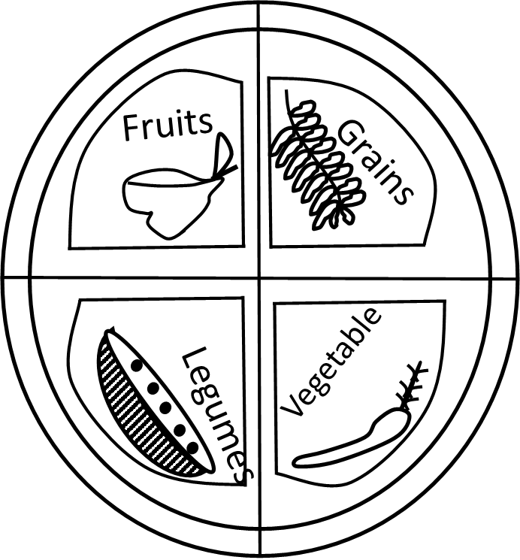

**USDA 2011**

USDA 2011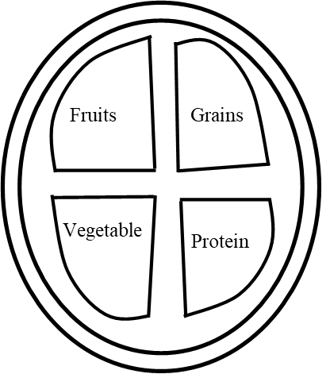

But this is now US government policy, it is called Myplate, and it does look in some way similar to what we would send them a couple of years earlier. Fruits and grains and vegetables, and they have this thing called the protein group. The protein group could be meat, but it could be beans, or tofu, or nuts or anything that is high in protein, it does not have to be meat. In fact there is no meat group anymore in federal guidelines. There is a dairy group there, but to their credit, soy milk counts. So, things are improving. So far, what we have talked about is getting away from the saturated fats, that is in cheese and bacon and meats; getting away from the trans-fat and snack foods; we are having in the vitamin E and the colorful foods, and there is one more step. It is not all food, there is something to say about exercise. At the university of Illinois, researchers brought in large group of adults, 120 of them, and they said is a brisk walk, three times a week. After a year, everyone went into the laboratory for brain scan. They measured the hippocampus which is at the center of the brain, and it is the seat of memory. It decides what should be let through into memory, and what should not be let through. It turned out that this organ, which is gradually shrinking in older adults, suddenly stopped shrinking.

The exercise found that their hippocampus was a little bit bigger, and a little bit bigger, and a little bit bigger, it was time was going backwards: it reversed brawn shrinkage, and on memory tests, they did substantially better. So I have devised my own exercise plan. I would like to present it to everyone, I do this three times a week.

I arrive at airport as late as possible, carrying massively heavy luggage, and just run for the plane. At the University of Illinois they had their own ideas, and their idea was a little simpler. I do a ten minute walk and do it three times a week. And then, next week, let us do a 15 minute walk, and the week after that 20. All we were doing was adding five minutes a week until we get to 40 minutes, and a 40 minutes brisk walk – this is not a trudge but it is a good brisk walk – 40 minutes, three times a week is all I need to improve memory and reverse brain shrinkage. Very simple. What I would like to do is to go back in time, and I want to sit down with my dad, and I want to say “Dad I found out something really important. We can change our diet we do not really need that cheese and the bacon. There is plenty of healthy things that we can eat. Let us bring in the colorful vegetables and fruits, let us make them part of our everyday fair. Let us lace up our sneakers, let us exercise together” Is too late for others but it is not too late for me. It is not too late for you either and if we take advantage of what we have now learned about how we can protect our brain, then perhaps, families will be able to stay together a little bit longer.

Exercise and nutrition for middle age and older individuals / Dr. Stella Volpel/ FEDX STU with aging comes many changes, negative and positive.

Exercise and nutrition can help to stave off some of the negative changes. Both play key roles to promoting and maintaining overall health throughout the life cycle.

Aging is hot a disease; many people stop doing things when they are aging which should not be so.

Aerobic Fitness and aging older individuals who exercise have shown some decline in aerobic fitness with age. Not to same extent as sedentary counter parts. Some evidence supports a 10% per decade decline in VO2 make in men and women in spite of activity level.

Maintaining habitual physical activity levels with advancing age is a critical levels preserving functional capacity metabolic profile and Aging.

Older exercisers have lipid profiles similar to young adults.

Better glucose concentrations compared to sedimentary counter parts.

Diet + Exercise influence energy balance

Wight maintenance

Weight lost

Weight gain

Energy Expenditure

Food intake

(From <http://www.scienceshool.org/2007/issued>)

Diet and exercise influence energy balance. It is true that when I eat food. I gain a lot of eight as a result of nutrients like carbohydrates, fats, protein and glucose being taken into my body to accelerate growth, resulting in the change of body like height, fatness etc. Weight maintenance includes having enough exercise like walking on the steps and I am going back into the room instead of using the elevators or lift. This will make me involuntarily exercise my body and will automatically result in weight loss and fatness to prevent some diseases like obesity.

This means when I eat, I have to exercise being it voluntary or involuntary to balance the food intake with energy expenditure. This is because when I eat food I gain weight and when I exercise leading to energy expenditure I lose weight to balance the food intake with energy expenditure for weight maintenance and healthy living to prevent disease like obesity and cardiovascular disease.

Randomly assigned to one of three groups.

Diet only

Diet + exercise

6 – and 12 – month follow – ups

(volpe etal, JAM Coll Nutri:2008, 27 (2))

Blood group, sugar level or glucose can be maintained when people eat and do a lot of exercise. Things like my lipid profile like the cholesterol level in my blood, my good cholesterol in my blood got better when I eat and do a lot of exercises than those who do not. So one of the studies I did in the lab included people who are overweight and obese. They were all overweight and I implemented this diet and exercise program with them. So the aim of the study was to deceive people to lose weight based on exercise/diet program. So I measure a bunch of things but I will talk about only a couple of things that I measured.

But the design of this study was probably a basic one. I included about 90 overweight and obese individuals. They were about 47 years of age with a body mass index of about 31, so most of them were overweight not so much obese. So what I did was I randomly assigned them to a diet group or an exercise group or a diet + exercise group. And the diet group I did not put them on a special diet or give them special food but I taught them what is healthy eating

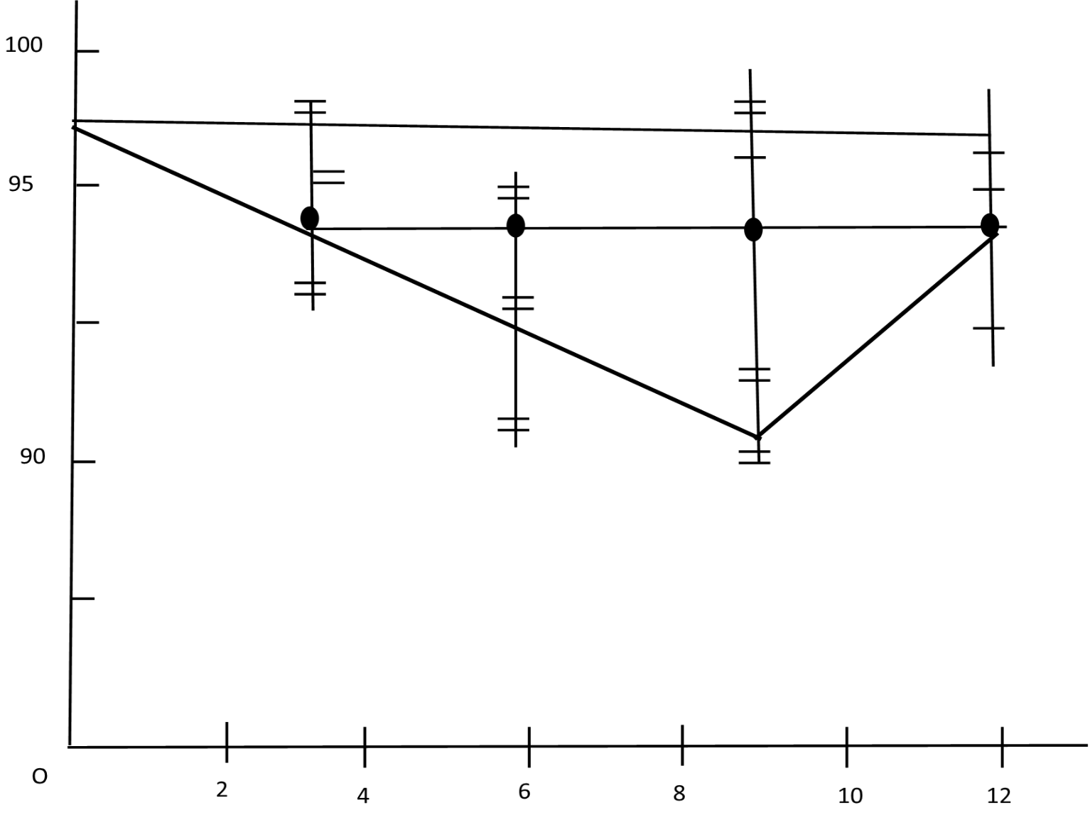



Months

Adopted from Volpe Et al: JAM Coll: Nutri: 2008, 27.2)

And the exercise group, I gave them skid machines whiles some of them find it difficult to use and I supervised the exercise program. They study it three days a week and up to five days a week which is 30 minutes succession and then after six months those in the two-exercise group, the exercise group and the diet or the exercise group, were given most of the trust to take home, so I followed them to see that they continue that exercise. But from my measurement of 9 and 12 months when I measure them 0, 3, 6, 9 and 12 months. Mind you I measure the body fat, the lipid level, I measure the dietary intake. But this is the change in body weight in women. And I can see that in women at about 6 months and 9 months, there was a significantly decrease in the body weight and a diet for exercise group. So whatever I expected; that is diet + exercise I expected greater energy expenditure and more intake.

But then what happens in 12months they overturn to normal back to what they used to be. So when they had the supervision of diet and exercise, they were better then what the used to be. All that I want is every one to be great when they live and everyone to be healthy but it always does not work.

So, but here is one thing I do when I was tired was that I did not prove the trigose right level in the blood nor in every group but that for exercise group, there were a lot of data there but I just have focus on null. But I also decrease the percentage body fat and I measured that by something called under water way which is one of the best better ways to measure percentage body fats.

Higher prevalence of obesity among African Americans compared to Caucasians. I am working currently on different kind research to try to change the environment to force people to better in their diet and exercise habit.

But now I am focusing on these two studies which are more or less for betterment of adults. So another study I did with one of the convenient samples, I did that within women or African American women about an average age of 78 years and I was predicting such age because a lot of these women a lot of diseases going on. These women that came has a lot of heart diseases, they have kidney diseases, diabetes etc. and we handled physiology of that beginning with the elders University of Pennsylvania and I managed to see how I could increase the physical activities.

So basically the design was that and I realized that I just told many that and I meant it and a lot of older individuals decrease the physical activities as they get older and even all people think some are getting older and they gain a little weight so why. One of the biggest thing is that if someone is getting older and decreasing in physical activity, and they have hypertension and then have diabetes, if I start to have people exercising and eating well, we might actually put them some of the medications that are better which means they will have less side effects and that make them feel that they must exercise more. So I see everything as a bloomy nice done and shows me with how much policy fund that we have with a lot of old adults.

American, Urban community dwelling women attending Penn’s Living independently for Elders (LIFE) on body weight.

(Funded by: University of Pennsylvania, School of Nursing- LIFE (grant).

It will look great if we can take some medications away from that, and make them happier. So what we do is that we try to go back to the original design, and our design is a small study, at 15 weeks and there was a convenience sample against women in the life time. Basically what we did is to monitor to build them up to what it entails these three days within a week. Mind you I have individuals there who are workers we have some of them there I call them my learners who have worked whiles some of them did not work but they need the system, to really not talking power working here. We are taking, getting women how to try exercising building form up and doing; really know what exercise is, do about 30 minutes procession. But in between we had to be resting and do cheer up precisely as well and

1. I tell you of these one, for the young students in here that research is not all that easy, and is never perfect.
2. That when I get people form up at stage of not exercising or who also have not put diseases, I have to really build them up slowly, and I have to be encouraging them as well. So what if I found even we found if the body weight was our major outcome?.



Body Weight

BMI

(n=20; Average age = 77.9 + 5.8 years

We found no changes in body weight. Ok, this alright but there is one thing that I feel they too tired is that in at each time, 0, 8 and 16 weight, we recorded the dietary intake and we would also give but we also give a list in called active calories around it, we have them rest. 27 for a week, there come to be some defects but we see to that but they give us some little bit more detailed information and so what we found from that was that 8 weeks to so we think we think it is because they were so excited to be in our program, very significant increase in a colony expanded based on the article accelemeter. And we saw the same thing with modern activities. This means that outside of what they were doing with us; they will generate more active.

To again for these women, I was hoping for that those activities that they were greater even when they were waiting for us. We found increase in physical activities. We also found some extent of quality exampling that they really did enjoy the fact, that they were the camera better than they wait at the women. So they do continue that program at life, loss of life to this particular study. We did have the control group but the good news was that we got the new moving on. So again age is not a disease and we can change our lifestyle at any point in our lives.



<p< 0.05vs reported (Lichman et al, NEng J med 1992 327 1393)

So I truly focused on exercise, for and now the nutrition part will be ended. We have about 38000 proposing a daily more than we actually need, so we really waste a lot of food especially in the United States. The slide shows me that there was a study done some long time ago but there was something, we have researched all together. What is frustrating is that when we ask people to tell us what they eat, what they do for the energy intake is the significantly underestimate what they take again. Does not surprise any of us but they did not eat the remainder but they might not want what is fatal they have eaten. And they also significantly over estimate how much physical activity they get energized. So people sort of think may be they do not think but then they might actually do something else.

Another slide describes eating of a whole doughnut if I got it. Speaking of doughnut with some people, in the morning, eating breakfast, is the really great way that I did like all over months but is the great way for many reasons. But actually people who eat practice, turn to have decrease disease and they also actually turn to have a better, body weight. They actually turn to maintain the body weight rather than those who still practice do I want because the want more calories. And also, they also eat practice, turn to make that the choice is actually out to day, and pay to those who do not.

By the way if I duly practice, I can spend about 15000 calories mostly if I do not because digestion, takes more energy. By skipping that, when it happens, my body shows that the times was not done a little bit more, answers I do not even want answers that protect them to that fact a little bit more and it actually goes against what people are trying to do. The only thing is to set goals to exercise, to set goals that are winning. Because if I set goals for myself, I will likely go after them, but the goals should be to be too half day because after sometimes, people will come back to me and say, oh I know, I really have to lose 50 pounds a week or may be 50 pounds every week to half a year. Then I will say ok, but we surely do not come to welcome 10 pounds informants and I say some up to the first but I really try to work on them. The everything is enjoy eating so, in all countries I think that we actually feel guilty about everything we put around and be we do not turn the sit and enjoy what when we eat. Growing up from two week time in a migrams with everything are with us with everything home made from what my parents have. We enjoy eating we always sat down together as a family; eat well. We have so much processed food and how that could have changed in our lives that; is we all want to eat fast. Even when I am studying or doing work or even when I turn away from my computer for about 10 minutes.

To try to actually know what I am eating. Because it is the old act of it takes 15 or 20 minutes, for the brain to know that I have actually eaten is true. So I will but because thus the other thing that we have to think what we want to do is we want to make sure that we actually know what we eat for.

We will all get there; we all try to eat fast or eating in a car and we spill out something. In return to what we eat on the run also make poor choices and I actually know that if I have to eat well or we are making a better choice. And preparing meals of family, if we are actually a family of one or two, we use to take up to about 40 minutes and allows a lot of time that allow us to eat something better. Even if it is to try to make meals a little bit better, and including healthier actions thus just something that of great thing that I do want. Honestly we only have on life. I think is really important that we enjoy and we have a good balanced diet, thus at work, but I think we have to enjoy what we do outside work. Enjoy every bit thus our habit are, spending time, outside work. We have to eat well and eat better balanced diet because the younger we now that the better we enjoy what we eat outside our work or at our work places.

When we are getting older and do eat and exercise to live longer is really what I think is so important.

Transcriber: Nika Kotnit

Reviewer: Demise RQ.

Thank you.

What do I eat?

It is Wednesday night, by the time I get out of here, it might be eight o’clock. I stop at the store on the way home to see if they have tale. But is it organic? Is it local? Is it in season?

Do I even like kale?

I get it. It is overwhelming, all of the choices I face with today. All of the things we are asked to consider about our food. A little over two years ago, I set myself a challenge: one year without processed food. The first question I might ask are ‘’why will I do that? And what makes a food processed? And I will get to those. But tonight, I want to focus on that choice of a Wednesday night. When I am wondering what to eat; I am a food writer, so on some level, I am paid to think about that choice – I am the editor of edible Baja Arizona, I am a food writer, so on some level. I am paid to think about that choice a local food magazine based here in Jackson – but I also happened to believe that these choices matter. That they impact the food system, and I have the power to un-process the foods we eat. So what makes a food processed? Of course, all foods are processed. Agriculture is a kind of process, so is cooking, fermenting, dicing, preserving. All foods are processed and often, they are better for it. But increasingly, they are not. Study after study has shown that it is less important what we are eating than how we are eating it. Thinking about the difference between corn and the cob: versus corn chips versus high fructose corn syrup. Some source three very different foods because of their level of processing. I spent a lot of time wrangling over the particulars, over many things that we found on our ingredient labels these days. But for me, what is processed, comes down to a quote from of all people, Mr. Rogers, which says,

There is a difference between foods people make with hands, or could bake, and foods that are made by machines. People can make corn into corn tortillas. People cannot really make high fructose corn syrup without access to a laboratory and an advanced chemistry degree. I spent a year thinking about processed food, I wrote a book about it, but tonight I want to focus on just three processes. The first is the process of how a food is gets from its source to a table. How vegetables get from the ground, in Mexico for example, to grocery above in Arizona. The second process is what happens to me when I actually eat that food. How my body responds when I think a glass of apple juice versus eating an apple. The third process is a little more complicated, it is the process of how the foods we buy; impact the communities we live in. often this process revolves the around money: it is the economy of food. And it is this last one, that of consumer spending that I find the most potential for unprocessing. So how does food get from its source to my table? This is the mariposa part of entry in Nogales. It is the largest inland port of entry in the US. In the winter, 70% of produce on supermarket shelves comes from the Mexico, and most of it comes through here. I like to say that it is the Ellis Island for Mexican produce a watermelon. How does the watermelon get from the ground in Hermosillo to a safe way in Tucson? It starts from on a farm, a really big farm, and 1,000 acres of watermelon. A migrating field crew goes in there and harvests them without a day. They pack them up, put them on a semi-truck, 40,000 pounds of vegetables and send them north to the border. There is a flurry of paper work, the border patrol, FDA, USDA, and finally, it arrives here to a 35 – degree warehouse in Nogales. There are about 100 of them there, and I spent a few days wondering through these warehouses. And let me tell you, the scale is staggering. At this particular warehouse, during their high season, every single day, they might move in and out 150,000 melons. I remember standing in this warehouse full of mangoes and it being inconceible to me, how this mass of fruit might ever just become one mango in one person’s kitchen. The system is vast. And its survival depends on pesticides refrigeration and semi - trucks compare that to this. This is what I eat. This is one week share from the Tucson CSA, the community supported agriculture program that I am member of .this produce comes from a farm owned by a guy named Frank. Yes we call him farmer Frank. Farmer Frank sends his two employees out into the field, they harvest enough produce for about 150 shares, wash it, put it on a truck and send it to Tucson. There is not a lot of storage and there are no pesticides. According to a study by USDA, almost 60% of conventionally grown produce is still contaminated with pesticides even after it has been washed. If that is not processed, what is it?

I have these two watermelons, one from Hermosillo, one from near Tucson.

What makes one more processed than the other? Well, the first difference is how they are grown. Conventionally versus organically one monoculture or on a diversified field. And the second is the process of how that food gets to me. On average, 91 cent of every dollar we spend on foods goes to the middlemen. It does not go to the people who grow our food. So when I buy food that is gone through this vast system, I am supporting that 91 cents. On the other hand, when I bought food from a CSA or a farmers market, I am helping to ensure that people who grow my own food get more than 9 cents on every dollar. Let us go to the second process. Once that food has gotten to me, what happens to my body when I actually eat it? Sugar is a good example of how the what; of a particular food is less important than the how. A lot of people ask me, is eating unprocessed hard? And the answer to that question is sugar. Sugar is in everything. Before I go on there, I will say I love sugar. I have such a veracious sweet tooth, that when I was a kid, my mom instituted a rule called ‘’one sweet a day’’ on which I was allowed one sweet every day instead of all the sweets, all the days. But sugar is in everything apart from that. It is in for example, in the blueberry flavored flax seeds. The spinach of breakfast confections. High in sugar. This particular brand of mustard is evidently a mix of sugar, honey and a little high fructose com syrup thrown in for good measure. Grape – Nuts a seemingly sensible solution to breakfast has four different kinds of sugar hidden on the ingredient label. And that is what makes sugar so tricky. It comes in so many different forms. It is really had to avoid. But what is important to know is that, for my body, sugar is sugar. All sugar molecules no matter the type; are eventually digested into glucose and fructose. What matters to my body instead is quality and speed. How much sugar I eat and how quickly it arrives through my system. I think about the difference between eating an apple and drinking a glass of apple juice. In the apple, I have to work to get that sugar, I have to bite it, chew it, swallow it, and it is all bound up in fiber and cellulose. So it trickles into my body slower. Apple juice on the other hand, is immediate and that; immediacy my body out. But the problem with sugar is that I am not alone. That is why it is everything. Unfortunately, there has been a lot of research in recent years that says sugar is simply not good for us. So what do we do? What is the alternative?

One alternative is to eat less sugar; the other alternative is to eat fake sugar. Diet desserts. The way that food companies makes dessert diet is the process out the sugar fat and replace them with chemicals so that my body thinks I am getting the good stuff. I am sure still getting my dessert. But anyone who has ever been on a diet knows that simply does not work. I eat one from brownie made with Splenda and I will want five more before I really feel full. Compare that to the sweets I ate during my year unprocessed. Homemade chocolate with raw honey; Cookies made with whole grain flour and molasses, and butter. These sweets satisfy my sweet craving, they filled me up and because they are all bound up in the foods with substance, that sugar trickled into my body slower. A lot of people ask when I tell them about my year of eating unprocessed food, how do I feel? Do I feel differently?

And the easiest answer to that question is simply, I feel full. For me, this is no small thing. I have dieted on and off my whole life. I have counted calories, I have done weight watchers, and really I have been through the wringer. But unprocessed is not a diet. When I eat unprocessed, I eat when I am hungry, and I stop eating when I am full. 20 dollars a week. But the fact of the matter is most of us has a few dollars that we could spend differently. This is the hide of a sheep that I spent two days helping to slaughter, butcher, and process using nothing but an 8 – inch craftsman knife. I will say I was raised by two vegetarians. I have been a vegetarian on and off my whole life, problems always being I actually kind of linked to eat meat. But I read what we have read. How destructive industrial meat is to the environment, water, our soils, how animals are treated. How can I eat meat in a way that seemed responsible? I spent two days in very close quarters with this sheep. And here is the surprise! It did not turn me off meat. Instead it made me so grateful that I could go to the farmers market and pay a local rancher who had gone to the same process with the reverence respect and I had and give me meat in return. I could pay money for mindfully produced meat. Indeed, if there is one take away from my year unprocessed, it is simply that, the money I spent matters. I am not saying we should all butcher our own meat, and grind our own grains or grow our own grains or grow our own food. What I am saying is that when I do it myself, I realized it is so worth the money to pay someone in our community who is doing it well. According to a study by local first Arizona, if everyone in a community the size of Tucson shifted 10% of their spending to a local business, together we will create. During my year, I did not grow weight or lose weight, but I ate a lot of delicious food. If there is one take away from sugar, it is that if I am going to eat something sweet is count. Savor it. Make it my one sweet a day. Do not waste my sugar on mustard. Let me move on to the last process. How do the food we buy impact the communities we leave in? Let me go back tonight. Wednesday night, I am wondering what to eat. Most of us assume if we want to have a healthy, sustainable meal, we need to spend more time. When I started my year unprocessed, I was very busy graduate student, earning a graduate student salary of about 18,000 dollars a year. I lived in this tiny little apartment without enough shade to grow a basil plant. Throughout my year, I saved every grocery receipt for every run in and run out purchase and at the end of the year, I sat down and tallied them up. The grand total, the amount I spent to feed myself in my year unprocessed, was about 4,900 dollars. What that means is that an amount I spent to feed my self-three, mostly organic, largely local, totally unprocessed meals for a year was about 4 dollars 50 cents a meal. I am aware that there are people for whom 4 dollars 50c a meal is simply unaffordable. It is out of their reach. I am really interested in that, I dedicated the last chapter of my book to endeavor of eating unprocessed on the amount of memory that food stamps recipients receive which is about 140 million dollars and new revenue for the city. Spending money locally has all sorts of multiplier effects. Spending 100 dollars at Tucson’s food co – op, and 73 dollars of that will stay in Tucson. Spending 100 dollar at safe way, and only 43 dollars stay here. The importance of the money that we are keeping here is also that we are withholding it from the balance sheets of those multinational corporations who are often using it, our money, to influence politics to grow unsustainable food, to waste energy. In short, to process and sell us foods that are not good for us. But apart from all that, the reason for eating unprocessed makes sense to me is that it is that, it is simpler. I do not have to worry about where my food is coming from because I know where it is coming from. I do not have to worry what is doing to my body, because I feel good. I do not have to worry about where my money is going because I know who is getting my money. It is one rule and then I do not have to think about it. I can do what I have always wanted to do with food which to simply enjoy it. After all, the point of food is not to stress us out, is to bring us together. We have to power to un-process our food system. Of course we do not do anything. I say I do things and I do things. I get home to make dinner and I go home actually to make dinner. It is only when I and you decide to make small changes in our own lives that big change begins to happen. Join the CSA ingredients labels, I go to the farmers market, ash questions of the people and companies that sell me my food, what do I eat? That is up to me but I have the power to make it a little unprocessed.

**TRANSCRIBER: MARAM TURKYA**

**REVIEWER: RHONDA JACOBS**

Imagine that I have a pill in front of me, and that pill can make more creative it can improve my energy. It can improve my memory, it can make me more tolerant to stress and make me more focused. Perhaps it can even make more - smaller. Well such a pill would sound too good to be true, right? But there actually such a pill, and it is called physical exercise. Physical exercise has tremendous effects on the brain, and the brain is one of the organs, perhaps the organ, that is most affected in a positive way if we move, I think that all of us know that we will feel better if we exercise but what most people do not know is that it will increase, basically, all of their cognitive functions – memory, creativity, attention, it all gets better.

So let us look at one of those functions:

Memory:

Now, the said truth is this. Memory shits as we get older; it gets physically smaller. The red structures I see he is the hippocampus. That is the memory center of the brain. It has other functions as well, but it is very important for memory.

And we have two hippocampus, one in the left hemisphere of the brain, and the other in the night.

Hippocampus reaches its peat size, when we are about 25-30, thereafter, it starts to shrink, and does so by up to 1% per year for the rest of our life. And that development has been thought to be inevitable; there is no way to charge this. We have known that if we think a lot of alcohol or use narcotics, the hippocampus will shrink faster, but to show down the shrinkage has been thought to be impossible. Until researchers in California started believing that maybe this could be affected by physical exercise and why did they think about physical exercise?

Why didn’t they think about cross words puzzles or sudolen or something like that?

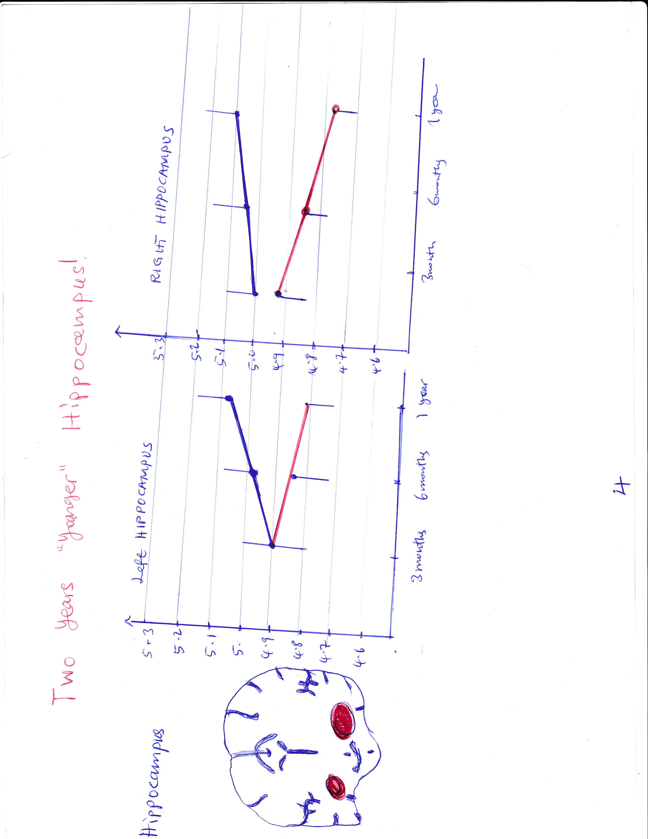Well, they had seen that when they put a running wheel, into the cage of laboratory mice, the will start running on the wheel and then they will form new brain cells in the hippocampus. And they form lofts of new brain cells in the hippocampus. The hippocampus actually grows. Now, those results were for mice. Can I automatically assume that the same thing happens for humans? No, I cannot of course, I have test if it first, and such an experiment has been made. About 100 individuals were collected and divided into two groups. One group that got to walk, three times a week, 40 minutes every time, test walk, they were not running. The other group did stretching exercises, three times a week, 40 minutes every time, with a big difference that the stretching group did not increase their pulse. Now, this lasted for 12 months, and the size of the hippocampus was measured before this 12 months’ period and after it. And when I measure the size of the hippocampus, I do so by MRI scanning. So what had happened? Well, if I took a look at the stretching group, their hippocampus had shrink by 1.4% during the year. It was 1.4% smaller. Which was a pretty expected result since it does shrink about 10% per year. But what was very surprising was what one saw when one looked at the walking group because their hippocampus had not decreased in size, but grown by 2%.

So instead of getting one year older, it had gotten two years younger in terms of size.

Now, the red structures I see there, that is the hippocampus. And I see the brain in the section like this on the picture and the red line is the stretching group, where the hippocampus had shrink ad the blue line is the walking group, where the hippocampus had grown and I can see the same has happened in both hemispheres of the brain. Now, when I see this, I may think: that does not matter to me. I do not care how big my hippocampus is. It does not affect my memory. But actually it does. Because this group, the walking group, had not only gotten a bigger hippocampus, they had increased their memory during this year. Memory was tested with several different memory tests, and the walking group had increased their memory, the ability to learn locations and spaces and finding my way around places, whereas the memory of the stretching group was unaffected. So it seems that it is possible to slow down or even reverse the shrinkage of one of the most important parts of the brain if I am physically active. Now, this is just one in a long line of the astonishing results that I have seen during the last years, when it comes to how physical activity affects the brain.

And these are some others. Results on creativity test increased by more than 50% the hour after walking. Twenty minutes on tests for reading comprehension. That was for kids – that was testing in school. And running increases our well – being so much that if is actually comparable to antidepressant for wild and moderate depressions. How about their: can it make us smatter? Well, that would sound too good to be true, right? Well one of us actually tried to answer this during a long time, and it has been very difficult to do so.

But actually data from Sweden was vital to give an answer or at least an indication of an answer to this question. What kind of data was that? Well, up until about 10 - years - old males to do testing before the military service. All 18 - year - old males had to go to military center, do a cardiovascular test, do a strength test, and do an IQ test. And when data was collected from 1.2 million Swedish 18-years-olds, this was what one saw: better cardiovascular fitness, higher IQ

B

A

9

8

7

6

5

4

3

2

1

9

8

7

6

5

4

3

2

1

Global intelligence/muscular strength

9

8

7

6

5

4

3

2

1

9

8

7

6

5

4

3

2

1

Global intelligence

Cardiovascular fitness (Stanine)

Verbal intelligence

Logical intelligence

Muscular strength (stanine)

Intelligence (staniline.)

Cardiovascular fitness (stanine)

9

8

7

6

5

4

3

2

1

9

8

7

6

5

4

3

2

1

D

c

9

8

7

6

5

4

3

2

1

9

8

7

6

5

4

3

2

1

Intelligence (Stanine)

Intelligence (Stanine)

Cardiovascular fitness (Stanine)

This is cardiovascular fitness on the X-axis, where 9 is the best, and 1 is the lowest. And as 1 can see, the better shape they were, the higher intelligence they had. Strength was not correlated to IQ. Eighteen-year old that were strong had neither high nor lower IQ than those that were not so strong. All of this I think can be summarized into very simple phrase, and the is the brain is built for movement. The brain works better if we move. But why is that? That may seem very strange from our perspective. But I think it is easier to understand if I take a step back and look upon the history of humanity. If I say that is 1 million years old, which is a time frame, that is often used, I could agree it should be a bit longer or shorter, but let us say 1 million years old. Then this is how I lived up until 10, 000 years ago. We were hunters and gathers on the savanna. Constantly chasing our food, not being settled in one place, and not farming the land to get the food and energy that we needed. Then about 10, 000 years ago we became farmers. And then 200 years age, we became industrialized. Now during the last 20 -30 years or so, we have become digitalized.

Cardiovascular fitness (Stanine)

Cardiovascular fitness (Stanine)

9

8

7

6

5

4

3

2

1

9

8

7

6

5

4

3

2

1

Technical intelligence

Visuospatial intell

Intelligence (Stanine)

Intelligence (Stanine)

9

8

7

6

5

4

3

2

1

9

8

7

6

5

4

3

2

1

Now these time a frames, there are so long, that it is very difficult to get an understanding of them on an intuitive level. It is impossible to think of a world without the internet anymore. And 200 years, that was an eternity. And 10, 000 years, is I think more of a theoretical concept than an actual time frame. So I think it is easier to understand and if I look upon humanity’s time as 24 hours. And if we do that this how we have loved from midnight until 23:40. And then we were farmers from 23:40 until 23:59:40 – 20 seconds before midnight. And finally this. And actually we were industrialized first. So we became digitalized 23:59:59 – one second before midnight. If I took a look at others in nature, I see that evolution normally makes show changes. It takes ten thousand or even hundreds of thousands of years before evolution make major changes with a species, and the same goes for us humans.

We have not changed in 10 or even 20000 years. If we can travel in a time machine 10,000 years back in time, I would meet people who were like us, had different language than us of course, and they had different experiences. But they basically have the same brains as we have and the same metal capabilities, and mental possibilities as well as we have. So biologically speaking, we are still here. And this is what has shaped us, because this is how we lived during the majority of mankind’s 24 hours. Now, what changes have we mad when we have gone from the savanna until our internet society? Well, those changes are enormous, of course, within a large number of areas, but one of them that we move less. Now how much less do we move? Well, that is difficult to say exactly because our ancestors did not have any activity trackers or steps counters, but it is at least possible to make a qualified guess by looking at some of the people who still loves like hunters and gatherers.

And there a few of those on the planet, among them Hadza people in Tanzania. They are one of the last groups that lives like hunters and gatherers and they walk about 11 – 12 km every day. They take between 15, 000 – 17, 000 steps. How about farmers?

Well then we can look at Anish people in the US. They live in Pennsylvania and Ohio and they have chosen to live without electricity. They do not have TVS or phone or internet and they live in a traditional farming society, and they take about 18, 000 steps per day. This can be compared to us in the Western World, where we take somewhere around 7000 steps per day. So we can conclude is that we have made a huge difference in a relatively short time. Perhaps we have cut it by half – the amount of movement that we get, when we have gone from the savanna until our society. And we have done that a time that is so short that biologically we have not change, biologically we are still here. If we combine this with the fact that physical activity makes us more creatives, improves even smatter, then we realized that a lot of people in today’s society could probably function better mentally.

If they just took the time to move more. And if we combine this with the fact that physical activity makes us less stressed and less anxious and less depressed, then I realized that some of the mental health problems that we see in today’s society, may be due to this –not all of them of course, but some of them. And some of them can definitely be treated with this. In this evolutionary context, I think a lot of the effects on the brain makes a lot more sense. If we assume that we are still backed biologically, which we are and then do we feel better if we exercise? Well, our ancestors, they did not run to go for the marathons. They run to catch food, to avoid predators, to fine new land where they could settle. All these things meant that they increased their chances of survival. And the brain will reward us within more dopamine a pleasant feeling of when we do things that are in line with increases the chances of survival. That is the mechanism that we tap into a day while we go jogging.

The brain thinks we are actually running for our lives when we are running today. Why is memory improved? Well, that maybe due to the fact that when our ancestors run during hunting and discovering new land and so on, they saw new things. They saw new environment, they experienced new thing during hunting and then it makes sense for the brain to increase memory somewhat because there is new important information incoming “I better remember this”. If we just sit in one place, the brain will intercept that as nothing new is happening. Because the brain has not been developed to have information passively from phones or tablets. It will think that nothing or new is going on while we sit in one place.

Why is focused increased?

Well, that may be due to hunting.

When our ancestors ran during the hunting increased focus was probably an advantage that can establish the most focus during the hunt is probably the one catching his or her prey. So in this evolutionary context, I think a lot of the effects on the brain makes more sense. And it is easier to understand why evolution has tailored our brain.

In such a way that it benefits so much from physical activity. This is something that I have thought a lot about. If it is so good for us, why do not we have it?

Why isn’t it the best there is?

Why this actually the best there is?

Because this is best, sitting in front of the TV. Well, I think we can understand that also from an evolutionary perspective. We had a shortage of calories for almost our entire history. Calories have been very to get by. If our ancestors were lucky to find sweet berries on the savaging or honey or something that contained a lot of calories they should feel the urge to eat it all. Eat every last berry because tomorrow may be these be gone. Then someone else has taken them and tomorrow I may not find any food. That crave for calories is very functional in a world were calories are hard to get by. But that crave for calories does not make a lot of sense in a world full if fast –food restaurants. When we take that crave for calories that evolution has built into us during millions and millions of years where calories are hard to get by, until today’s society where calories are basically free, that is when I get the problems that I see with diabetes and overweight and so on. The amount of energy that we have in our bodies is not just dependent such as food, but also how much energy we use. And that is I think, why we have this drive to stay in the coach, to not waste our valuable calories.

We do not have to waste our energy. That explains the paradox why it is so important for the brain to move, but at the same time, we are basically lazy. Once I have known all of these and heard all of those, I would probably think that these might be exaggerated if this was the case we would have known about this. And I think the answer to this is this: we have always known about this. This is Hippocrates. He is considered the father of medicine and he said 2, 500 years ago. “Walking is man’s best medicine”.

He could have added “woman’s” here, but apart from that, this is very much to the point. He knew those without any research report or MRI Scanners or anything like that. We have always known this, but I think we have forgotten about it during the last 150 years.

And the reason for that is I think, that we have had such a tremendous medical development during the last 200 or 150 years. All the things that I take for granted in medicine: MRI scanners vaccines, x-rays, antibiotics, basically all of them has seen the height of day during the last 150 years. And that phenomenal development has pushed this old knowledge to the background. And a way to illustrate that is this, I think. Which one does not fit here? Without thinking too much.

The MRI scanner, the da Vinci Robot, this cancer seeking molecule or these. Of course we take away these, because they remind us of the fitness industry. There is nothing wrong with the fitness industry, but we do not attach any medical value to it. That is the kind of mistake we make over and over again. We think that something as simples as these cannot be worth as much as all of these technologies that billions and billions of dollars has been put into. But actually, they can. And I would say that is one beats them all, actually. And a lot of the findings on how the brain is affected by physical exercise has been done with MRI scanner. And it is almost an irony, I think, that one of the most advanced medical technologies we have is now helping us rediscover one of least advanced or simplest medical technologies namely these or whatever I like to put on when I go exercising. I sometimes get the question: “what does exercise mean to me”? And this how I see it. It is a step back to the lifestyle that I have been developed for. So I forget about my association to sports. Exercise is about something much more fundamental than that. And not only is it a way to optimize the body, but it is a way to optimize the brain.

[www.ted.com/tedx](http://www.ted.com/tedx)

**What I Should Know About Good Nutrition**

Good nutrition is the key to my good mental and physical health. Eating a balanced diet is an important part of good health for everyone. The kind and amount of food I eat affects the way I feel and how my body works.

**What healthy eating is all about**

Most of us DO know what healthy eating is all about: less fried food, less sugar and more vegetables and fruits. When it comes to having good nutrition, however, too many of us do not know the full details of the benefits of good nutrition and how to go about achieving it.

www.activehealth.sg/read/nutrition/what-is-good-nutritio…

**The importance of nutrition in my daily life**

Good nutrition is the key to good mental and physical health. Eating a balanced diet is an important part of good health for everyone. The kind and amount of food you eat affects the way you feel and how your body works. Nutrients are ingredients in food that help you: Grow.

www.kidney.org/atoz/content/nutritionwyska

**Why nutrition is important for good mental and physical health**

Good nutrition is the key to good mental and physical health. Eating a balanced diet is an important part of good health for everyone. The kind and amount of food I eat affects the way you feel and how my body works.

www.kidney.org/atoz/content/nutritionwyska

**Good nutrition and why is it important**

Most of us DO know what healthy eating is all about: less fried food, less sugar and more vegetables and fruits. When it comes to having good nutrition, however, too many of us do not know the full details of the benefits of good nutrition and how to go about achieving it.

Nutrition is an essential aspect of a healthy lifestyle and the importance of getting it right cannot be overstated – let us start by going into the benefits of having a nutritious diet.

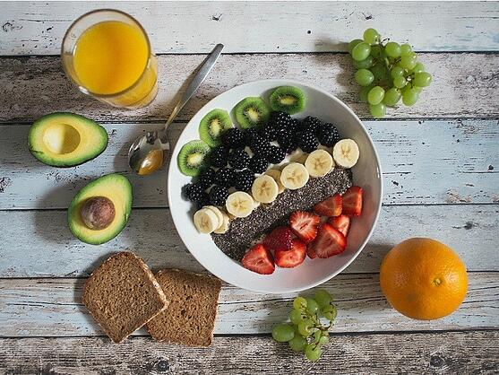

[https://www.activehealth.sg/hsfs/hubfs/Active%20Health%20Website/Read/2019/What%20is%20good%20nutrition%201.jpg?width=558&name=What%20is%20good%20nutrition%201.jpg](https://www.activehealth.sg/hs-fs/hubfs/Active%20Health%20Website/Read/2019/What%20is%20good%20nutrition%201.jpg?width=558&name=What%20is%20good%20nutrition%201.jpg)

**How good nutrition boosts my health**

• Weight management

A lot of us mistakenly associate weight loss with fad diets, but eating a nutritious diet is really the best way to go about maintaining a healthy weight and at the same time attaining the necessary nutrients for healthy body function. Swapping unhealthy junk food and snacks out for nutritious food is the first step to keeping your weight within a healthy range relative to my body composition, without the need to jump on the fad-diet bandwagon.

• Protecting me from chronic diseases

Many chronic diseases such as type-2 diabetes and heart disease are caused by poor nutrition and obesity. With 1 in 9 Singaporeans suffering from diabetes, the emphasis on good nutrition is higher than ever. Taking a preventive approach with a whole food-based nutrition plan also reduces the risk of developing other related diseases such as kidney failure.

• Strengthening my immune system

Our immune system requires essential vitamins and minerals in order to function optimally. Eating a wholesome and varied diet ensures my immune system functions at peak performance and guards against illnesses and immunodeficiency problems.

• Delaying the onset of ageing

Certain types of food such as tomatoes and berries can increase vigour and improve cognitive performance, all the while protecting your body against the effects of ageing.

• Supporting my mental well-being

Eating the right foods can actually make you happier – nutrients such as iron and omega-3 fatty acids found in protein-rich food can boost my mood. This contributes to better overall mental well-being and protects me against mental health issues.

So, how does one build a sensible nutrition plan then? Healthy eating is all about eating balanced proportions of nutrient-rich foods from the various food groups, as well as adopting several healthy eating habits.



<https://www.activehealth.sg/hsfs/hubfs/Active%20Health%20Website/Read/2019/What%20is%20good%20nutrition%202.jpg?width=800&name=What%20is%20good%20nutrition%202.jpg>

**How to achieve good nutrition in my diet**

Each food group provides different nutrients and benefits, so eating a balanced diet that includes foods from all five groups is essential. These are the different food groups that I should keep in mind.

1. Whole grains

Whole-grain foods such as brown rice and bread are forms of carbohydrates, specifically unrefined carbohydrates. They provide me with energy, healthy fibre, vitamins, minerals and antioxidants, and aid with digestion. For people who are diagnosed with coeliacs or those with non-coeliac gluten sensitivity, it's important that you include other carbohydrate alternatives to ensure that your abstinence from wheat doesn't cost you in terms of essential nutrients.

“Gluten-free carbohydrate alternatives include rice products, buckwheat (technically a pseudocereal), quinoa and starchy vegetables (e.g. sweet potato, yam, pumpkin, corn),” says Ang Sin Hwee, Associate Sport Dietitian at Singapore Sport Institute. “As following a gluten-free diet may lead me to unknowingly cut out certain nutrients, it is recommended that you seek help from a registered dietitian.”

2. Fruits and vegetables

Various forms of produce are rich sources of vitamins and minerals that help regulate body functions and protect it against chronic diseases. To get the most nutrients out of my fruits and vegetables, eat them whole – for example, eat whole fruits instead of having them juiced.

3. Protein

Protein is the primary nutrient responsible for building and repairing muscle tissue in the body. Animal meat is the most common source of protein, but there are also several plant-based options to choose from such as nuts and legumes. Individuals on plant-based diets should ensure that eat the right combination of plant protein to ensure that their dietary needs are adequately met.

4. Dairy

Dairy products are rich in important nutrients like calcium, potassium, phosphorus, vitamins A, D and B12. Foods like milk, yoghurt and cheese are great examples of dairy which can be found in practically every grocer stores.

5. Fat and sugar

Dietary fat (such as the kind I get from fish and olive oil) is essential for good health as they regulate cholesterol levels in my body while promoting healthy cell function. Monounsaturated, polyunsaturated and saturated fat all play a role in this aspect of good health. On the other hand, the additional fat I often find in fried food should be minimised as they are largely polyunsaturated fat derived from processed vegetable oils such as soybean and rapeseed.

Due to their low threshold for oxidisation, overconsumption of polyunsaturated fat can lead to inflammatory conditions and the formation of free radicals. Artificial trans fat is also a strict “no-no”. Sugar should also be limited – while the natural sugars present in fruits and whole grains are healthy, the refined sort I get with cakes and snacks can affect my weight and lead to metabolic diseases if consumed in excess.

Apart from eating foods from the above-mentioned food groups, there are three other healthy eating habits to maintain in order to keep my nutrition plan on point.

• Keep portion sizes regulated

Managing portion sizes is all about ensuring that I am are getting the right amounts of nutrients and calories from my food. Over-eating or under-eating deprives you of nutrients and can affect your weight, so always regulate your meal portions. When buying food, check out the serving sizes on the nutrition labels to see what amounts to a regular serving and how much it provides in terms of nutrients.

• Prioritise fresh food

Fresh, whole foods are the ones I will derive maximum nutritional benefits from. Always I go for foods in their purest, unprocessed form such as fresh fruits, vegetables and meat when possible. If I go with processed alternatives, I pick those that have undergone simple changes such as dehydration and flash freezing to minimise nutrient loss. Also, I keep an eye on the ingredients list to ensure that I am consuming as little additives with my food as possible.

• Practice healthier seasoning habits

Consider tempering my salt intake with other herbs and spices to add a new dimension of flavour to your food. For example, basil, garlic, paprika and cayenne can turn an ordinary chicken breast dish into a gastronomical delight! Salt is the most common food seasoning used in cooking, but too much sodium can lead to high blood pressure and hypertension, particularly with those who are already susceptible to said conditions.

Maintaining a nutritious eating plan is simple enough; evaluating whether it is nutritious enough can be straightforward as well. I Just look out for five simple enough indicators of whether I am getting enough from my food.

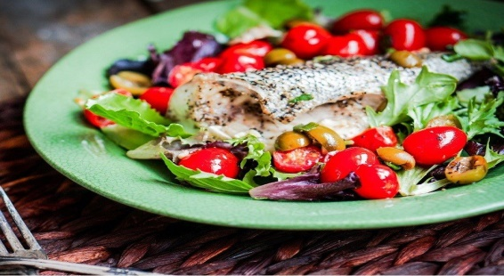

<https://www.activehealth.sg/hsfs/hubfs/Active%20Health%20Website/Read/2019/What%20is%20good%20nutrition%203.jpg?width=800&name=What%20is%20good%20nutrition%203.jpg>

**Indicators of a nutritious diet**

1. Body composition

A well-structured nutrition plan should allow an individual to maintain a healthy physique within acceptable body fat levels (18-24% for men and 25-31% for women). This also means that it should support metabolic health through a number of means, such as promoting healthy hormone function, insulin sensitivity and physical recovery.

2. Healthy cholesterol levels and blood pressure

Monitoring my cholesterol levels and blood pressure is crucial because having a healthy weight does not discount the possibility of issues in these areas. While dietary cholesterol does not have as much effect on blood cholesterol levels as we once thought, it can still be influenced by my overall dietary fat intake. On the other end, excessive sodium intake can lead to hyper-extension, of which one of the symptoms happens to be elevated blood pressure levels.

3. Healthy skin and hair

The condition of my skin and hair are good indicators of the quality of my nutrition. If I am getting enough nutrients, my skin should be firm, supple and of a rich hue rather than flaking and pale. My hair should be smooth and strong rather than dry and brittle; unexplained hair loss is often a sign of malnutrition.

4. Sleep and energy levels

Getting the right amount of nutrients and calories will help me stay energised due to its ability to promote restful sleep. If you find myself feeling sluggish, It could be a sign of either a distinct lack of calories and/or nutrients, driving my body into “starvation mode” which hampers its restorative capabilities.

5. Regular bowel movements

My bowel movements reflect whether I am getting sufficient fibre from my diet, so if I find myself being constipated, load up on more fruits and vegetables to get my digestive system going.

While these five indicators of a nutritious diet may give me a decent idea of how to go about achieving my nutrition goals, getting the help of a certified nutritionist can help improve my odds of success while avoiding the common pitfalls.

**Why I should consider seeing a nutritionist**

• Advice and meal plans

When I am a busy working adult, planning my meals to meet my nutritional requirements can be too much work. A nutritionist can handle this easily and probably plan a more nutritious meal than I can. I can also get advice on food and nutrition, instead of searching through possibly unreliable sources on the internet and endlessly questioning their integrity.

• Adaptation

No battle plan survives the first contact, and the same goes for nutrition plans. However, a well-trained nutritionist will know exactly how and where to make adjustments to my eating plan in order to get me back on track. From recently-discovered food allergies to accidental bingeing, it's all par for the course to a nutritionist.

• Help me stick to my goal

It can be hard to work through diet-related problems alone. Having a nutritionist means I have someone to work through problems and relapses with as well as someone to push me towards achieving your nutrition goals. Apart from diet-related advice, nutritionists can also offer emotional support when you are struggling to maintain the diet.

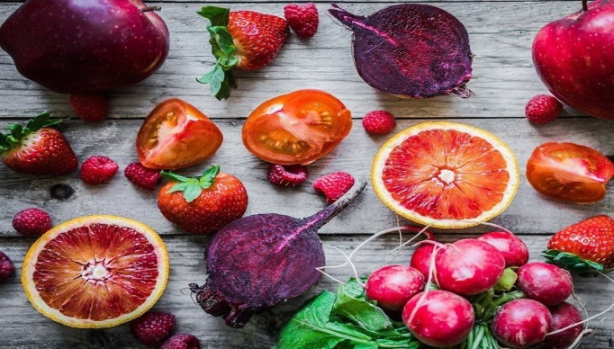

<https://www.activehealth.sg/hsfs/hubfs/Active%20Health%20Website/Read/2019/What%20is%20good%20nutrition%204.jpg?width=800&name=What%20is%20good%20nutrition%204.jpg>

**Picking the right nutritionist**

If I have decided that seeing a nutritionist is a worthy investment, it is important to consider the different types of nutritionists. Not all nutritionists are equally qualified, so do a background check before you engage one. Some nutritionists are also registered dietitians who can help you create a tailor-made eating plan. Nutritionists who are not registered dietitians can usually only give advice in specific areas, such as sports nutrition.

There is yet another type of nutritionist called the holistic nutritionist. They focus on overall health and wellness, so if I have a specific health problem or goal to work towards to such as coping with a metabolic disorder, a holistic nutritionist may not be able to help as much. Furthermore, certifications for holistic nutritionists aren't as regulated so there's always the risk of being stuck with a lemon.

Whether or not it is to the advice of a professional or my inner voice, enjoying good nutrition is something that everyone should work towards. Good nutrition contributes heavily to your overall health and wellness and should never be skimped on. I can start my journey by joining our Active Health Coaches at Active Health Labs located island-wide for a fitness and health assessment to get the insights that will help me plan my nutrition plan better. From there on, it's upward and onward!

**How nutrition does affect mental health and wellbeing**

Nutrition affects mental health and wellbeing, and promotes and maintains healthy brain development in children and young people. How are nutrition and mental health linked? Healthy eating helps children and young people cope more effectively with stress, better manage their emotions and get a good sleep – all of which assist learning.

beyou.edu.au/fact-sheets/wellbeing/nutrition-and-mental-…

**A balanced diet can improve my mental health**

Eating a balanced diet that contains the nutrients my brain and gut needs can complement other therapies and approaches are using to manage mental health. To ensure I am getting the right foods for my particular circumstances, it can help to seek professional support from a nutritionist.

www.nutritionist-resource.org.uk/articles/nutrition-and-me…

**What I eat affect my mental health**

Brain function and mental health might not be the first thing I think about when I think about the food and drinks I put into my body, but Kristine Carlson draws a comparison between the brain and another complex, high-performance machine. “Most people probably do not equate a healthy diet with a good mood or better memory,” Carlson says.

thewholeu.uw.edu/2020/03/02/nnm-2020-nutrition-and-th…

The absence of mental illness does not equal mental health. Just as the lack of physical illness does not equal physical wellness.

To reap the benefits of mental health, special attention to the growth of practices that improve mental health is necessary. There’s, unfortunately, no magic wand, magic pill, or special potion that will move someone along the continuum of mental health.

Personal intention and consistent practice of daily interventions are vital to realizing the benefits. Consider my mental health like a piggy bank. I will inevitably have interactions and experiences that are negative that deplete that bank. Those who have a consistent practice in boosting mental health have a larger account in which they regularly deposit those dividends.

Being “north of neutral” does not happen by accident. Let me explore where I can see some of these benefits. Improving your mental health improves not only you but also the world around you. The state of our mental health affects our relationships. Imagine the possibilities of realizing the benefits of positive mental health.

**The Benefits of Mental Health**

The benefits of intentionally practicing to improve mental health are a response to the chronic stress reported at epidemic levels around the world. Chronic stress has been proven to deteriorate the hippocampus (McLaughlin, Gomez, Baran, & Conrad, 2007).

This stress also leads to decreased concentration and memory, confusion, loss of sense of humor, anger, irritability, and fear. Obviously, stress is not good for the brain, and improved mental health practices can reduce the risk.

Other benefits of mental health include, but are not limited to:

* Reduction in anxiety.
* Improved moods.
* Clearer thinking.
* A greater sense of calm or inner peace.
* Increased self-esteem.
* Reduced risk of depression.
* Improvements in relationships.

The development of practical coping skills has never been more necessitated in this ever-changing world. Rather than continuing to simply soldier on, a focus on thriving through adversity is where mental health benefits can be achieved. Improved mental health has been well documented with the introduction of improved levels of physical fitness.

The fitness industry has decades of research showing the benefits of taking special and intentional care of one’s body. The concept of being mentally healthy is not necessarily new, but it certainly has more areas of growth in scientific research. This is likely because historically, medicine has studied what was wrong so that it could be cured.

A more recent approach to physical and mental well-being has been *prevention.* Exercise is a preventative activity for both physical and mental health. When you strengthen your body, there is less pain in aging. The same can be said for strengthening our mental health.

**Benefits of mental health through physical fitness include, but are not limited to:**

* Sharper memory.
* Clarity in thinking.
* Higher self-esteem.
* Better sleep.
* Increased energy.
* Stronger resilience.
* Increased BDNF (Brain-Derived Neurotrophic Factor), which improves neurotransmission.

Counseling has, unfortunately, had a stigma attached. The medical model was developed to fix what was “broken.” People receiving counseling are not broken. Human beings are malleable and can rewire themselves. A professional counselor can help with this plasticity by allowing the release of painful or unhelpful thoughts and behaviors.

**Potential Benefits of Counselling:**

* Improvement in communication and interpersonal skills.
* Greater self-acceptance.
* Increased self-esteem.
* Improved self-expression and management of emotions.
* Relief from depression, anxiety, and other mental health conditions.
* Clarity.

Coaching is another area where practitioners can increase the benefits of mental health. While coaching is not therapy, it can be very therapeutic. Having a trained coach can create areas of growth that clear the way for massive personal improvement.

For more information, I can also read our post on the scientifically proven [Benefits of Counseling](https://positivepsychology.com/benefits-of-counseling/).

**Potential Benefits of Coaching:**

* Learning acceptance and self-appreciation
* Improved connection with self and others
* Simplifying life
* Reduced stress
* Harmony and peace
* Increased self-awareness
* Reduction in isolation
* Improvements in relationships
* Improved communication
* Overcoming procrastination
* Gaining work and or life satisfaction
* Increased self-reliance
* Improved decision making
* Mindset shifts
* Increased self-worth
* Improved time management skills

**A Look at the Research**

Exercise may be one of the most underused treatments for improving mental health. Research has shown that patients suffering from depressive or anxiety sensitive disorders benefit significantly from increased exercise interventions (Smits et al., 2008).

The Center for Disease Control recommends 150 minutes of moderate activity or 75 minutes of vigorous activity to reduce the risk of premature death. Astonishingly, most of the population fails to come close to meeting the guidelines to improve their well being.

The research has not determined which type of exercise is the most beneficial for mental health. Aerobic exercise strengthens the cardiovascular system but also releases serotonin to improve mood. However, weight training and mind spirit practices like yoga show great benefits as well.

Journaling is a powerful tool used as an intervention in many different areas of well being. The benefits can be seen not only in mental, but also physical wellness. Research has shown improvement in breast cancer patient recovery through the use of journaling.

Adolescent use of reflective journaling has shown increases in self-efficacy, self-regulation, and self-motivation. Reflective journaling has also been used to the great benefit of those working to overcome addiction.

The use of a journal offers a space to release inner fears and stress as a reflective process. The reduction of stress and unwanted negative thoughts are benefits that are seen through consistent practice. Journaling has also been proven to improve critical thinking skills.

There is a limited amount of empirical research in the area of coaching. However, concerning men, coaching has had significant forward progress. Men tend to seek help less actively than women (McKelley & Rochlen, 2007) but are more likely to seek coaching due to the reduced stigma attached. While coaching is not therapy, it can benefit participants with clarity, perspective shifts, and improvements to motivation in all areas of life.

**Most Interesting Scientific Findings**

A fascinating study done on mice shows the [**benefits of exercise**](https://positivepsychology.com/exercise-neurological-benefits/) on the reduction of sensitivity to social defeat and stress (Lehmann, Weigel, Elkahloun, & Herkenham, 2017). The study found the structures of the brain that have reduced function when facing chronic social defeat. Like humans, mice are sensitive to social interactions. The stress from the interactions that are defeating alter parts of the brain and can show up in humans as anxiety or depression.

Interestingly though, when the mice were introduced to regular exercise, their brains showed less reaction to the chronic social defeat and higher functionality in some regions of the brain. Chronic stress alters the brain. Exercise reduces sensitivity to that stress, allowing for the brain to function properly.

Another interesting study was done in Canada (Dwyer, Piquette, Buckle, & McCaslin, 2013), illustrating the benefits of journaling as a counseling tool for women overcoming a gambling addiction. Participants from this study were instructed on effective journaling practice, in addition to group counseling. Less relapse and improved growth in areas of overcoming thoughts around the addiction were reported in the results.

A school intervention study (Zyromski, Bryant, & Gerler, 2009) found reflective journaling promoted increased academic achievement and reduced instances of violence. This research was a qualitative analysis of student intervention targeting attitudes, behaviors, and peer relationships.

Results found that kids participating in the reflective activities of an online intervention changed the perception of peer relationships to improve interactions and requests for assistance.

Research in coaching, especially with chronic medical patients, has shown benefits in improved mental health. Accountability is huge! We all get bogged down in the day to day of life. A coach helps keep things on track and improves communication between doctors and patients (Leveille et al., 2009). A reduction in chronic pain was reported in a study on the benefits of having a health coach when facing severe medical problems.

**5 Things I Can Do To Realize These Benefits**

**1. Move My body**

If more people knew the benefits of exercise on avoidance of neurodegenerative diseases such as Alzheimer’s Disease, more people would be running to join a local gym. Exercise helps increase ROS (reactive oxygen species), resulting in decreases in the incidence of oxidative stress-related diseases (Deslandes et al., 2009). All disease has links to inflammation.

Regular exercise increases the body’s ability to reduce that inflammation, therefore, slowing the aging process.

I start small and grow my exercise practice slowly and consistently. Jumping in with excessive weight training or aerobic exercise can be harmful and lessen the willingness to continue with the practice. A slow, steady increase in levels of activity is highly recommended. Nobody becomes The Rock overnight.

**2.Counselling**

When thoughts and feelings are interfering with my daily life, advice can be very helpful. Navigating trauma, depression, and anxiety, or other strains on mental health is complicated. Doing it alone makes it even more so. Reaching out for help from a professional does not mean I am weak; it means I am ready to start getting stronger.

**3. Coaching**

People come to coaching for a variety of reasons. Coaches specialize their practices, just as counselors do, to best serve their clients. Seeking the services of a coach can help clients realize their power in their actions and generate motivation to move from A to B, while space is held by a trained professional.

**4. Journaling**

There are a million ways to start a journaling practice. Keeping track of thoughts, actions, and motivations can be very powerful when actively reflecting on personal change. It helps adults and children alike. It also shines a light on daily actions and whether I am honest with myself.

**5. 12 Intentional Activities**

Engaging in the activities that come most naturally to a practitioner are specific ways to improve mental health. The benefits are outlined in *The How of Happiness* by Sonja Lyubmorisky. The “how” is always an individual approach but highly beneficial when intentionally focused.

* Savor life
* Nurture social relationships
* Express gratitude
* Commit to your goals
* Create coping strategies
* Practice acts of kindness
* Engage in flow experiences
* Cultivate optimism
* Practice spirituality
* Take care of your mind and body
* Learn to forgive
* Avoid over-thinking and social comparison

**A Take-Home Message**

The first step in realizing the benefits of mental health is recognizing the need for improvement. We all have work to do. There is no human (not even the Dalai Lama) who can say that they have achieved perfection in mental health. All humans face adversity, yet our ability to handle that adversity can grow like a muscle.

The benefits of mental health far outweigh the effort it takes to begin a practice for improvement. Whether it is grabbing a friend to start a walking practice, or heading off to the store to pick out a notebook to start my journaling practice, I can begin today. We are all one decision away from the many benefits of mental health.

If I want to embark on this journey, I select a book from our list of [mental health books](https://positivepsychology.com/mental-health-books/) for a start.

[www.maintainingmentalhealth.com](http://www.maintainingmentalhealth.com)

**17 Benefits of Good Health – Lifestyle – Mental Well-Being – Safety Standard**

A wise man once said that being healthy is one the greatest gift that I will ever get in my life. That statement is completely true. This is because with a good health condition, then basically I can make the full use of my life compared to those who live with various health issues. But, somehow many people still do a lot of unhealthy things and still underestimate the importance of being healthy.

Yes, I know that being healthy means that I would have some kind of restriction to certain stuffs. I should not eating too much junk foods, sitting in a place in a very long time, etc. But, with a strong will power, being healthy is not impossible. For those of us who still underestimate the importance of a good health, then I will find a lot of benefits of good health in the list below:

**1. Live a Happy Life**

Whenever I am having a good health, there is no doubt that I will feel happier. This is because I would not have any concern or fear regarding my health condition. Also, having a good health means that I will feel less stress than people with a chronic disease. Imagine if I am having a chronic disease, I need to fight against my disease. Second, I also need to spend a lot of money. Third, I would not enjoy many of my hobbies during my life if I have a bad health condition. Those things, of course, will promote the symptoms of depression.

**2. Get Closer With My Loved Ones**

If I have a good health, then of course I will have more time to spend with my loved ones, whether it is my family, parents, friends, or life partners. Having a good health will enable me to do many activities together with them. Thus, I will get closer to them. In the matter of fact, if I have a great relationship with my loved ones, then without a doubt that thing will bring me happiness and joy in my life. my life will be filled with many great things after that. Meanwhile, if I have a bad health condition, then I would not have opportunity to get closer to my loved ones.

**3. Save a Lot of Money**

This is also one of the most obvious benefits that I would get whenever I have a good health. If I have a good health, then I will have a lot of money to be saved. Whenever I am having a bad health condition, then of course I will visit my doctor, buy some medicines, pay the hospital service, and many more. I know that I need to spend a lot of money in order to afford all of those things. Imagine if I am having a good health, then the money that I spend to buy medicines or to visit the doctor will be saved. Thus, I can spend them to fulfill My other daily needs or even MY hobbies.

**4. I will not Feel the Pain of Many Diseases**

A wise man says that a good health is the greatest asset that I could have and I need to keep it during my life. There is nothing wrong about that statement. This is because as already mentioned above, a good health will bring happiness and joy in my life. Being sick or having a chronic disease is really painful not only for my body, but also for my mind. I will feel a lot of discomfort whenever I am having a disease and I could not enjoy my life anymore. So, being healthy is very important and I will not feel any pain or discomforts that caused by various diseases.

**5. Increases Productivity**

There is no doubt that my productivity will be increased if I have a good health. If I am healthy, then I could do literally anything that I want. In addition to that, I could do many things in a relatively short amount of time with a high standard. Imagine if I am having a disease, then of course I will spend most of my day in the bed to rest. This phenomena is not good at all for my productivity. Being healthy means that the time spent “out of action” will be reduced.

**6. More Energized**

There is no surprise that I will feel more energized whenever I have a good health condition. I will do every task with a high energy and determination whenever I am in a great condition. Thus, my productivity and efficiency will be increased too. Meanwhile, if I am having a bad health condition, then I will feel tired so quickly whenever I am doing various activities. Because of that, my productivity will be decreased and I will need a lot of time just to finish one of my tasks. So, it is important to keep the health of my body so that I will feel more energized and I can finish my task immediately.

**7. Enjoy Physical Activities**

Being healthy means that I can do anything I want, especially doing sports and other physical activities. In the matter of fact, I can enjoy my physical activities more whenever I am in a fit condition. This is important because doing physical activities will bring a lot of greatness for my body and mind in the future. Doing physical activities will alleviate all of the symptoms of depression and also, they will boost my immune system. Meanwhile, if I have a bad health condition, then of course I will get tired very quickly. Thus, I could not enjoy any physical activity that I do.

**8. Enjoy My Hobbies**

Every person has their own hobbies, but I need to have a good health in order to do and enjoy them. Whenever I have a good health condition, then I can do all of my hobbies, whether it is playing sports, playing games, fishing, climbing a mountain, and many more. Just imagine if I have a poor health, I will feel tired very quickly and I Will not have enough energy to do my hobbies. Those kind of things would promote the symptoms of depression, which is not good for my mental health. So, if I want to do my hobbies as well as enjoy them, then I need to make sure that I have a good health condition.

**9. Longer Longevity**

Being healthy means that I have a bigger chance to live longer compared to those who have a poor health conditions. This is because whenever I am having a good health condition, I will feel happier and have less stress compared with people with poor health condition.

As I already know, stress and depression are two of many main factors that could worsen my health condition. Also, they will lead me to more severe health issues. In addition to that, most of the people who have a chronic health condition tend to feel extremely desperate and then start to lose their hope to continue their lives. Because of that fact, there is no surprise that people with poor health conditions tend to have a shorter lifespan.

**10. Better Sex Quality**

Many people often feel that having sex is exhausting because I requires a lot of energy in order to satisfy myself and my life partner. However, I need to have a good health in order to get more energized. Whenever I am in a good health condition, there is no doubt that I will enjoy my sex life better compared to whenever I have a bad health condition. More importantly, whenever I have a quality sex life, then of course I will have a great relationship with my life partner. That thing, the feeling of to love and being loved in return, of course would make my life become more enjoyable.

**11. Able to Think Clearer**

Have a healthy body and mind would also enable me to think clearer. Whenever I am having a problem and I need to solve it quickly, I will tend to make a right choice whenever I am having a good health condition. This is because I am able to concentrate more on certain things whenever I have a fit condition. That is why I will perform better in a test or an exam if I am in a fit condition.

Meanwhile, whenever I am having a bad health condition, then my mind will feel tired easily when I am thinking about something. Also, I will get easily distracted with some discomfort that I feel because of my health issues. So, I need to keep my health if I want to perform better in an exam.

**12. Better Emotional Well Being**

This benefit of a good health is closely related to the benefit that already mentioned above. So, being healthy means that I would be able to think clearer than before. That phenomena will directly affect my emotional well being. Whenever I have a clear mind, then I will be able to make some kind of wise and rational decision in every situation. Thus, I would be prevented from many bad things that would happen to me if I am making a bad decision because of my unstable emotional well being. So, let me keep my health so that I can keep my emotion stable.

**13. Better Spiritual Health**

There is no surprise if I have a good health condition, then I will also have a better spiritual health compared with those who have a bad health condition. Being healthy means that I would have a chance to enjoy my own life. Thus, I will have a bigger chance to be fulfilled spiritually. This condition would bring a big impact in my life because you could feel that I am blessed by God. Because of that, I will have a closer relationship with God and that is a good thing. Being closer to God would also trigger me to become a better person in life.

**14. Better Opportunity to Help Others**

This benefit of a good health is related to benefit that already mentioned above. So, whenever I have a good health, then I will also have a bigger chance to getting closer to God. That thing would automatically trigger me to become a better person than before. Helping other who needed help would be a perfect show off. Another reason, being healthy means that I can do a lot of things that people with health issues cannot do. Thus, I would have a better opportunity to help other people .I must agree that after helping other people, I would feel happier and that is good for the improvement of my personality as a person.

**15. Become a Role Model for Other People**

Who does not want to be a role model for other people? Become a source of inspiration from other people is one of the nicest things to get. So, the simplest thing that I could do so that I can become a role model for others is being healthy and maintain my healthy condition with a lot of positive activities. Whenever I have a good health condition, I will have a chance to shine and show other people what is the importance of being healthy. Also, whenever other people saw that I am doing a lot of positive activities, such as sports, meditation, etc, then of course I will motivate them to do the same thing.

**16. I Will Not Become a Burden for Other People**

The next benefit that I could get from having a good health is that I will not become a burden for other people. Whenever I have a chronic disease, then there is no doubt that it will take a lot of money to buy a medicine and pay the doctor. That thing, undoubtedly, will make me become a burden to other people. They need to work very hard to make money so that they can afford to buy the medication and the doctor for me. So, being healthy means that I can do anything I want and more importantly, I will not become a burden for other people.

**17. Boost the Self-Esteem**

There is also no surprise that whenever I am having a good health, it means that I can improve your self-esteem. One of the best ways to keep the good health is eating a well-balance diet and doing a lot of exercise. Knowing that my body is in a good shape would automatically boost my confidence. Another reason, being healthy means that I will have a good chance to help others who need help. Knowing the facts that I am helping other people would also improve my self-confidence. Those things would also be very beneficial to improve my quality as a person. The benefits of good life, though.

**Tips to Maintain a Good Health**

So, after I know all of the benefits of a good health, then of course I need to implement the healthy habits. If I am implementing the healthy habits, then I will get all of the benefits that already explained above. So, the most important question: what should I do so that I could maintain our good health? Well, I will find various tips so that I could maintain the good health:

**1. Doing the Exercises**

This is one of the most important things for me to do in order to maintain the good health. This is because doing various exercises would be very good for my mental health, as well as my body health. Various chemicals that my body will release whenever I am doing exercises would alleviate stress, boost my energy, and of course, keep my positive mind in check.

**2. Eat Well**

I will make a selection of what kind of food that I will eat would be a good idea to maintain the good health. This is because diet plays a very crucial role; of course, every person has their own choice regarding his/her diet. But, I make sure that I always find a balance whenever I eat. I need to eat foods which contain various nutrients to support the health of my body.

**3. Create a Good Opinion of Myself**

This seems simple, but very hard to do. I need to love myself and create a good opinion of myself. This is very important since the self-esteem would boost my mental health. Thus, I will have a better chance to maintain my good health.

**4. Get Enough Sleep**

Having enough time to sleep would be extremely beneficial to boost my health. Sleeping for around 7 to 8 hours per day would be enough. Thus, I will have a better energy and emotional well being to face the challenge in the next day. If I do not have enough time to sleep, then of course I will feel tired easily, and it will affect my health condition in the future.

**5. Find the Balance in My Life**

This is also important to boost my health. Maybe I have a lot of things to finish in my job or I have the deadline to catch so that I need to work even in the weekend. But, that habit is unhealthy and it is very important to take a day off, forget about my work, and just enjoy whatever my hobbies are. I find the balance between work and social life would be very good to maintain a good health.

**6. Manage My Stress**

There is no doubt that stress is one of the main source of many health conditions. So, I need to manage it carefully. I could not avoid the stress feeling in life, but I can manage it. I find the source of my stress and try to overcome it with whatever way that comforts me. Doing exercises, playing games, watching movies, hang out with my friends, or eating my favourite dish would be a good way to alleviate the stress.

So, now I already know all of the benefits of a good health, as well as various tips on how to maintain the good health. Keeping the good health is not easy, but with a strong willpower, then of course I could achieve it. By having a good health, then I will have a lot better opportunity to make a full use of my life. Another reason, being healthy means that I could do a lot of great things in life. So, I do the good habits now and stay healthy.

[www.benefitsofgoodmentalhealth.com](http://www.benefitsofgoodmentalhealth.com)

|  |  |
| --- | --- |
| **NUTRITION AND MENTAL HEALTH** | |
| 1. Nutrition | Nutrition can be defined as is **t**he study of nutrients in food, how the body uses them, and the relationship between diet, health, and disease. Nutritionists use ideas from molecular biology, biochemistry, and genetics to understand how nutrients affect the human body. |
| 1. Poor nutrition | Poor nutrition has been associated with;   * externalising behaviour (such as hyperactivity, aggression, disobedience) * symptoms of attention deficit hyperactivity disorder * poor concentration and tiredness, which interfere with learning * immune system function, which is also linked to mental health * delayed brain development – high-fat, high-sugar diets can affect proteins in the body that are important for brain development * iron deficiency, which has been linked to cognitive function impairments associated with learning and memory * nutrient deficiencies, which have been associated with mental health conditions including depression and anxiety (we know that fruits and vegetables, grains, fish, lean red meats and olive oils are rich in important nutrients such as folate, magnesium, vitamins and zinc which all impact on body and brain functions, including mood regulation). |
| 2. Food insecurity | Food insecurity can result in:   * psychological stress – high levels of ongoing stress have been related to depression and delayed brain development * poorer academic performance * time off from school * anxiety * aggression * difficulty getting along with others. |
| 3. Chemicals in the Brain Regulate Mood | Chemicals in the Brain Regulated Mood include;   * [**Serotonin**](https://www.lifeadvancer.com/low-levels-of-serotonin/) – boosted by eating complex carbohydrates. * **Dopamine and norepinephrine** – enter the bloodstream by eating proteins. * **Acetylcholine** – manufactured from choline, a B vitamin, influences memory and learning. |
| 4. Other foods that combat depression | Other foods that combat depression includes:   * Turkey * Walnuts * Low-fat dairy * Whole grains * Green tea * Turmeric |
| 5. Fermented Foods to Combat Low Mental Moods | Fermented Foods to Combat Low Mental Moods include;   * Yogurt * Kefir * Soy Sauce * Tempeh * Kimchi |
| 6. Poor Diet Predict Mental Illness | It is true that relationship between food and mental health is as a result of poor diet that predicts mental illness; seeing how one has diet and what they eat can affect or even influence the presence of mental illnesses. |
| 7. Depression is a disorder | Depression is a disorder associated with major symptoms such as increased sadness and anxiety, loss of appetite, depressed mood, and a loss of interest in pleasurable activities. |
| 8. Dietary supplements | Dietary supplements containing phenyl alanine and/or tyrosine cause alertness and arousal |
| 9. The significance of various nutrients in mental health, with special relevance to depression | Various nutrients in mental health with special relevance to depression includes;  Carbohydrates are naturally occurring polysaccharides and play an important role in structure and function of an organism. In higher organisms (human), they have been found to affect mood and behaviour.  Proteins are made up of amino acids and are important building blocks of life. As many as 12 amino acids are manufactured in the body itself and remaining 8 (essential amino acids) have to be supplied through diet.  Essential fatty acids; Omega-3 fatty acids. The brain is one of the organs with the highest level of lipids (fats). Brain lipids, composed of fatty acids, are structural constituents of membranes.  Thiamine; modulate cognitive performance particularly in the geriatric population.  Vitamin B12 delays the onset of signs of dementia (and blood abnormalities); cobalamin enhances cerebral and cognitive functions in the elderly; it frequently promotes the functioning of factors related to the frontal lobe, in addition to the language function of people with cognitive disorders.  Calcium; selective serotonin uptake inhibitors (SSRIs) inhibit absorption of calcium into bones. The SSRIs can also lower blood pressure in people, resulting in falls which may lead to broken bones.  Chromium; association of chromium in humans depression have been recorded which indicate the significance of this micronutrient in mental health.  Iodine plays important role in mental health. The iodine provided by the thyroid hormone ensures the energy metabolism of the cerebral cells.  Iron is necessary for oxygenation and to produce energy in the cerebral parenchyma (through cytochrome oxidase), and for the synthesis of neurotransmitters and myelin. Iron deficiency is found in children with attention-deficit/hyperactivity disorder.  Selenium intake is associated with lowered mood status which improves mood and diminishes anxiety.  Zinc participates among others in the process of gustation (taste perception); the full genetic potential of the child for physical development and mental development may be compromised due to deficiency (even subclinical) of micronutrients.  Folate; patients with depression have blood folate levels, which are, on an average, 25% lower than healthy controls.Low levels of folate have also been identified as a strong predisposing factor of poor outcome with antidepressant therapy. |
| 10.How a poor diet can impact our mental health | Food that homeless people can most afford is also what is more likely to negatively affect their mental health. |
| 11.How baking can improve my mental health | Calming, rewarding, and providing focus, baking can be a great way to help lift my mood. |
| 12. Ten (10) sweets I can bake in under 15 minutes | Ten (10) sweets I can bake in under 15 minutes are;  1. [Self-saucing chocolate pudding](http://www.sbs.com.au/food/recipes/self-saucing-chocolate-pudding)  2. Christina Tosi's crackle  3. Madeleines  4. Polish caramel pine cones  5. Vietnamese almond cookies  6. Fat rascals  7. Chocolate crackle cookies  8. Bosnian kiflice  9. Cream scones  10. Campfire toasted bananas |
| 13.What else I try for happy baking | What else I try for happy baking include; Belgian lemon tea cake, Hazelnut and raspberry cake, Masala chai carrot cake, |
| 14. 7 ways I eat to boost my brainpower, without taking supplements | The 7ways I eat to boost my brain power without taking supplements.  1. Caffeine; a cup of coffee or tea has boosted my mental alertness.  2. Nuts; help my brainwave function, learning, cognition and sleep. I eat nuts several times a week may help reduce the risk of atrial fibrillation (AF) and possibly heart failure.  3. I enjoy a low-GI diet and eat often; help to enhance my brain function.  4. I eat leafy greens, avos and eggs;  5. Berries are one of the richest sources of antioxidants around and have great anti-inflammation properties which can help reduce inflammation in my brain.  6. When I am dehydrated, I am more likely not to be able to think clearly; I drink around two litres of water a day  7.Oil fish; long chain omega 3s, in oily fish improve my learning and memory, and reduce inflammation in my brain. |
| 15. How diet can affect my mental wellbeing | How diet can affect my mental wellbeing include by eating regularly, I keep my blood sugar levels consistent.  Eating every three to four hours is fine to prevent my energy levels dropping as a result of blood-sugar levels dipping  I drink plenty of fluids; Dehydration can impact my mental wellbeing by making it harder for me to think clearly and focus. Dehydration is seen by the body as a stressor, leading to symptoms of low energy, poor focus, confusion and irritation.  I eat a balanced diet; healthier diets protect against depression.  I try to avoid junk food when I am tired: foods can impact digestion and make me feel unwell, and this is intricately related to my mood; feeling uncomfortably bloated, which leads to sluggish feelings accompanied by a brain fog, and this then impairs mental clarity.  I Cut back on processed food: Foods and drinks with added sugars, such as soft drinks, are very problematic to health; diets high in these types of foods – as well as those with added fats, salt and highly-processed flours – are linked to worse mental health as well as obesity, heart disease, diabetes and other conditions.  I eat a diverse diet for my gut microbes; A good diet, particularly one that is diverse and high in plants and seeds, has been linked to reduced levels of depression  I avoid binge drinking; Excessive (binge) drinking appears to damage the lining of the gut, which can promote inflammation. Inflammation, in turn, increases the risk of a host of diseases, including depression. |
| 16. How I can improve my mental health by eating better | How I can improve my mental health by eating better involves me eating a balanced diet and eating better. |
| 17. How to plan my meals | How I plan my meals.  I pick my first meal, then work in chronological order to plan for the week using any leftover ingredients from the previous recipes.  I plan to use perishable produce first and move towards tins, frozen and long life produce by the end of the week.  If a recipe does not use up a whole vegetable I can also double up and batch cook the meal, then freeze the cooked meal in portions to eat later.  I make Miguel's one-pan gnocchi and veg bake using many frozen and long-life ingredients. |
| 18. Changing meat-free Mondays | Switching out meat for more high-fibre vegetables and pulses can also benefit my health without giving up meat entirely. |
| 19. I get personal about food waste | Food waste comes in many forms and by getting to know my habits, I make a personalised game plan to tackle my food waste. |
| 20. The Imperfect series to fight food waste | How to make vegetables last longer  How to make salad last longer  How to make your root veg last longer  How to use up leftover tins and jars  What to do with stale bread |
| 21. Food with extra ap-peel. | The bits of fruits and vegetables I often throw away for no reason other than habit; The leaves, skins, stalks and peels of fruits, herbs and vegetables can often be used as a "free" flavouring or to add extra nutrition to my diet. |
| 22. Carbohydrates (carbs) are one of three macronutrients found in food and drink, the other two being protein and fat. | My body breaks carbohydrates down into glucose, which provides energy for my body and brain. |
| 23. Carbs can be divided into ‘simple’ (also known as ‘refined’), and ‘complex’ | Simple carbs are sugars – which include lactose in dairy products, fructose in fruit and ‘free’ sugars in sweets, sugary drinks and desserts. When I consume them, their simple molecular structure mean they break down quickly – causing spikes in my blood sugar and my pancreas to release insulin  Complex carbs on the other hand, are starchy carbohydrates such as pasta, bread and rice. There are fibre-rich options including wholegrain versions of pasta, rice and bread, as well as some vegetables and fruit and pulses. |
| 24. A low-carb diet | one that restricts the consumption of carb-heavy food and drinks (such as juices, beer and sugary sodas), on the basis you replace them with other nutrient-dense ingredients. With less carbs for energy, the body is forced to turn to its fat stores and convert fat into energy instead. |
| 25. A low-carb diet; is right for me | If I have Type 2 diabetes (T2D), there is evidence cutting the carbs could help, or even reverse, my condition. |
| 25. Low-carb might not be for everyone | There is emerging research highlighting the positive impact of low-carb diets on T2D, that does not mean it is suitable for everyone. |
| 26. Whether a keto diet is the best way to lose weight | The low-carb, high-fat ketogenic diet is promoted online and in the media as a weight-loss tool and seemingly all-round magical healer. Yet it was first developed in the 1920s for children with epilepsy. |
| 27. What to eat on a keto diet | My body uses whichever energy source is most readily available. This is normally glucose (sugar) converted from carbohydrates. If I drastically limit my carbohydrate consumption and replace it with fat, my body is eventually forced to use fat from food or my stores as energy instead. This process is called ‘ketosis’ |
| 28.A keto diet will help me lose weight. | Research has shown a ketogenic diet can induce rapid weight loss, partly from water loss but also some fat loss. However, the “weight loss effect becomes similar to other dietary approaches after one year”, according to a 2019 review of low-carb diets. |
| 29. The keto diet might not be for everyone | If I take any medication or have any medical issues, I consult a doctor or dietitian before starting a keto diet. For some people, a keto diet may cause harm, even with careful monitoring |
| 30. Alternatives ways to lose weight | checking my portions sizes are sensible, with potentially a small decrease and an increase in my vegetable intake. |
| 31. How I can reduce my risk of diabetes | I calculate my risk  Taking the test to find out if I am at risk.  Eating well to beat diabetes |
| 32. What a healthy diet is. | Vegetables can be eaten in abundance without concern. They are low in calories and can cost very little, so I include them in every meal.  Vegetables contain lots of fibre, good digestion, increases feelings of fullness after eating and slows down the absorption of sugars into the bloodstream. The wider the variety of vegetables I eat the better.  Beans and pulses do count towards my five-a-day, and are a great way to add lean protein to meals.  Whole grains, such as brown rice and wholemeal bread, are complex carbohydrates. It has been questioned whether people with, or at risk of, Type 2 diabetes should eat carbohydrates at all, but when it comes to carbohydrates, quality counts.  It is all too easy to make refined carbohydrates, such as white bread, pasta and most cereals, the foundation of every meal, but this should be avoided.  **Wholegrains** are better than refined grains because the husk of the seed is retained. This is often the most nutritious part of the grain, containing fibre and protein that keep me full for longer.  I read food labels carefully: some products boast that they contain 'healthy wholegrains', but are also full of sugar and other additives. Not that long ago, brown bread could just be white bread dyed brown.  **Protein** is associated with high levels of satiety (feelings of fullness) and can help control my appetite.  Some of the best sources of protein also contain fibre, vitamins and/or healthy fats. Other sources can be high in fat and salt; processed meats are a particular concern and should be consumed, at most, infrequently.  Good sources of protein include fish, lean unprocessed meats, lentils, low-fat Greek yoghurt, eggs, nuts and many beans (e.g. soya beans used to make tofu).  **Fruits** are good for me because they contain high levels of vitamins, minerals and fibre. However, some types are high in sugar, so aim to include a wide variety in my diet, but get most of my five-a-day from vegetables. Tropical fruits in particular tend to be high in sugar.  I choose whole fruits rather than juices and smoothies. Whole fruits contain fibre, which slows down my body's absorption of sugars and fills me up. Fruit juice has had most of the fibre removed so it is essentially a sugary drink. The same can apply to smoothies, but it depends how they have been made. Juicing also makes it harder to judge portion sizes, so it is easier to overindulge.  Dried fruits are typically very sugary and one portion is about a tablespoonful. It is easy to exceed this, so it is better to eat fresh fruits.  **Fat** is essential to good health, but I do not need much. It is also associated with high levels of satiety (fullness after eating), which helps control my appetite.  It is important to eat the right types of fat. Some fats are bad for my health, for example trans fats, found in processed foods, and saturated fats, found in processed meats, ghee or lard. Other fats have a protective effect. Good fats include extra virgin olive oil and fats found in fish, vegetables and nuts.  Foods high in both fat and sugar are very bad for my health and I have to avoid them. I am cautious of foods labelled 'low-fat' because the fat can be replaced with other unhealthy ingredients.  Water. Thirst is often confused with hunger, so it is important to keep hydrated if I am trying to eat better.  Water is best because it is calorie-free and there is no doubt that it is good for us. Many other drinks are laden with sugar or contain caffeine and additives; soft drinks, energy drinks and milky coffees are particularly bad.  Keep drinks containing artificial sweeteners as an occasional treat (there is evidence to suggest they increase my desire for sweet foods). If I do not enjoy the taste of water, I give it extra flavour by adding healthy ingredients such as citrus fruits, ginger or mint. Alternatively, I try herbal teas.  The amount of water I need varies, but clear or very pale urine is a good sign that I am getting enough. |
| 33. Burning calories: gym v everyday activity | Exercise is essential for good health. It does not only helps to maintain a healthy weight, but can lower blood-sugar levels because it helps my body to use insulin more effectively. I do not need to join the gym, just aim for high levels of everyday activity, including walking, housework, playing with children and hobbies – anything that gets me moving. |
| 34. Sugar is a master of disguise. | Research suggests that added sugar is now the main source of sugar in our diets. |
| 35. Honey is a free sugar too. | Table sugar consists of two simple sugars bonded together. These simple sugars are glucose and fructose. Honey is also made up of glucose and fructose. It is commonly believed that honey is a healthier alternative to sugar. |
| 36. How I can fend off sugar cravings | I train my brain to enjoy less sweet foods and have plenty of healthier snack alternatives at hand. |
| 37. How I can check food labels for added sugar | I read the ingredients list and nutritional information per 100g. |
| 38. I check if sugar is hiding under these names too: | Sucrose  Glucose  Maltose  Lactose  Fructose  Molasses  Hydrolysed starch  Agave nectar  Corn syrup  Rice malt syrup  Honey  Golden syrup |
| 39. Foods to avoid | I need to minimize my consumption of foods that are high in fat or sugar. These foods are high in calories and will not help me to feel full. This means I must avoid:  Sugar-sweetened drinks (diet versions are allowed)  Confectionery  Chocolate  Ice cream  Biscuits  Cakes  Pastries  Crisps or other savoury snacks  Jam, marmalade or other preserves |
| 40. Real food makes a difference | Nutrient-rich foods are best for optimum health and feeling full |
| 41. I am aware of how and where I eat | I have my meals at a table and focus on my food rather than partaking in ‘distracted eating’ |
| 42. Poor nutrition is a significant and modifiable risk factor for development of mental illness. | According to the 2013 New Zealand Health survey, the rates of psychiatric illnesses in children doubled over the last five years. Internationally, there has been a 3-fold increase in ADHD, a 20-fold increase in autism, and a 40-fold increase in bipolar disorder in children. And the graph here shows there has been a 4-fold increase in the number of people who have disability as a direct consequence of an underlying psychiatric illness. |
| **WHAT I LEARNT ABOUT GOOD NUTRITION AND MENTAL HEALTH** | |
| 1. What I Should Know About Good Nutrition | Good nutrition is the key to my good mental and physical health. Eating a balanced diet is an important part of good health for everyone. The kind and amount of food I eat affects the way I feel and how MY body works. |
| 2. What healthy eating is all about | Most of us DO know what healthy eating is all about: less fried food, less sugar and more vegetables and fruits. When it comes to having good nutrition, however, too many of us do not know the full details of the benefits of good nutrition and how to go about achieving it. |
| 2. The importance of nutrition in my daily life | Good nutrition is the key to good mental and physical health. Eating a balanced diet is an important part of good health for everyone. |
| 3. Good nutrition is the key to good mental and physical health | It is true that good nutrition is the key to good mental and physical health. Eating a balanced diet is an important part of good health for everyone. The kind and amount of food I eat affects the way you feel and how my body works. |
| 4. Good nutrition and why is it important | Most of us DO know what healthy eating is all about: less fried food, less sugar and more vegetables and fruits. When it comes to having good nutrition, however, too many of us do not know the full details of the benefits of good nutrition and how to go about achieving it. |
| 5. How good nutrition boosts my health | Good nutrition boosts my health by;  Weight management.  Protecting me from chronic diseases.  Strengthening my immune system.  Delaying the onset of ageing.  Supporting my mental well-being. |
| 6. How to achieve good nutrition in my diet | To achieve good nutrition is eating a balanced diet that includes foods from all five groups is essential |
| These are the different food groups that I should keep in mind. | The different food groups that I should keep in mind include the below.  1Whole grains; They provide me with energy, healthy fibre, vitamins, minerals and antioxidants, and aid with digestion  2. Fruits and vegetables; are rich sources of vitamins and minerals that help regulate body functions and protect it against chronic diseases  3 Protein; Protein is the primary nutrient responsible for building and repairing muscle tissue in the body.  4. Dairy products are rich in important nutrients like calcium, potassium, phosphorus, vitamins A, D and B12. Foods like milk, yoghurt and cheese are great examples of dairy which can be found in practically every grocer stores.  5. Fat and sugar; Dietary fat (such as the kind I get from fish and olive oil) is essential for good health as they regulate cholesterol levels in my body while promoting healthy cell function. |
| 7. Three other healthy eating habits to maintain in order to keep my nutrition plan on point. | Three other healthy eating habits to maintain in order to keep my nutrition plan on point are;  1. Keeping portion sizes regulated; Managing portion sizes is all about ensuring that I am are getting the right amounts of nutrients and calories from my food.  2. Prioritizing fresh food; Fresh, whole foods are the ones I will derive maximum nutritional benefits from.  3. Practice healthier seasoning habits; |
| 8. Indicators of a nutritious diet | The indicators of a nutritious diet are;  1. Body composition: A well-structured nutrition plan should allow an individual to maintain a healthy physique within acceptable body fat levels (18-24% for men and 25-31% for women).  2. Healthy cholesterol levels and blood pressure: Monitoring my cholesterol levels and blood pressure is crucial because having a healthy weight does not discount the possibility of issues in these areas.  3. Healthy skin and hair: The condition of my skin and hair are good indicators of the quality of my nutrition.  4. Sleep and energy levels; Getting the right amount of nutrients and calories will help me stay energized due to its ability to promote restful sleep.  5. Regular bowel movements; My bowel movements reflect whether I am getting sufficient fibre from my diet, so if I find myself being constipated, load up on more fruits and vegetables to get my digestive system going. |
| 9. Why I should consider seeing a nutritionist | I have to consider seeing a nutritionist due to ;  • Advice and meal plans  • Adaptation  • Help me stick to my goal |
| 10. Picking the right nutritionist | If I have decided that seeing a nutritionist is a worthy investment, it is important to consider the different types of nutritionists. Not all nutritionists are equally qualified, so do a background check before you engage one. Some nutritionists are also registered dietitians who can help you create a tailor-made eating plan. Nutritionists who are not registered dietitians can usually only give advice in specific areas, such as sports nutrition. |
| 11. How nutrition does affect mental health and wellbeing | Nutrition affects mental health and wellbeing, and promotes and maintains healthy brain development in children and young people. |
| 12.A balanced diet can improve my mental health | Eating a balanced diet that contains the nutrients my brain and gut needs can complement other therapies and approaches are using to manage mental health. |
| 13. What I eat affect my mental health | What I eat affects my mental health because, good nutrition and balanced diet gives a good mental health: whiles unbalanced diet or poor nutrition gives a poor mental health. |
|  |  |
| **BENEFITS OF MENTAL HEALTH** | |
| 1. The benefits of intentionally practicing to improve mental health | The benefits of intentionally practicing to improve mental health are a response to the chronic stress reported at epidemic levels around the world. Chronic stress has been proven to deteriorate the hippocampus.  This stress also leads to decreased concentration and memory, confusion, loss of sense of humor, anger, irritability, and fear. Obviously, stress is not good for the brain, and improved mental health practices can reduce the risk. |
| 2. Other benefits of mental health include, but are not limited to: | The other benefits of mental health include, but not limited to;  Reduction in anxiety.  Improved moods.  Clearer thinking.  A greater sense of calm or inner peace.  Increased self-esteem.  Reduced risk of depression.  Improvements in relationships. |
| 3. Benefits of mental health through physical fitness include, but are not limited to: | Benefits of mental health through physical fitness include but are not limited to;  Sharper memory.  Clarity in thinking.  Higher self-esteem.  Better sleep.  Increased energy.  Stronger resilience.  Increased BDNF (Brain-Derived Neurotrophic Factor), which improves neurotransmission. |
| 4. Potential Benefits of Counselling: | The potential benefits of counseling are;  Improvement in communication and interpersonal skills.  Greater self-acceptance.  Increased self-esteem.  Improved self-expression and management of emotions.  Relief from depression, anxiety, and other mental health conditions.  Clarity. |
| 5. Potential Benefits of Coaching: | The potential benefits of coaching include;  Learning acceptance and self-appreciation.  Improved connection with self and others.  Simplifying life.  Reduced stress.  Harmony and peace.  Increased self-awareness.  Reduction in isolation.  Improvements in relationships.  Improved communication.  Overcoming procrastination.  Gaining work and or life satisfaction.  Increased self-reliance.  Improved decision making.  Mindset shifts.  Increased self-worth.  Improved time management skills. |
| 6. Five Things I Can Do To Realize These Benefits | 1. Move My body  2. Counselling  3. Coaching  4. Journaling  5. Twelve (12) Intentional Activities;  •Savor life  •Nurture social relationships  •Express gratitude  •Commit to your goals  •Create coping strategies  •Practice acts of kindness  •Engage in flow experiences  •Cultivate optimism  •Practice spirituality  •Take care of your mind and body  •Learn to forgive  •Avoid over-thinking and social comparison |
| **17 Benefits of Good Health – Lifestyle – Mental Well-Being – Safety Standard** | |
| 1. Live a Happy Life | Whenever I am having a good health, there is no doubt that I will feel happier. This is because I would not have any concern or fear regarding my health condition. Also, having a good health means that I will feel less stress than people with a chronic disease. |
| 2. Get Closer With My Loved Ones | If I have a good health, then of course I will have more time to spend with my loved ones, whether it is my family, parents, friends, or life partners. Having a good health will enable me to do many activities together with them. |
| 3. Save a Lot of Money | This is also one of the most obvious benefits that I would get whenever I have a good health. If I have a good health, then I will have a lot of money to be saved. Whenever I am having a bad health condition, then of course I will visit my doctor, buy some medicines, pay the hospital service, and many more |
| 4. I will not Feel the Pain of Many Diseases | Being sick or having a chronic disease is really painful not only for my body, but also for my mind. I will feel a lot of discomfort whenever I am having a disease and I could not enjoy my life anymore. |
| 5. Increases Productivity | There is no doubt that my productivity will be increased if I have a good health. If I am healthy, then I could do literally anything that I want. In addition to that, I could do many things in a relatively short amount of time with a high standard. |
| 6.More Energized | There is no surprise that I will feel more energized whenever I have a good health condition. I will do every task with a high energy and determination whenever I am in a great condition. Thus, my productivity and efficiency will be increased too. |
| 7. Enjoy Physical Activities | Being healthy means that I can do anything I want, especially doing sports and other physical activities. In the matter of fact, I can enjoy my physical activities more whenever I am in a fit condition |
| 8. Enjoy My Hobbies | Every person has their own hobbies, but I need to have a good health in order to do and enjoy them. Whenever I have a good health condition, then I can do all of my hobbies, whether it is playing sports, playing games, fishing, climbing a mountain, and many more |
| 9. Longer Longevity | Being healthy means that I have a bigger chance to live longer compared to those who have a poor health conditions. This is because whenever I am having a good health condition, I will feel happier and have less stress compared with people with poor health condition. |
| 10. Better Sex Quality | Whenever I am in a good health condition, there is no doubt that I will enjoy my sex life better compared to whenever I have a bad health condition. |
| 11. Able to Think Clearer | Whenever I am having a problem and I need to solve it quickly, I will tend to make a right choice whenever I am having a good health condition |
| 12. Better Emotional Well Being | Being healthy means that I would be able to think clearer than before; That phenomena will directly affect my emotional wellbeing. |
| 13. Better Spiritual Health | Being healthy means that I would have a chance to enjoy my own life. Thus, I will have a bigger chance to be fulfilled spiritually. |
| 14. Better Opportunity to Help Others | Whenever I have a good health, then I will also have a bigger chance to getting closer to God. That thing would automatically trigger me to become a better person than before. Helping other who needed help would be a perfect show off. |
| 15. Become a Role Model for Other People | Become a role model for other people means becoming a source of inspiration for other people is one of the nicest things to get. |
| 16. I Will Not Become a Burden for Other People | Whenever I have a chronic disease, then there is no doubt that it will take a lot of money to buy a medicine and pay the doctor undoubtedly, will make me become a burden to other people. |
| 17. Boost the Self-Esteem | I am having a good health, it means that I can improve your self-esteem. Good health is eating a well-balance diet and doing a lot of exercise. |

How **Nutrition and Mental Health** is related to the course I am doing at AIU in PhD. Civil engineering in the United States of America.

Nutrition can be defined as is **t**he study of nutrients in food, how the body uses them, and the relationship between diet, health, and disease. Nutritionists use ideas from molecular biology, biochemistry, and genetics to understand how nutrients affect the human body. To achieve good nutrition requires me eating a balanced diet that includes foods from all five groups which is essential.

Seventeen benefits I can derive from good nutrition and mental health as Atlantic International University (AIU) PhD. Civil Engineering student include; Live a Happy Life, Get Closer With My Loved Ones, Save a Lot of Money, I will not Feel the Pain of Many Diseases, Increases Productivity, More Energized, Enjoy Physical Activities, Enjoy My Hobbies ,Longer Longevity, Better Sex Quality, Able to Think Clearer, Better Emotional Well Being, Better Spiritual Health, Better Opportunity to Help Others, Become a Role Model for Other People, I Will Not Become a Burden for Other People, Boost the Self-Esteem. Good nutrition is the key to my good mental and physical health. Eating a balanced diet is an important part of good health for everyone and I am not exempted as an AIU PhD. Civil Engineering Student. The kind and amount of food I eat affects the way I feel and how my body works. Good nutrition is the key to good mental and physical health. Eating a balanced diet is an important part of good health for everyone. It is true that good nutrition is the key to good mental and physical health. Good nutrition boosts my health by; weight management, protecting me from chronic diseases, Strengthen my immune system, delaying my onset of ageing, Support my mental well-being.

Nutrition affects my mental health and wellbeing, and promotes and maintains my healthy brain development as an AIU PhD. Civil Engineering Student. Eating a balanced diet that contains the nutrients my brain and gut needs complement other therapies and approaches are using to manage mental health. What I eat affects my mental health because, good nutrition and balanced diet gives me good mental health: whiles unbalanced diet or poor nutrition will gives me poor mental health.

Whenever I am having a good health, I feel happier because I would not have any concern or fear regarding my health condition. Also, my good health means that I feel less stress than people with a chronic disease. I have a good health and I have more time to spend with my loved ones, whether it is my family, parents, friends, or life partners and this enable me to do many activities together with them.

It saves me a Lot of Money which is one of the most obvious benefits that I get whenever I have a good health. If I have a good health, then I will have a lot of money to be saved. Whenever I am having a bad health condition, then of course I will visit my doctor, buy some medicines, pay the hospital service, and many more.

Being sick or having a chronic disease is really painful not only for my body, but also for my mind. I will feel a lot of discomfort whenever I am having a disease and I do not enjoy my life. There is no doubt that my productivity increased because I have a good health. If I am healthy, I do literally anything that I want. In addition to that, I could do things in a relatively short amount of time with a high standard.

There is no surprise that I feel more energized whenever I have a good health condition. I do every task with a high energy and determination whenever I am in a great condition. Thus, my productivity and efficiency increased. Being healthy means I can do anything I want, especially doing sports and other physical activities like learning. In matter of fact, I enjoy my physical activities more whenever I am in a fit condition as a PhD. Civil Engineering student from Atlantic International University from the United States of America, working at the same time in Ghana Air Force as a Flight Engineer on the CASA C295M; Aeronautic Society Founder Chief Executive Officer and Lecturer to provide quality training for members and organizations.

I have hobbies, but I need to have a good health in order to do and enjoy them. Whenever I have a good health condition, I do all of my hobbies, whether it is playing sports, playing games, fishing, climbing a mountain, learning , reading and many more. Being healthy means that I have a bigger chance to live longer compared to those who have a poor health conditions. This is because whenever I am having a good health condition, I will feel happier and have less stress compared with people with poor health condition.

Whenever I am in a good health condition, there is no doubt that I enjoy my sex life better compared to whenever I have a bad health condition.

Whenever I am having a problem and I need to solve it quickly, I tend to make a right choice whenever I am having a good health condition. When I am healthy I am able to think clearer than before; that phenomena directly affect my emotional wellbeing. When I am healthy I have chance to enjoy my own life. Thus, I have a bigger chance to be fulfilled spiritually. Whenever I have a good health, then I also have a bigger chance to getting closer to God. That thing would automatically trigger me to become a better person than before. Helping other who needed help would be a perfect show off.

Become a role model for other people means becoming a source of inspiration for other people is one of the nicest things I like to get. If I have a chronic disease, then will take a lot of money to buy a medicine and pay the doctor undoubtedly, will make me become a burden to other people. I am having a good health which means that I improved my self-esteem. Good health is eating a well-balance diet and doing a lot of exercise.

Exercising the body and exercises helps people to stop smoking, contributes to my mental health and mood improvement, maintains peoples thinking, learning, and judgement skills sharp as they grow, strengthens bones and muscles, minimises my risk of falls, helps me to sleep well, helps improve sexual health, prolong life span of people living longer. These make me as a PhD. Civil engineering student from Atlantic International University in the United States, healthier and strong to carry out my academic works excellently.

It prevents me from going to the hospital to absent myself from school activities like academic works and facilitate my learning rate. This prevent me from going to the hospital to visit the medical doctor for the diagnoses of diseases and the prescription of drugs after the diseases diagnoses for the drugs to be administered being it orally or by injection either intravenous or intramuscular injection. It prevents me from wasting money at the hospital for purchasing of drugs. Instead of using the money for drug purchasing, I use it to gain knowledge by paying my school fees and concentrating on my courses to build my environment and country as large by training people in my Aeronautic society of which I am the founder, the Chief executive officer and the Lecturer at the same time to provide quality training to members in the field of Engineering, science and aeronautics.

Good nutrition and mental health, goes a long way to prevent financial allocation for the importation of drugs into the country for various disease treatments and training of medical practitioners like doctors and nurses and minimise building of health sectors like hospitals and clinics. This will increase productivity in the civil engineering industries since employees will be strong and healthy to work and will not be week and sick to absent themselves from work. It will also maximize profit as a result of maximum input from employees for good efficiency to maximize production in the engineering industries to boost the industry economy and boost the economy of the nation as a whole. It will go a long way to boost investors investment in the engineering industries as no investor will like to invest in a notion whose citizens are not strong, not healthy, mentally not fit and week but will rather like to invest in a country whose citizens are strong, healthy, mentally fit, energetic and hardworking to keep production moving to the highest peak to maximize produce and increase profit to eliminate loss and boost the industrial economy as a result higher productivity and higher profit due to high work efficiency attributed to employees seriousness and dedication to work.

I will say Nutrition and Mental Health is truly, fantastically related to the course I am doing in Atlantic International University as a PhD. Civil Engineering Student and it is very beneficial to me, and to the members of my Aeronautic Society because we are doing a lot of nutrition and mental health program exercise from the course I am Pursuing from the university, in my Aeronautic Society of which I am the Founder, the Chief Executive Officer and the Lecturer. It is also beneficial to my Society and my country as a whole. This due to the fact that knowledge acquired, practiced and shared gives educational power, strength and health in connection with Love, Nutrition and Mental Health. It also boost investment, productivity, accelerates development and the economy of the engineering industry, prevent diseases, reduces importation of drugs for treatment of diseases, minimize citizens mortality and prolong the life span of the citizens in the nation and the whole world. Tips I use to maintain a Good Health as AIU PhD. Civil Engineering Student in Conjunction with My PhD. Civil Engineering Programme from Atlantic International University in the United States of America is that, after I know all of the benefits of Nutrition and good health, then I need to implement some healthy habits which include Doing the Exercises, Eating Well, Creating a Good Opinion of Myself, Getting Enough Rest, Finding the Balance in My Life, and Managing Stress.

Nutrition and Mental Health, is very excellent crucial for life survival and actually related to the course I am doing in Atlantic International University as a PhD. Civil Engineering Student and I appreciate it.

**Conclusion**

In conclusion, I learnt that Nutrition can be defined as is **t**he study of nutrients in food, how the body uses them, and the relationship between diet, health, and disease. Nutritionists use ideas from molecular biology, biochemistry, and genetics to understand how nutrients affect the human body.

Nutrition and mental health include the following; Poor nutrition, Food insecurity, Other foods that combat depression, Fermented Foods to Combat Low Mental Moods, Poor Diet Predict that Mental Illness, Depression which is a disorder, Dietary supplements, The significance of various nutrients in mental health, with special relevance to depression, How a poor diet can impact our mental health, Ten (10) sweets I can bake in under 15 minutes, What else I try for happy baking, The 7 ways I eat to boost my brainpower without taking supplements, How diet which can affect my mental wellbeing, How I can improve my mental health by eating better, How I plan my meals, Changing meat-free Mondays, How I get personal about food waste, The Imperfect series to fight food waste, Food with extra ap-peel., Carbohydrates (carbs) which are one of three macronutrients found in food and drink, the other two being protein and fat, Carbs which can be divided into ‘simple’ (also known as ‘refined’), and ‘complex’, A low-carb diet, What to eat on a keto diet, The keto diet might not be for everyone, Alternatives ways to lose weight, Alternatives ways to lose weight, How I can reduce my risk of diabetes, What a healthy diet is, Burning calories: gym v everyday activity, Sugar is a master of disguise, Honey is a free sugar too, How I can fend off sugar cravings, How I can check food labels for added sugar, I check if sugar is hiding under some names, Foods to avoid, Real food makes a difference, To be aware of how and where I eat, Poor nutrition is a significant and modifiable risk factor for development of mental illness.

What I learnt about good nutrition and mental health included; What I Should Know About Good Nutrition, What healthy eating is all about, The importance of nutrition in my daily life, Good nutrition is the key to good mental and physical health, Good nutrition and why is it important, How good nutrition boosts my health, How to achieve good nutrition in my diet, The different food groups that I should keep in mind, Three other healthy eating habits to maintain in order to keep my nutrition plan on point, Indicators of a nutritious diet, Why I should consider seeing a nutritionist, Picking the right nutritionist, How nutrition does affect mental health and wellbeing, A balanced diet can improve my mental health, What I eat affect my mental health.

The benefit of mental health include: The benefits of intentionally practicing to improve mental health, which are a response to the chronic stress reported at epidemic levels around the world proven to deteriorate the hippocampus. The other benefits of mental health include, but not limited to; Reduction in anxiety, Improved moods, Clearer thinking, A greater sense of calm or inner peace, Increased self-esteem, Reduced risk of depression, Improvements in relationships.

Benefits of mental health through physical fitness include but are not limited to; Sharper memory, Clarity in thinking, Higher self-esteem, Better sleep, Increased energy, Stronger resilience, Increased BDNF (Brain-Derived Neurotrophic Factor), which improves neurotransmission. The potential benefits of counseling like; Improvement in communication and interpersonal skills, Greater self-acceptance, Increased self-esteem, Improved self-expression and management of emotions, Relief from depression, anxiety, and other mental health conditions Clarity. The potential benefits of coachingand Five things I can do to realize these benefits. Seventeen (17) Benefits of Good Health – Lifestyle – Mental Well-Being – Safety Standard like Live a Happy Life, ,Get Closer With My Loved Ones, Save a Lot of Money, I will not Feel the Pain of Many Diseases, Increases Productivity6.More Energized, Enjoy Physical Activities, Enjoy My Hobbies, Longer Longevity, Better Sex Quality, Able to Think Clearer, Better Emotional Well Being, Better Spiritual Health, Better Opportunity to Help Others, Become a Role Model for Other People, I Will Not Become a Burden for Other People, Boost the Self-Esteem. The tips for the habits of implement after knowing all the benefits of good health include;Doing the Exercises, Eat Well, Create a Good Opinion of Myself, Get Enough Sleep, Find the Balance in My Life, Manage My Stress.

**Bibliography**

The surprisingly dramatic role of nutrition in mental health | Julia Rucklidge | TEDxChristchurch

beyou.edu.au/fact-sheets/wellbeing/nutrition-and-mental-health

Australian Bureau of Statistics (ABS). (2017). Australian Health Survey: Consumption of Food Groups from the Australian Dietary Guidelines, 2011-12. Canberra: ABS. Retrieved from http://www.abs.gov.au/ausstats/abs@.nsf/Lookup/4364.0.55.012main+features12011-12.

[http:/diet.hajimeru.biz/category/health/nutritionj/](http://http/diet.hajimeru.biz/category/health/nutritionj/)

Bourre JM. Effect of nutrients (in food) on the structure and function of the nervous system: Update on dietary requirements for brain, Part 1: Micronutrients. *J Nutr Health Aging.*2006;10:377–85.

[www.ted.com/tedx](http://www.ted.com/tedx)

<https://neurosciencenews.com/files/2020/01/diet-mental-health-neurosciecnenews-public.jpg>

www.mentalhealth.org.uk/a-to-z/d/diet-and-mental-health

neurosciencenews.com/diet-mental-health-15384/

www.melbournechildpsychology.com.au/blog/the-role-of-

https://sova.pitt.edu/educate-yourself-can-a-poor-diet-predict-mental-illness

<https://sova.pitt.edu/wp-content/uploads/2018/11/StockSnap_PB8FBPTS2V-768x512.jpg>

<http://www.healingwell.com/LIBRARY/depression/beardsley/.asp>

<http://www.scienceshool.org/2007/issued>

[www.activehealth.sg/read/nutrition/what-is-good-nutrition-and-why-is-it-important](http://www.activehealth.sg/read/nutrition/what-is-good-nutrition-and-why-is-it-important)

[www.kidney.org/atoz/content/nutritionwyska](http://www.kidney.org/atoz/content/nutritionwyska)

[www.maintainingmentalhealth.com](http://www.maintainingmentalhealth.com)

[www.benefitsofgoodmentalhealth.com](http://www.benefitsofgoodmentalhealth.com)