Name: Simon Alazar

Student ID. UB54183SAR63168

Program: BA in Architecture

Advisor: Dr. Kanbiro Orkaido

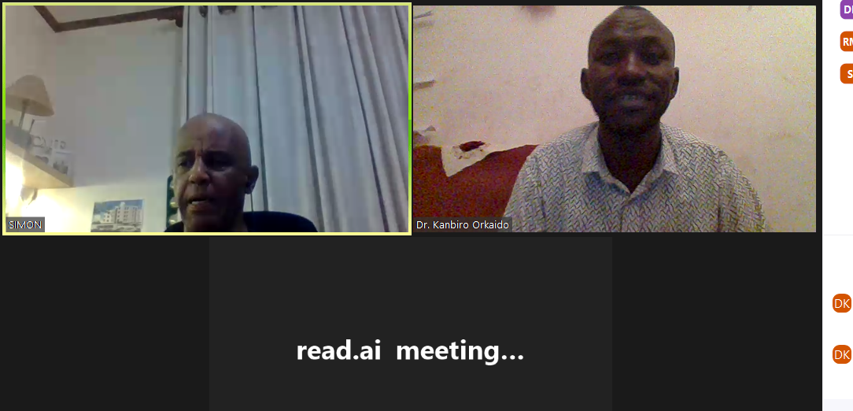

Course name: final program evaluation: <https://app.read.ai/analytics/meetings/01HM71MY91T737TYYA9BBST1PD?utm_source=Share_CopyLink>